- Created a batch file with .bat extension to check all the files with specific pattern.
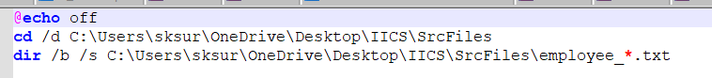
- Created an empty command file with just column header.
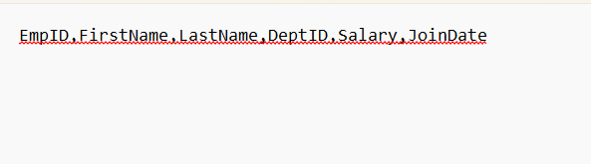
- Created a mapping
- In the source properties:
  - Selected object type as “command”.
  - Sample object as “emp_list_command.txt”.
  - Command as “C:\Users\sksur\OneDrive\Desktop\IICS\SrcFiles\FF_Source_Command.bat”
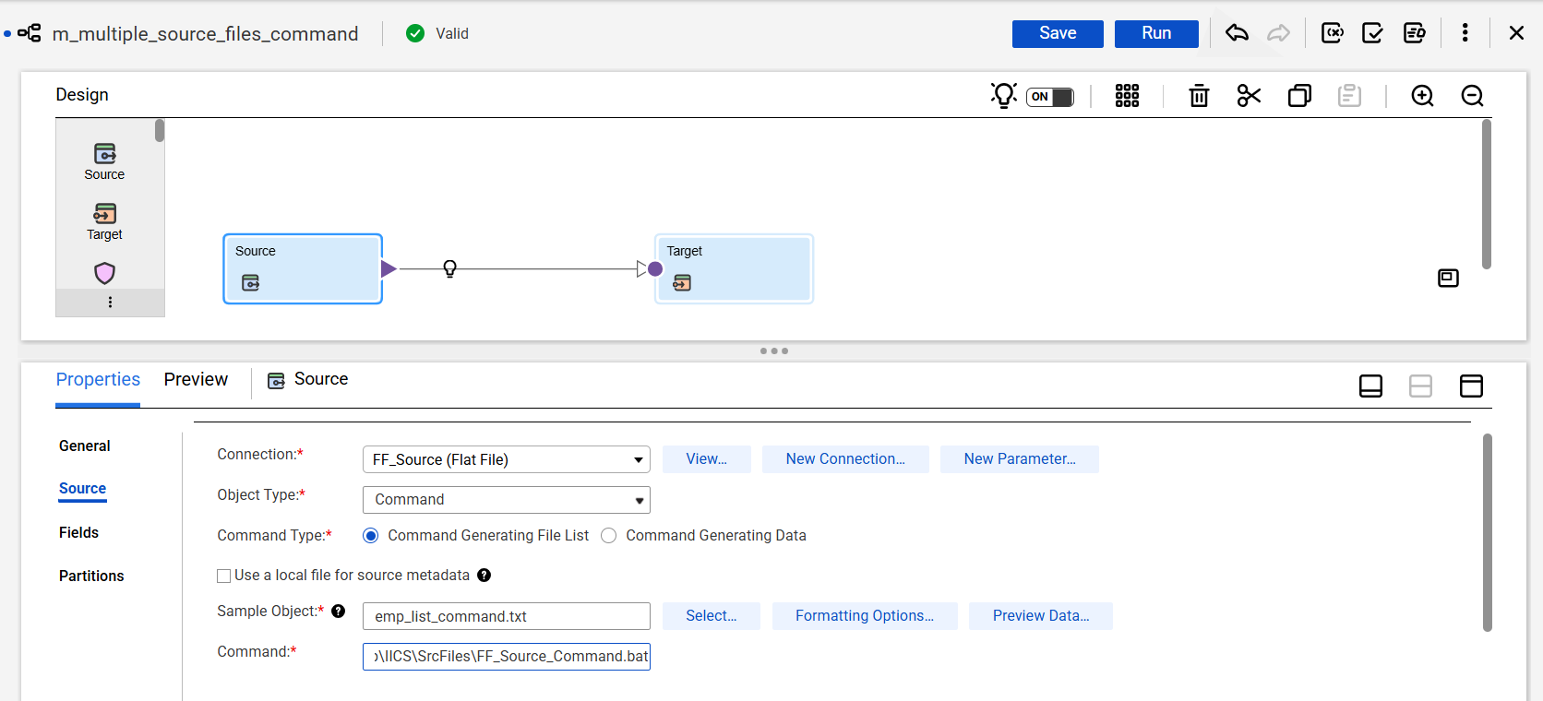
- Selected taget connection and filename.
- Ran the job.
