Joins in Oracle:
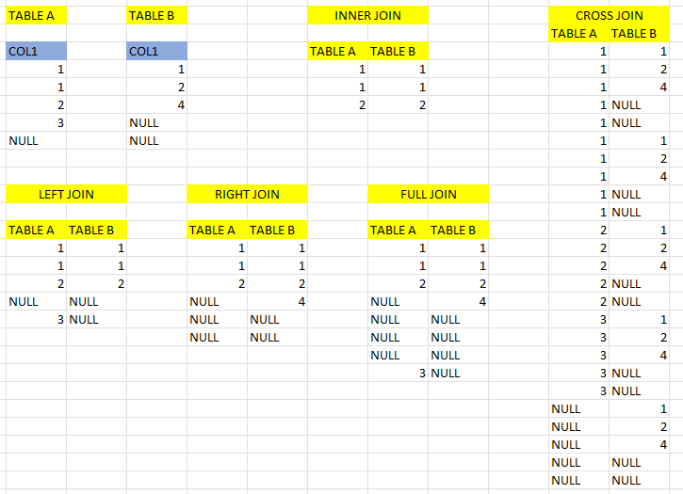

Scenario 1: Inner Join
Source 1: Employee(Oracle)
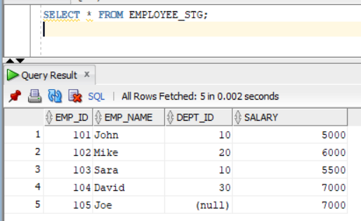
Source 2: DEPARTMENT_STG.txt (Flat File)
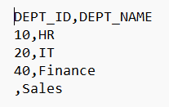
Created a mapping and selected 2 sources.
Added a Joiner transformation.
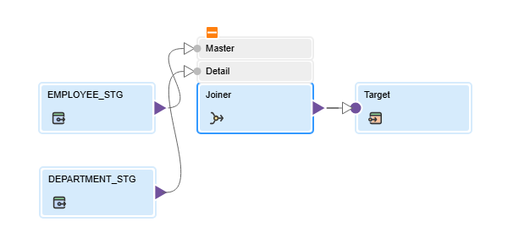
If the columns names are same in the sources, it will throw the error.
Rename the columns to resolve the conflicts.
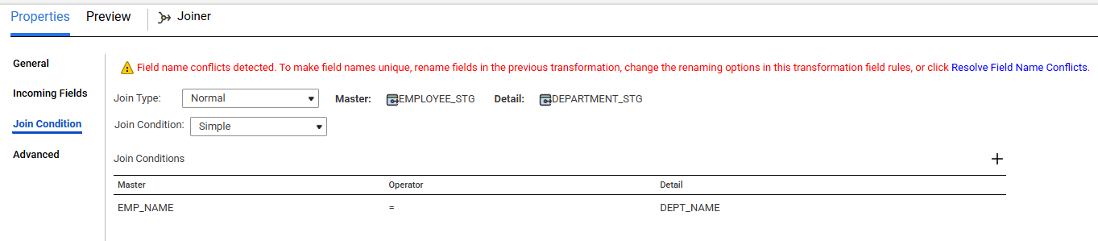
Click on Resolve Field Name Conflicts.
Join type is normal for inner join.
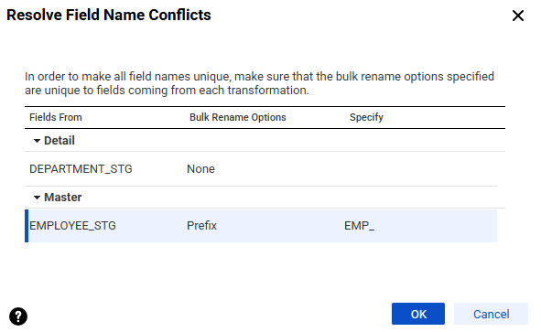

TARGET:
CREATE TABLE "EMPLOYEE_DEPT_STG"
( "EMP_ID" NUMBER,
"EMP_NAME" VARCHAR2(50),
"EMP_DEPT_ID" NUMBER,
"DEPT_DEPT_ID" NUMBER,
"DEPT_NAME" VARCHAR2(50),
"SALARY" NUMBER
);

In target mapped all the fields.
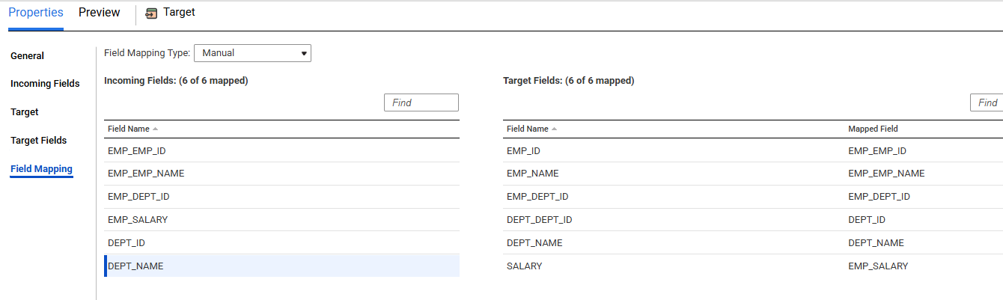
Ran the job.
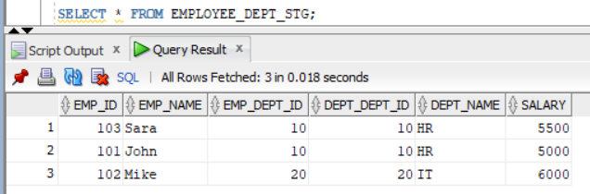

NULLs are not compared in joiner. Need to replace NULLs with default values to match.

Scenario 2: Detail Outer Join
All records from master and only matching records from detail table.
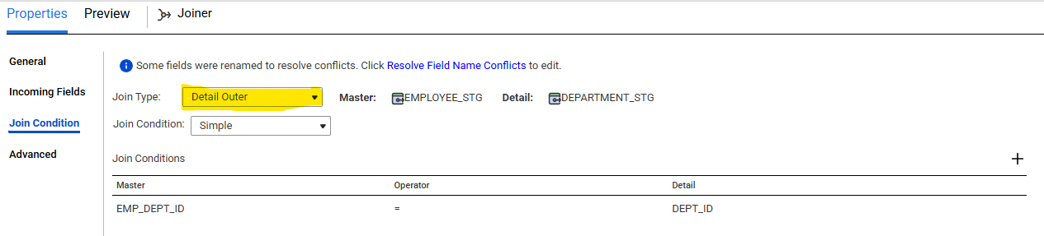
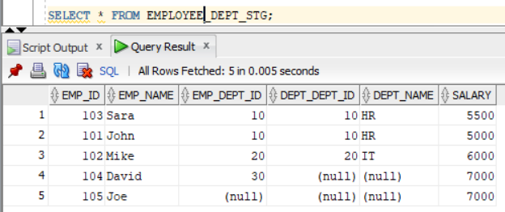

Scenario 3: Master Outer Join
All records from detail table and only matching records from master.
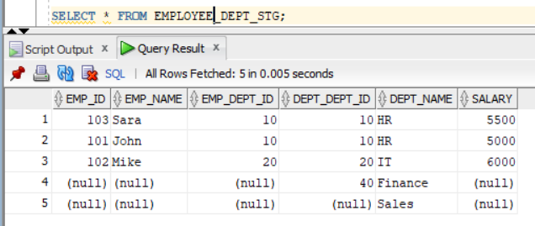

Scenario 4: Full Outer Join
