DDL:
Source:
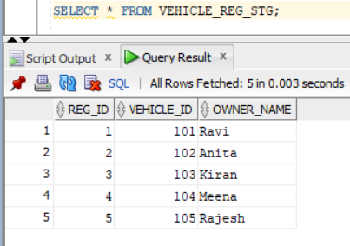
Lookup Data:
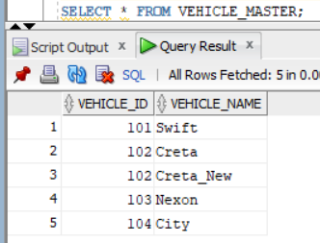
Created a dummy mapping.
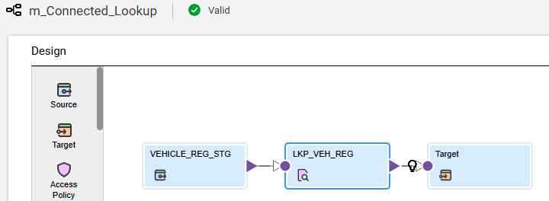
In the lookup object selected the object and added the join condition.
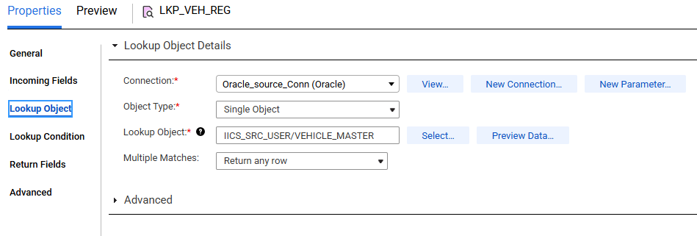
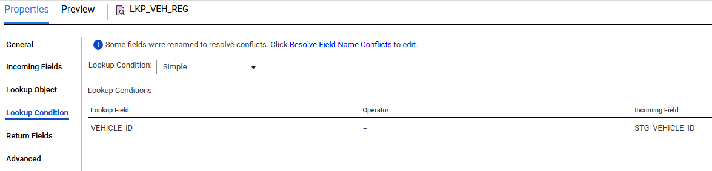
Created a target file and ran the job.
Scenario 1: Multiple Matches(Return any row)(default)
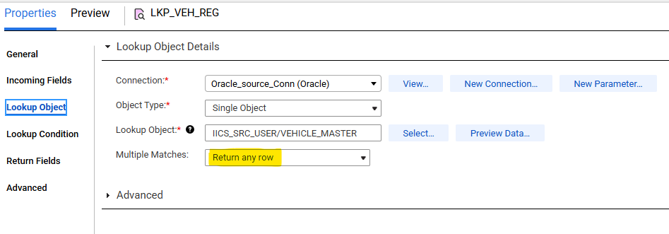
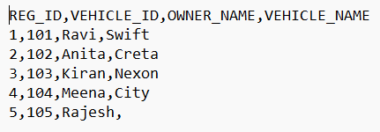

Scenario 2: Multiple Matches (Return first row)
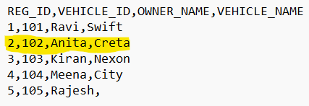
Scenario 3: Multiple Matches (Return last row)
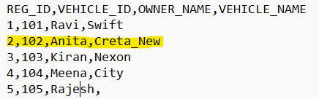
Scenario 4: Multiple Matches (Return all rows)
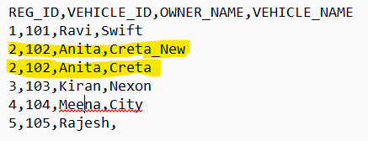
Scenario 5: Multiple Matches (Report error)
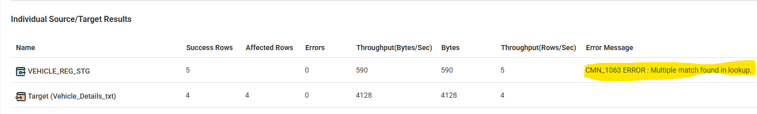
It loaded all the records except duplicate records.
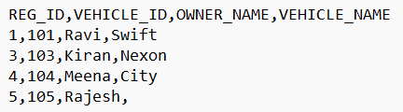
Scenario 6: Lookup Override
Added query in lookup override and ran the job.
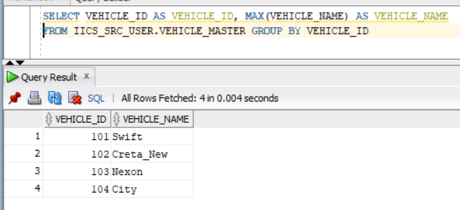
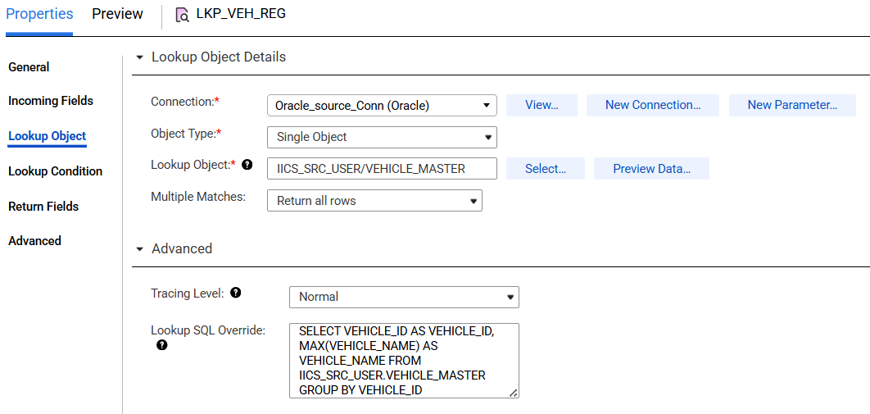
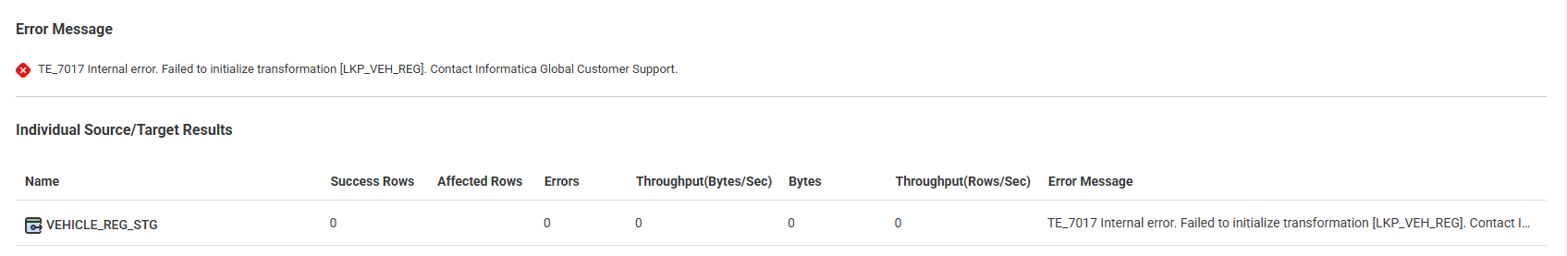

To Add lookup override query we need to add below property.
Administrator -> Runtime Environments -> select RE -> Click Edit ->
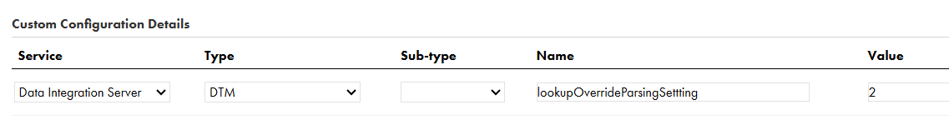
After 5 to 10 minutes ran the job.
