Created a Sample mapping.
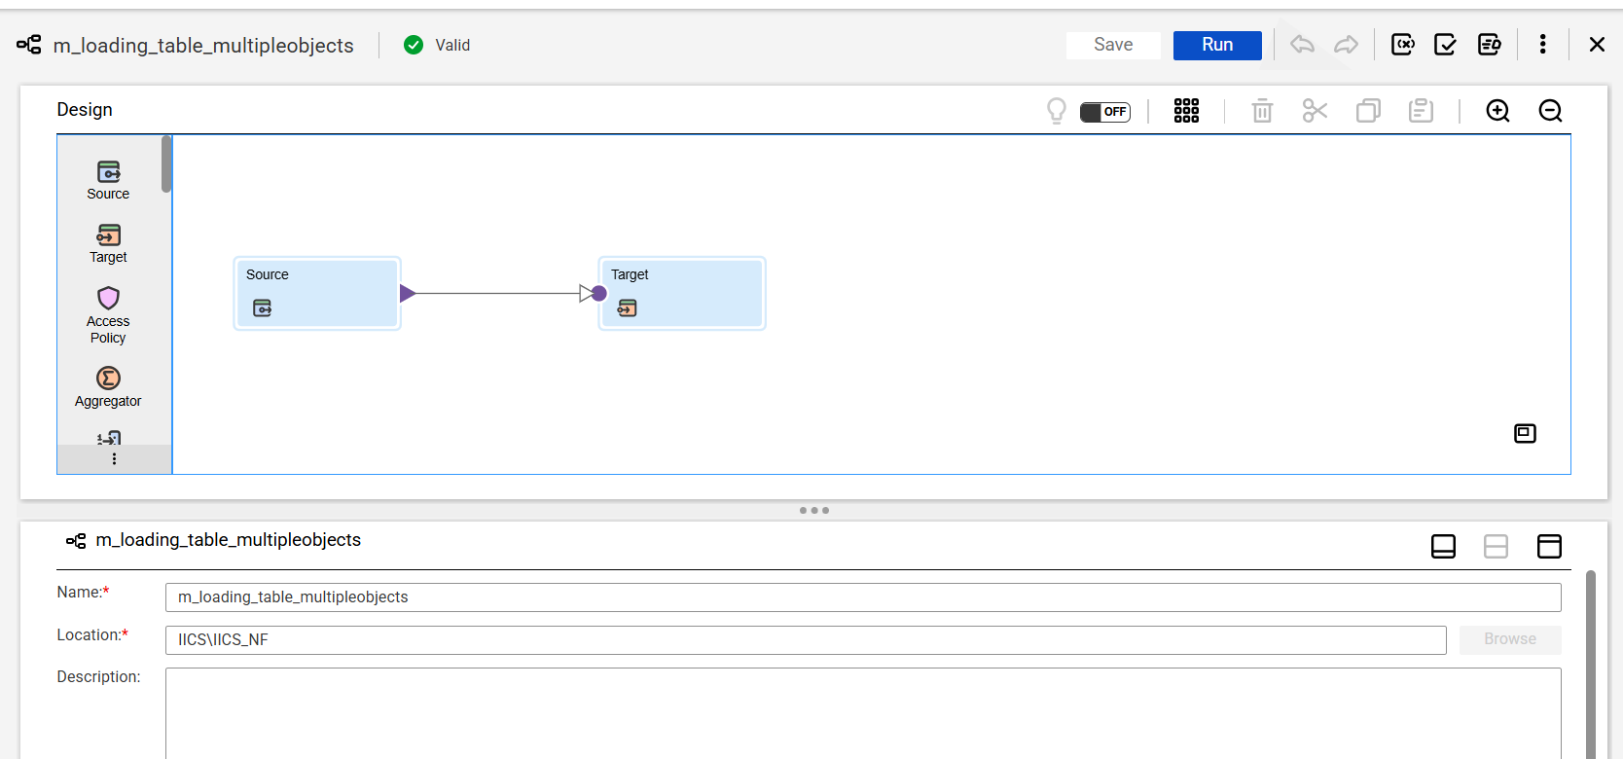
Created 2 tables in oracle.
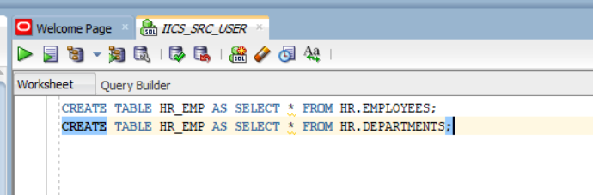
In the sources tab:
- Selected source connection
- Object type as “Multiple Objects”
- Clicked on 3 dots under “Objects and Relationships” and selected dept table.
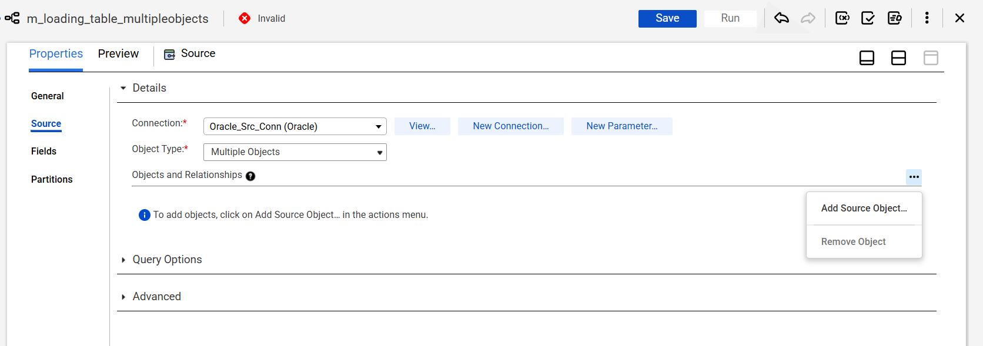

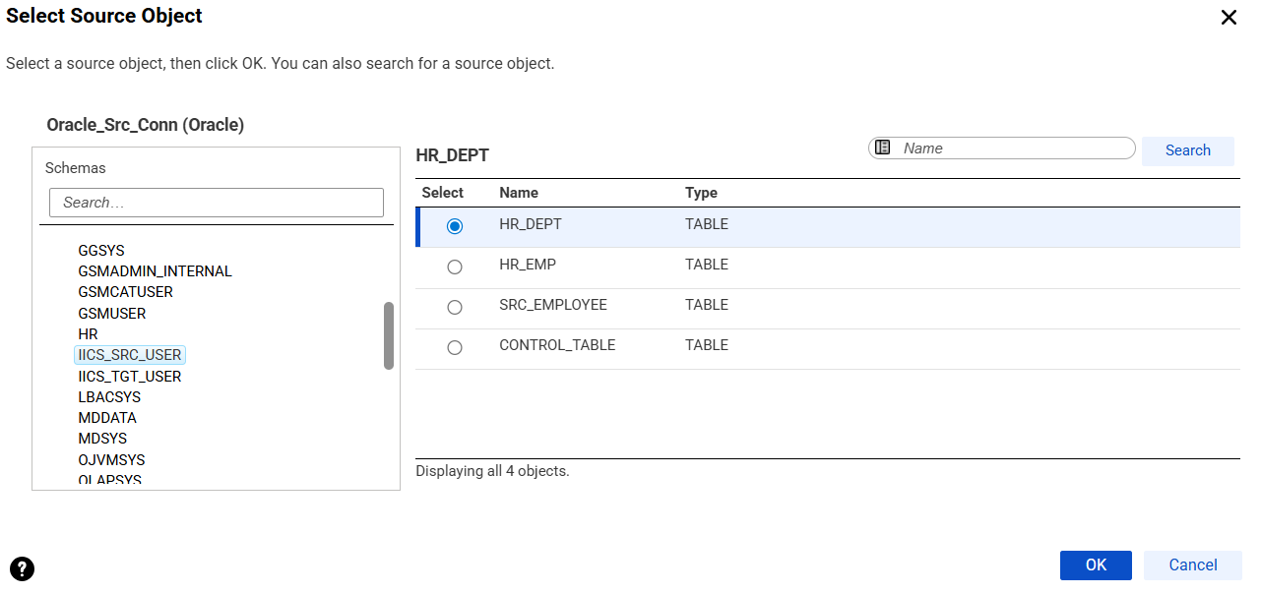
Clicked on Related Objects Action Menu -> Click on Add Related Objects
