Step 1: Open any browser and search for “iics trial account”.
Step 2: open “Choose your free cloud platform trial” URL.
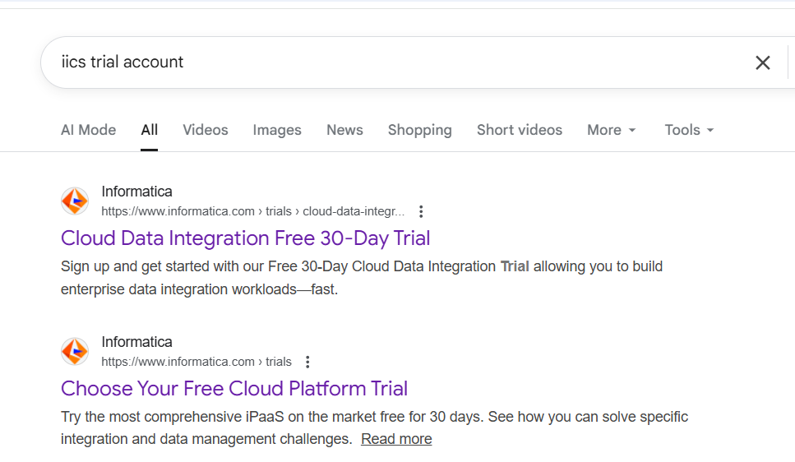
Step 3: Scroll down and select “start trial” of “real time integration”.
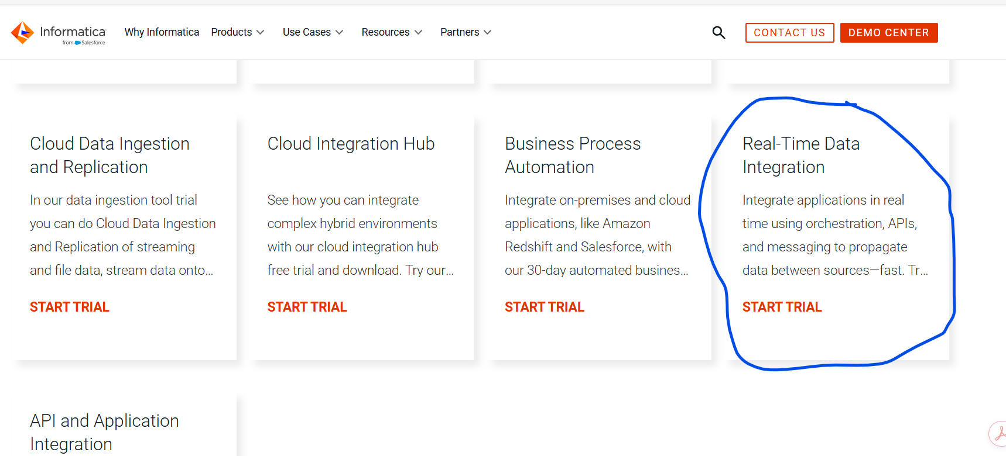

Step 4: Currently Gmail is not working.
Step 5: Go to browser and search for temp mail.

Step 6: Click on first link
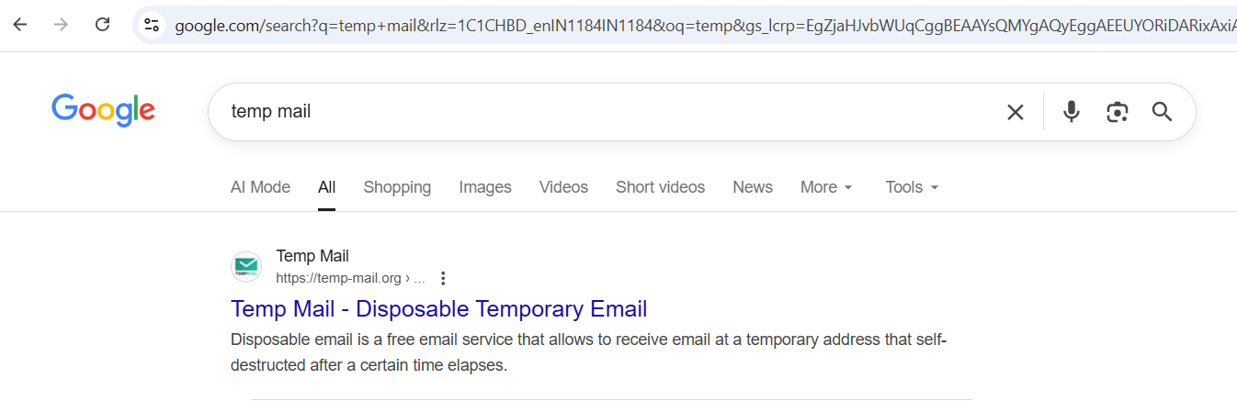

Step 7: Create an account with with the temporary mail provided in temp mail.
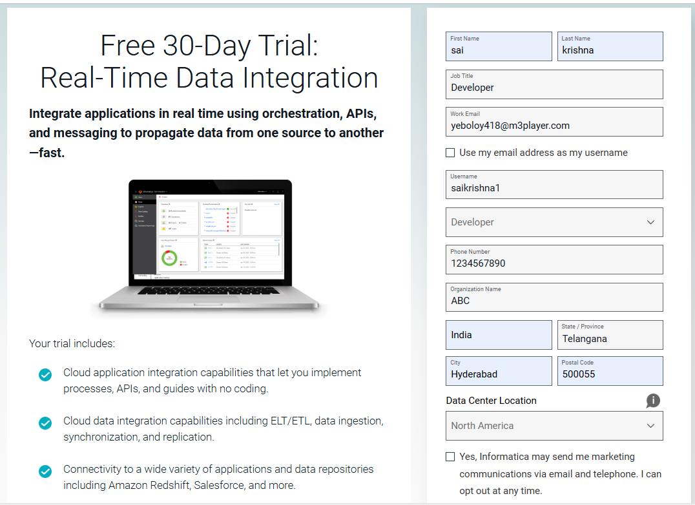

Step 8: you will receive verification mail to temporary mail inbox in temp mail web page.
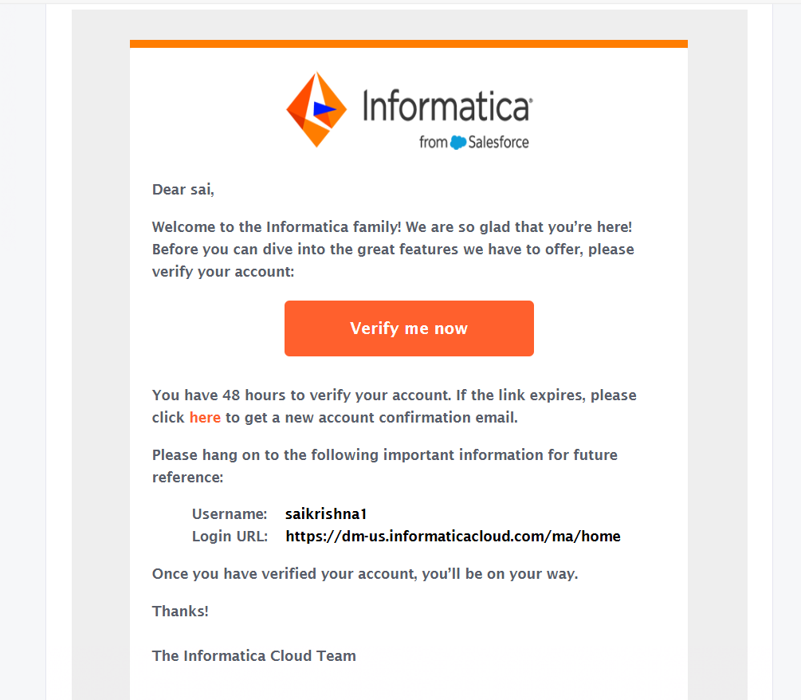
Step 9: Create a password and login.
Step 10: go to Administrator and install secure agent.
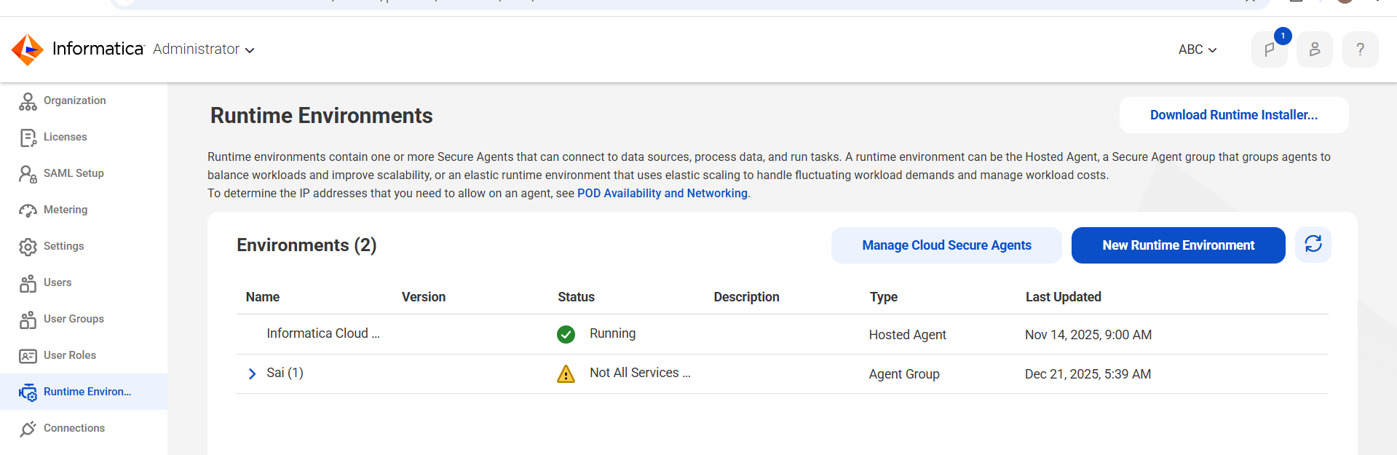

Step 11: Install the secure agent and run the service with user name and install token.
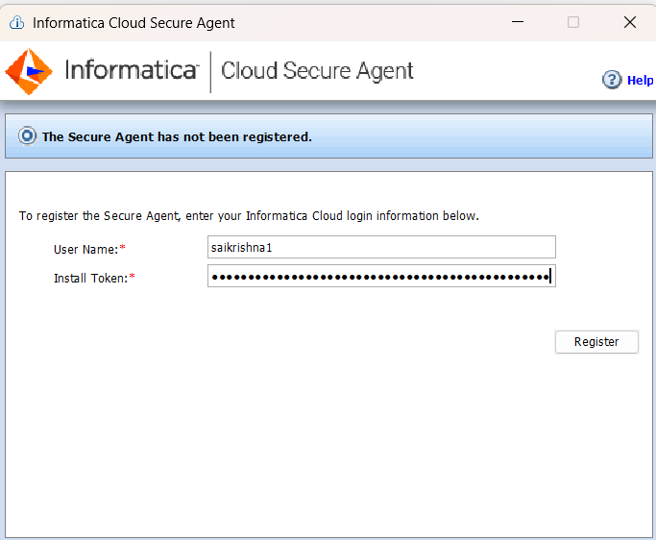
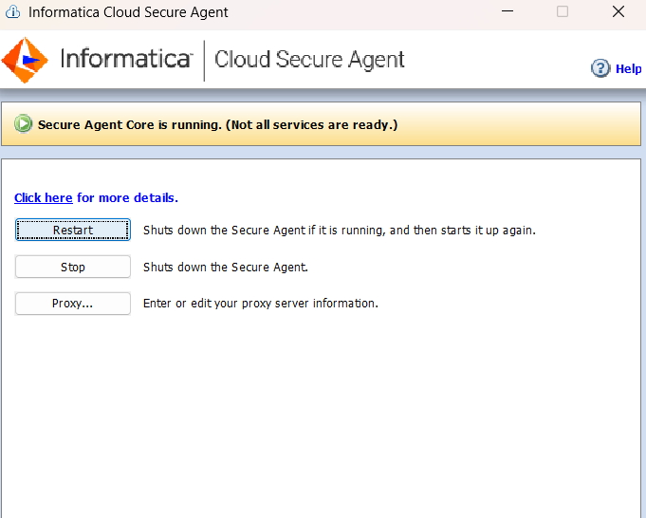
Step 12: Refresh the page and you will see new secure agent and it may take some time to active all services.
