Created source table and inserted data.
CREATE TABLE TRANSACTION_STG (
TXN_ID NUMBER(10),
CUST_ID NUMBER(10),
AMOUNT NUMBER(15,2),
TXN_TYPE VARCHAR2(20),
TXN_DATE DATE,
STATUS VARCHAR2(20)
);

INSERT INTO TRANSACTION_STG VALUES (1, 201, 10000, 'CREDIT', TO_DATE('01-JAN-2025','DD-MON-YYYY'), 'SUCCESS');
INSERT INTO TRANSACTION_STG VALUES (2, 202, 5000, 'DEBIT', TO_DATE('02-JAN-2025','DD-MON-YYYY'), 'FAILED');
INSERT INTO TRANSACTION_STG VALUES (3, 203, 20000, 'CREDIT', TO_DATE('03-JAN-2025','DD-MON-YYYY'), 'SUCCESS');
INSERT INTO TRANSACTION_STG VALUES (4, 204, 15000, 'DEBIT', TO_DATE('04-JAN-2025','DD-MON-YYYY'), 'SUCCESS');
INSERT INTO TRANSACTION_STG VALUES (5, 205, 7500, 'CREDIT', TO_DATE('05-JAN-2025','DD-MON-YYYY'), 'PENDING');
INSERT INTO TRANSACTION_STG VALUES (6, 206, 0, 'DEBIT', TO_DATE('06-JAN-2025','DD-MON-YYYY'), 'SUCCESS');
INSERT INTO TRANSACTION_STG VALUES (7, 207, 50000, 'CREDIT', TO_DATE('07-JAN-2025','DD-MON-YYYY'), 'SUCCESS');
INSERT INTO TRANSACTION_STG VALUES (8, 208, 12000, 'TRANSFER', TO_DATE('08-JAN-2025','DD-MON-YYYY'), 'SUCCESS');
INSERT INTO TRANSACTION_STG VALUES (9,209, 18000, 'CREDIT', TO_DATE('09-JAN-2025','DD-MON-YYYY'), 'REVERSED');
INSERT INTO TRANSACTION_STG VALUES (10,210, 250000, 'CREDIT', TO_DATE('10-JAN-2025','DD-MON-YYYY'), 'SUCCESS');
COMMIT;
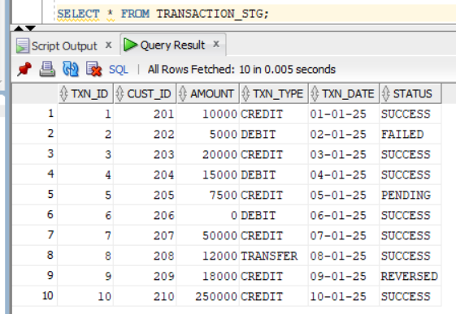
Created target table.
CREATE TABLE TRANSACTION_TRG (
TXN_ID NUMBER(10),
CUST_ID NUMBER(10),
AMOUNT NUMBER(15,2),
TXN_TYPE VARCHAR2(20),
TXN_DATE DATE,
STATUS VARCHAR2(20)
);
Created a dummy mapping.
Selected Source and target and enabled “Truncate Target” in target table.
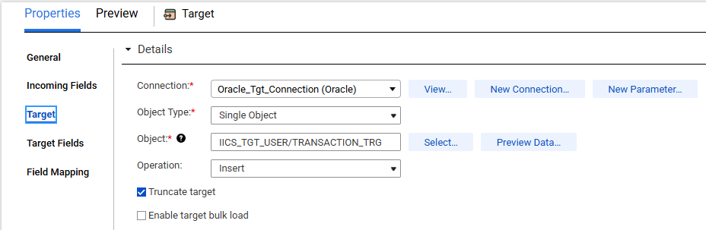

Scenario 1: Filter Condition: Simple
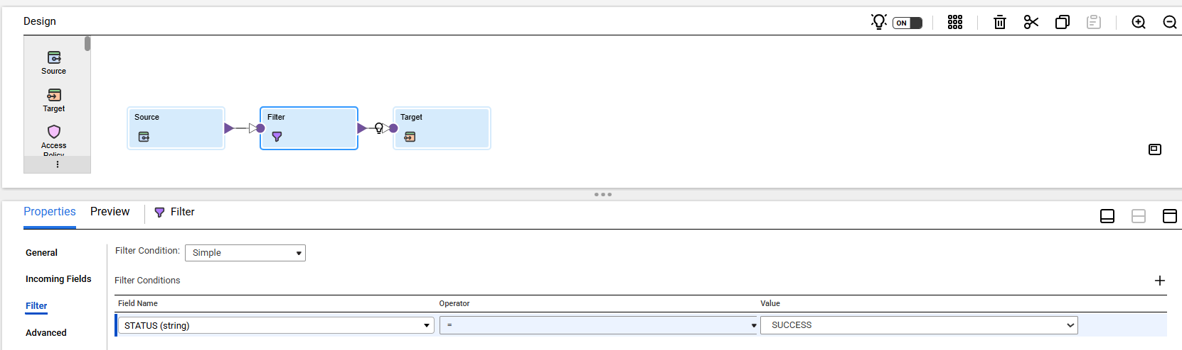
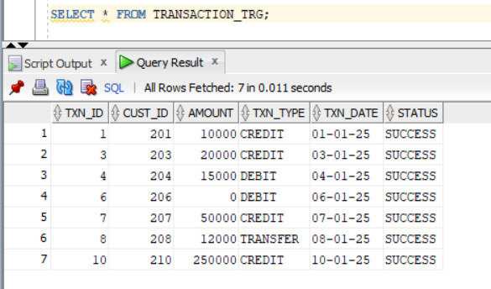

Scenario 2: Filter Condition: Advanced
