- Created 3 files with same structure.
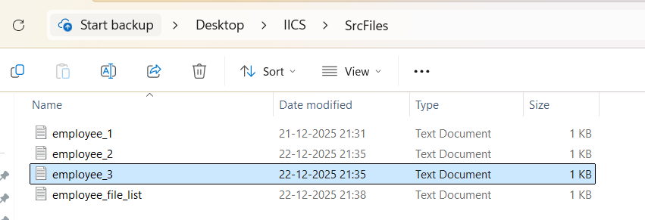
- Created a list file named “employee_file_name.txt” and placed all the 3 file names along with paths in list file.
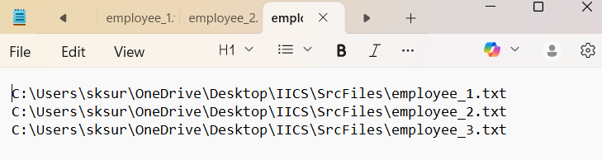
- Created a new mapping.
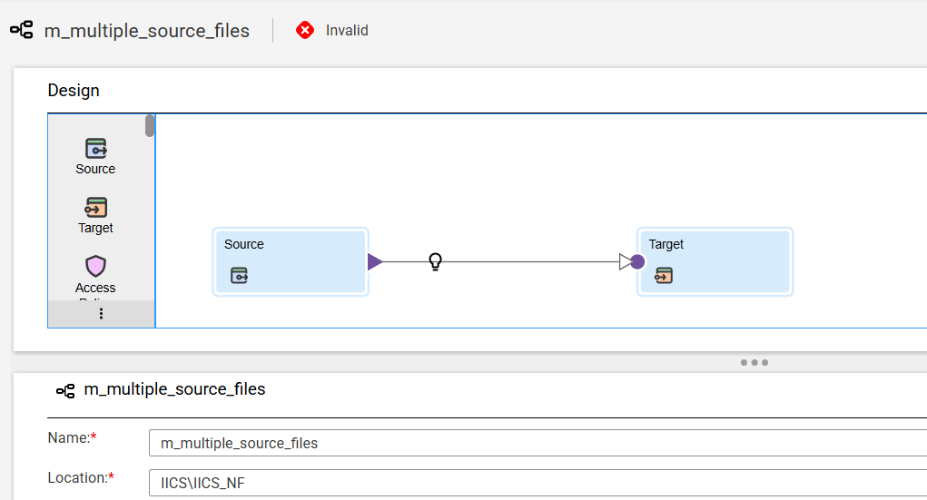

- In the source properties:
  - Selected available source connection
  - Selected source type “File List”
  - Selected object as “employee_file_name.txt”
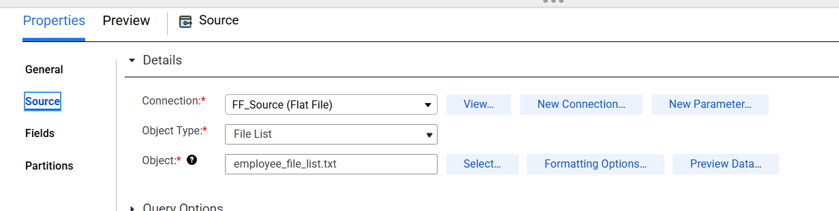
- In the target properties:
  - Selected available target connection
  - Selected available target file.
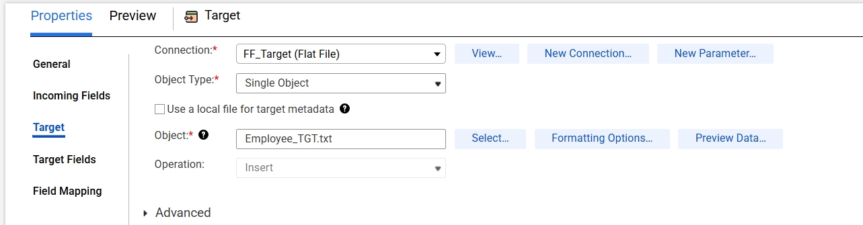
- Completed the field mapping.
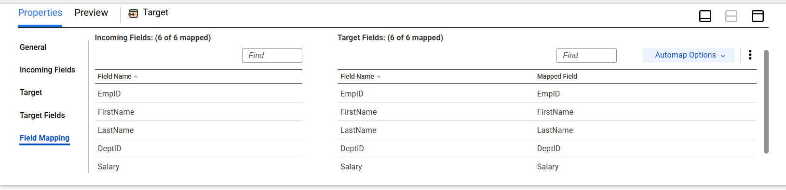
- Saved and ran the job.
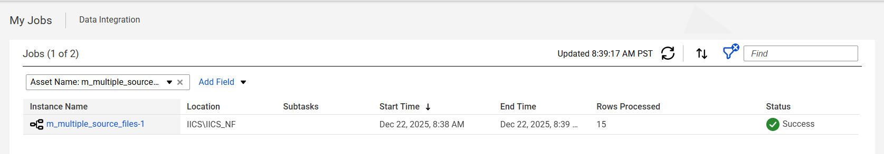
- 15 rows inserted from 3 files.
