- Created a mapping to load data from one table to another.
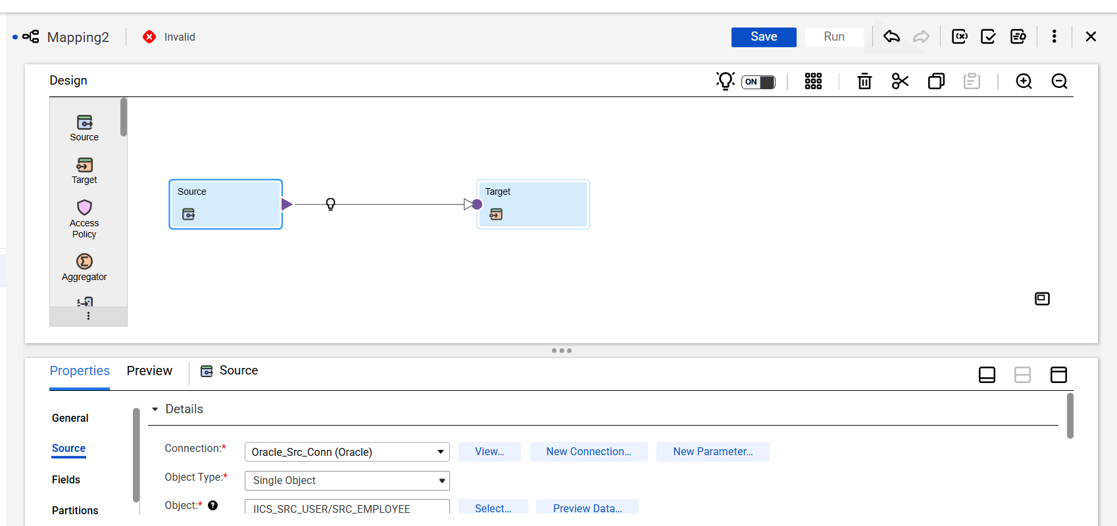
- In the source properties click on “New Connection”.
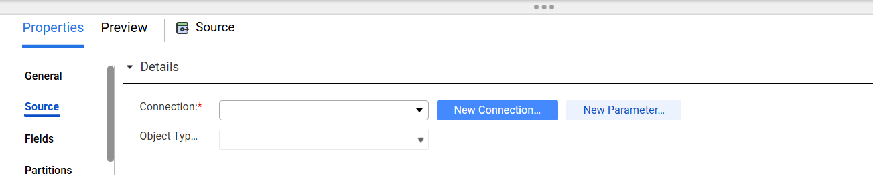
- Select Oracle and click “Continue Setup”.
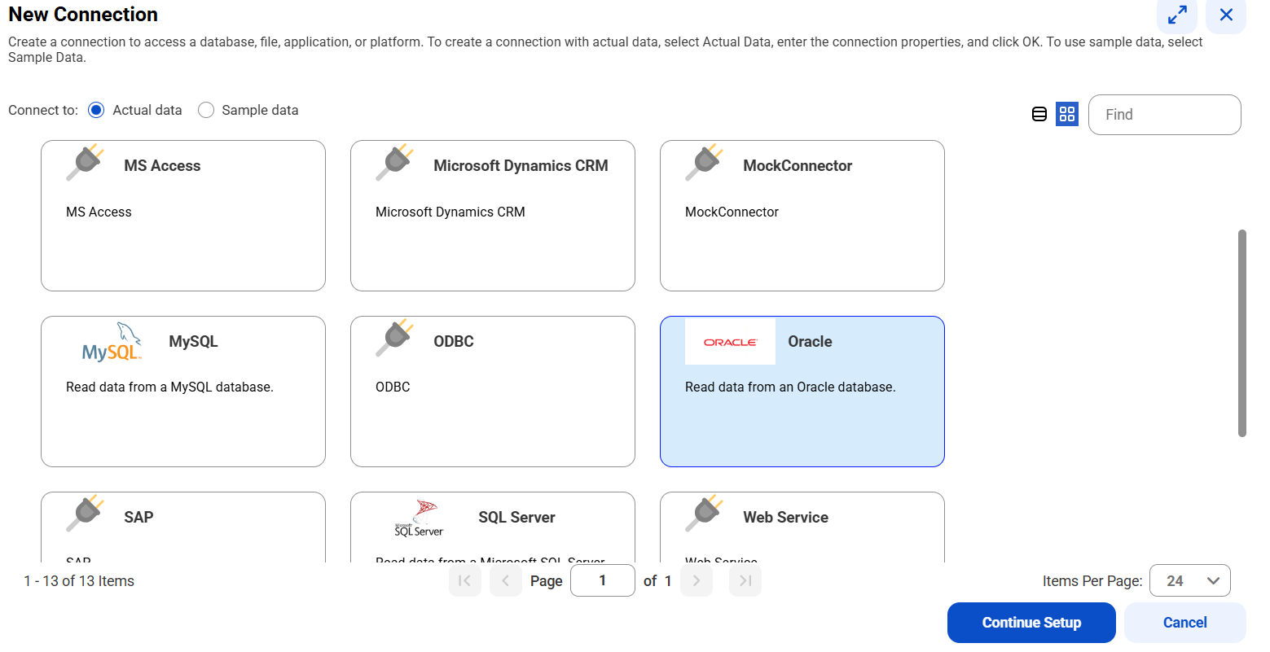
- Add all the necessary details and click on test and click on add.
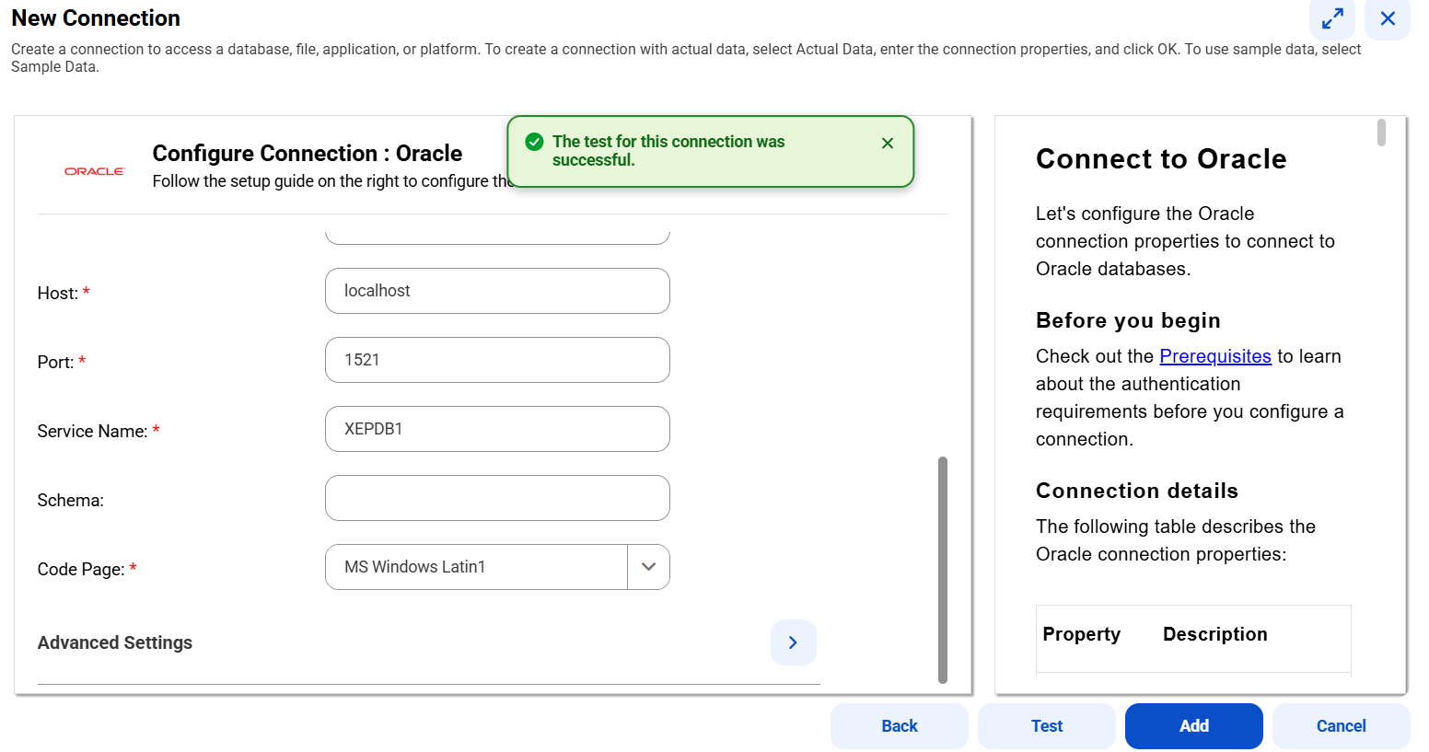
- For host name and service name right click on oracle connection and go to properties.
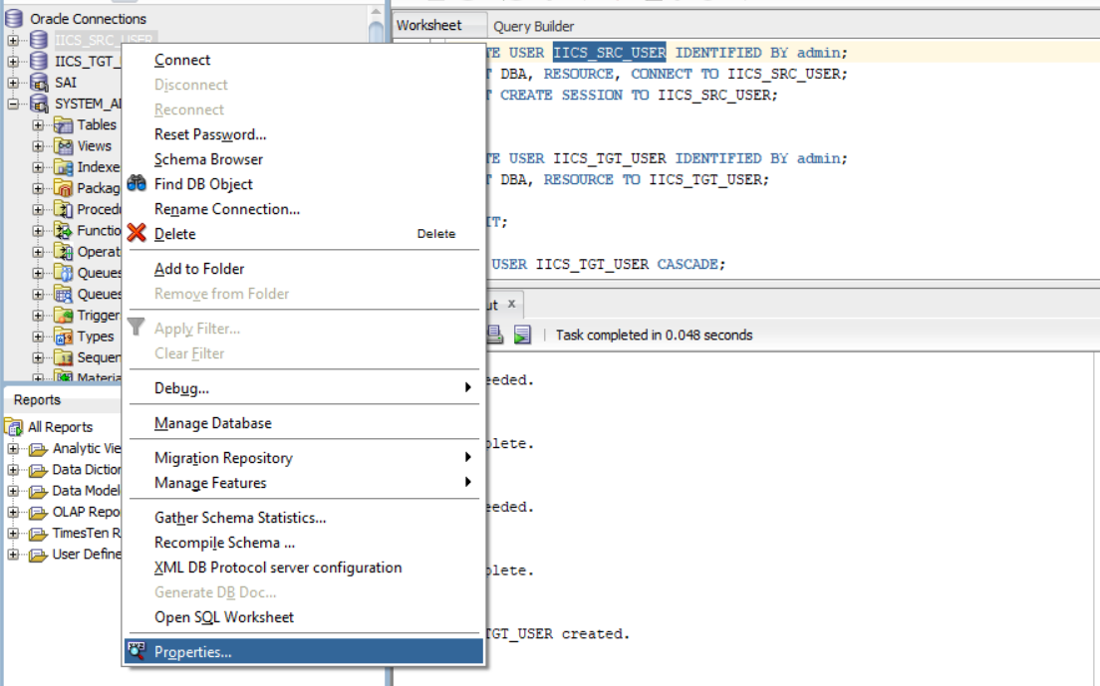

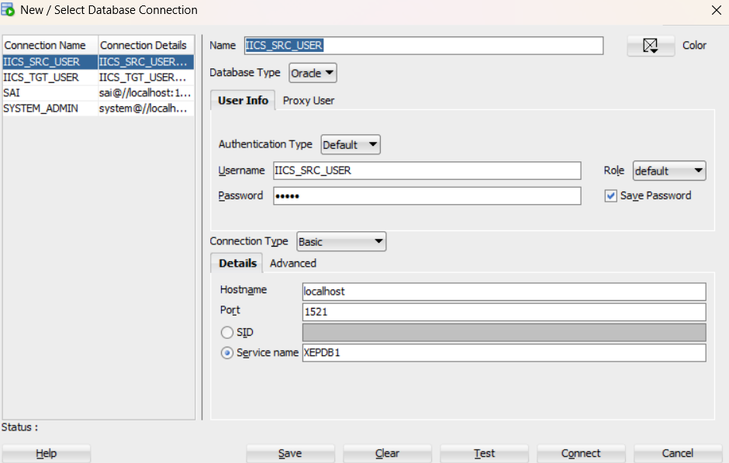
- Created a sample table and loaded multiple records.

CREATE TABLE SRC_EMPLOYEE
(
EmpID NUMBER,
FirstName VARCHAR2(15),
LastName VARCHAR2(15),
DeptID NUMBER,
Salary NUMBER,
JoinDate DATE
);

INSERT INTO SRC_EMPLOYEE VALUES (101,'Michael','Rogers',14,55000,TO_DATE('2023-01-15', 'YYYY-MM-DD'));
INSERT INTO SRC_EMPLOYEE VALUES (102,'Anand','Manikutty',14,62000,TO_DATE('2022-03-10', 'YYYY-MM-DD'));
INSERT INTO SRC_EMPLOYEE VALUES (103,'Carol','Smith',37,71000,TO_DATE('2021-11-25', 'YYYY-MM-DD'));
INSERT INTO SRC_EMPLOYEE VALUES (104,'Joe','Stevens',37,48000,TO_DATE('2023-06-05', 'YYYY-MM-DD'));
INSERT INTO SRC_EMPLOYEE VALUES (105,'Mary-Anne','Foster',14,95000,TO_DATE('2020-08-12', 'YYYY-MM-DD'));
INSERT INTO SRC_EMPLOYEE VALUES (105,'Mary-Anne','Foster',14,95000,TO_DATE('2020-08-12', 'YYYY-MM-DD'));
COMMIT;
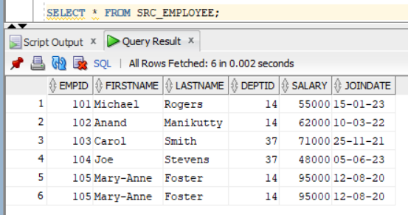

- In the Query options added one sample filter and sorter.
- We can only sort the data in ascending order in Query options.
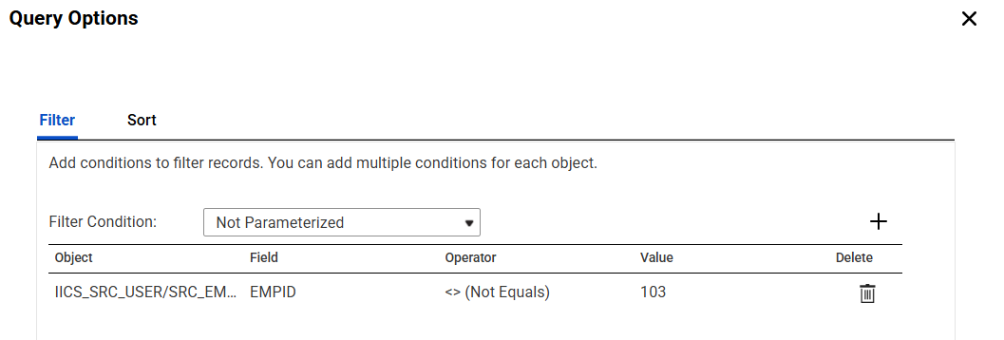
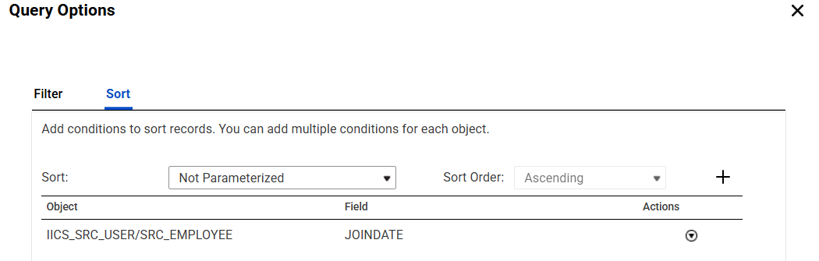
- Checked the option “select distinct only”.
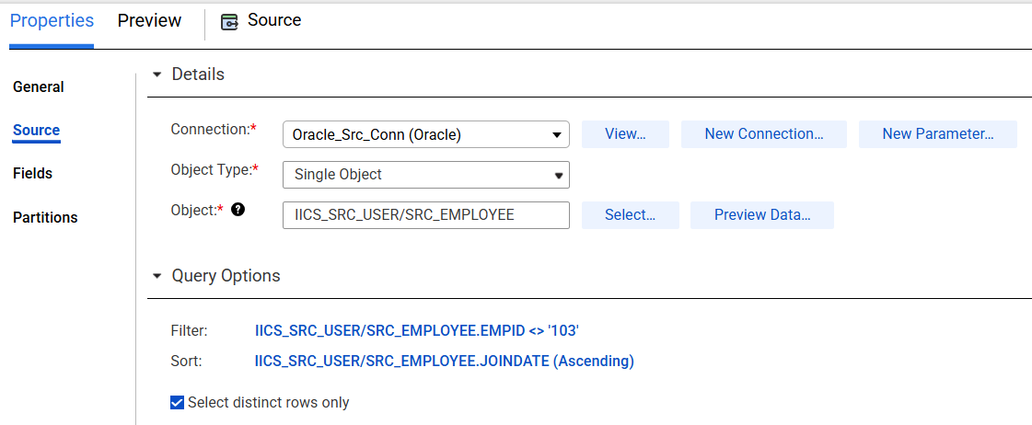
- Created a sample table to store mapping start and end timings.
CREATE TABLE CONTROL_TABLE
(
MAPPING_NAME VARCHAR2(100),
RUNDATE DATE,
START_TIME TIMESTAMP(9),
END_TIME TIMESTAMP(9)
);
- Added a query in Pre SQL to add an entry in the table.
- Added a query in Post SQL to update the entry in the table.
- Added target as flat file.
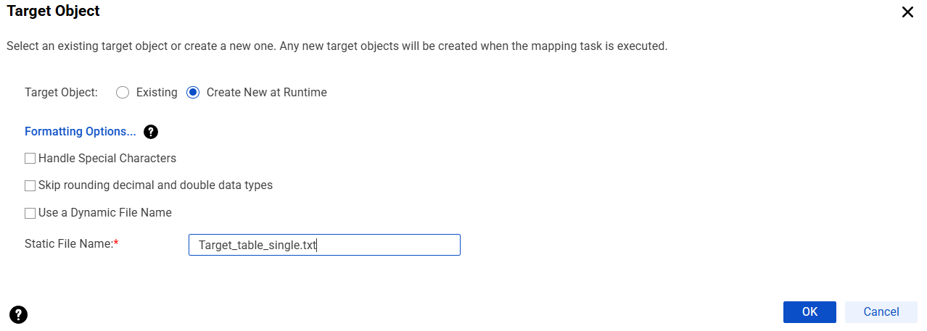
- Saved and ran the job.
- It loaded only 4 records because of filter and select distinct in source.
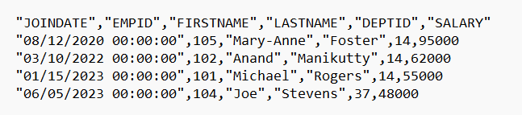
- It updated control table with start time and end time.
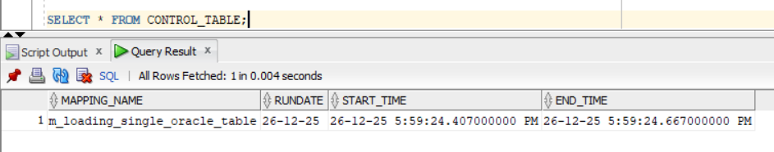

Note: If you give SQL override query, it will discard all the conditions set in the Query options.

