- Copied the existing mapping
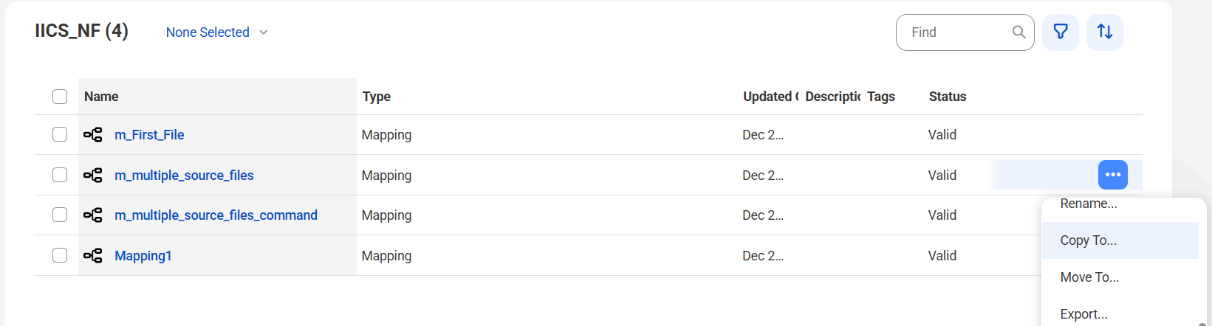
- It is created with “- copy 1” and renamed as per requirement.
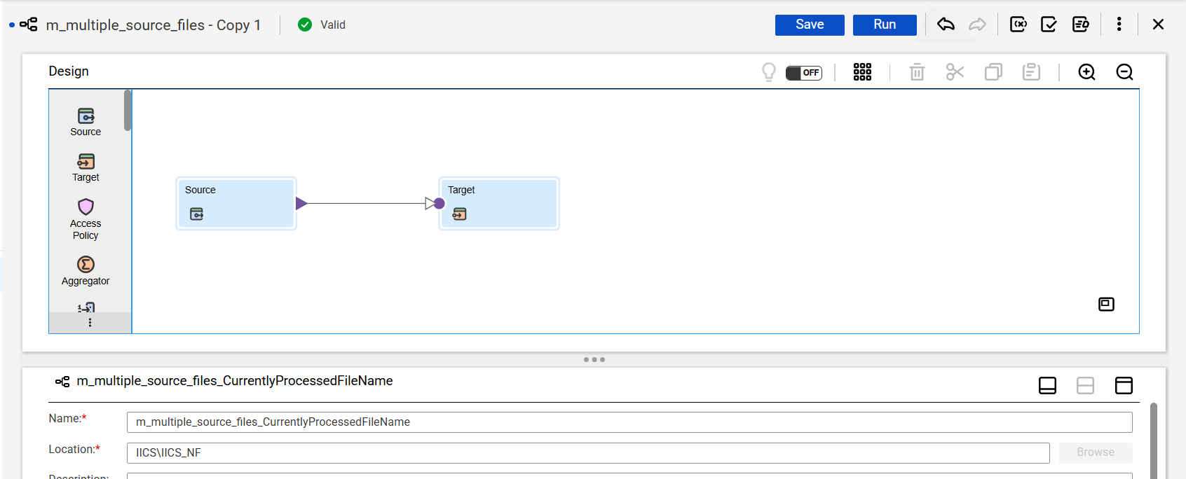
- Go to fields in source properties and check the box “Add Currently Processed Filename field”.
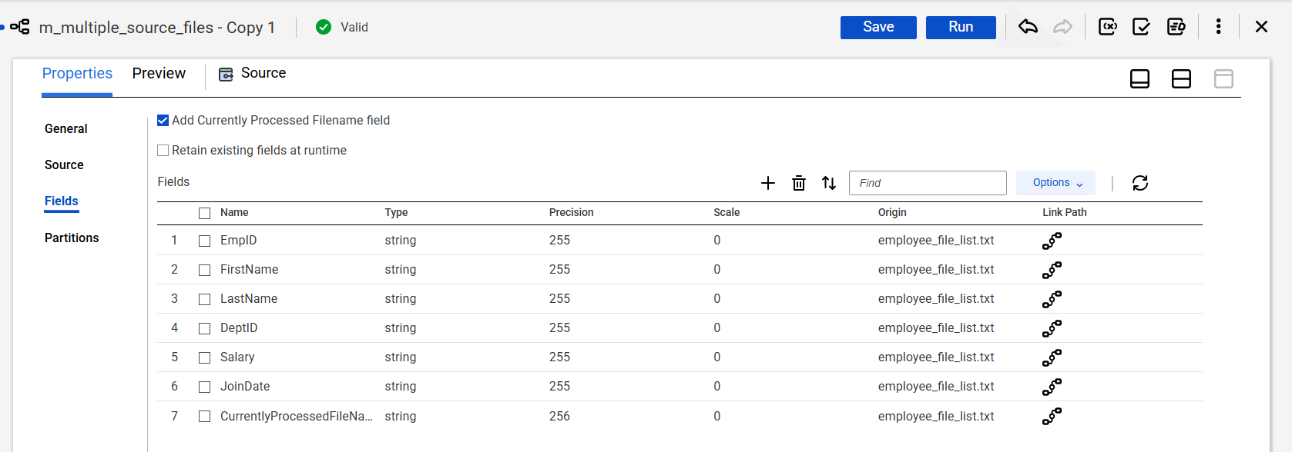
- Saved and ran the job.
