Created Source table and inserted data.
CREATE TABLE EMPLOYEE_STG (
EMP_ID NUMBER(10),
FIRST_NAME VARCHAR2(50),
LAST_NAME VARCHAR2(50),
EMAIL VARCHAR2(100),
SALARY NUMBER(10,2),
BONUS NUMBER(10,2),
JOIN_DATE DATE,
DEPT_CODE VARCHAR2(10),
PHONE VARCHAR2(15),
STATUS VARCHAR2(1)
);

INSERT INTO EMPLOYEE_STG VALUES
(101, 'sai', 'kumar', 'sai.k@gmail.com', 50000, 5000,
TO_DATE('12-JAN-2022','DD-MON-YYYY'), 'it', '9876543210', 'a');

INSERT INTO EMPLOYEE_STG VALUES
(102, 'RAVI', 'SHARMA', 'ravi@gmail.com', 65000, NULL,
TO_DATE('05-MAR-2021','DD-MON-YYYY'), 'hr', '9123456780', 'i');

INSERT INTO EMPLOYEE_STG VALUES
(103, 'anita', 'reddy', NULL, 40000, 2000,
TO_DATE('10-DEC-2023','DD-MON-YYYY'), 'fin', '9988776655', 'a');
INSERT INTO EMPLOYEE_STG VALUES
(104, 'John', 'Doe', 'john.doe@gmail.com', NULL, NULL,
TO_DATE('15-AUG-2020','DD-MON-YYYY'), 'ops', NULL, 'a');
COMMIT;
- Converting FIRST_NAME and LAST_NAME to proper case
- If the EMAIL is NULL then creating email as FIRST_NAME.LAST_NAME@domain.com
- Replacing NULL with 0 in SALARY column.
- Replacing NULL with SALARY * 0.1 in BONUS.
- Converting DEPT_CODE to upper case.
- Calculating YOE
- Masking phone number
- Adding employee status field
- Generate Row Number
Created mapping and selected source.
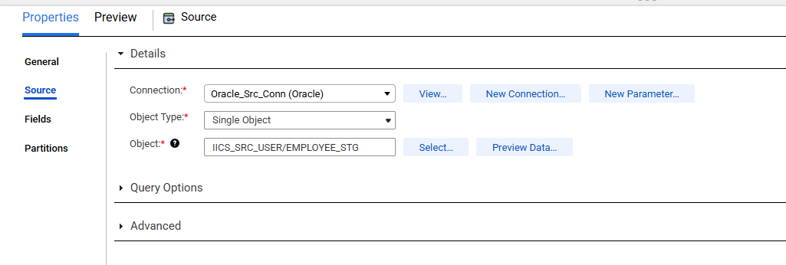
Created an Expression transformation and created required fields.
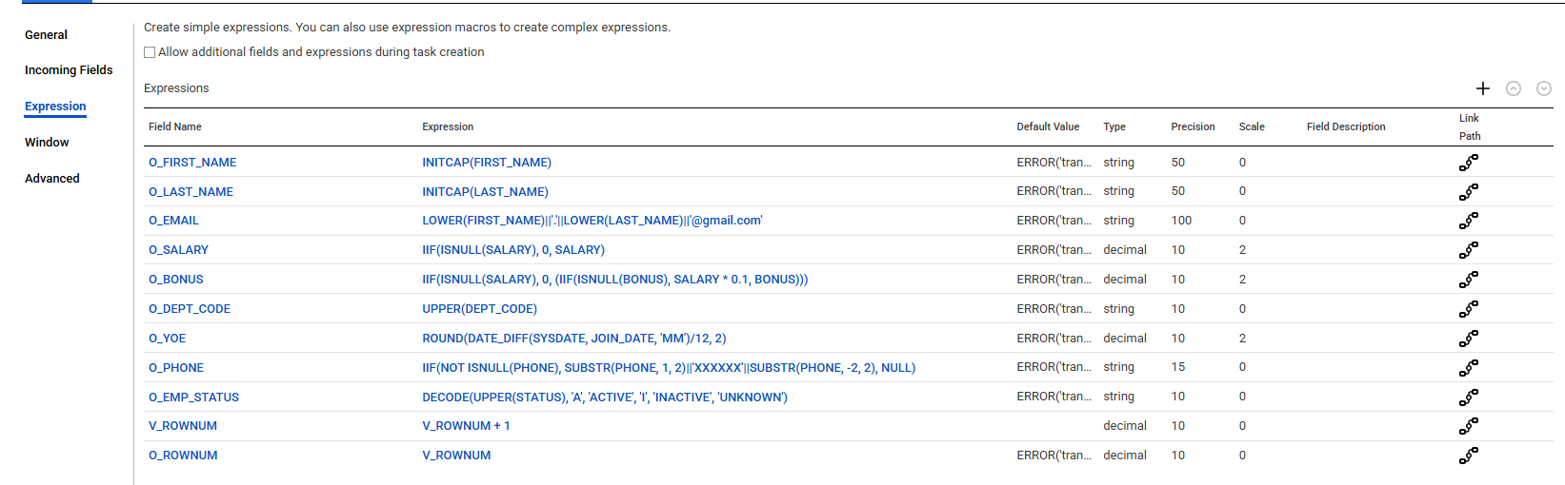
Created target table.
CREATE TABLE EMPLOYEE_STG_TRG (
EMP_ID NUMBER(10),
FIRST_NAME VARCHAR2(50),
LAST_NAME VARCHAR2(50),
EMAIL VARCHAR2(100),
SALARY NUMBER(10,2),
BONUS NUMBER(10,2),
JOIN_DATE DATE,
DEPT_CODE VARCHAR2(10),
YEARS_OF_EXP NUMBER(10),
PHONE VARCHAR2(15),
EMP_STATUS VARCHAR2(10),
ROW_NUM NUMBER(10)
);
COMMIT;
Created target and mapped all the columns.
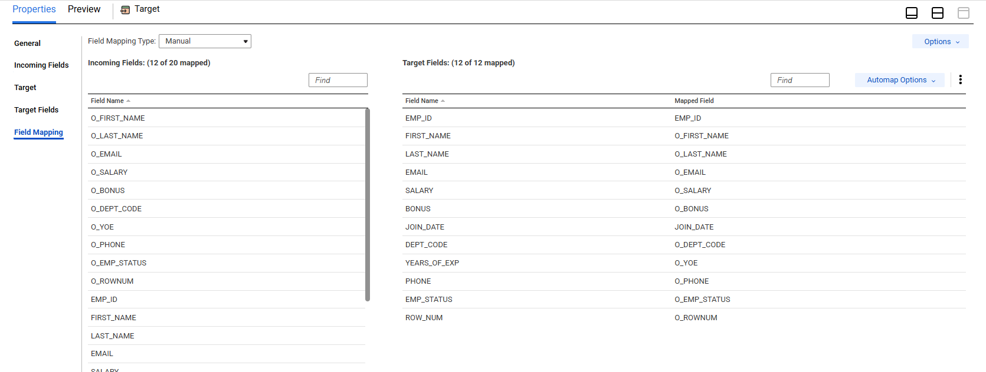

Source Data:
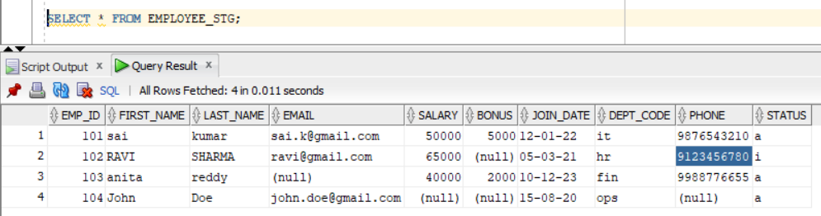
Target Data:
