- Created a new mapping
- In the source properties:
  - Selected source connection
  - Selected object type as “parameter”
  - Clicked on new parameter to create a parameter.
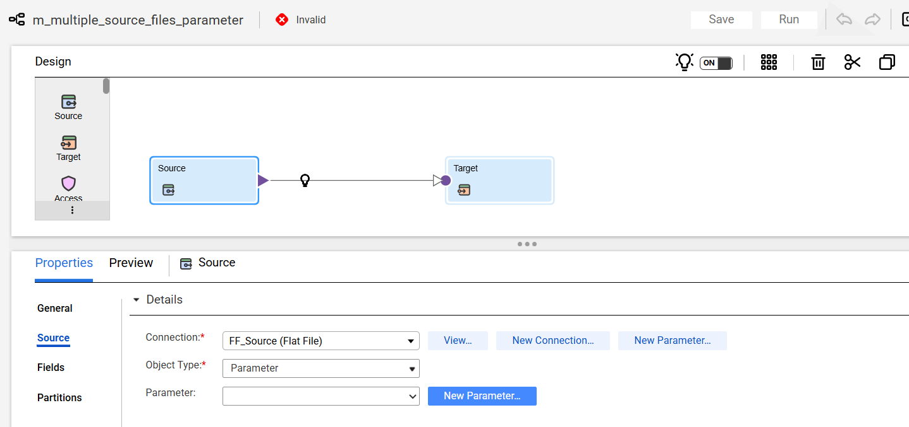
- Created a new parameter with the name “p_Source_File” and selected “Allow parameter to be overridden at run time”.
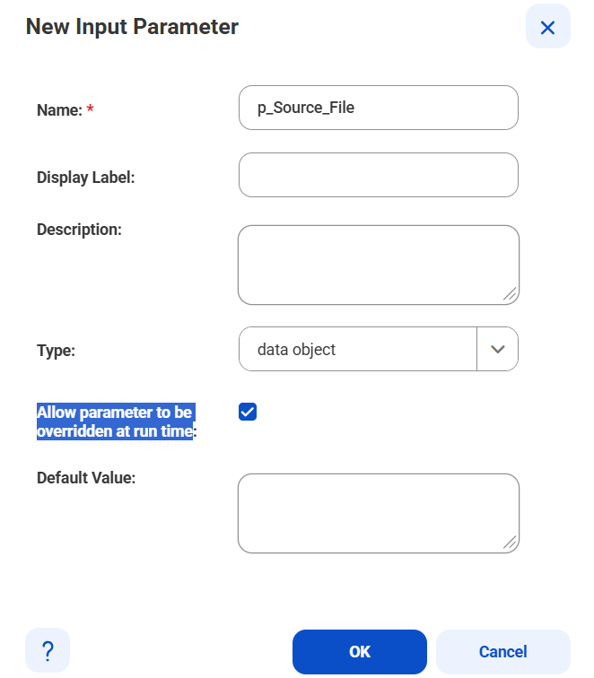
- Selected target properties.
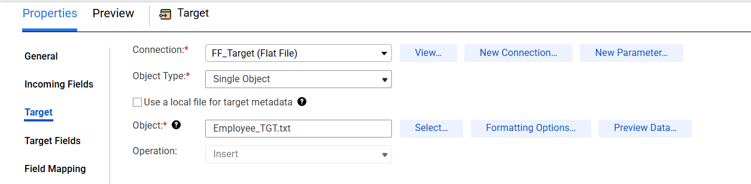
- Saved and ran the job.
- First tab select the runtime environment.
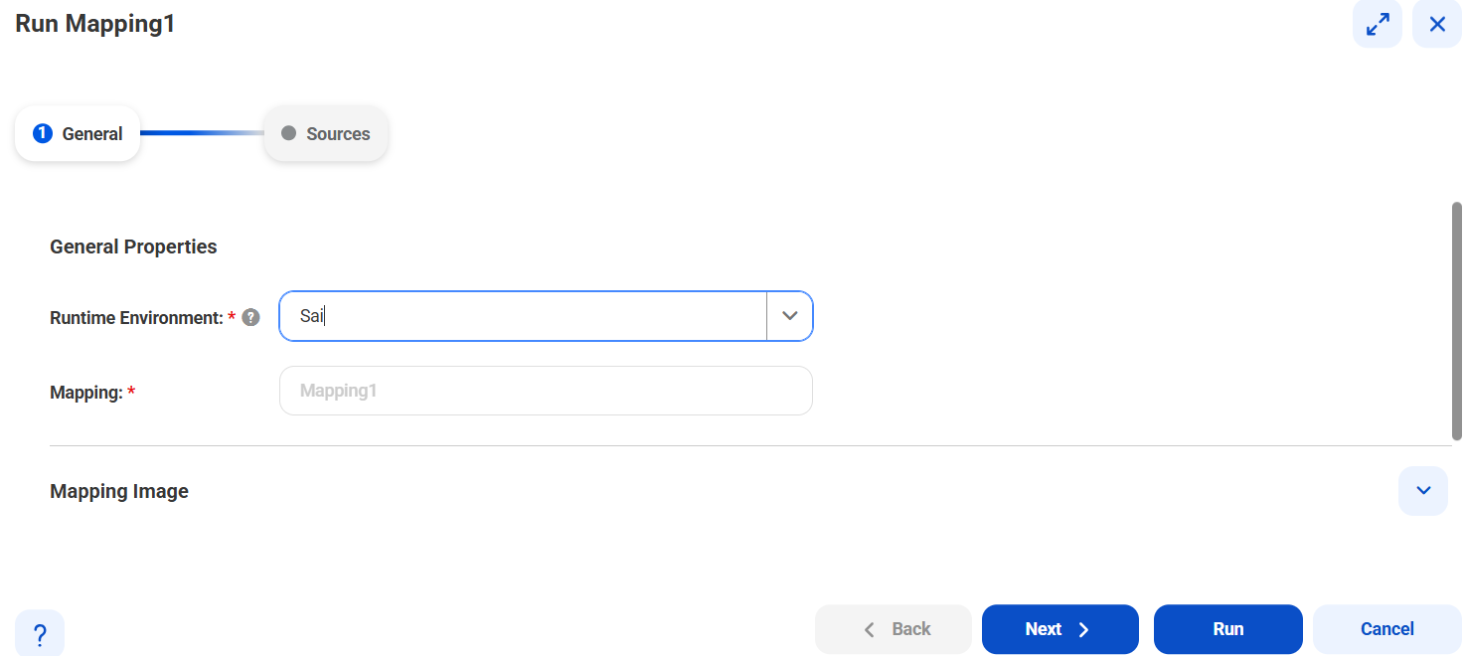
- In the second tab, selected the file and ran the job.
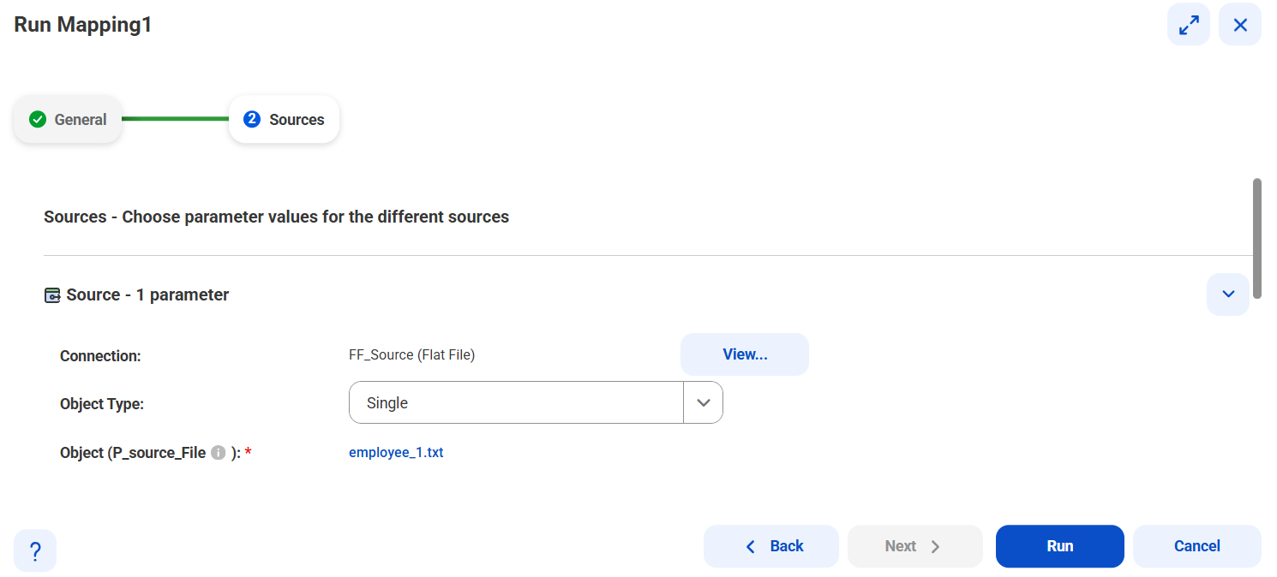
- 5 records from first file processed.
