DDL:
CREATE TABLE ORDERS (
ORDER_ID NUMBER,
CUSTOMER_ID NUMBER,
PRODUCT_ID NUMBER,
QUANTITY NUMBER,
ORDER_DATE DATE
);

INSERT ALL
INTO ORDERS VALUES (101, 1, 1001, 2, DATE '2024-01-10')
INTO ORDERS VALUES (102, 2, 1002, 1, DATE '2024-01-11')
INTO ORDERS VALUES (103, 3, 1003, 5, DATE '2024-01-12')
INTO ORDERS VALUES (104, 4, 1004, 3, DATE '2024-01-13')
INTO ORDERS VALUES (105, 5, 1005, 4, DATE '2024-01-14')
INTO ORDERS VALUES (106, 6, 1006, 2, DATE '2024-01-15') -- no match case
SELECT * FROM DUAL;

CREATE TABLE PRODUCTS (
PRODUCT_ID NUMBER,
PRODUCT_NAME VARCHAR2(50),
PRICE NUMBER
);

INSERT ALL
INTO PRODUCTS VALUES (1001, 'Laptop', 50000)
INTO PRODUCTS VALUES (1002, 'Mobile', 20000)
INTO PRODUCTS VALUES (1003, 'Tablet', 30000)
INTO PRODUCTS VALUES (1004, 'Monitor', 15000)
INTO PRODUCTS VALUES (1005, 'Keyboard', 2000)
-- Duplicate to test behavior
INTO PRODUCTS VALUES (1005, 'Keyboard_New', 2500)
SELECT * FROM DUAL;

COMMIT;

Source
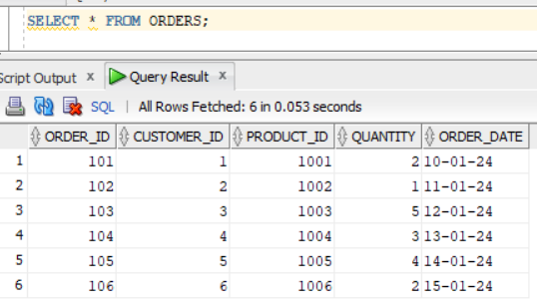
Lookup
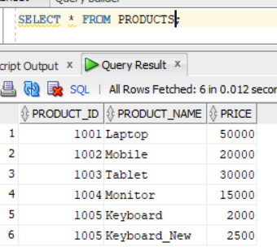
Created a mapping.
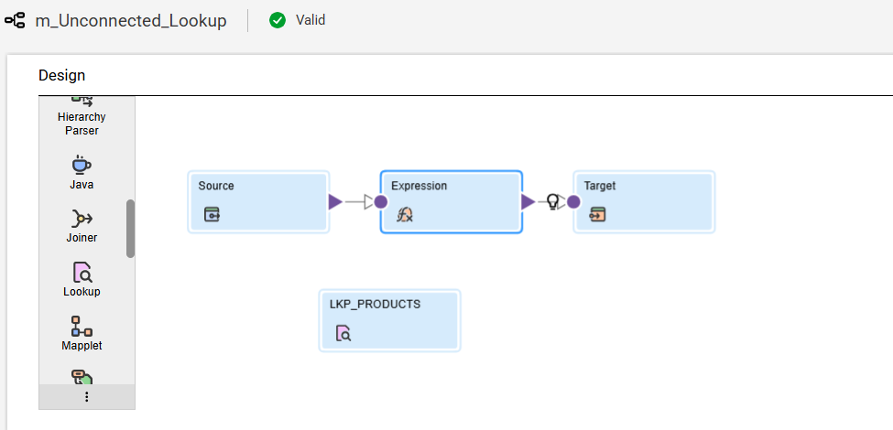
Created one incoming field in lookup to join.
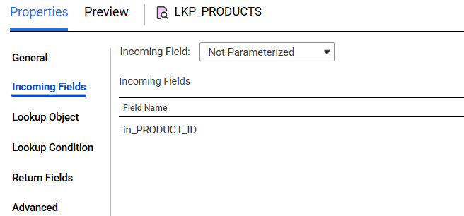
Selected Lookup object.
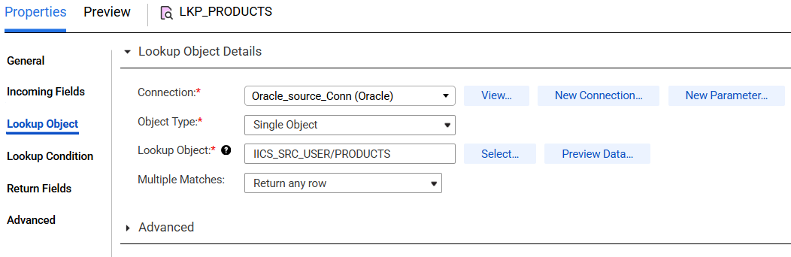
Added a join condition.
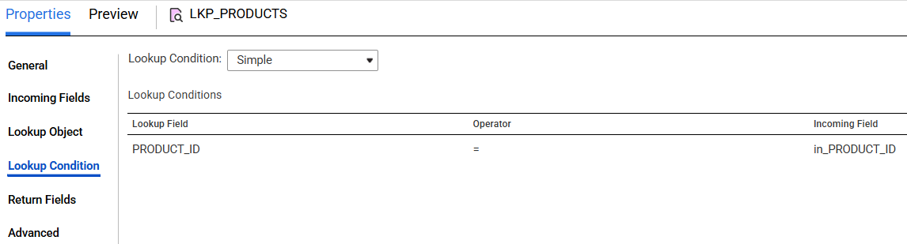
Selected the return port.
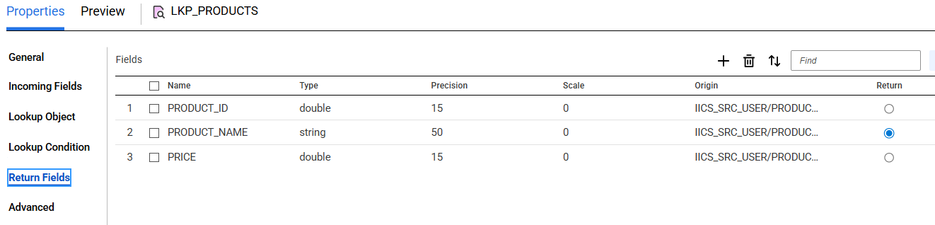
In the expression added a condition.
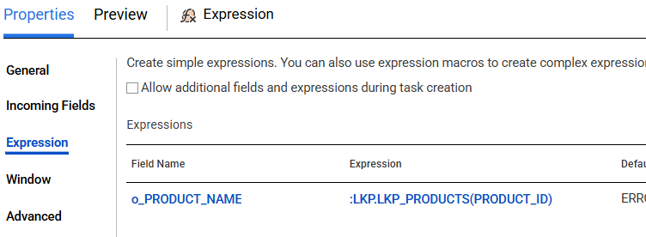
Mapped the fields in target and ran the job.
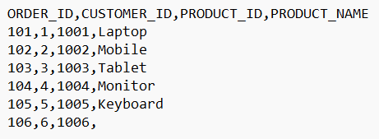
Scenario 2: Return multiple columns
First concatenate the required columns with delimiter.
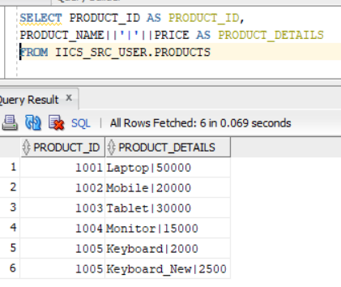
Add the query in both Query and Lookup SQL Override under Lookup Object.
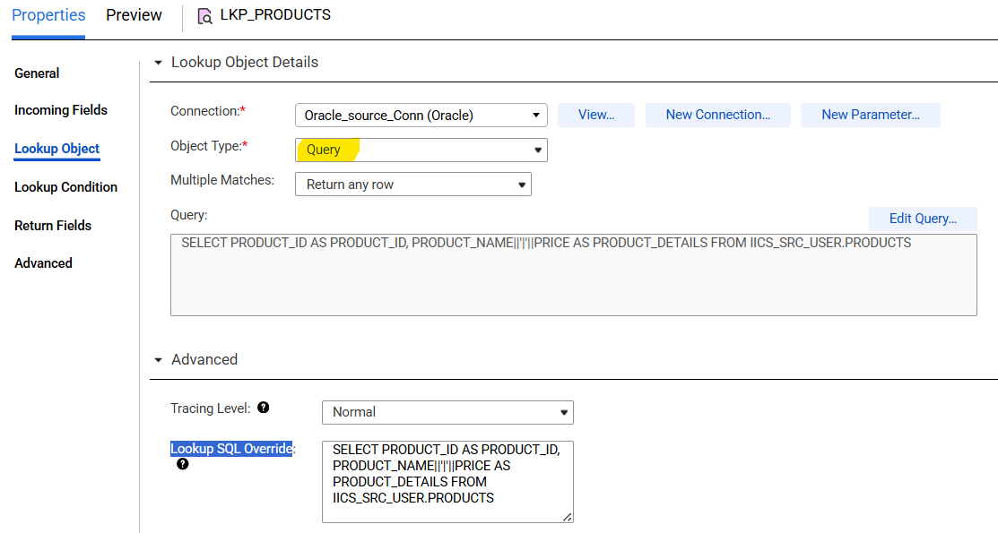
In the expression split the columns based on delimiter.
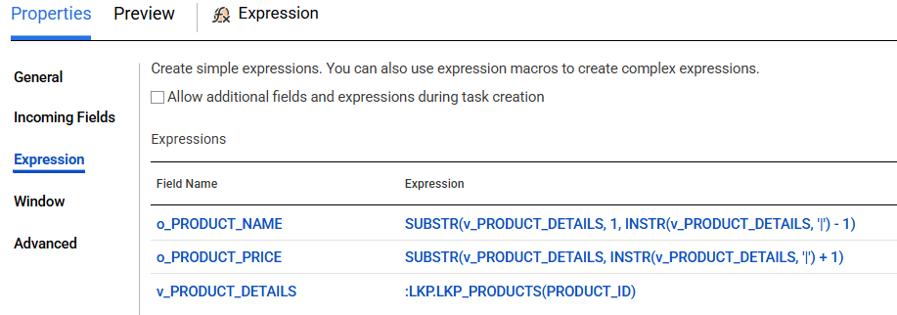
Mapped the fields in target and ran the job.
