Created a mapping and selected source table.
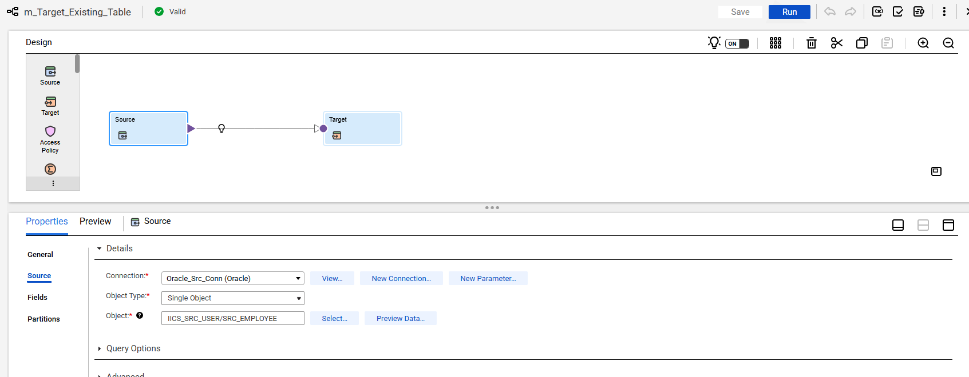
Created target table similar to source.
CREATE TABLE TGT_EMPLOYEE AS
SELECT * FROM IICS_SRC_USER.SRC_EMPLOYEE WHERE 1=2;
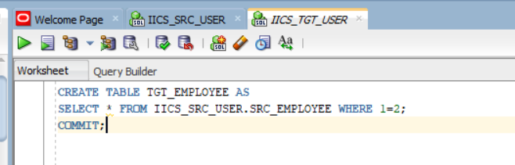

Selected target table and enabled Truncate target option.
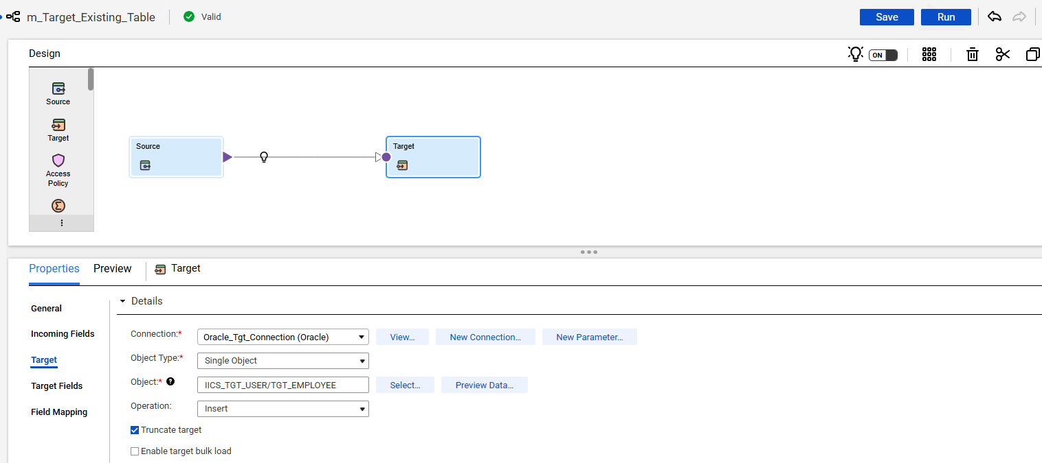
Saved the mapping and ran the job.
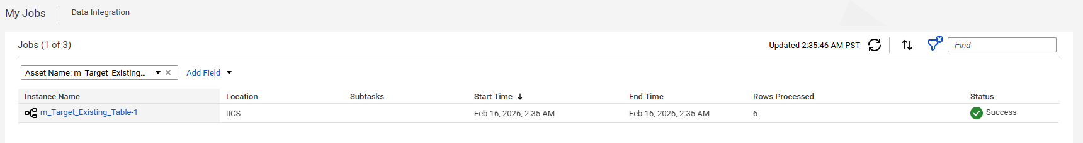
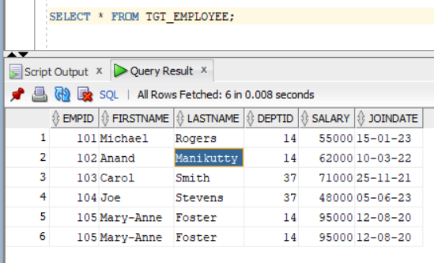

Deleted the duplicates using below query.
DELETE FROM TGT_EMPLOYEE
WHERE ROWID IN (
SELECT rid FROM (
SELECT ROWID rid,
ROW_NUMBER() OVER (PARTITION BY empid, firstname ORDER BY ROWID) rn
FROM TGT_EMPLOYEE
)
WHERE rn > 1);
