Source:
CREATE TABLE EMPLOYEE_STG (
EMP_ID NUMBER(10),
EMP_NAME VARCHAR2(50),
DEPT VARCHAR2(30),
SALARY NUMBER(10,2),
STATUS CHAR(1),
JOIN_DATE DATE,
CITY VARCHAR2(30)
);

INSERT ALL
INTO EMPLOYEE_STG VALUES (1, 'Rahul', 'HR', 30000, 'A', TO_DATE('01-JAN-2022','DD-MON-YYYY'), 'Mumbai')
INTO EMPLOYEE_STG VALUES (2, 'Anita', 'HR', 40000, 'A', TO_DATE('15-MAR-2021','DD-MON-YYYY'), 'Delhi')
INTO EMPLOYEE_STG VALUES (3, 'Vikram', 'IT', 60000, 'A', TO_DATE('10-JUN-2020','DD-MON-YYYY'), 'Bangalore')
INTO EMPLOYEE_STG VALUES (4, 'Sneha', 'IT', 50000, 'I', TO_DATE('20-SEP-2019','DD-MON-YYYY'), 'Hyderabad')
INTO EMPLOYEE_STG VALUES (5, 'Arjun', 'IT', 70000, 'A', TO_DATE('05-FEB-2023','DD-MON-YYYY'), 'Chennai')
INTO EMPLOYEE_STG VALUES (6, 'Kiran', 'Finance', 55000, 'A', TO_DATE('11-NOV-2021','DD-MON-YYYY'), 'Mumbai')
INTO EMPLOYEE_STG VALUES (7, 'Meena', 'Finance', 65000, 'A', TO_DATE('25-DEC-2020','DD-MON-YYYY'), 'Delhi')
INTO EMPLOYEE_STG VALUES (8, 'Rohit', 'HR', 35000, 'I', TO_DATE('18-AUG-2018','DD-MON-YYYY'), 'Pune')
INTO EMPLOYEE_STG VALUES (9,'Sanjay', 'Finance', 48000, 'A', TO_DATE('09-JAN-2019','DD-MON-YYYY'), 'Kolkata')
SELECT * FROM DUAL;

COMMIT;

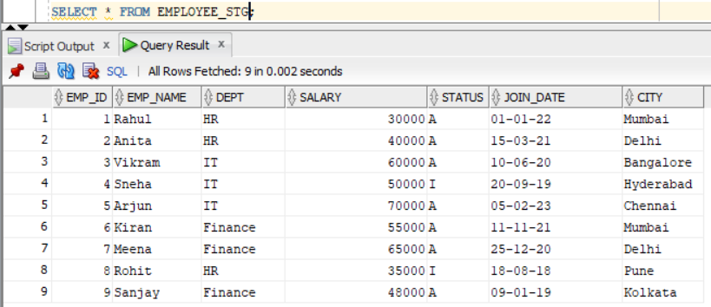

Scenario 1: Average salary in each department
Target Table:
CREATE TABLE DEPT_AVG_SAL (
DEPT VARCHAR2(30),
AVG_SALARY NUMBER(10,2)
);

Created a mapping.
Selected source and added filter for active transactions and sorted based on DEPT in Query Options.
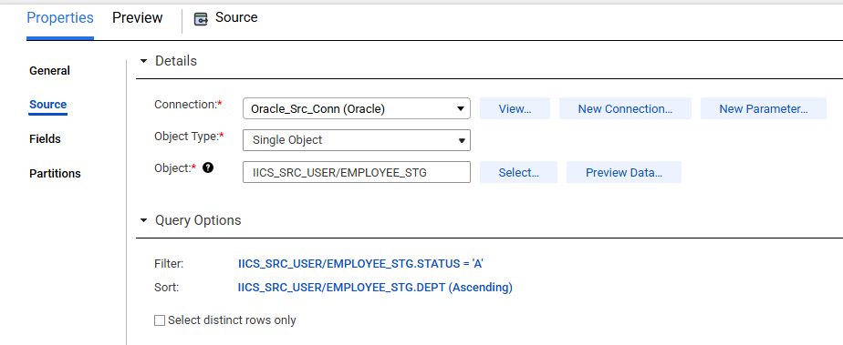

Added Aggregator transformation.
Group by on DEPT and took AVG(SALARY) as aggregate.
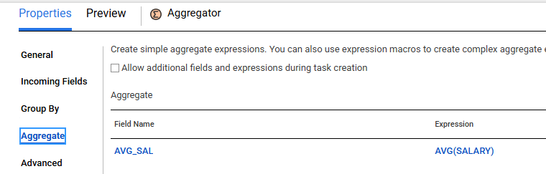

Mapped fields in target.
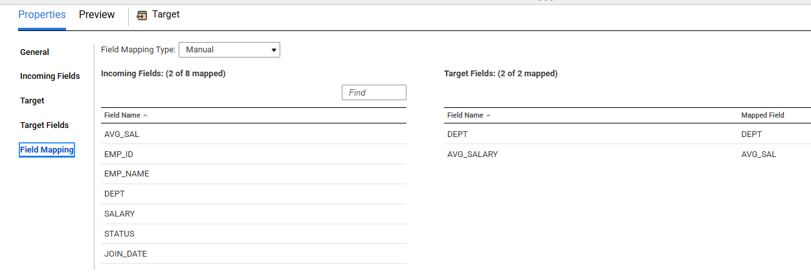

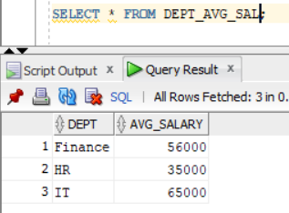

Scenario 2: Non-Aggregated and Non group by column
For this example, I have connected EMP_NAME column to the target which is neither a group by column nor an aggregated column.
For each group it picked the last record’s EMP name and loaded in target.

Source:
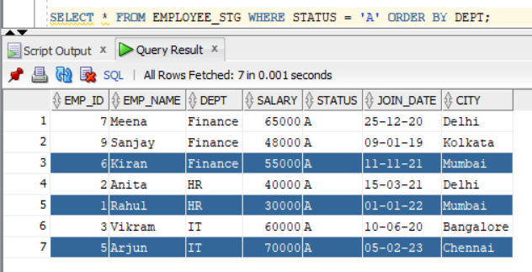

Target:
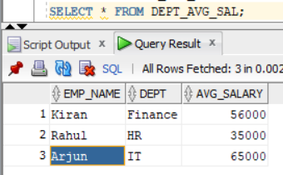
Scenario 3: Remove Duplicates
Source
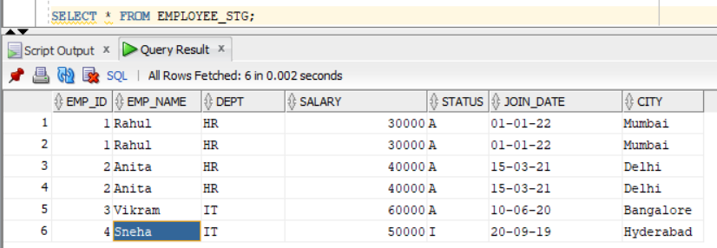
Created target table with the same structure.
Group by on all fields in aggregator.
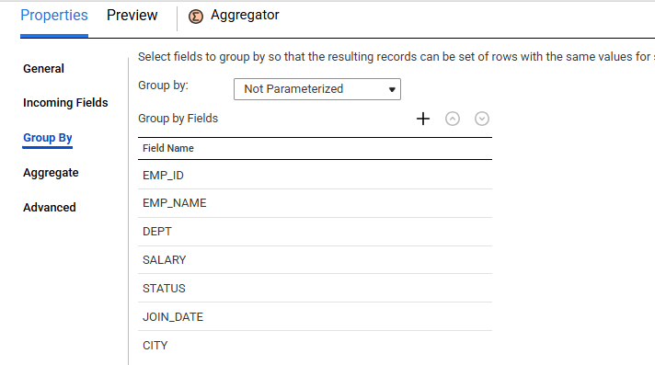

Target Data:
