Created a table and inserted data in source database.
CREATE TABLE S_EXPRESS
(
ID VARCHAR2(30),
NAME VARCHAR2(30),
DOB VARCHAR2(30)
);
INSERT INTO S_EXPRESS VALUES (100, 'Ravi', '20200803');
INSERT INTO S_EXPRESS VALUES (101, 'Shiva Ram', '20160802');
INSERT INTO S_EXPRESS VALUES (102, 'Ali Khan', '20120203');
COMMIT;

Created target table in target database.
CREATE TABLE T_EXPRESS
(
ID VARCHAR2(30),
NAME VARCHAR2(30),
DOB VARCHAR2(30),
UPPER_ VARCHAR2(30),
LENGTH_ VARCHAR2(30),
SUBSTR_ VARCHAR2(30),
TO_DATE_ DATE,
TO_DECIMAL_ NUMBER(5,2),
IIF_ VARCHAR2(30)
);

COMMIT;

Created a mapping and selected source and target.
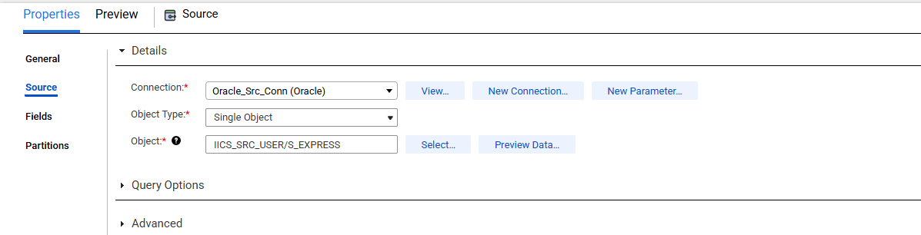
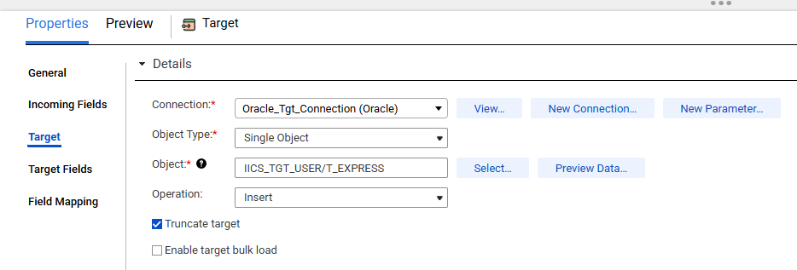
Created an Expression transformation and created few output fields.
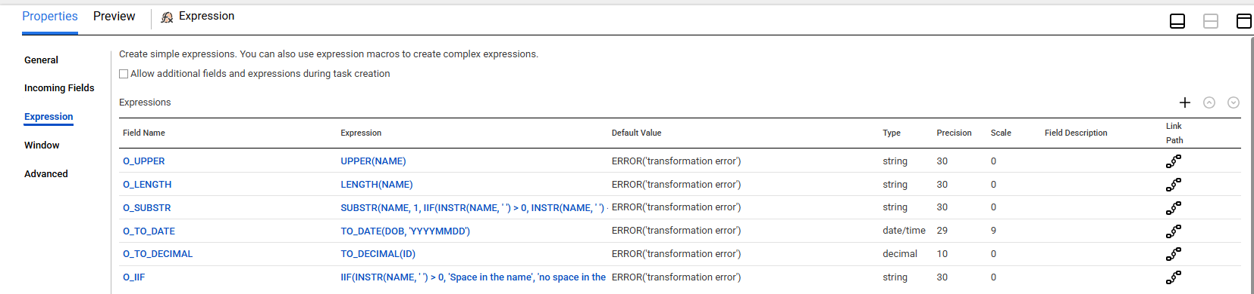
In the target field mapping mapped all the fields and ran the job.
