Sequence in Oracle:
CREATE SEQUENCE emp_seq
START WITH 1
INCREMENT BY 1
MAXVALUE 5
MINVALUE 1
CYCLE
CACHE 3;

SELECT EMP_SEQ.CURRVAL FROM DUAL;--sequence EMP_SEQ.CURRVAL is not yet defined in this session
SELECT EMP_SEQ.NEXTVAL FROM DUAL;--1
SELECT EMP_SEQ.NEXTVAL FROM DUAL;--2
SELECT EMP_SEQ.CURRVAL FROM DUAL;--2
SELECT EMP_SEQ.NEXTVAL FROM DUAL;--3
SELECT EMP_SEQ.NEXTVAL FROM DUAL;--4
SELECT EMP_SEQ.CURRVAL FROM DUAL;--4
SELECT EMP_SEQ.NEXTVAL FROM DUAL;--4
SELECT EMP_SEQ.NEXTVAL FROM DUAL;--1

Scenario 1: Adding NEXTVAL in target

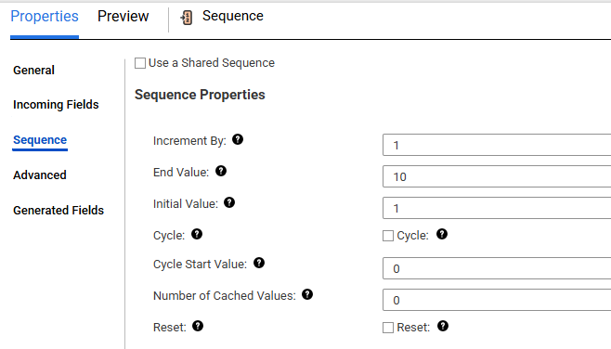
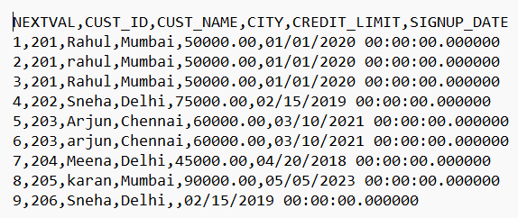

Scenario 2: Adding CURRVAL in target.
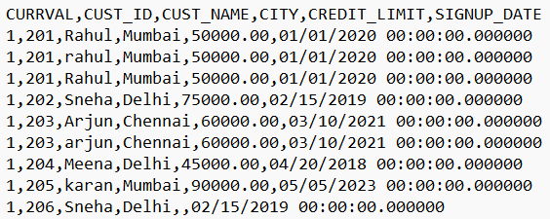
Scenario 3: Adding both CURRVAL and NEXTVAL columns
CURRVAL = NEXTVAL + Increment By
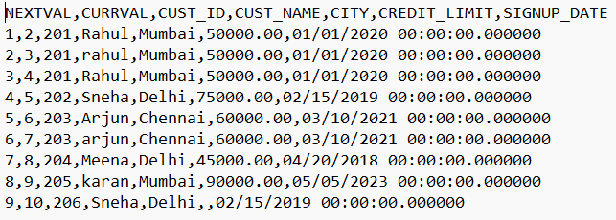

Scenario 4: Cycle
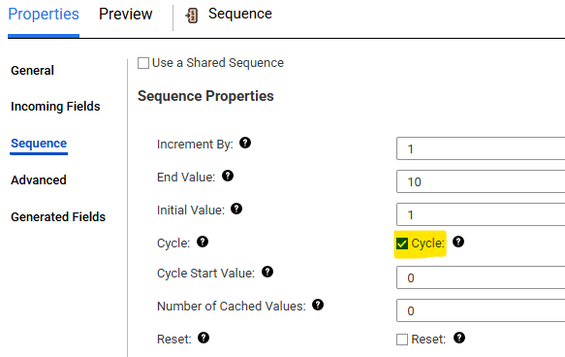
Click on 3 dots and select ‘New Mapping Task’.

Select name and runtime environment and click Next.
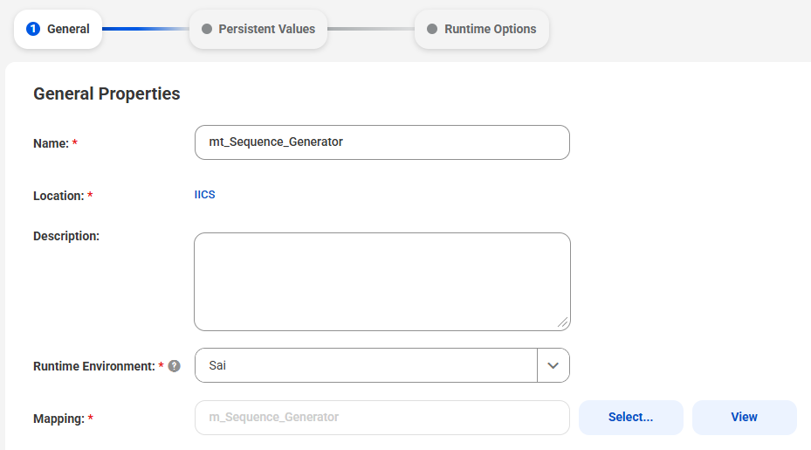
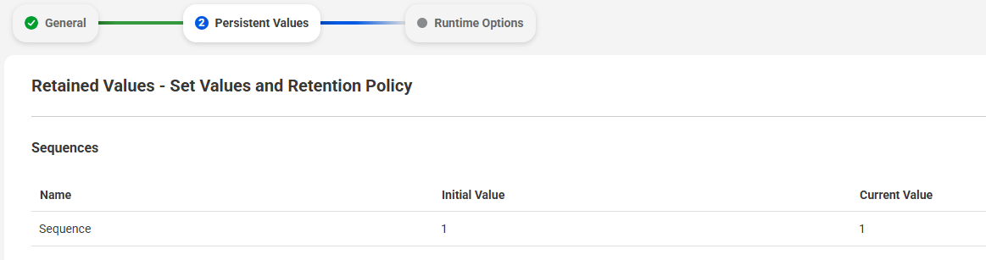
Save and run the mapping task
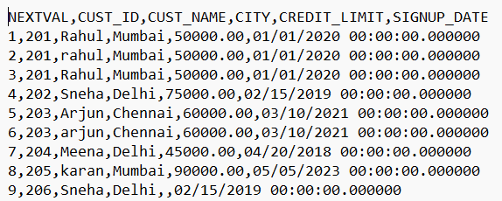
Close and re open the task.
If we scroll down we will be able to see the sequence value.
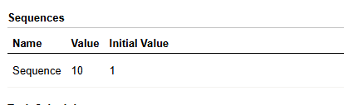
Run the mapping task again.
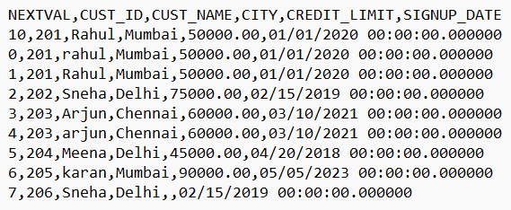

Scenario 5: Reset
We need to keep both cycle and reset options otherwise once the end value is reached, for the next record it will throw ‘Overflow error. The Sequence Generator transformation has reached the end of the configured end value’.
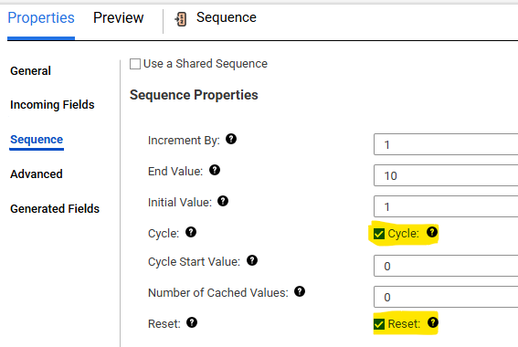
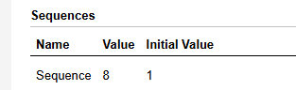
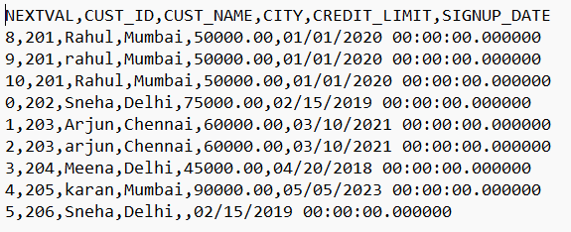
Edit the current value to 1 in mapping task and run the job again.
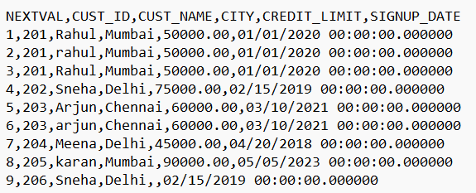
Now mapping task won’t save the last value.
Run the job again.
