**Warehouse creation:**

**In Web UI**

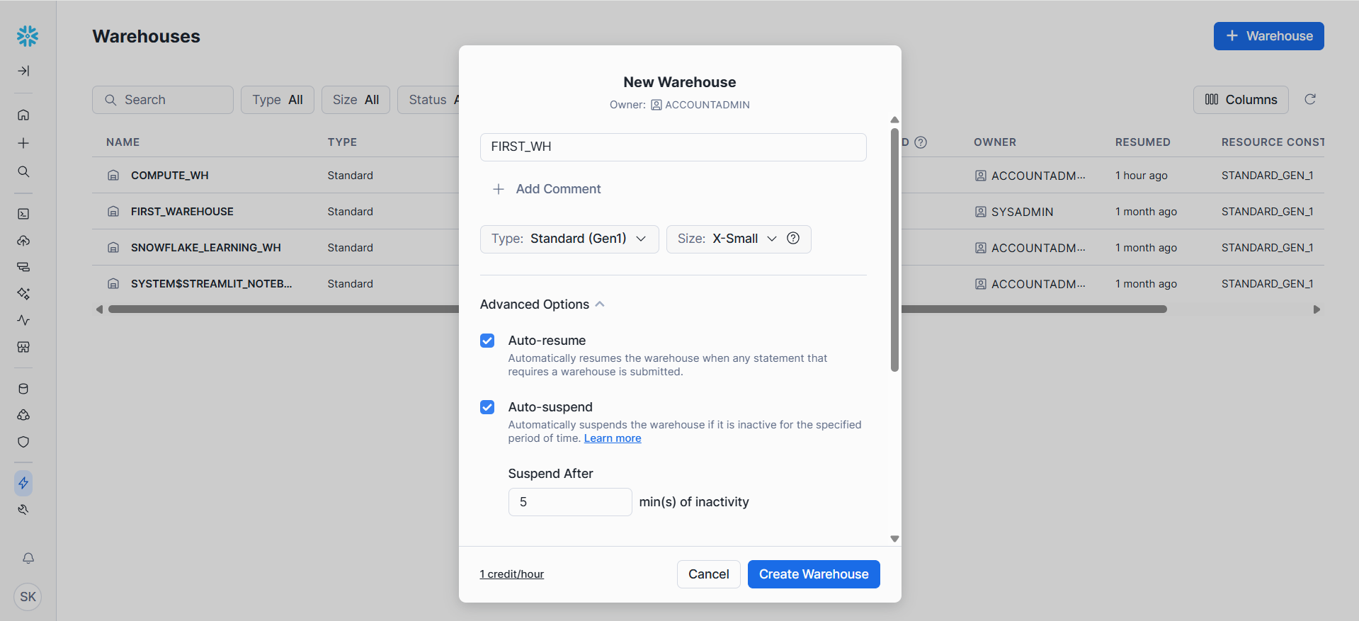

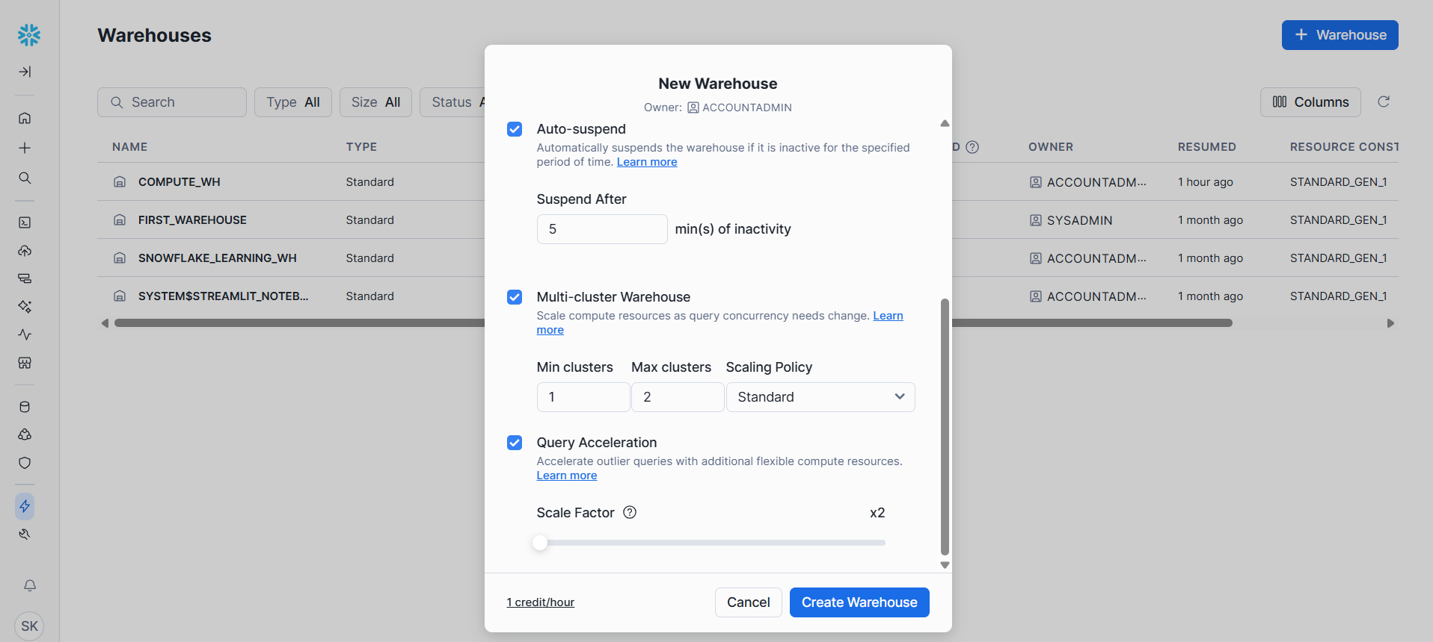

**Using Snowsight**

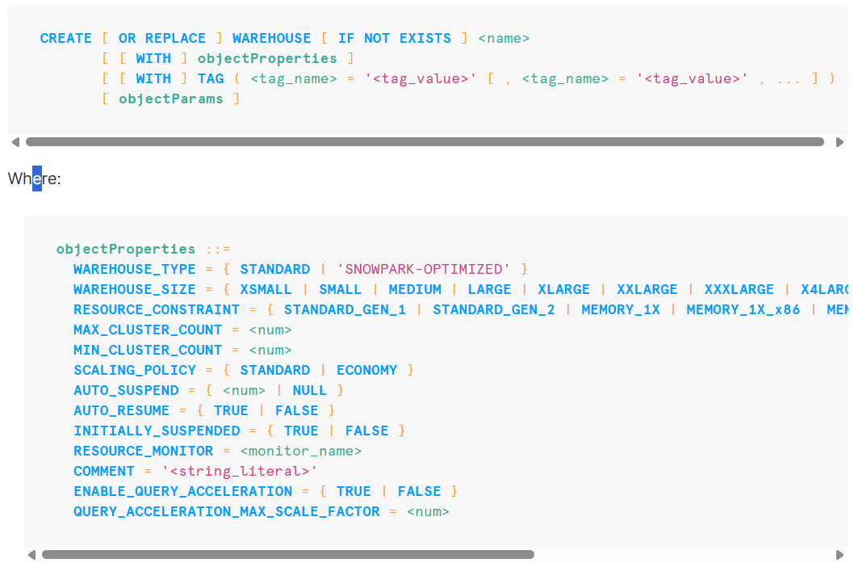

**Example:**

**CREATE OR REPLACE WAREHOUSE SAI_WH**

**WITH**

**WAREHOUSE_SIZE = XSMALL**

**MIN_CLUSTER_COUNT = 1**

**MAX_CLUSTER_COUNT = 3**

**SCALING_POLICY = STANDARD**

**AUTO_SUSPEND = 300 --5 MINIUTES**

**INITIALLY_SUSPENDED = TRUE**

**COMMENT = 'This is our first warehouse';**

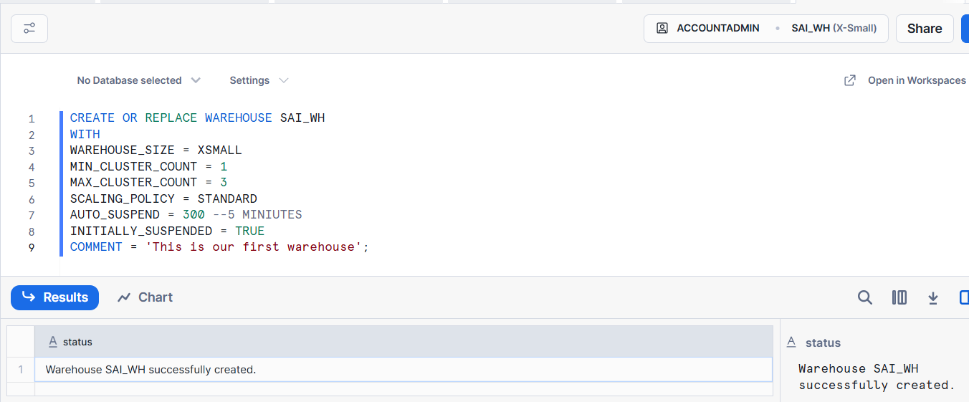

**Data Types:**

| Data Type | Description | Example |
| --- | --- | --- |
| NUMBER / DECIMAL / NUMERIC | Fixed-point decimal numbers (can specify precision and scale). | NUMBER(10,2) → 12345.67 |
| INT / INTEGER / BIGINT / SMALLINT / TINYINT / BYTEINT | Integer numbers (all are stored as NUMBER). | 100 |
| FLOAT / FLOAT4 / FLOAT8 / DOUBLE / DOUBLE PRECISION / REAL | Floating-point numbers. | 123.4567 |
| VARCHAR / CHAR / CHARACTER / STRING / TEXT | Variable-length string. Default length is unlimited. | 'Hello' |
| CHAR / CHARACTER | Fixed-length string (padded with spaces). | 'A ' |
| BINARY / VARBINARY | Binary strings (used for files, encrypted values, etc.). | 0xDEADBEEF |
| DATE | Stores calendar date (no time). | 2025-10-14 |
| TIME | Stores time of day (no date). | 12:30:45 |
| TIMESTAMP | Alias for TIMESTAMP_NTZ. | 2025-10-14 12:30:45 |
| TIMESTAMP_NTZ | Timestamp without time zone. | 2025-10-14 12:30:45 |
| TIMESTAMP_LTZ | Timestamp with local time zone. | 2025-10-14 12:30:45 |
| TIMESTAMP_TZ | Timestamp with explicit time zone. | 2025-10-14 12:30:45 +05:30 |
| BOOLEAN | True/False values | TRUE, FALSE |
| VARIANT | Can store JSON, Avro, ORC, Parquet, XML, etc. | {'name': 'Sai', 'age': 30} |
| OBJECT | Key-value pairs (similar to JSON objects). | {'a':1, 'b':2} |
| ARRAY | Ordered list of elements. | [1,2,3,4] |
| GEOGRAPHY | Stores geospatial data in WGS 84 standard. | 'POINT(-122.35 37.55)' |

**Stages:**

In Snowflake, stages are locations where data files are stored before being loaded into tables or after being unloaded from tables.  
They act as intermediate storage areas for data ingestion and extraction.

| **Feature / Property** | **User Stage** | **Table Stage** | **Named Stage** |
| --- | --- | --- | --- |
| 🏗 **Creation** | Automatically created for each user | Automatically created for each table | Manually created by user |
| 👥 **Scope / Ownership** | Specific to each user | Specific to a single table | Shared — can be used by multiple users/tables |
| 🗂 **Usage Purpose** | Temporary, personal file staging | Staging files linked to one table | Centralized or external data staging |
| 📦 **File Location** | Internal only (Snowflake-managed) | Internal only (Snowflake-managed) | Internal or external (e.g., S3, Azure, GCS) |
| 🔐 **Access Control** | Only the owner (user) can access | Only table owner / granted roles | Full RBAC (can grant privileges) |
| 🧭 **Reference Syntax** | @~ | @%table_name | @stage_name |
| ⬆️ **PUT/GET Support** | Yes | Yes | Yes (internal), not needed for external |
| 🧾 **File Persistence** | Temporary | Temporary | Persistent (managed manually) |
| 🌐 **Integration with External Storage** | ❌ No | ❌ No | ✅ Yes |
| 💡 **Typical Use Case** | Testing, quick uploads | One-table loading | Production pipelines, shared data, external data |

**Steps to create stage:**

//first create database

CREATE OR REPLACE DATABASE FIRST_DB;

//use the database

USE DATABASE FIRST_DB;

//create stage schema to store stages

CREATE OR REPLACE SCHEMA external_stages;

// creating stage object from publicly available s3 bucket

CREATE OR REPLACE STAGE FIRST_DB.external_stages.aws_stage

url='s3://bucketsnowflakes3';

// List files in stage

LIST @FIRST_DB.EXTERNAL_STAGES.aws_stage;

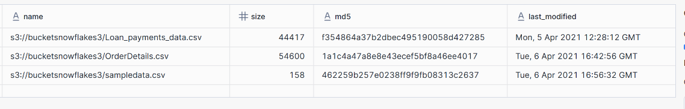

// Creating ORDERS table to load data from staging area

CREATE OR REPLACE TABLE FIRST_DB.PUBLIC.ORDERS (

ORDER_ID VARCHAR(30),

AMOUNT INT,

PROFIT INT,

QUANTITY INT,

CATEGORY VARCHAR(30),

SUBCATEGORY VARCHAR(30));

// Copy command with pattern for file names

COPY INTO FIRST_DB.PUBLIC.ORDERS

FROM @FIRST_DB.external_stages.aws_stage

file_format= (type = csv field_delimiter=',' skip_header=1)

pattern='.*Order.*';



**Example to load only specific columns:**

//creating table

CREATE OR REPLACE TABLE FIRST_DB.PUBLIC.ORDERS_EX (

ORDER_ID VARCHAR(30),

AMOUNT INT

);

//copy command to load only first 2 columns

COPY INTO FIRST_DB.PUBLIC.ORDERS_EX

FROM (select s.$1, s.$2 from @FIRST_DB.external_stages.aws_stage s)

file_format= (type = csv field_delimiter=',' skip_header=1)

files=('OrderDetails.csv');

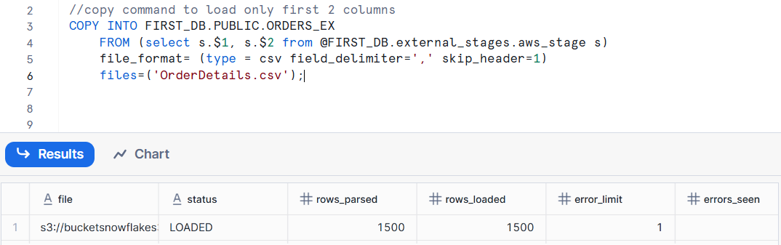

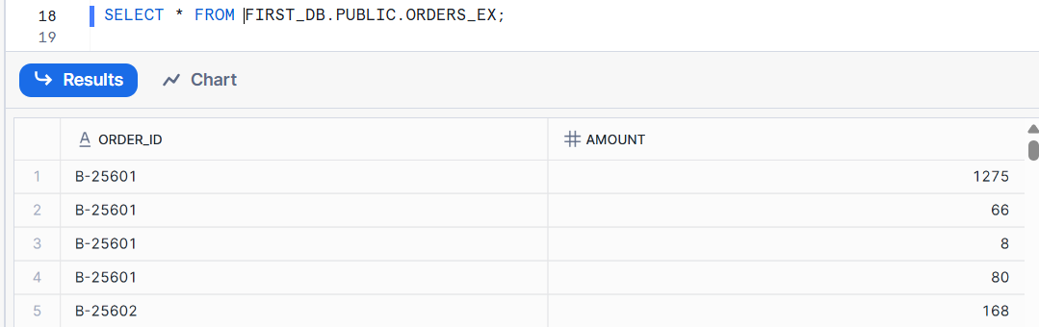

**Example 2 to load only specific columns:**

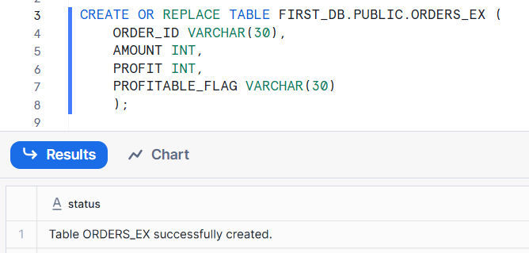

COPY INTO FIRST_DB.PUBLIC.ORDERS_EX (ORDER_ID,PROFIT)

FROM (select

s.$1,

s.$3

from @FIRST_DB.external_stages.aws_stage s)

file_format= (type = csv field_delimiter=',' skip_header=1)

files=('OrderDetails.csv');

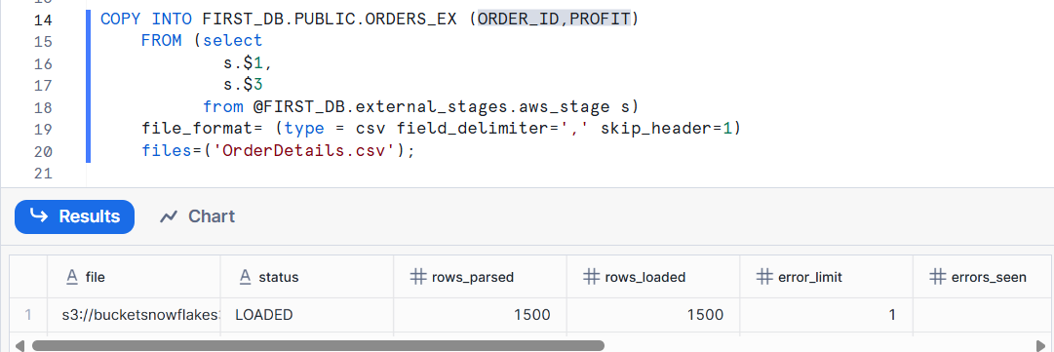

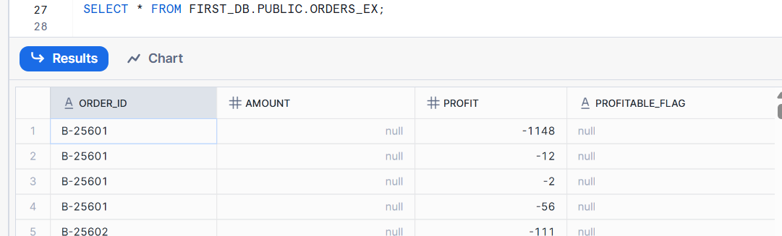

**Copy Command: ON_ERROR options**

| Option | Behavior | When to Use |
| --- | --- | --- |
| ABORT_STATEMENT *(default)* | Stops the entire load if any error occurs. | When you want strict data quality. |
| CONTINUE | Loads valid records and skips the bad ones. | When you can tolerate some bad records. |
| SKIP_FILE | Skips the entire file if any error occurs in that file. | When you want to skip problematic files entirely. |
| SKIP_FILE_<n> | Skips the file if the number of errors in that file exceeds n. | When some errors are okay, but not too many. |
| SKIP_FILE_<n>_PERCENT | Skips the file if the error rate exceeds n%. | Useful for large files where a few errors are acceptable. |

**Example : CONTINUE**

**// Create new stage**

CREATE OR REPLACE STAGE FIRST_DB.external_stages.aws_stage_errorex

url='s3://bucketsnowflakes4';

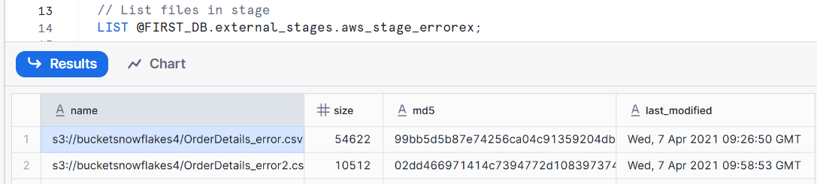

// Create example table

CREATE OR REPLACE TABLE FIRST_DB.PUBLIC.ORDERS_EX (

ORDER_ID VARCHAR(30),

AMOUNT INT,

PROFIT INT,

QUANTITY INT,

CATEGORY VARCHAR(30),

SUBCATEGORY VARCHAR(30));

// Error handling using the ON_ERROR CONTINUE option

COPY INTO FIRST_DB.PUBLIC.ORDERS_EX

FROM @MANAGE_DB.external_stages.aws_stage_errorex

file_format= (type = csv field_delimiter=',' skip_header=1)

files = ('OrderDetails_error.csv')

ON_ERROR = 'CONTINUE';

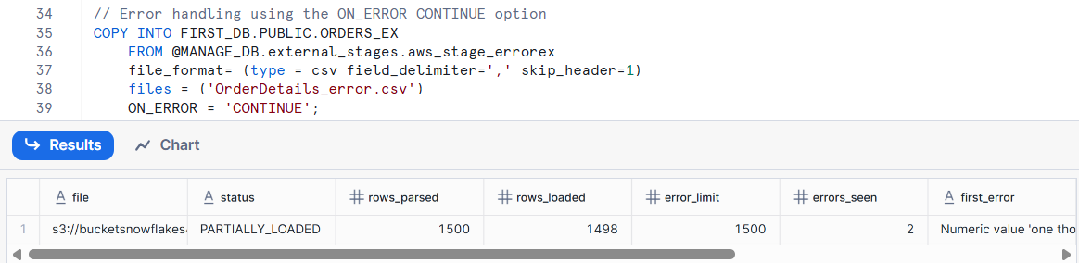

**Example : ABORT_STATEMENT**

COPY INTO FIRST_DB.PUBLIC.ORDERS_EX

FROM @FIRST_DB.external_stages.aws_stage_errorex

file_format= (type = csv field_delimiter=',' skip_header=1)

files = ('OrderDetails_error.csv','OrderDetails_error2.csv')

ON_ERROR = 'ABORT_STATEMENT';

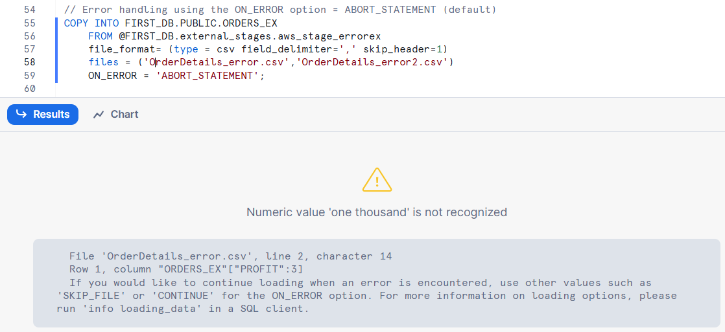

**Example : SKIP_FILE**

// Error handling using the ON_ERROR option = SKIP_FILE

COPY INTO FIRST_DB.PUBLIC.ORDERS_EX

FROM @FIRST_DB.external_stages.aws_stage_errorex

file_format= (type = csv field_delimiter=',' skip_header=1)

files = ('OrderDetails_error.csv','OrderDetails_error2.csv')

ON_ERROR = 'SKIP_FILE';

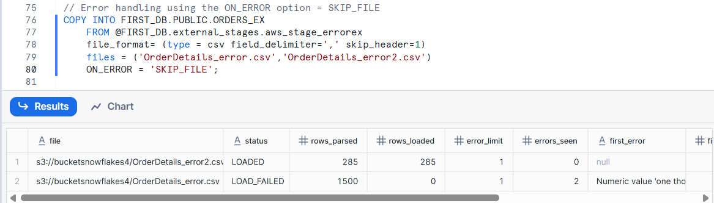

**Example : SKIP_FILE_<number>**

COPY INTO FIRST_DB.PUBLIC.ORDERS_EX

FROM @FIRST_DB.external_stages.aws_stage_errorex

file_format= (type = csv field_delimiter=',' skip_header=1)

files = ('OrderDetails_error.csv','OrderDetails_error2.csv')

ON_ERROR = 'SKIP_FILE_2';

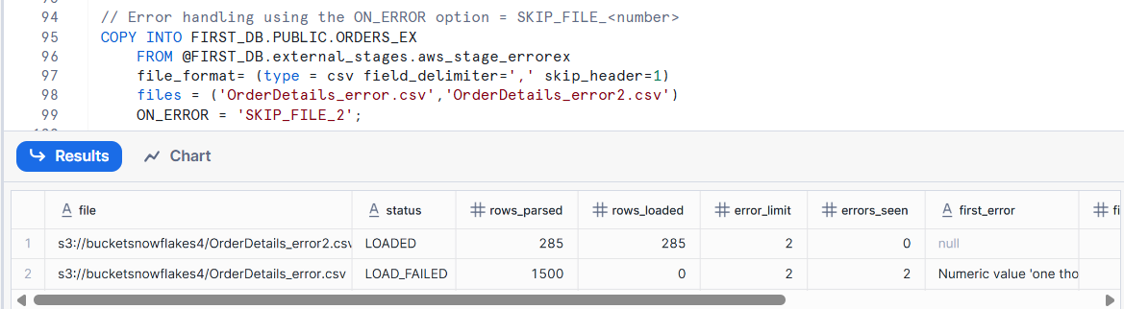

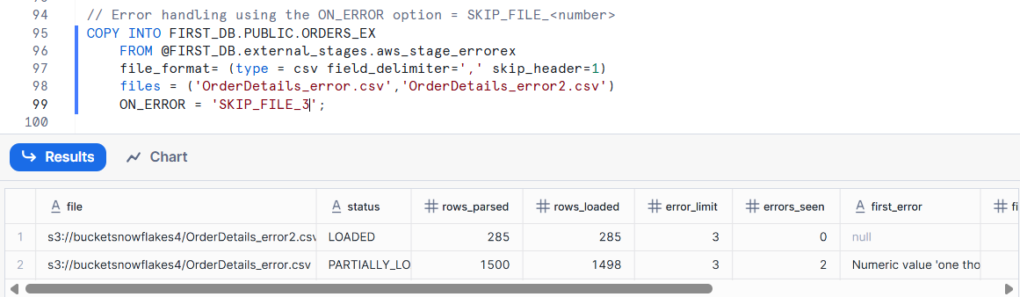

**Example : SKIP_FILE_<number>_PERCENT**

COPY INTO FIRST_DB.PUBLIC.ORDERS_EX

FROM @FIRST_DB.external_stages.aws_stage_errorex

file_format= (type = csv field_delimiter=',' skip_header=1)

files = ('OrderDetails_error.csv','OrderDetails_error2.csv')

ON_ERROR = 'SKIP_FILE_3%';

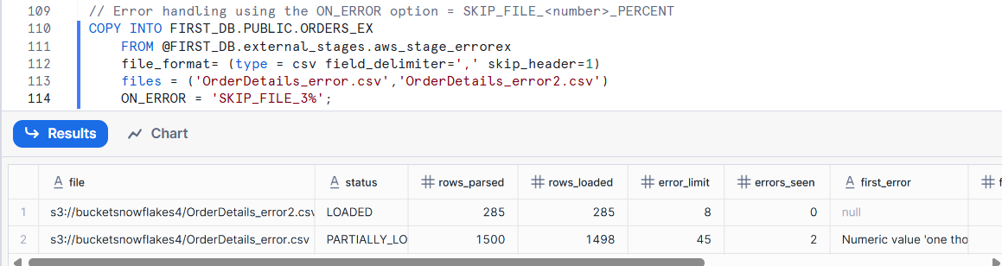

| **Limit Type** | **Limit** | **Best Practice** |
| --- | --- | --- |
| Per compressed file | 5 GB max | Prefer smaller files (100–250 MB) |
| Per uncompressed file | 50 GB max | Split files for speed |
| Per row | 16 MB | Avoid very wide records |
| Total COPY load size | No hard limit | Use parallel load with many files |
| Number of files per COPY | Thousands recommended, not millions | Batch loads if needed |