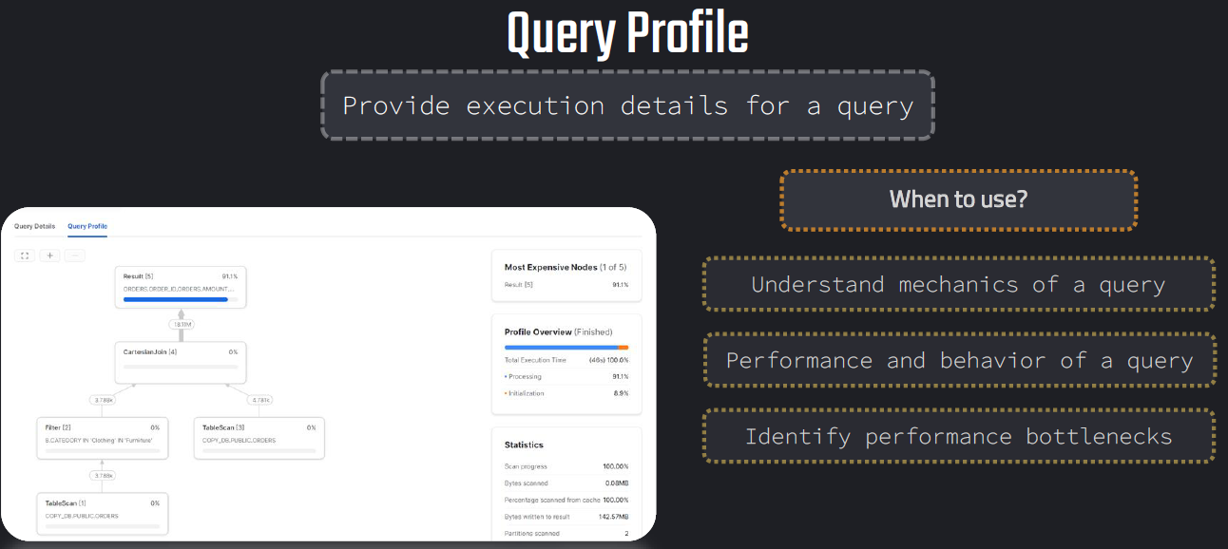

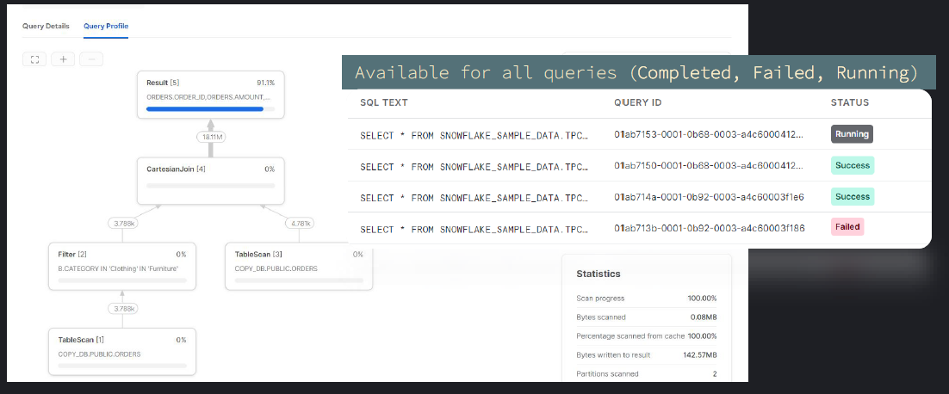

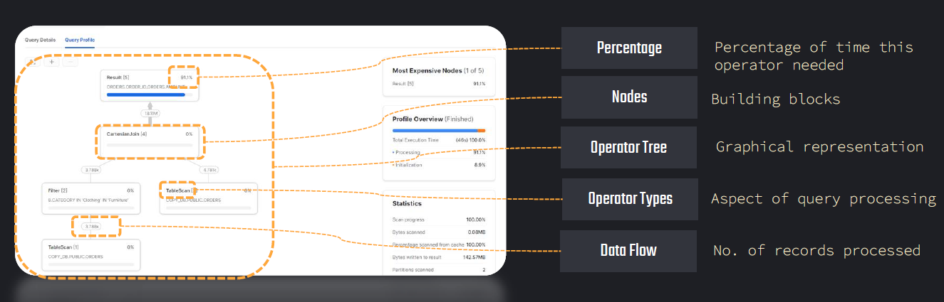

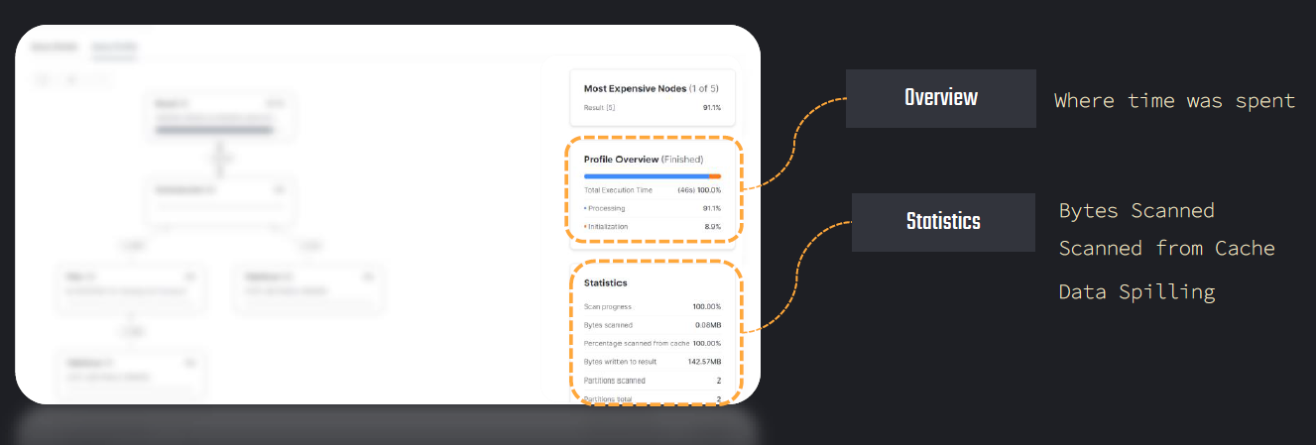

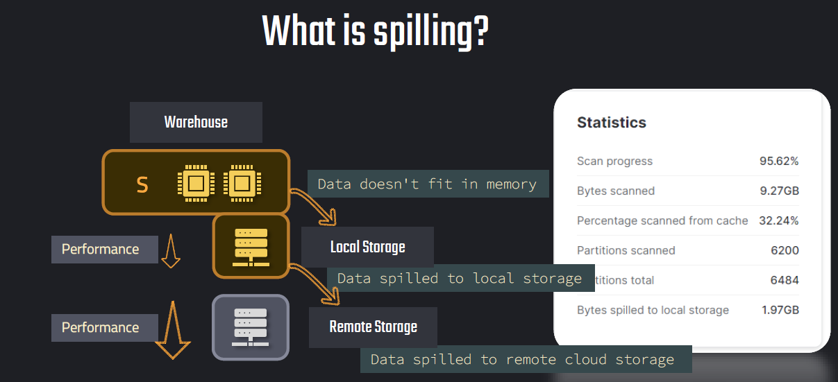

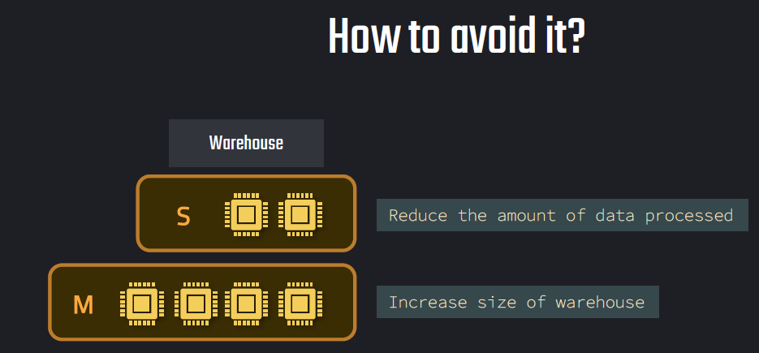

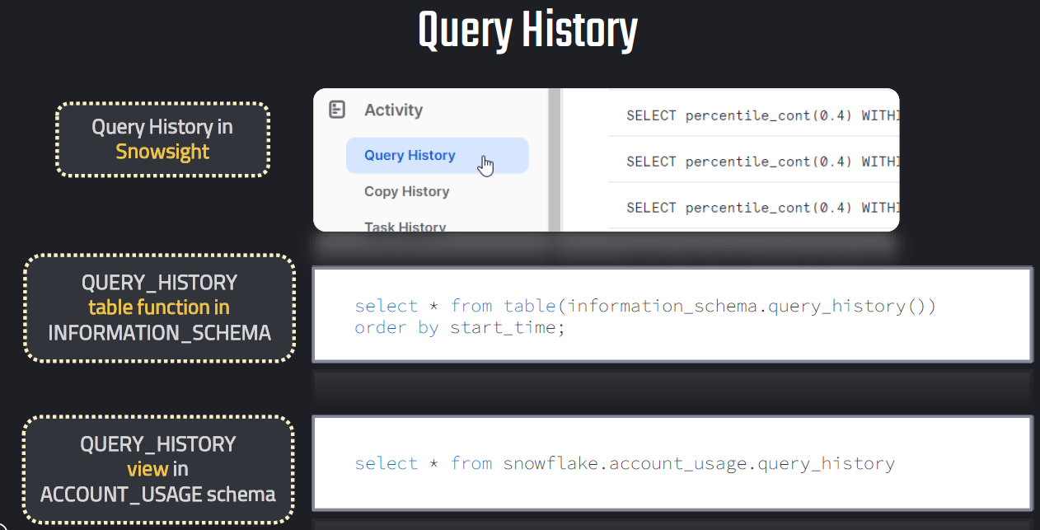

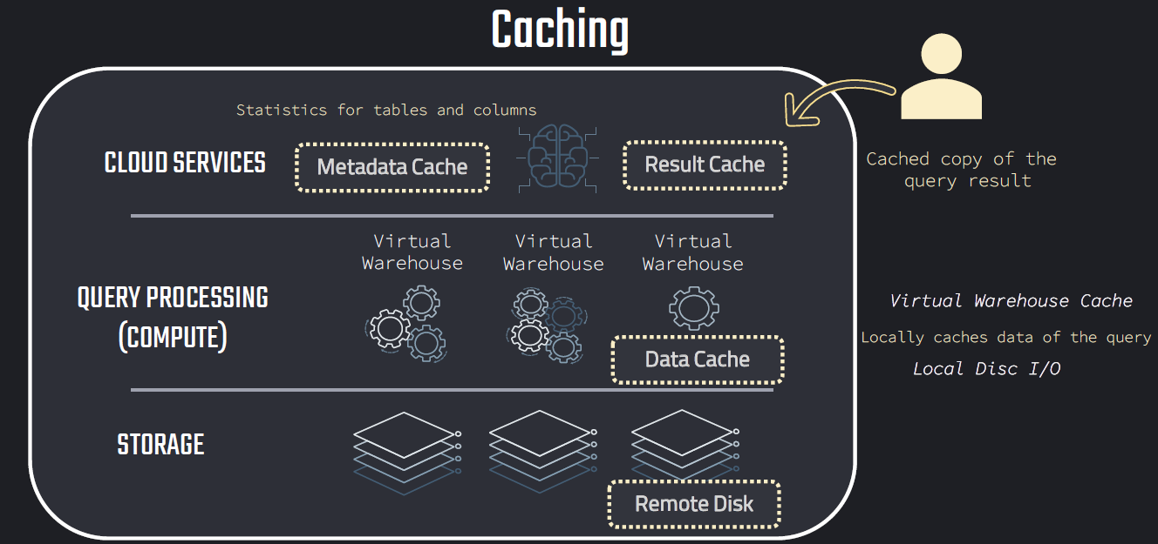

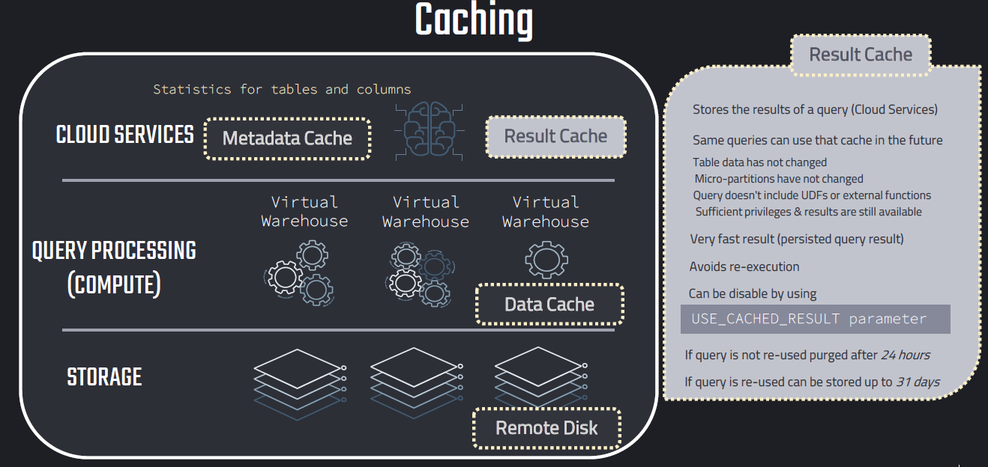

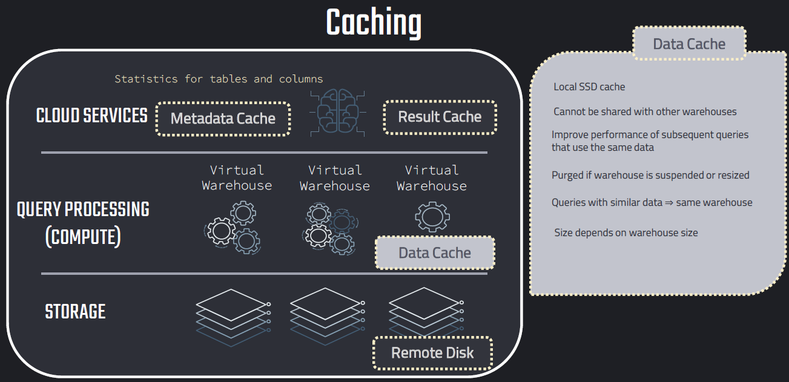

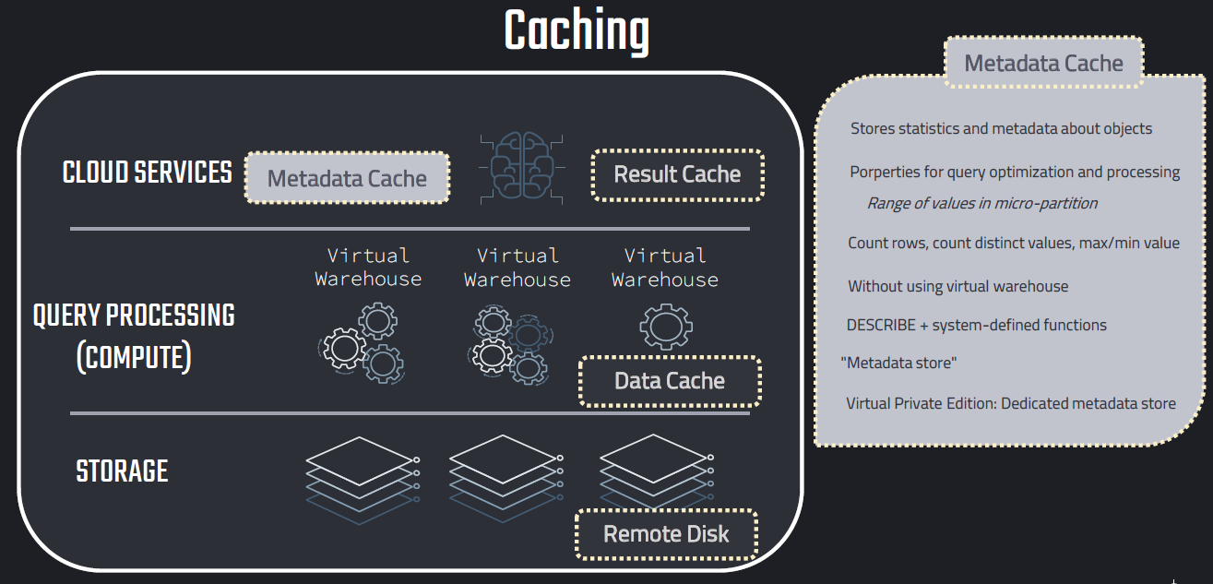

**Example:**

USE SCHEMA SNOWFLAKE_SAMPLE_DATA.TPCH_SF10;

USE ROLE ACCOUNTADMIN;

//// Query Result Cache ////

-- Use of Cache

SELECT * FROM ORDERS;

--First time it took 12s

--second time it took 44ms

Click on Query ID

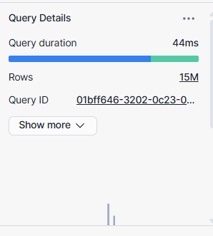

Second time it fetched data from results cache.

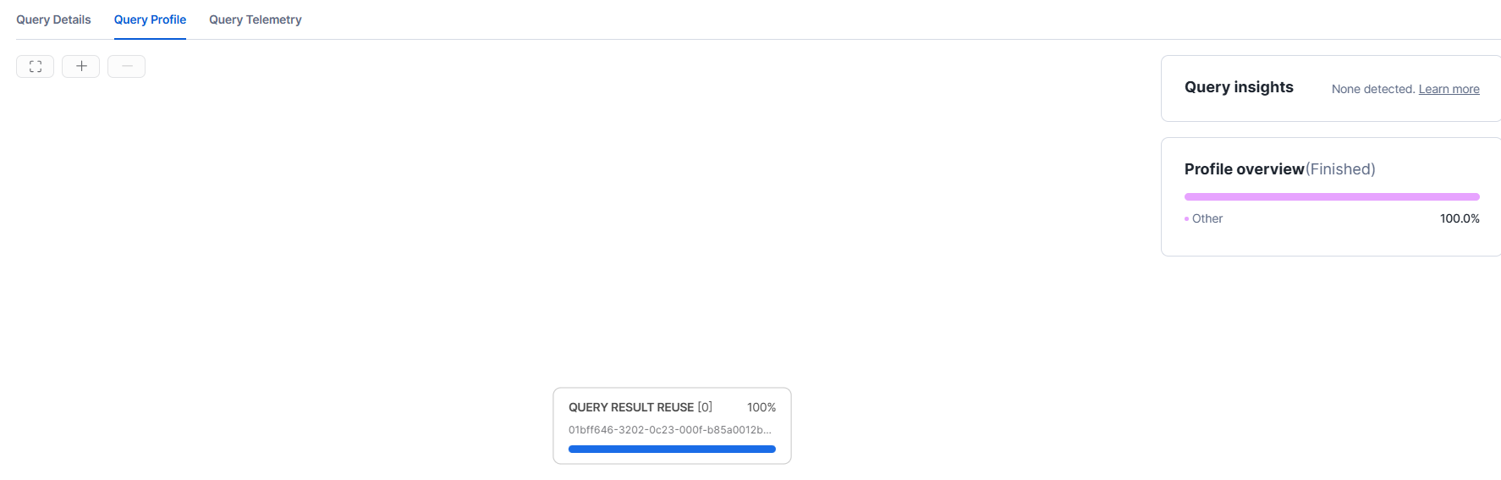

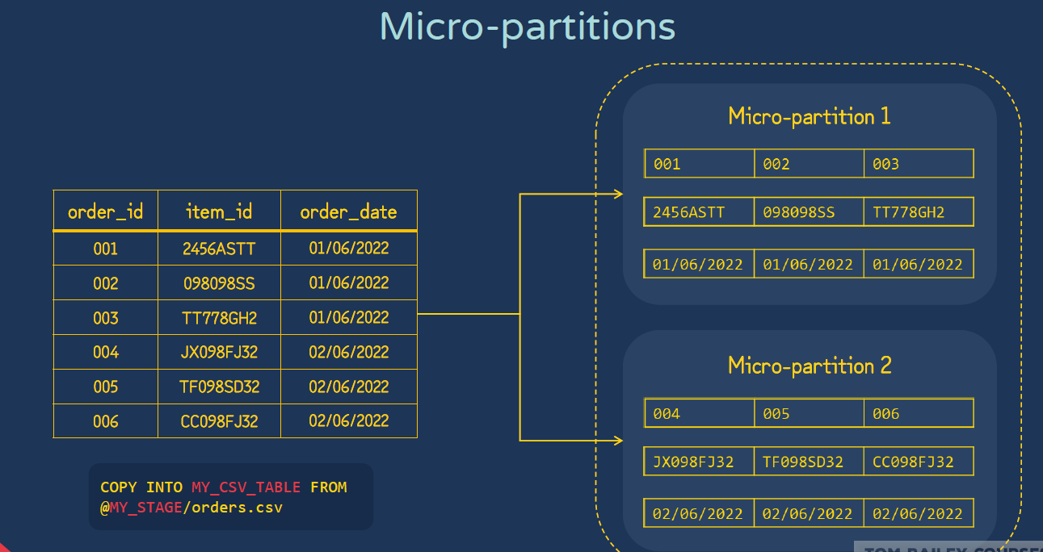

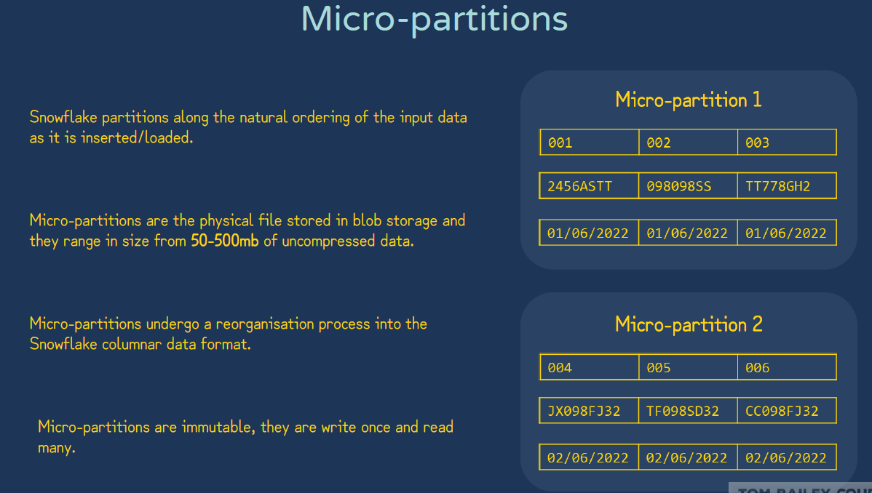

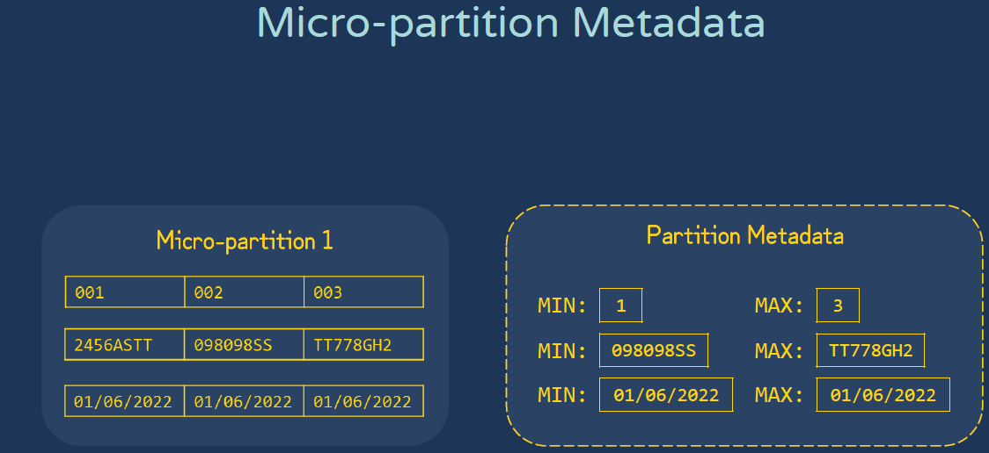

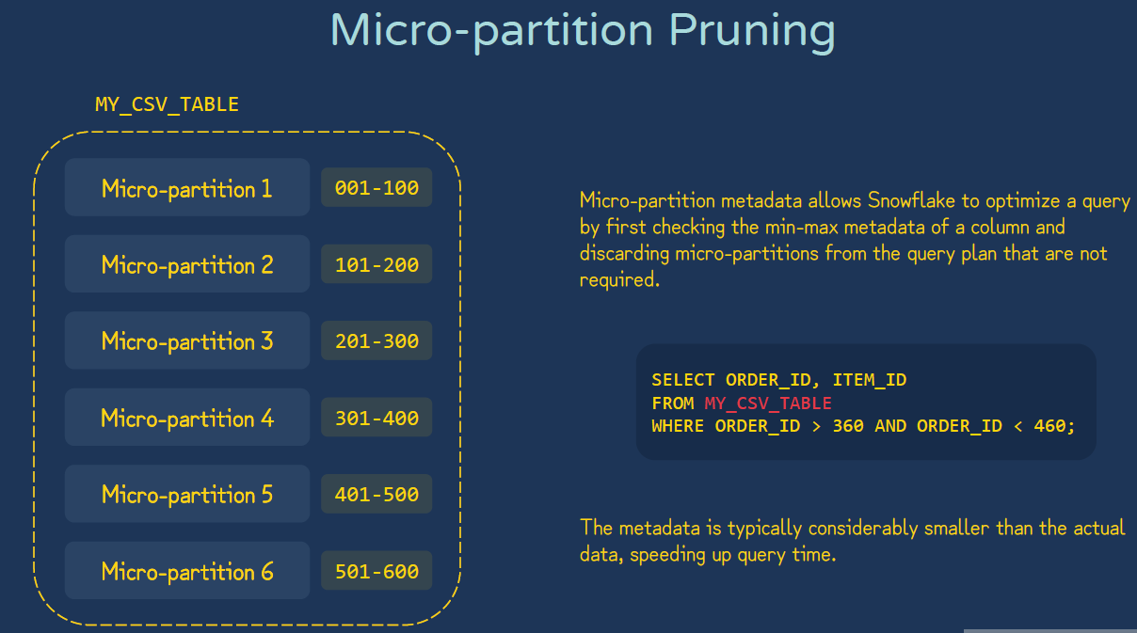

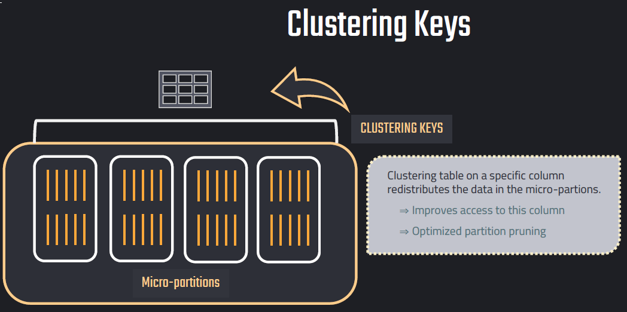

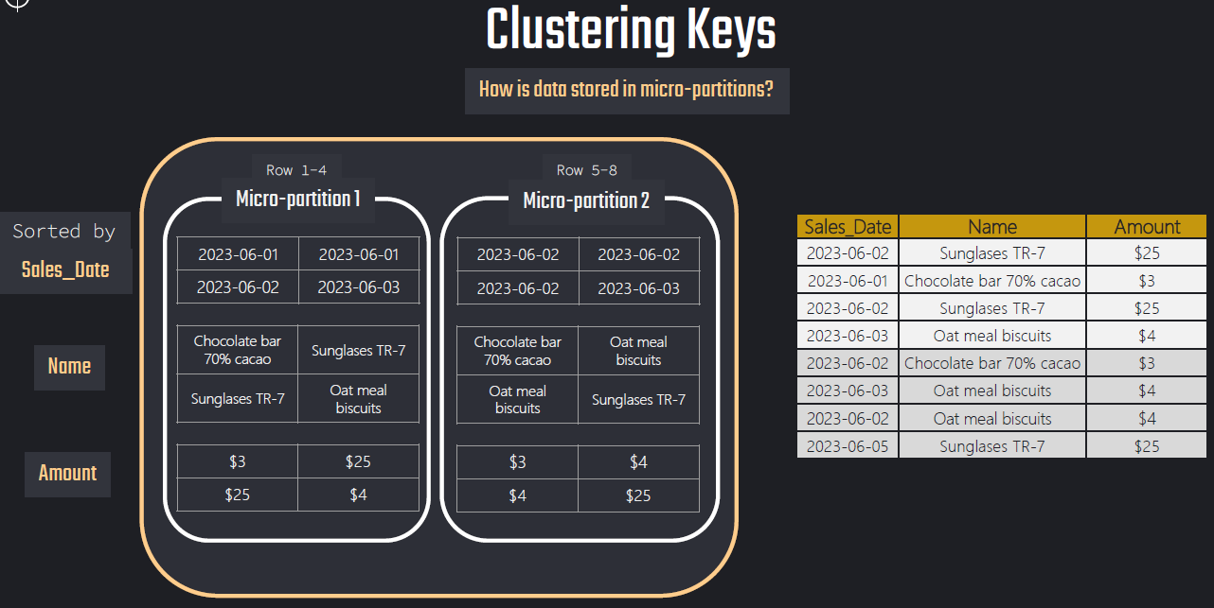

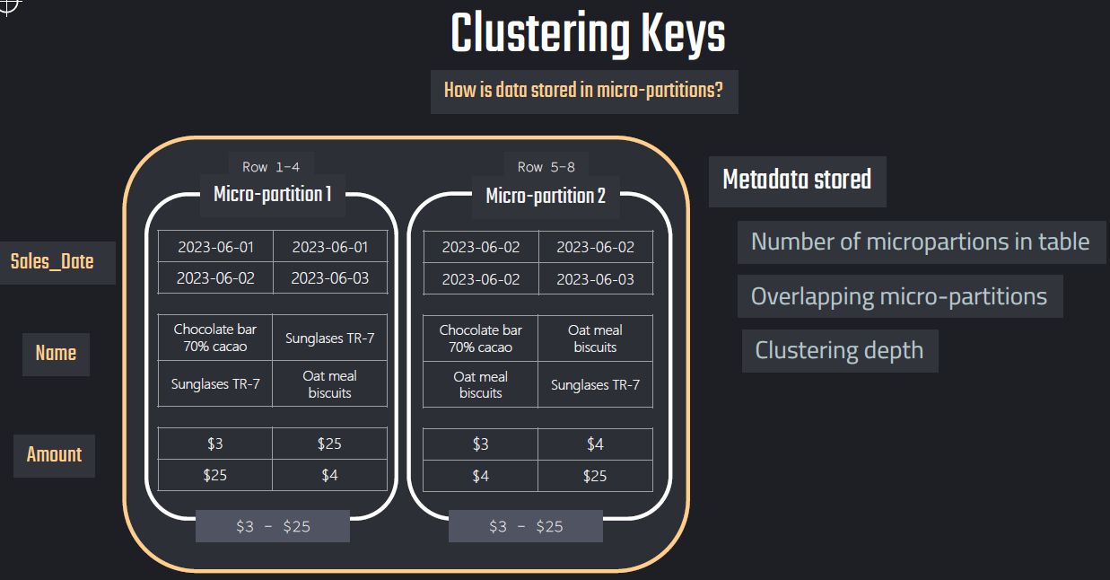

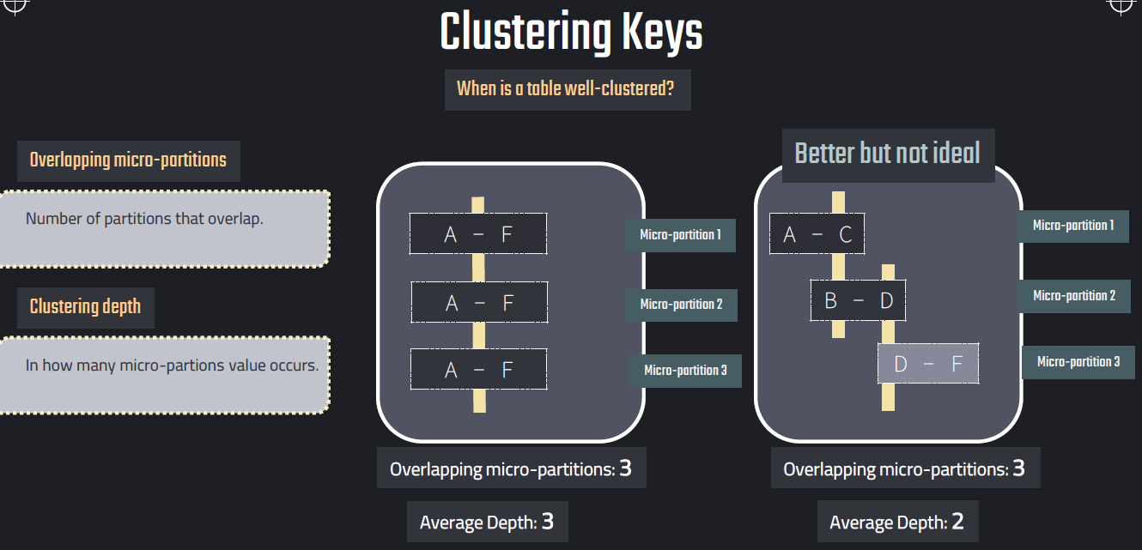

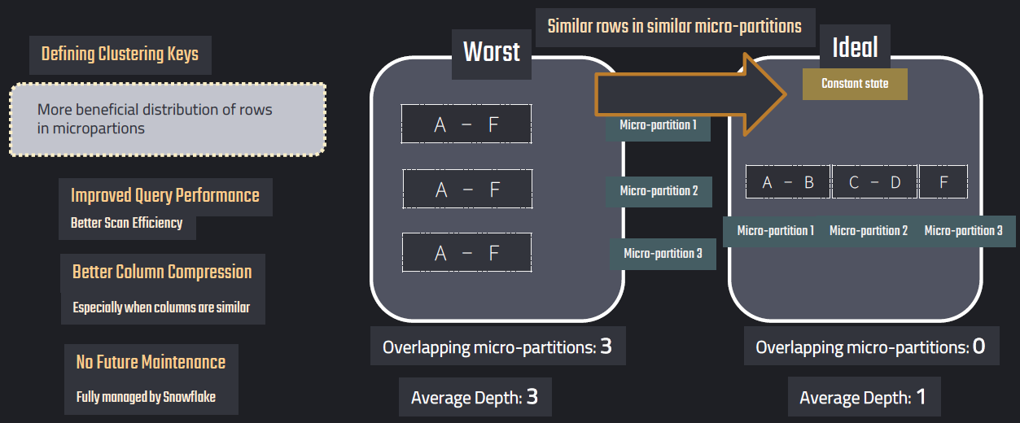

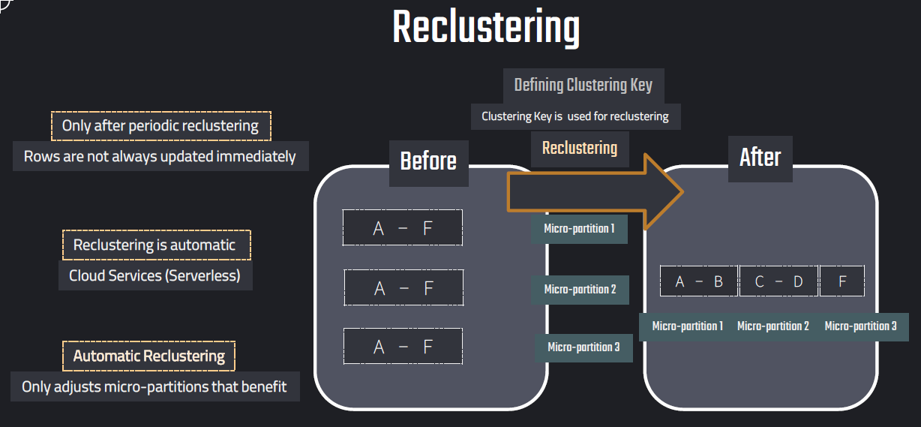

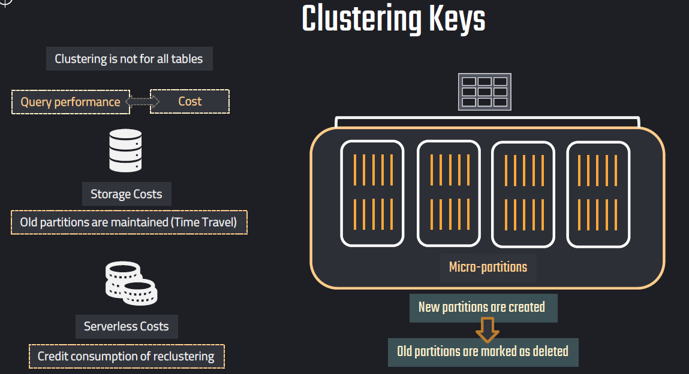

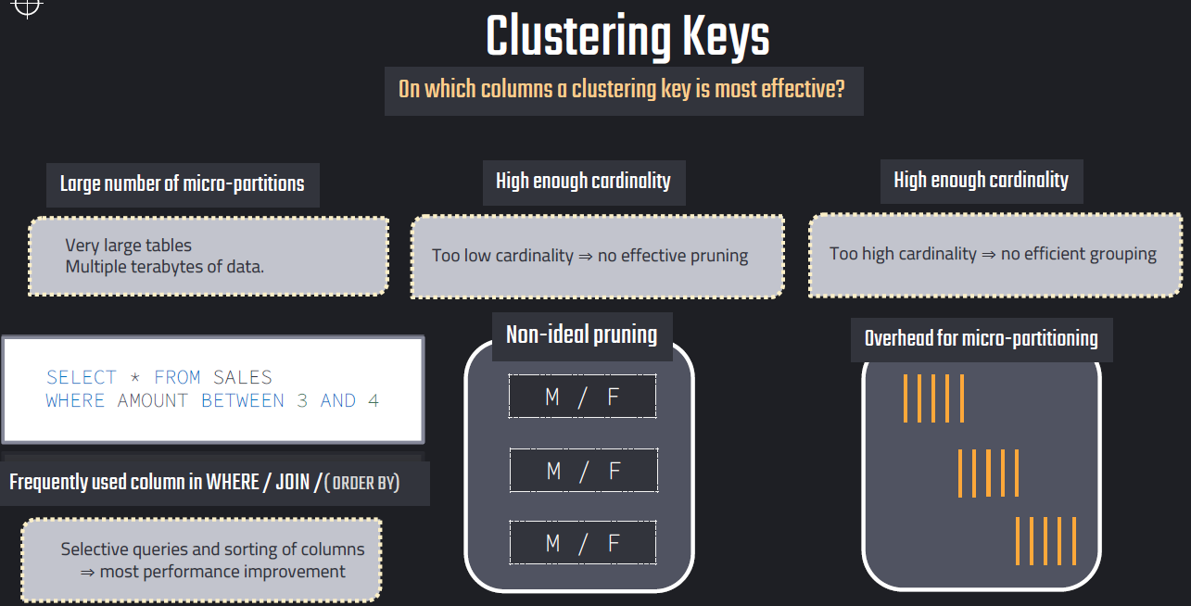

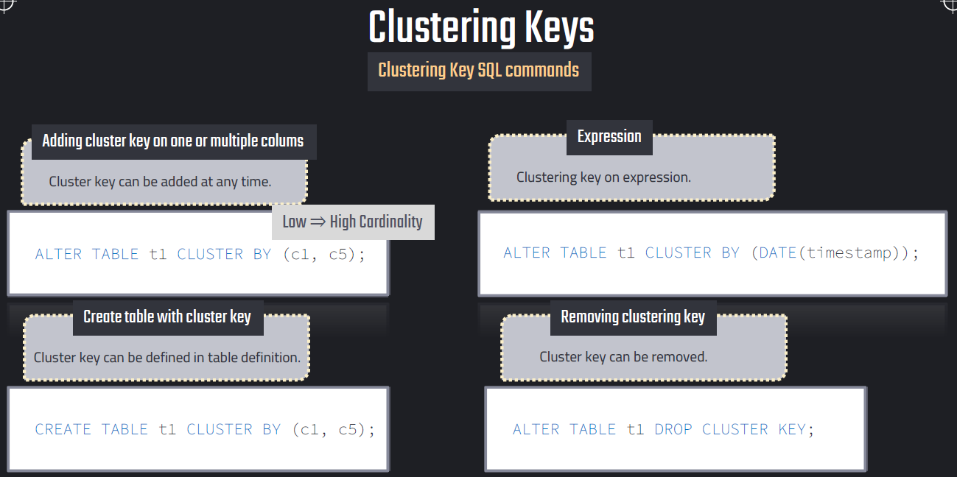

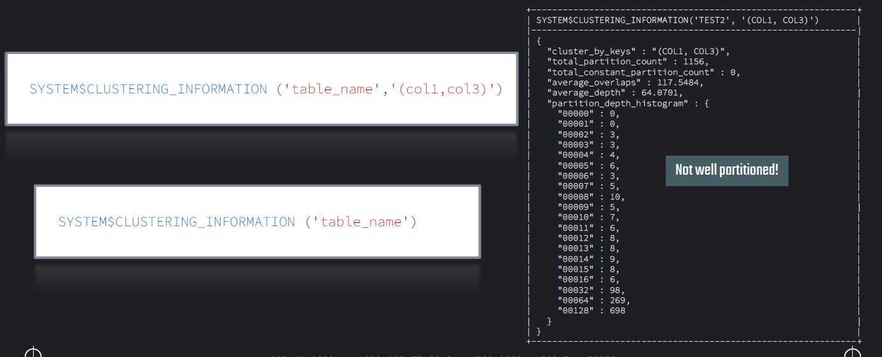

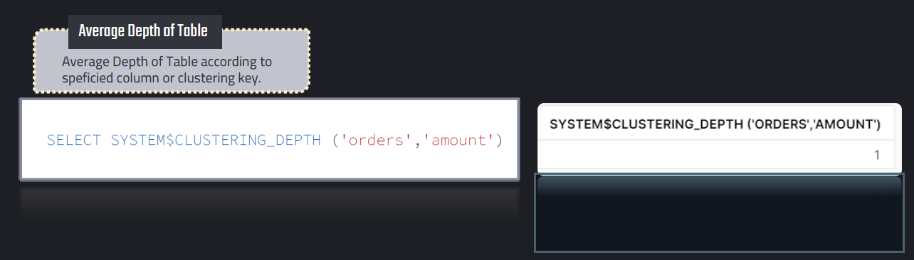

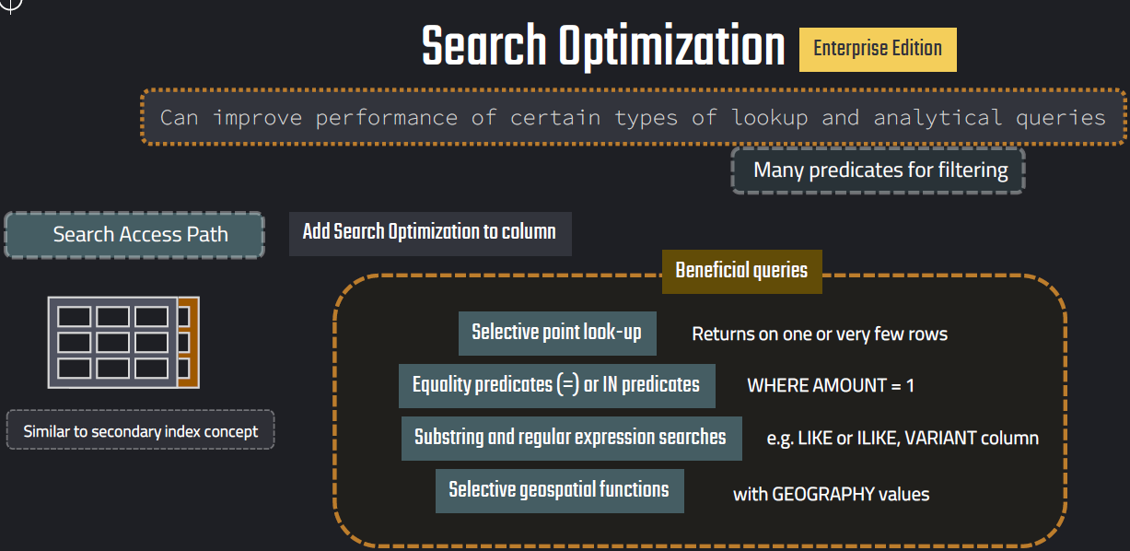

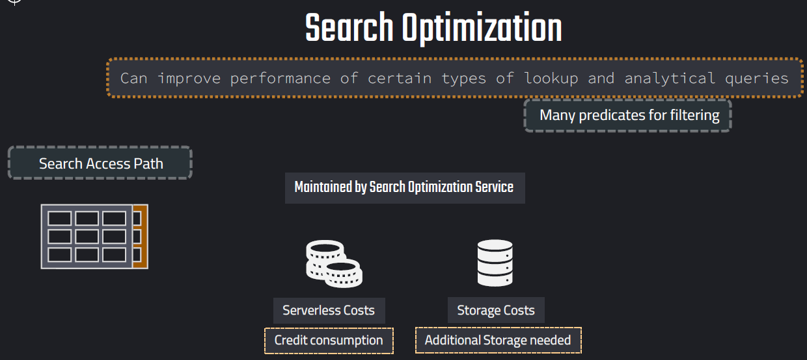

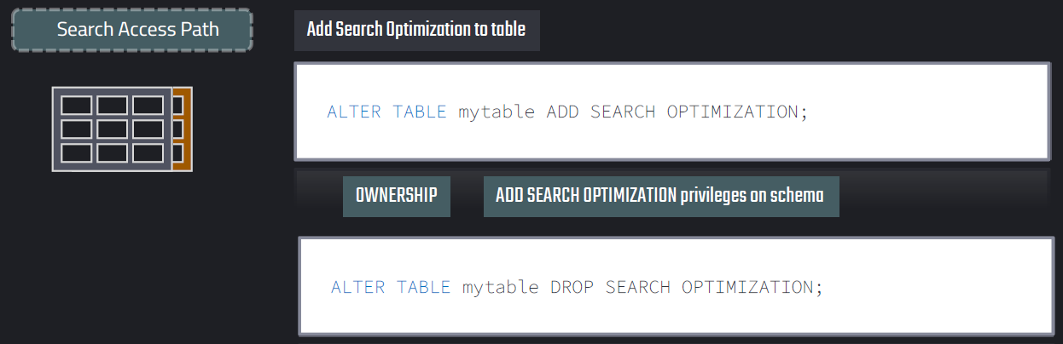

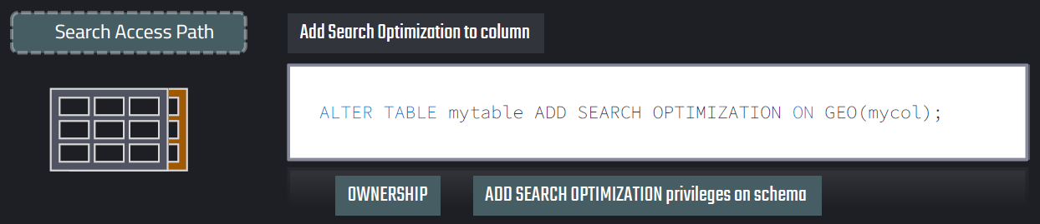

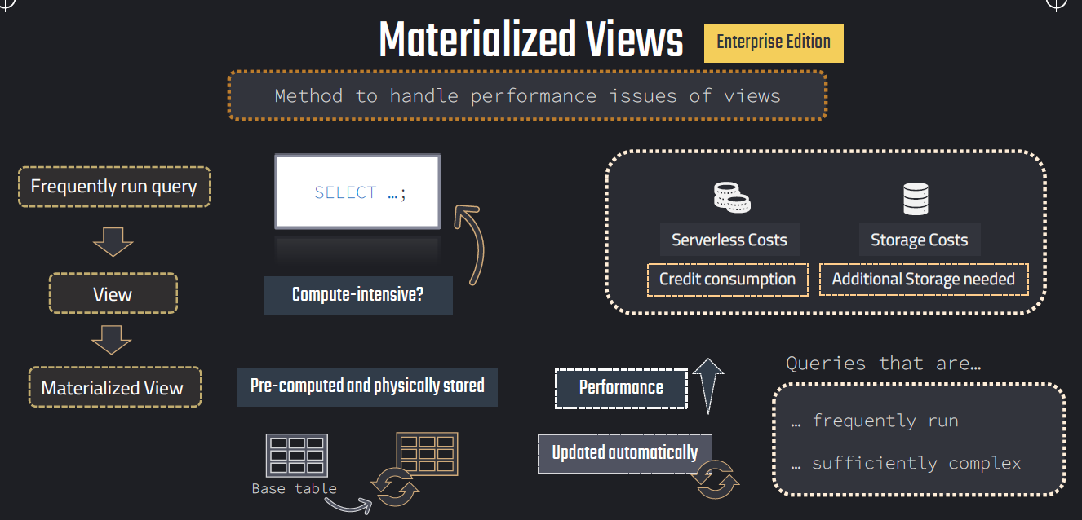

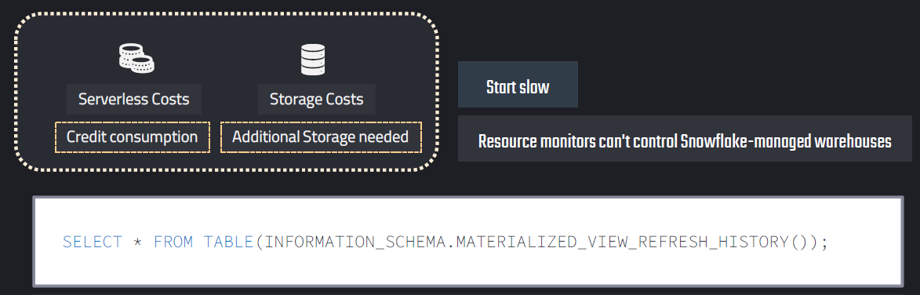

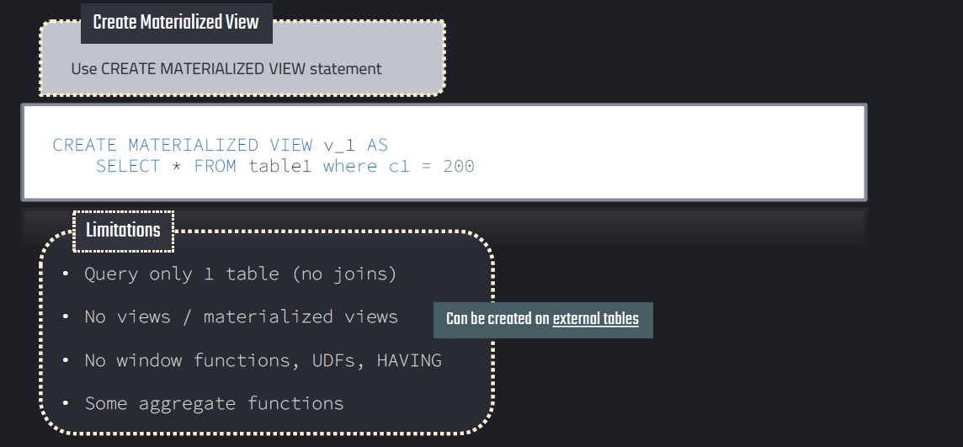

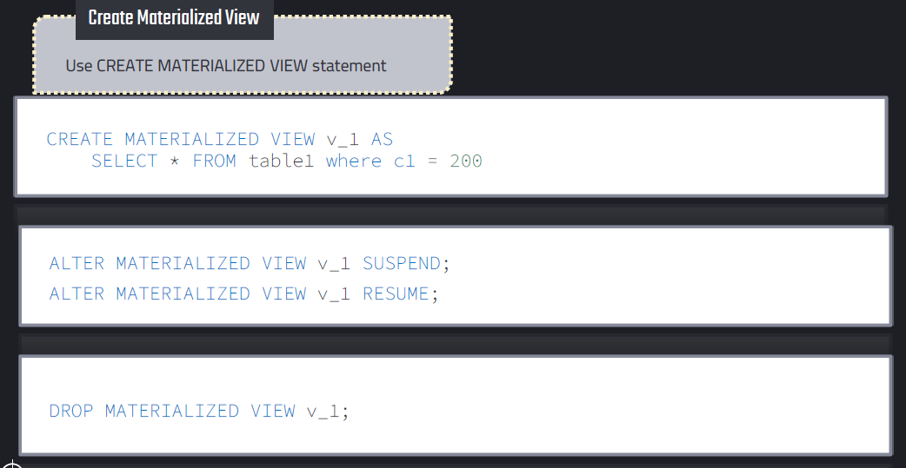

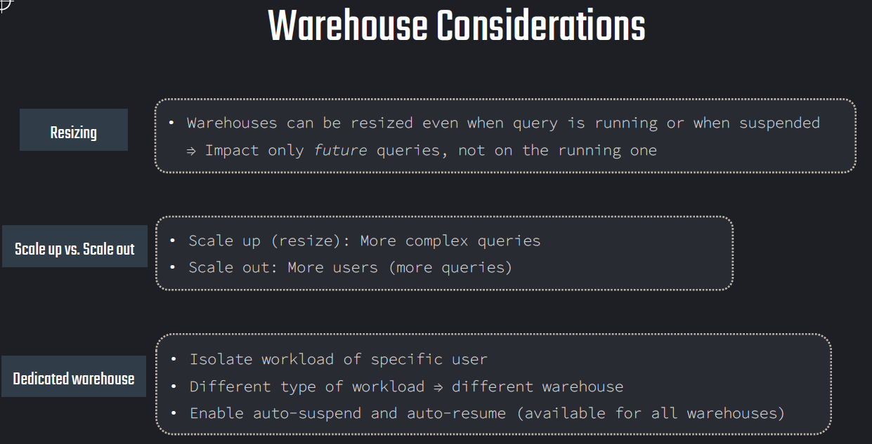

**Query Acceleration Service:**

The Query Acceleration Service is a feature that can be enabled for a Virtual Warehouse which accelerates parts of query workload automatically by offloading portions of query processing to the additional compute resources provided by the service. These additional resources provisioned by QAS work in parallel reducing the overall time spent in scanning and filtering.

The queries that benefit from Query Acceleration Service are:

* Queries with large scans and selective filters.
* Workloads with unpredictable data volume per query.
* Adhoc analytics.

Note that Query Acceleration Service is an **Enterprise Edition (or higher)** feature.

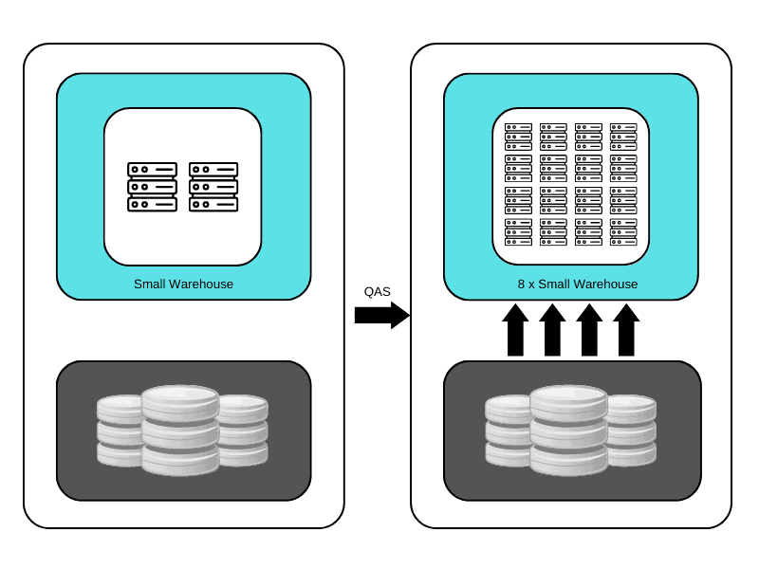

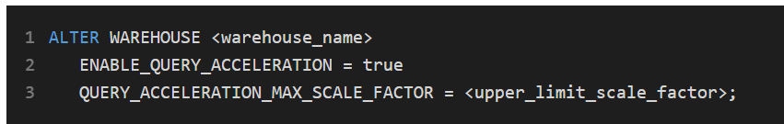

The Scale Factor in Query Acceleration Service is a control mechanism which lets you select the maximum number of the compute resources a warehouse can lease for Query Acceleration. The scale factor is a **multiplier value** for number of compute resources of same warehouse size and cost.

For example, if you set a scale factor to 8 for a SMALL warehouse.

* The warehouse can lease compute resources up to 8 times the size of SMALL warehouse.
* As the SMALL warehouse costs 2 credits per hour, leasing these resources would cost up to 16 credits per hour ( 2 credits per hour X 8 times compute resources)

Few key points related to Scale Factor

* The default value of Scale Factor is 8 if it is not explicitly set.
* Setting the scale factor to 0 eliminates the upper bound limit and allows queries to lease as many resources as necessary and available to execute the query.
* The Query Acceleration Service is billed by the second, only when the service is in use. These credits are billed separately from warehouse usage.
* Snowflake automatically determines whether the query would benefit from using the Query Acceleration Service, and will only deploy this if it’s estimated to improve query performance and overall throughput.

Use SYSTEM$ESTIMATE_QUERY_ACCELERATION or views to see potential benefit.

The **QUERY_ACCELERATION_ELIGIBLE** view also identifies queries along with warehouses that might benefit from the query acceleration service.

SELECT * FROM SNOWFLAKE.ACCOUNT_USAGE.QUERY_ACCELERATION_ELIGIBLE;

The billing data of Query Acceleration Service can be found in:

SNOWFLAKE.ACCOUNT_USAGE.QUERY_ACCELERATION_HISTORY

INFORMATION_SCHEMA.QUERY_ACCELERATION_HISTORY()