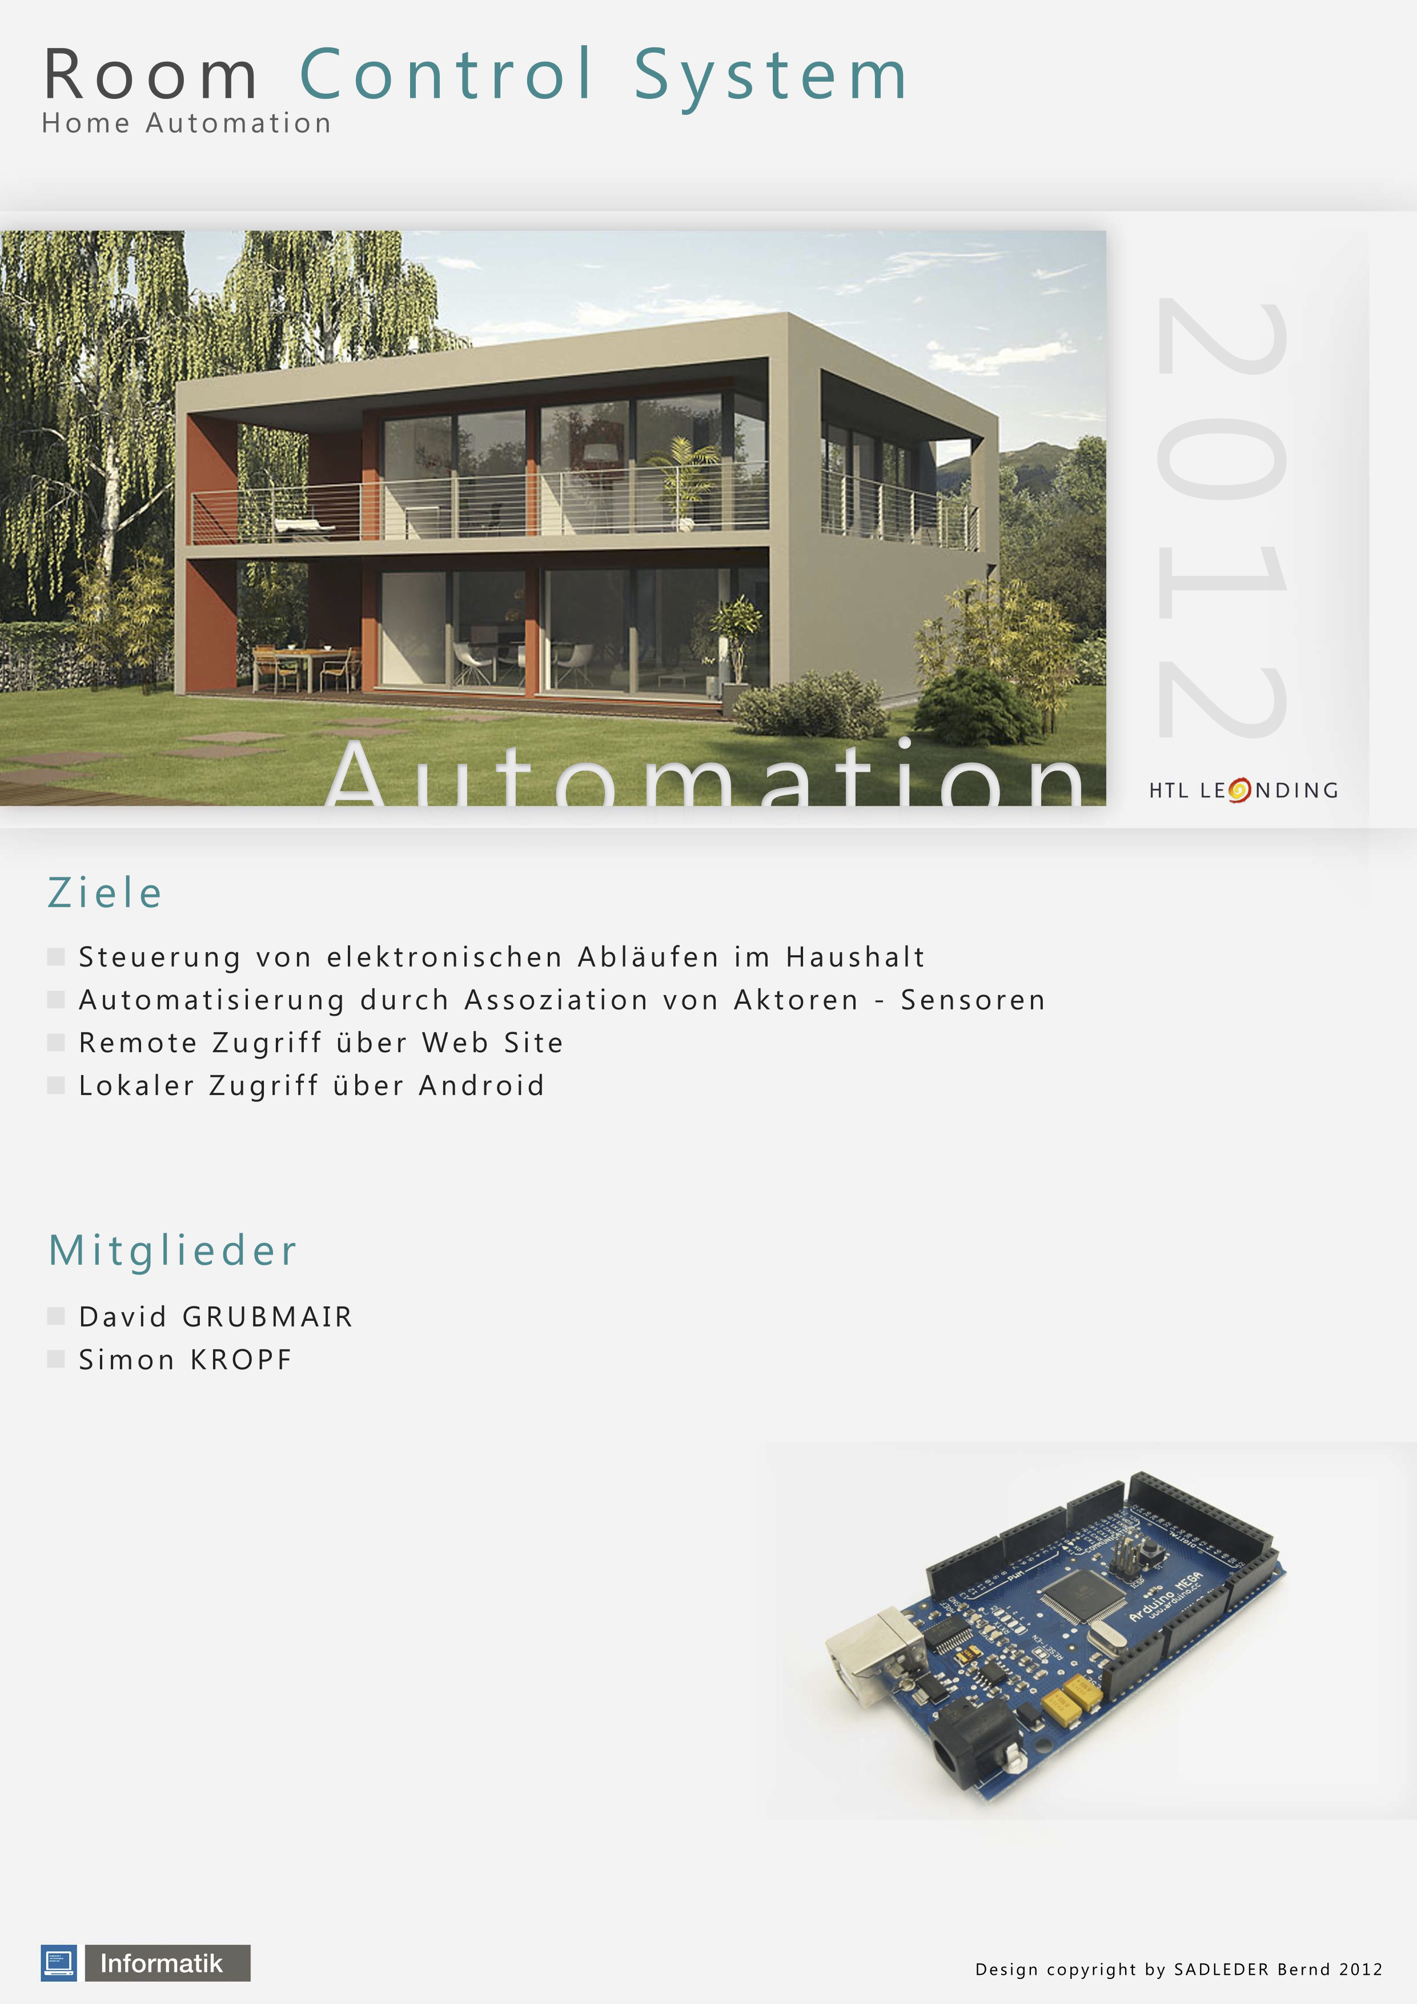

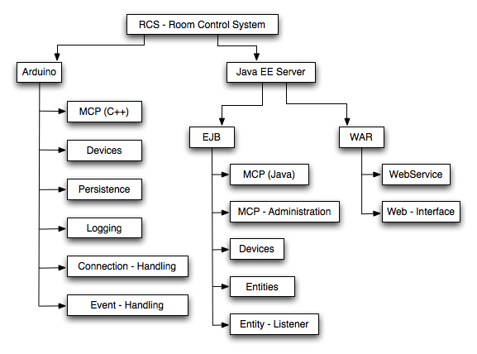
Projekt structure plan

Status report

Finished packages

Arduino
- MCP (C++)
- Persistence
- Connection – Handling
- Event – Handling

Java EE Server
- EJB
- MCP (Java)
- MCP – Administration
- Devices
- Entities
- WAR
- WebService

Currently working packages

Arduino
- Devices (33%)
- Logging (70%)

Java EE Server
- EJB
- Entity – Listener (80%)
- WAR
- Web – Interface (30%)

