BT305 Lab3 Assignment:

Name: Sumit Kumar

Roll No. 210106076

2. Download 1PGB.pdb from Protein Data Bank

A) Run PROSS to get the Phi, Psi, Chi1, and Chi2 dihedral angles.

Note down the dihedral angles of the helix, Beta Strand, Anti parallel Beta Sheet

------------------------------|---------------------|---------------------|

| Statistic | Observed | Expected

| Mean Helix Phi | -69.3 sd=9.2 | -65.3 sd=11.9 |

| Mean Helix Psi | -34.2 sd=16.9 | -39.4 sd=25.5 |

| # res with Gauche+ Chi | 23 ( 50%) | 25 ( 55%) |

| # res with Gauche- Chi | 7 ( 15%) | 9 ( 20%) |

| # res with Trans Chi | 16 ( 34%) | 11 ( 25%) |

| Mean Chi Gauche+ | -65.4 sd=12.0 | -66.7 sd=15.0 |

| Mean Chi Gauche- | 60.6 sd=15.9 | 64.1 sd=15.7 |

| Mean Chi Trans | 167.0 sd=11.7 | 168.6 sd=16.8

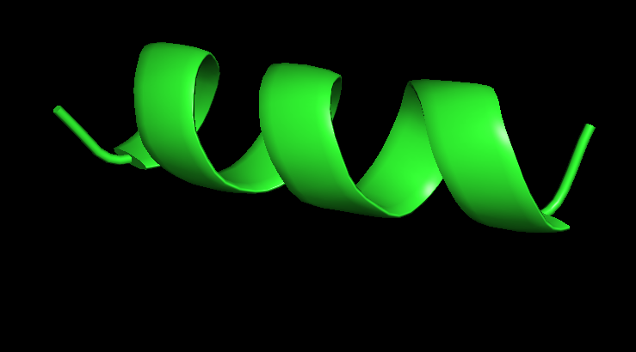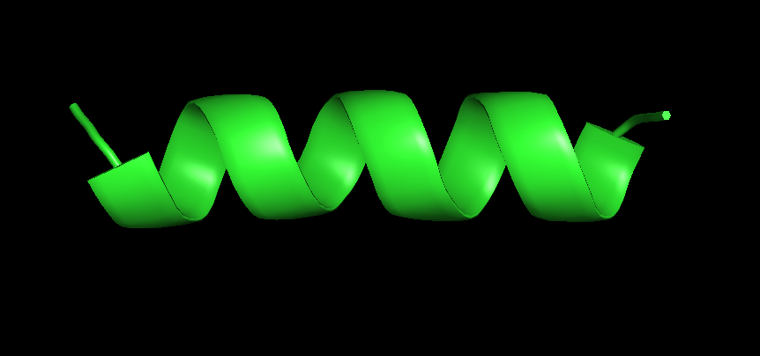

Designed VS Extracted helix from original PDB file



Designed VS Extracted anti-parallel-beta-sheet from original PDB file