BT305 Lab4  
Name: Sumit Kumar  
Roll number: 210106076

4. Superimpose the structures using SPDB Viewer and calculate the RMSD of your designed protein with the original 1L2Y.pdb  
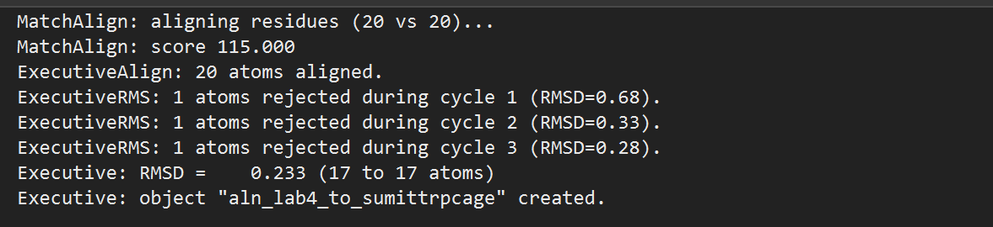

RMSD value = 0.233

5. Take snapshots of both proteins by saving it as a picture file, and present as side by side images in your record book.  
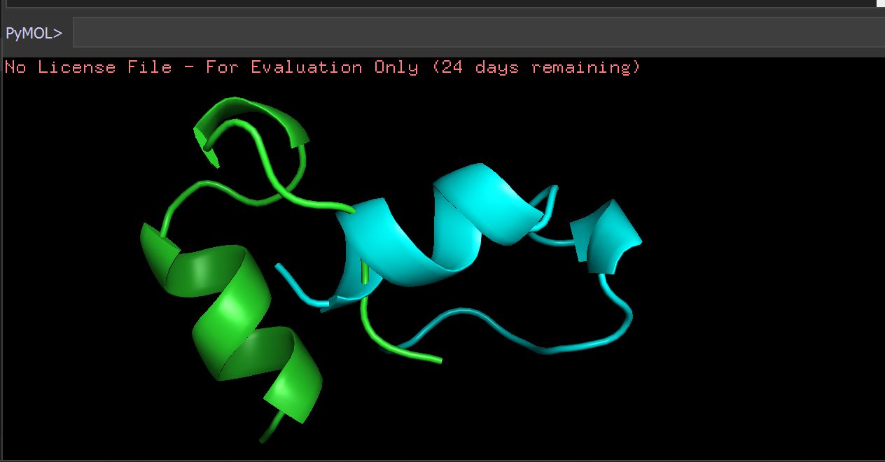

Non-Aligned side by side images of proteins

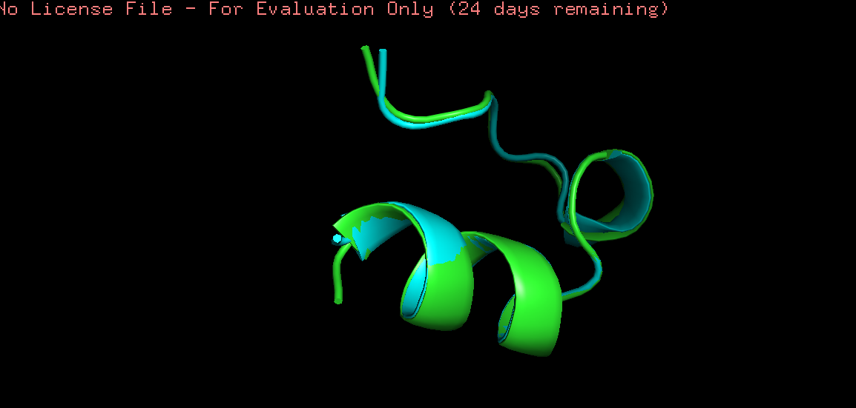

Aligned image of proteins