**BT305 Lab Assignment 7**

**Name: Sumit Kumar**

**Roll No. 210106076**

**1.**

1PGB

Initial:

phi & psi angles of 4th residue : -129.838 126.485

phi & psi angles of 8th residue : -86.0263 179.722

Deviation After EM:

phi & psi angles of 4th residue : 7.438 6.42

phi & psi angles of 8th residue : -41.5487 -11.122

Deviation After MD:

phi & psi angles of 4th residue : 19.884 11.112

phi & psi angles of 8th residue : -56.2887 21.131

TRP Cage

Initial:

phi & psi angles of 4th residue : -61.5746 -42.7245

phi & psi angles of 8th residue : -73.2076 -18.7175

Deviation After EM:

phi & psi angles of 4th residue : 7.3421 8.5531

phi & psi angles of 8th residue : 3.9723 -9.5835

Deviation After MD:

phi & psi angles of 4th residue : -4.7935 11.4069

phi & psi angles of 8th residue : -96.2384 128.3735

Alpha-Helix

Initial:

phi & psi angles of 4th residue : -64.6311 -34.1108

phi & psi angles of 8th residue : -61.6178 -42.1426

Deviation After EM:

phi & psi angles of 4th residue : 11.6488 -7.0309

phi & psi angles of 8th residue : 3.2649 -13.0852

Deviation After MD:

phi & psi angles of 4th residue : 18.9604 -41.948

phi & psi angles of 8th residue :8.5922 -2.2798

Beta-Sheet

Initial:

phi & psi angles of 4th residue : -103.326 122.067

phi & psi angles of 8th residue : -72.7477 -36.7

Deviation After EM:

phi & psi angles of 4th residue : 17.3887 5.357

phi & psi angles of 8th residue : 5.4159 3.3185

Deviation After MD:

phi & psi angles of 4th residue : 1.763 -78.5052

phi & psi angles of 8th residue : 132.75 -38.07

2. Energy With Time

1PGB

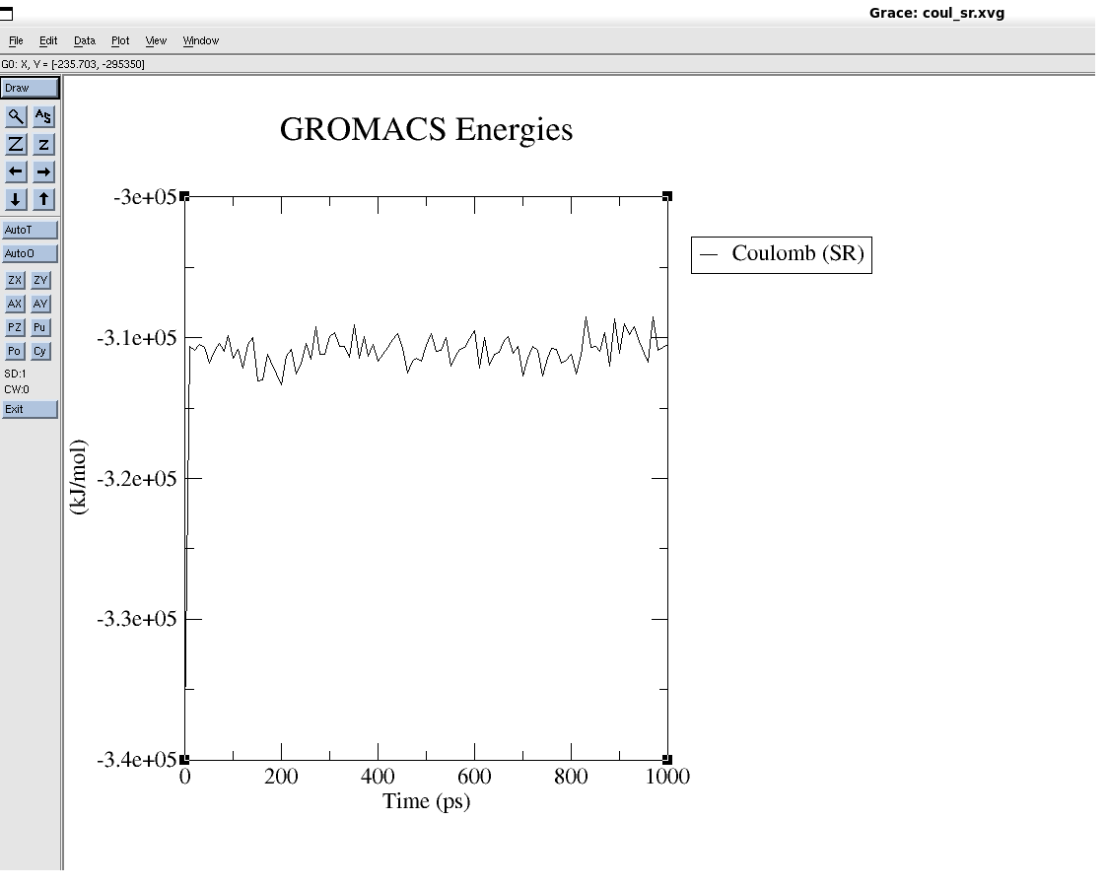

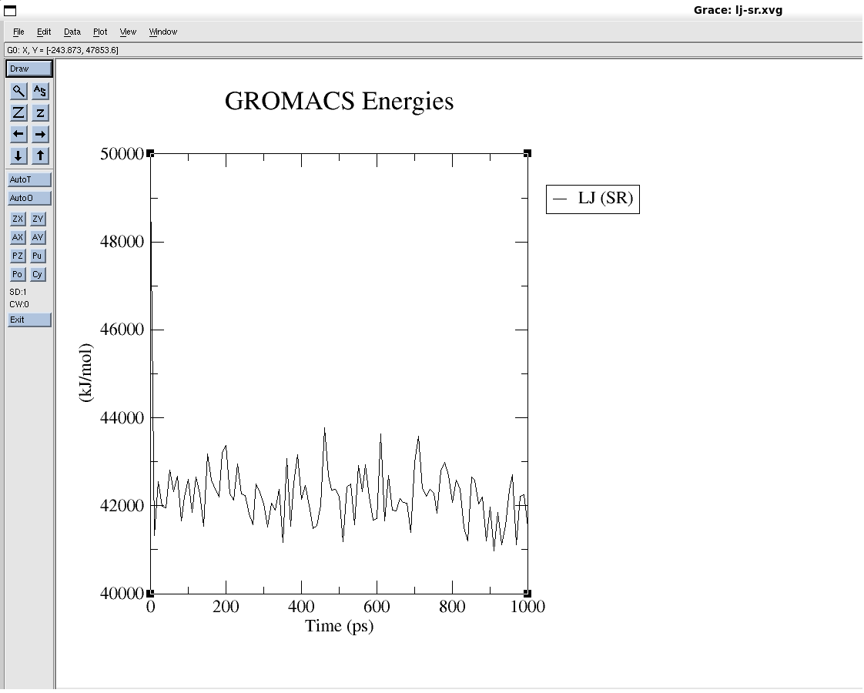

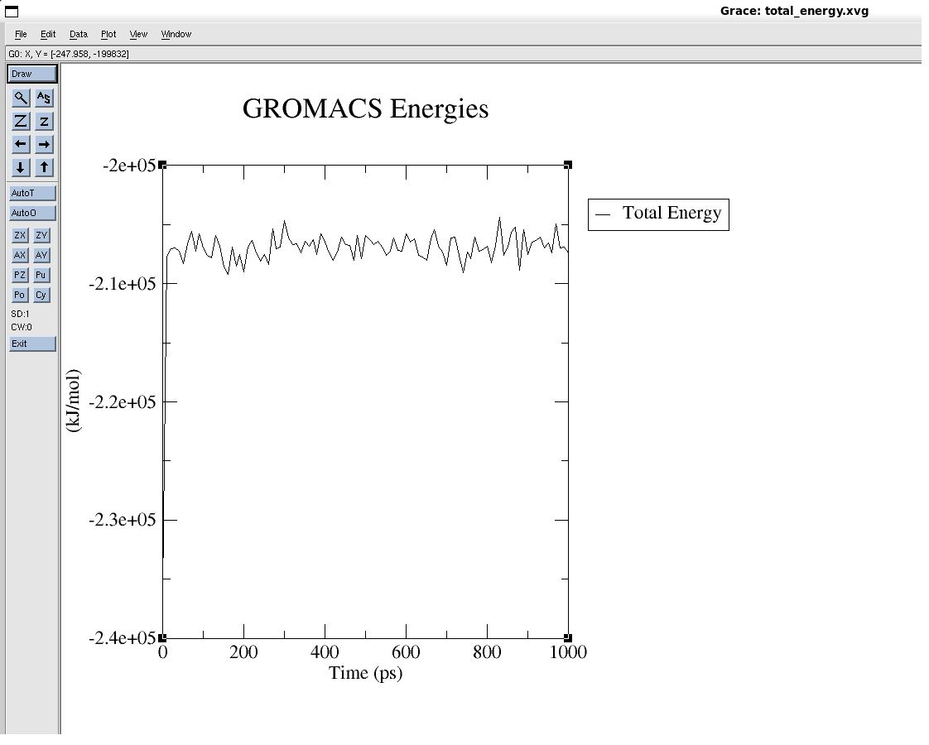

TRP Cage

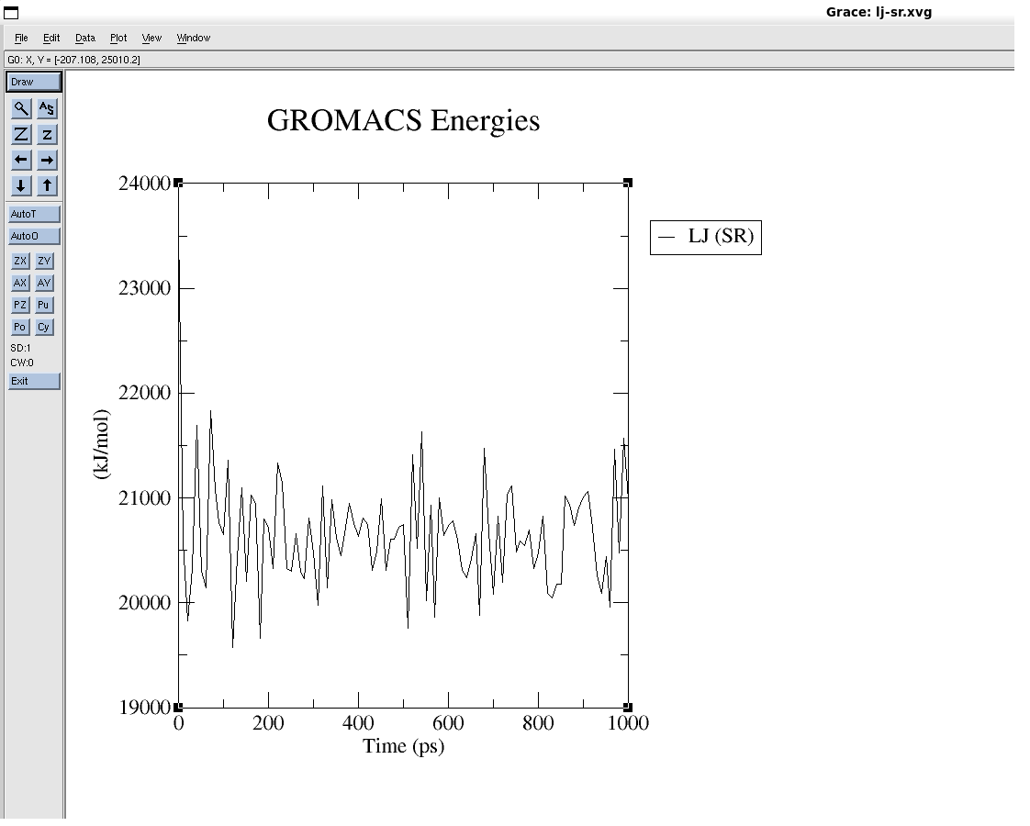

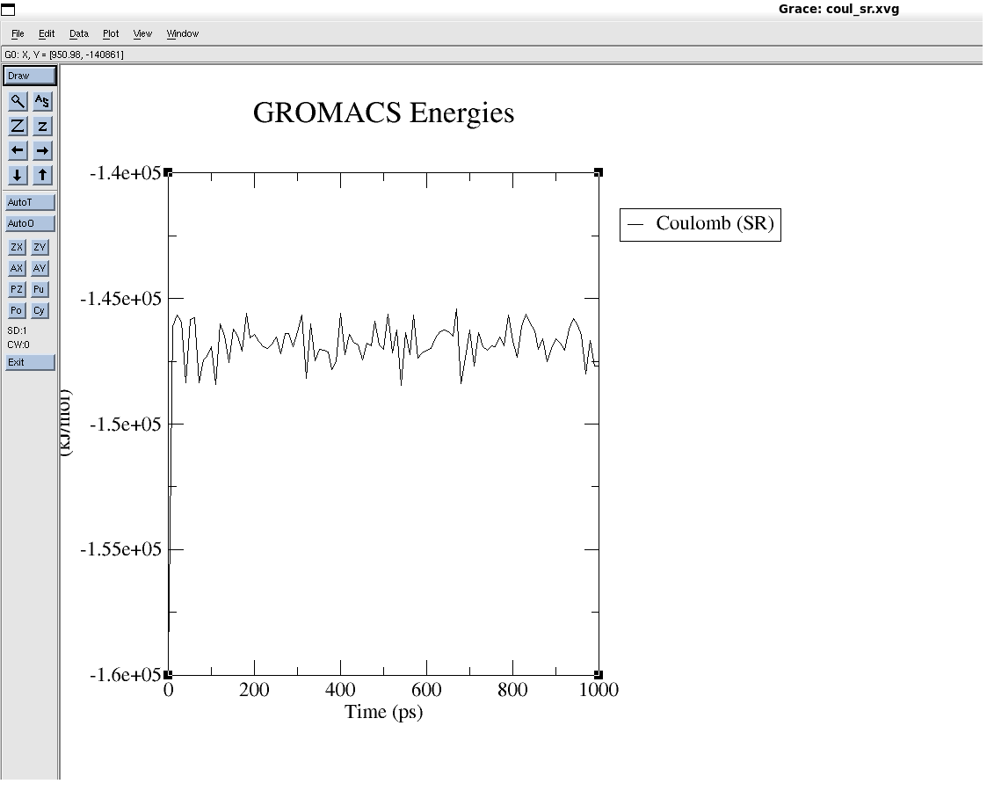

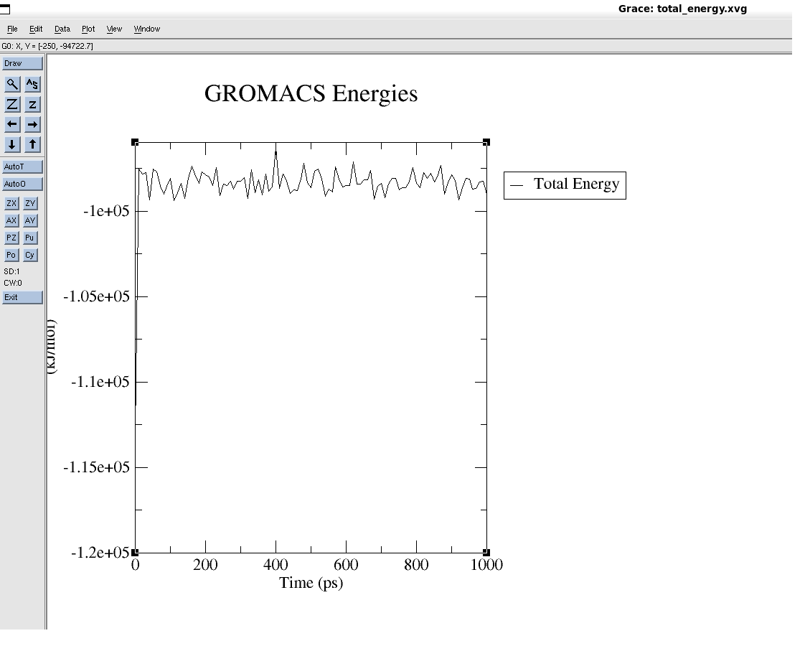

Alpha-Helix

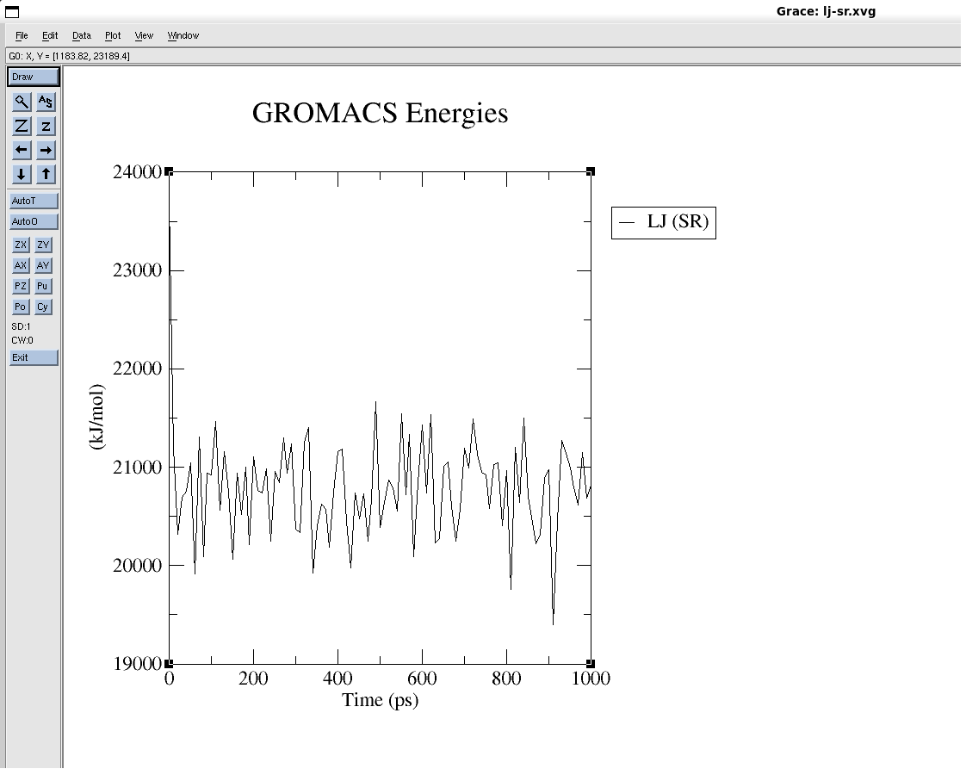

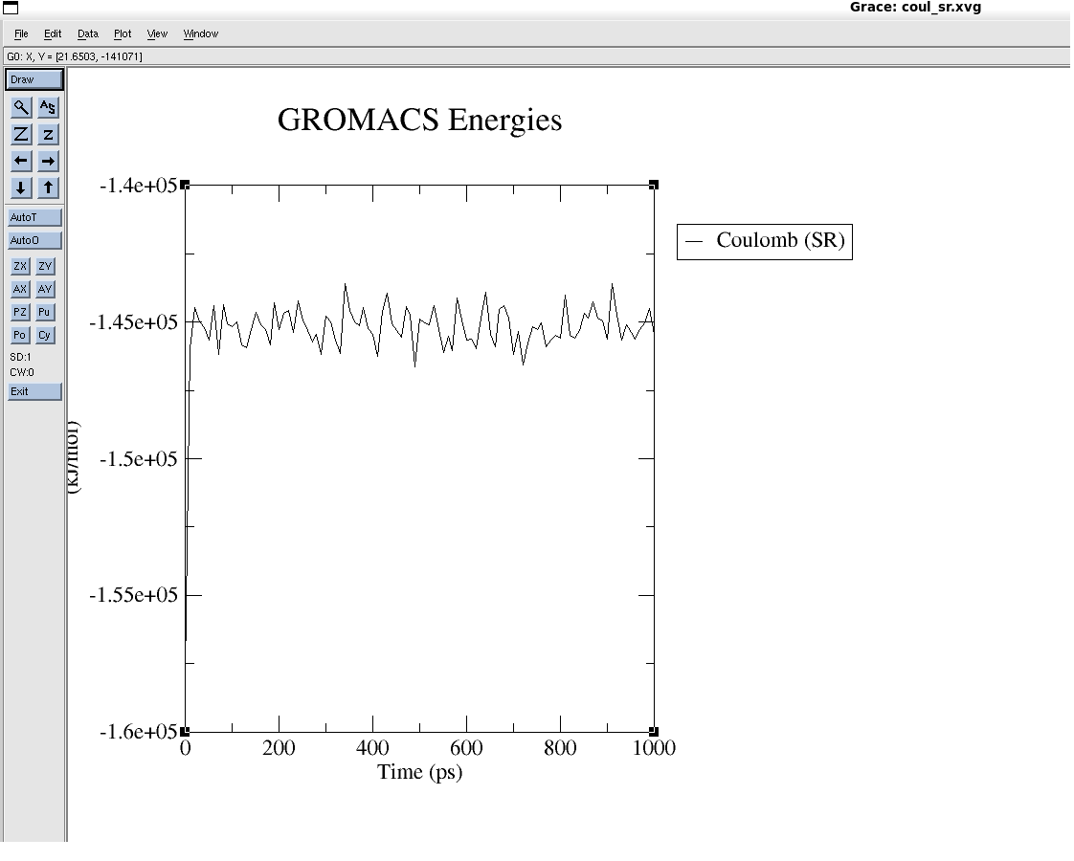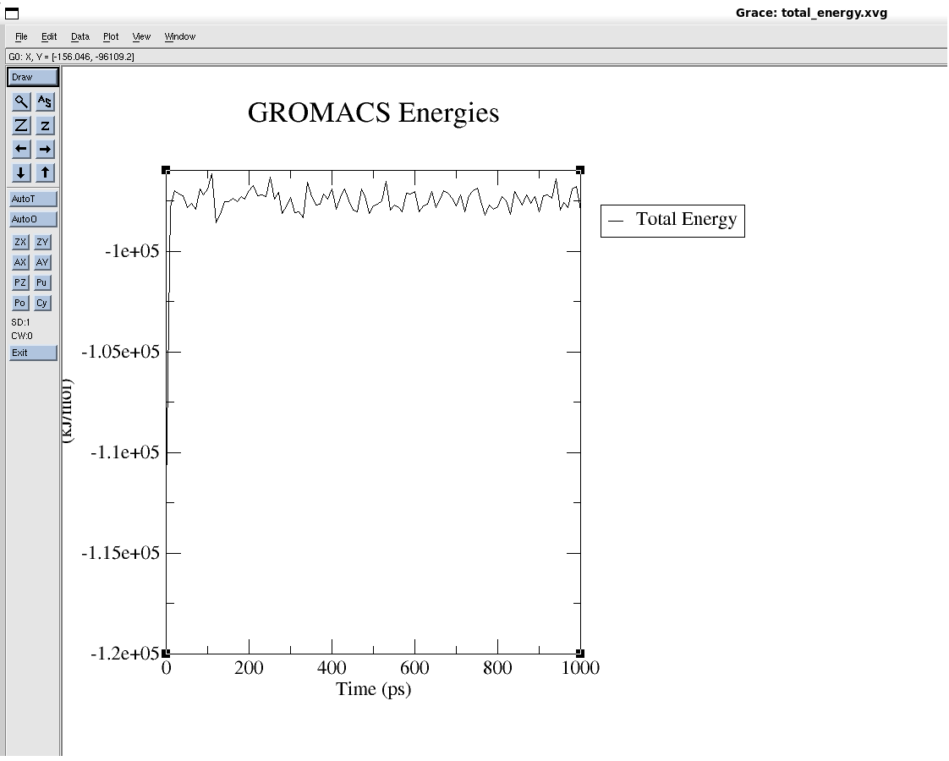

Beta-Sheet

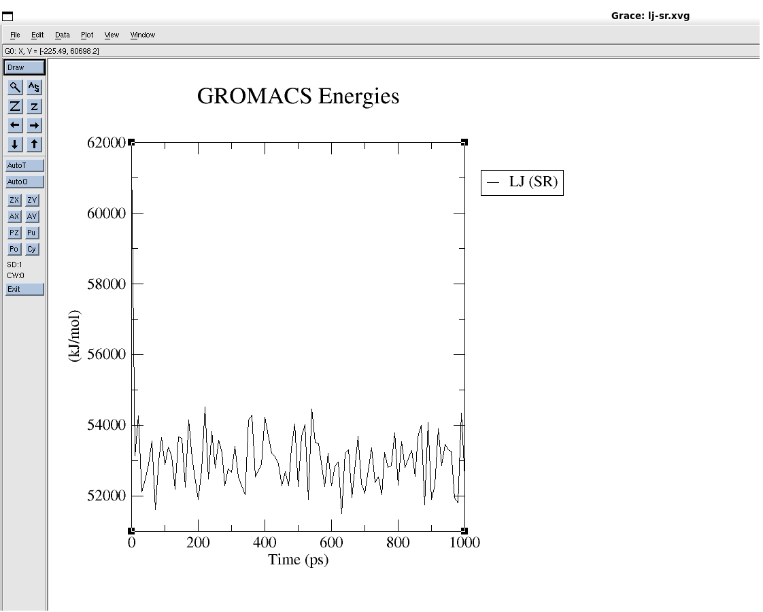

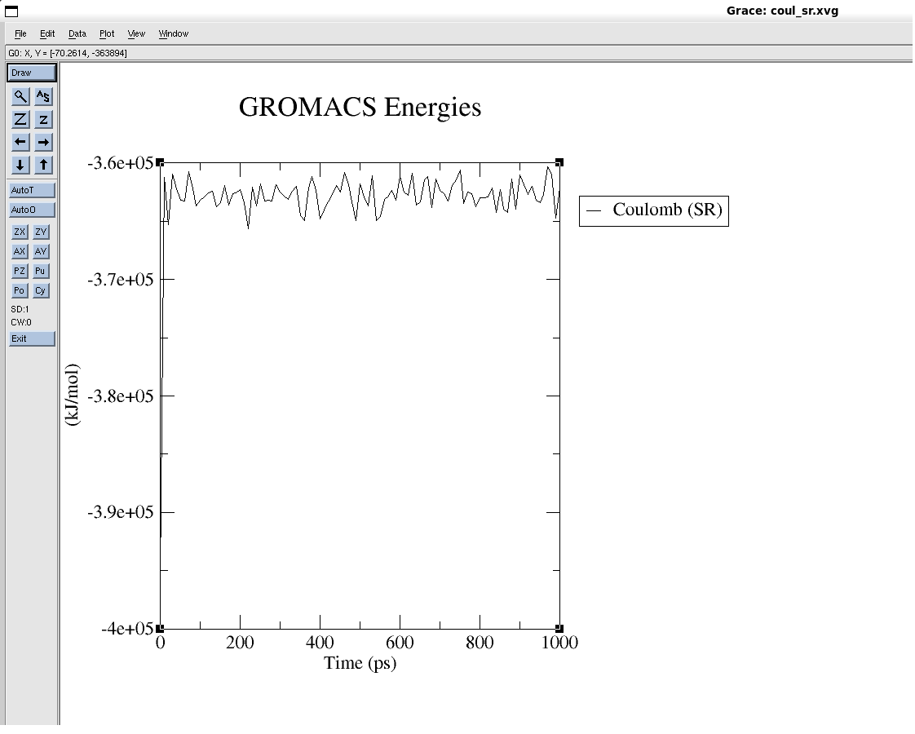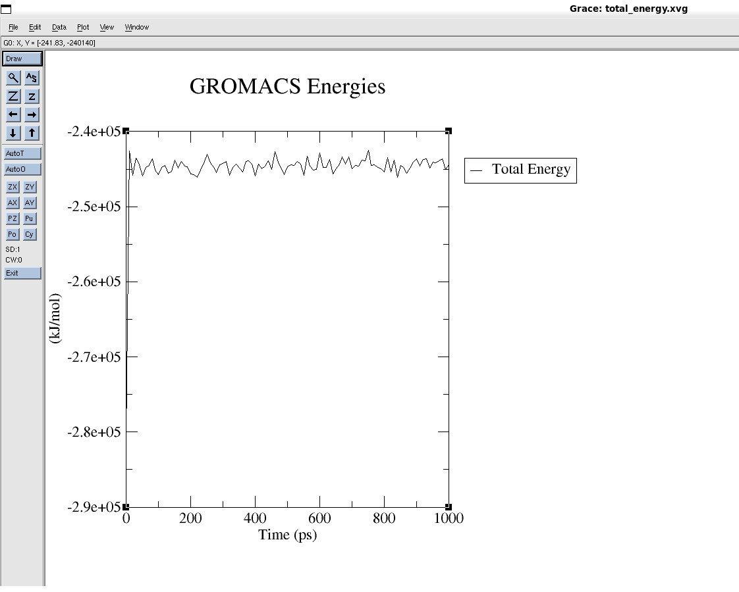

3.

The radius of Gyration of TRP: 0.538806

The radius of Gyration of PGB: 0.70167

The radius of Gyration of Helix: 0.382169

The radius of Gyration of BetaSheet: 0.938183

4. Cluster Analysis