**BT305 Lab Assignment 8**

**Name: Sumit Kumar**

**Roll No. 210106076**

Section 1

1.

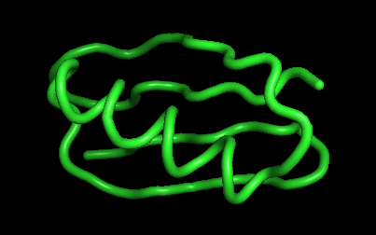 Number of clusters for cutoff 0.15=3 Number of clusters for cutoff 0.1=18

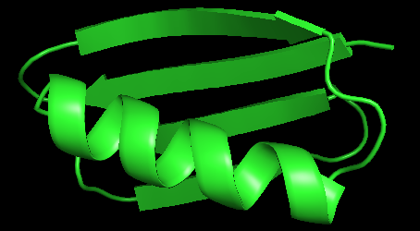 Number of clusters for cutoff 0.30=1

**Impact of Higher Temperature (363 K) on Conformational Sampling and Flexibility:**

the increased thermal energy would likely lead to greater conformational sampling and increased conformational flexibility. This could result in a larger number of clusters being formed compared to the simulation at 300 K. The broader distribution of conformations due to increased thermal energy may lead to the identification of more distinct structural states or conformations, thereby increasing the number of clusters observed in the free energy landscape analysis.

**Please find the attached video files in the movie folder**

**Observations:**

Increased Vibrational Motion: At a higher temperature, molecules tend to vibrate more vigorously due to increased thermal energy. Consequently, you may observe increased overall motion and fluctuations in the protein structure in the MD trajectory at 363 K compared to 300 K.

Faster Dynamics: At 363 K, the increased Vibrational Motion increased thermal energy accelerates molecular motion, leading to faster dynamics in the MD trajectory compared to 300 K. This acceleration could result in quicker transitions between different structural states or conformations of the protein.

Section 1

Exercise 1:

1. TRP: RMSD = 0.000

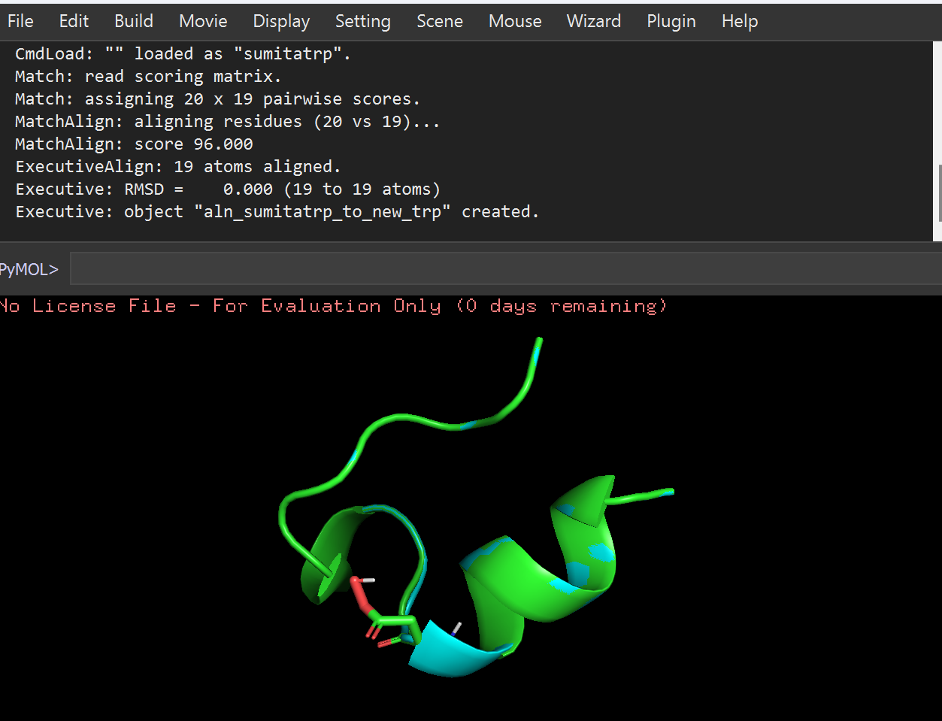

TRP : RMSD = 0.000

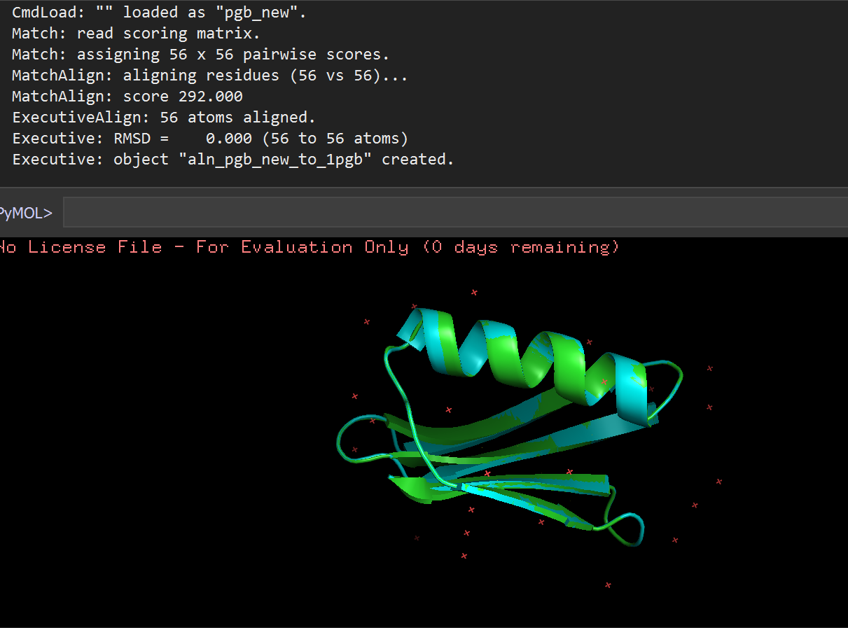

2:

ALA → N[[C@H](mailto:C@H)](C(=O)N[C@H](C=O)C)C

PHE → N[C@H](C=O)Cc1ccccc1

GLU → N[C@H](C=O)CCC(=O)O

LYS → N[[C@H](mailto:C@H)](C=O)CCCCN

Exercise 2:

Question: Convert 1PGB.pdb to smiles?

Answer:

N[C@H](C(=O)N[C@H](C(=O)N[C@H](C(=O)N[C@H](C(=O)N[C@H](C(=O)N[C@H](C(=O)N[C@H](C(=O)N[C@H](C(=O)NCC(=O)N[C@H](C(=O)N[C@H](C(=O)N[C@H](C(=O)N[C@H](C(=O)NCC(=O)N[C@H](C(=O)N[C@H](C(=O)N[C@H](C(=O)N[C@H](C(=O)N[C@H](C(=O)N[C@H](C(=O)N[C@H](C(=O)N[C@H](C(=O)N[C@H](C(=O)N[C@H](C(=O)N[C@H](C(=O)N[C@H](C(=O)N[C@H](C(=O)N[C@H](C(=O)N[C@H](C(=O)N[C@H](C(=O)N[C@H](C(=O)N[C@H](C(=O)N[C@H](C(=O)N[C@H](C(=O)N[C@H](C(=O)N[C@H](C(=O)N[C@H](C(=O)NCC(=O)N[C@H](C(=O)N[C@H](C(=O)NCC(=O)N[C@H](C(=O)N[C@H](C(=O)N[C@H](C(=O)N[C@H](C(=O)N[C@H](C(=O)N[C@H](C(=O)N[C@H](C(=O)N[C@H](C(=O)N[C@H](C(=O)N[C@H](C(=O)N[C@H](C(=O)N[C@H](C(=O)N[C@H](C(=O)N[C@H](C(=O)N[C@H](C(=O)O)CCC(=O)O)[C@H](O)C)C(C)C)[C@H](O)C)Cc1ccccc1)[C@H](O)C)CCCCN)[C@H](O)C)C)CC(=O)O)CC(=O)O)Cc1ccc(cc1)O)[C@H](O)C)CC1=c2c(=NC1)cccc2)CCC(=O)O)CC(=O)O)C(C)C)CC(=O)N)CC(=O)O)CC(=O)N)C)Cc1ccc(cc1)O)CCC(=O)N)CCCCN)Cc1ccccc1)C(C)C)CCCCN)CCC(=O)O)C)[C@H](O)C)C)C)CC(=O)O)C(C)C)C)CCC(=O)O)[C@H](O)C)[C@H](O)C)[C@H](O)C)CCC(=O)O)CCCCN)CC(C)C)[C@H](O)C)CCCCN)CC(=O)N)CC(C)C)[C@H](CC)C)CC(C)C)CCCCN)Cc1ccc(cc1)O)[C@H](O)C)CCSC.O.O.O.O.O.O.O.O.O.O.O.O.O.O.O.O.O.O.O.O.O.O.O.O