**BT305 Lab Assignment 9**

**Name: Sumit Kumar**

**Roll No. 210106076**

1. Binding Energy of most probable conformation: -8.8
2. Residue present in ligand binding sites: Iso-Leucine, Histidine, Alanine

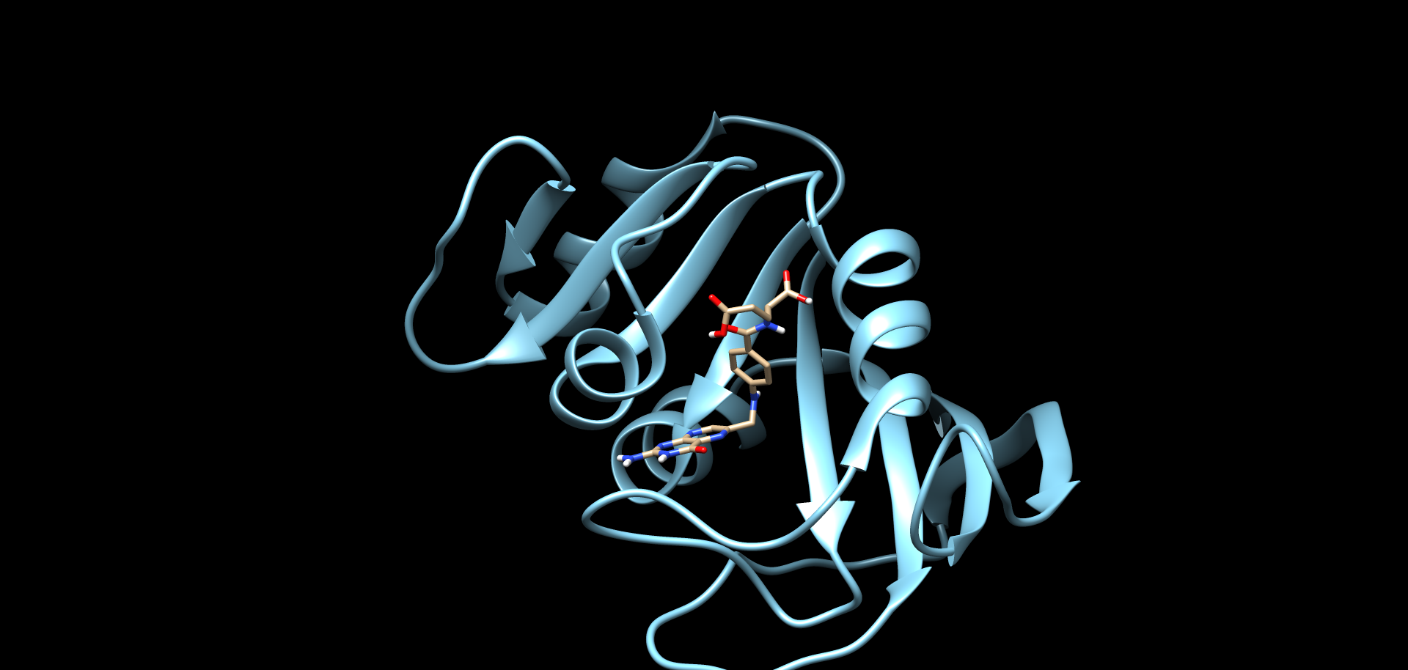

1. Nature of Amino Acids present in ligand binding sites:

Iso-Leucine: Non-polar aromatic amino acids

Histidine: Basic Amino Acid

Alanine: Non-polar amino acid

5.

|  |  |  |
| --- | --- | --- |
|  | Target-Based Docking | Blind Docking |
| Binding Energy | 201.2 | -8.8 |
| Number Of Residues | 1 | 2 |
| Residues | ASP | MET,HIS, ILE |