3/21/2015

Podduturi Sai Krishna & Podduturi Chethana

sxp148330 & cxp140630

Online Gadget Store

By Vintage Group

# Project Description:

Vintage website is an online application to buy and sell gadgets. Customers can sign up to the application, search for the required gadgets and buy any desired products. Registered users can also add desired items to their shopping cart and save them for future purchases. Customers can even view their purchase history and add reviews.

# Architecture:

1. Client sends service request to the application server through the webpage.
2. Web Server (WAMP) accepts the request through web services and processes it.
3. Application logic (PHP) will then access Data Access Layer to connect to Database and performs the desired operation.

1. Application Layer then creates a JSON object and sends the object as response to the client browser through web services.

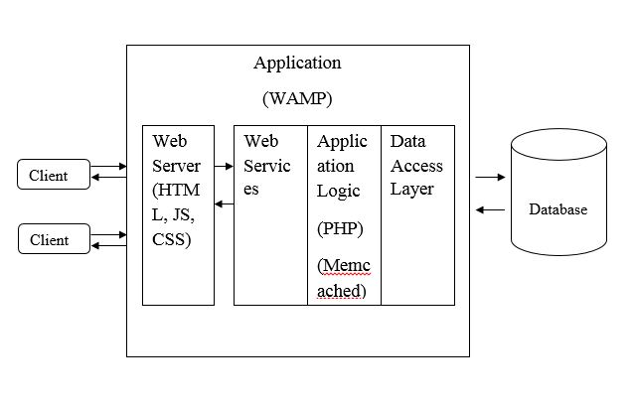

# Implementation:

* For designing GUI, the technologies that will be used are HTML, JS, JQuery and CSS.
* In the Application module, WAMP is the open source web server that will be used.
* The Web Services are implemented using SOAP.
* The Application Logic uses PHP along with Memcached for high performance.

# Mandatory Services:

1. *Product Search*: The website provides options to search for products using product name.
2. *Product Purchase*: The website allows registered users to purchase desired gadgets.
3. *Product Review*: The customers can provide reviews on the gadgets.
4. *Product Catalogue:* Product title, Price and Product description is provided for each product. Customers can also search for products according to the type and brands available in the store. Special price offers are also provided on selected products.

# Various Other Functionalities:

1. *Create Account:* Customers can create their account by providing their details like name, address, etc. Each customer will need to create a unique username.

1. *Login:* Customers can access their account using their respective username and password.
2. *User Details:* Customers can view their details in My Account page.
3. *Add/Update Cart:* Customers can add or update their desired items to the shopping cart.
4. *History*: Customers can view their purchase history.

# Core Features:

## Authentication/Authorization (Login):

The authentication here is implemented using user login. User needs to login using their credentials. Only the registered users can Log in. Constraints imposed while signing up are User name should be their Email ID and is validated, password should be of minimum length 8 characters and mobile number shall be of length 10 digits and authentication is done using SHA1 encryption.

## High Performance:

This is achieved using distributed caching technique. It is implemented using Memcached which is distributed. Once an entry is placed in the cache, all machines in the cluster can retrieve the cached item. Invalidating an entry in the cache invalidates it for everyone. Memcache is installed and this feature is implemented for gadget search functionality for this project. Here when a person searches for a gadget then the server first searches in the memcache, if there is a hit then it returns the result back if not, then it searches in the main memory and returns the result back.

## Encryption:

Implemented using TLS which stands for Transport Layer Security and is a form of security for sites that handle sensitive information such as customer names, Email ID’s, mobile numbers, and their addresses. TLS is essential for any site that sells goods or services as it ensures that all information handled stays private and secure. A self-signed certificate is created and key is generated using TLS and configured the https (in httpd.conf) for Vintage website.

## Compression:

To make the data flow faster from the server to client compressing technique is used. Compression is useful because it helps reduce resource usage, such as data storage space or transmission capacity. Gzip compression is used here.

## Asynchronous web service call:

In the context of a web page, it's more likely that the service is synchronous, but that it is being accessed asynchronously throughout our web design. The service is being called via AJAX. The call is made to the service, and the page then continues. When the response comes in, either the success or the failure functions are executed, asynchronously.

# Problems Encountered:

1. There was a problem encountered while implementing memcached because of wrong version installed for the Wamp (Apache) Server.
2. The problem occurred while implementing “Asynchronous web service” using AJAX, as the PHP function call was overriding the AJAX function call. We solved it by removing the PHP function call.