1.Introduction

The data is about local penguins in Antarctica ,where the Palmer station monitoring the ecology Palmer Long-Term Ecological Research (LTER) . they record data in order to understand their population dynamics, responses to changing climate etc.

The dataset consist of 8 features related to the Penguins which are :

* Species :only three species are observed overall.
* Island: Which island the penguins are based on.
* Sex: Determining the sex of the penguin.
* body mass,bill length and width,flipper length.

The flowchart shows how data have different cateorgies,in this project I have worked with only 100 penguins data. Penguins can have two sex either male or female. Then both sex can have 3 different species and can be from 3 different island.

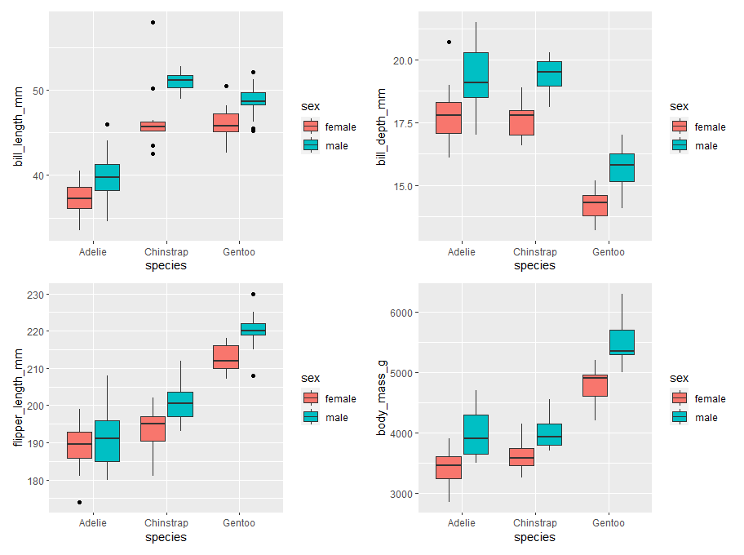2.Exploratory Analysis

