GRADIQ – STUDENT PERFORMANCE PREDICTION SYSTEM
A PROJECT REPORT
SUBMITTED BY
Roll Number | Registration Number | Student Code | Student Name
24103460087 | 24103002868 | BWU/BCA/24/091 | Krishanu Singha
Of in partial fulfilment for the award of the degree
BACHELOR OF COMPUTER APPLICATIONS (HONOURS)
IN
DEPARTMENT OF COMPUTATIONAL SCIENCE

BRAINWARE UNIVERSITY
398, Ramkrishnapur Road, Barasat, North 24 Parganas, Kolkata - 700 125

INDEX
Sl | Content |  | Page No.
1 | ABSTRACT
2 | INTRODUCTION | 1
3 | LITERATURE SURVEY | 2
4 | SYSTEM ANALYSIS AND DESIGN | 3
5 | METHODOLOGY | 4
6 | IMPLEMENTATION | 7
7 | TESTING AND DEBUGGING
8 | CONCLUSION
9 | FUTURE ENHANCEMENT
10 | REFERENCES

ABSTRACT
Gradiq – Student Performance Prediction System is a machine learning-based academic project developed to estimate students' final examination marks from academic, behavioural, and study-related factors. The main objective of the project is to study how multiple student-related attributes can be analysed together and used to predict a numerical academic outcome.
The project uses a synthetically generated dataset containing 1,000 initial student records. The dataset includes gender, age, parental education, extracurricular participation, tutoring, attendance percentage, previous marks, assignment score, weekly study hours, participation score, sleep hours, screen-time hours, and final marks. Missing values, duplicate records, and a few impossible values are intentionally introduced to demonstrate data inspection and cleaning.
The machine learning workflow includes data loading, data inspection, duplicate removal, correction of invalid values, missing-value treatment, exploratory data analysis, feature preparation, an 80:20 train-test split, model training, and model evaluation. Linear Regression, Random Forest Regressor, and Gradient Boosting Regressor are trained and compared using Mean Absolute Error (MAE), Root Mean Squared Error (RMSE), and R² Score. Five-fold cross-validation is also performed on the training data.
The notebook further applies permutation importance to identify which input features are most influential for the selected model. An additional classification task groups students into three performance levels: At Risk, Average, and Good. Finally, the selected regression model is saved using Joblib and used to demonstrate prediction for a new student record.
The dataset and target marks are generated synthetically for academic demonstration. Therefore, the results show how the algorithms work on the constructed dataset and should not be interpreted as verified prediction accuracy for real students. The project provides a foundation for further work using genuine, properly authorized academic data.

INTRODUCTION
Education plays an important role in the development of individuals and society. Academic performance is commonly assessed through examination marks, assignments, attendance, classroom participation, and other learning activities. These factors may provide useful information about a student's academic progress and learning habits.
With the development of data science and machine learning, educational data can be analysed using computational techniques. Machine learning algorithms can identify patterns in historical records and estimate numerical outcomes. Student performance prediction is one such application in which different academic and behavioural factors are used to estimate expected marks.

1.1 Problem Statement
Students' final academic performance may be associated with several factors, such as previous marks, attendance, assignment performance, study hours, participation, sleep, screen time, and access to tutoring. Considering these factors separately may not provide a complete understanding of academic performance. A systematic approach is required to prepare the data, analyse relationships, and evaluate whether machine learning algorithms can estimate final marks.
The project addresses the problem of developing a reproducible machine learning workflow that can inspect student-related data, clean incomplete or invalid records, identify patterns through exploratory data analysis, compare prediction algorithms, and estimate final marks from selected input features.

1.2 Proposed System
The proposed system, Gradiq – Student Performance Prediction System, is a Python-based machine learning workflow implemented in a Jupyter Notebook. It generates a structured synthetic dataset, performs data cleaning and exploratory analysis, prepares features, trains regression algorithms, evaluates model performance, and demonstrates prediction for a new student.
The notebook uses Linear Regression, Random Forest Regressor, and Gradient Boosting Regressor for numerical prediction. It also includes a separate Random Forest classification task to categorize performance into At Risk, Average, and Good groups. The model outputs and visualizations help explain the process and compare the algorithms.

1.3 Objectives of the Project
- To generate a structured dataset containing academic, behavioural, and study-related attributes of students.
- To inspect missing values, duplicate records, and values outside permitted ranges.
- To clean the dataset by removing duplicates, correcting impossible values, and filling missing values.
- To perform exploratory data analysis using statistical summaries, distributions, correlation analysis, andvisualizations.
- To prepare input features for machine learning and divide the dataset into training and testing subsets.
- To train and compare Linear Regression, Random Forest Regressor, and Gradient Boosting Regressor.
- To evaluate the regression models using MAE, RMSE, R² Score, and five-fold cross-validation.
- To identify influential features using permutation importance.
- To classify student performance into At Risk, Average, and Good categories.
- To save the selected model and demonstrate prediction for a new student record.

1.4 Scope and Significance of the Project
The scope of the present project is the development and evaluation of a notebook-based machine learning workflow for student performance prediction. It covers synthetic dataset generation, data inspection, preprocessing, exploratory data analysis, regression model training, model comparison, feature importance, classification, model saving, and a sample prediction.
The project demonstrates how different student-related factors can be processed and analysed using Python libraries. It provides an academic example of supervised machine learning and helps understand the complete workflow from raw data to prediction. The current project is based on synthetic data and is not a validated system for making decisions about actual students.

1.5 Organization of the Report
This report is organized into the same major sections followed in the university project-report format. The introduction explains the background, problem, proposed system, objectives, and scope. The literature survey discusses educational data mining and prediction techniques. System analysis and design describe the notebook workflow and requirements. Methodology explains dataset preparation, EDA, model training, and evaluation. Implementation describes the notebook and its outputs. Testing and debugging discuss verification of the implemented workflow, followed by conclusion, future enhancement, and references.

2. LITERATURE SURVEY
Educational Data Mining (EDM) is an area of research that focuses on analysing data generated in educational environments. It uses statistical and computational methods to discover patterns related to learning activities, student behaviour, academic performance, and educational outcomes. Prediction and classification are common tasks in this field.
Cortez and Silva (2008) studied the use of data mining techniques to predict secondary school student performance. Their work examined student-related attributes and academic information to understand factors associated with final grades. The study illustrates the potential of data mining methods for analysing educational records and estimating academic outcomes.
Romero and Ventura (2010) reviewed the state of the art in educational data mining. Their review discussed prediction, clustering, relationship mining, and visualization as important applications of data mining in education. The work highlights how data analysis can support the understanding of student learning and educational processes.
Kotsiantis, Pierrakeas, and Pintelas (2004) examined machine learning techniques for predicting students who may be at risk of dropping out in distance learning environments. Their work demonstrates the use of student-related data and predictive algorithms for identifying patterns that may require academic attention.
Al-Barrak and Al-Razgan (2016) explored the use of decision trees for predicting students' final grade point average. Their study is relevant to the present project because it demonstrates how machine learning models can analyse educational attributes and produce interpretable academic predictions.
Hussain et al. (2018) discussed educational data mining and the analysis of students' academic performance using machine learning tools. Their work emphasizes the usefulness of data preparation, algorithm selection, and evaluation when analysing educational datasets.

2.1 Machine Learning in Student Performance Prediction
Machine learning algorithms learn relationships from examples in a dataset. In student performance prediction, the input features may include previous academic marks, attendance, assignment results, study hours, and other student-related attributes. A model is trained using records where the actual target marks are known. It can then estimate marks for a new record with the same input structure.

2.2 Regression Algorithms
Regression algorithms are used when the target variable is numerical. In this project, the target variable is final_marks. Linear Regression provides a baseline model by fitting a linear relationship between the input features and final marks. Random Forest Regressor combines the predictions of multiple decision trees, while Gradient Boosting Regressor builds trees sequentially to reduce prediction errors.

2.3 Model Evaluation
Regression models must be evaluated using suitable measures. Mean Absolute Error represents the average absolute difference between actual and predicted marks. Root Mean Squared Error gives greater weight to larger errors. R² Score indicates how much variation in the target is explained by the model on the evaluated dataset. Cross-validation provides additional information about performance across different subsets of the training data.

2.4 Feature Importance
Feature importance methods help examine which input variables are useful to a trained model. The project uses permutation importance, which measures the decrease in model score after the values of one feature are randomly shuffled. A larger decrease indicates that the model relies more on that feature for the evaluated data. It does not establish that the feature causes the predicted outcome.

2.5 Relevance to the Present Project
The present project applies these concepts through a notebook-based workflow. It creates a synthetic dataset, performs data cleaning, analyses distributions and correlations, trains multiple regression models, compares evaluation metrics, calculates permutation importance, and performs an additional classification task. The project is intended as an academic demonstration of machine learning methods in student performance analysis.

3. SYSTEM ANALYSIS AND DESIGN

3.1 System Analysis
System analysis identifies the purpose, inputs, processing requirements, and outputs of the proposed project. Gradiq is implemented in a Jupyter Notebook that performs student performance analysis and prediction through a sequence of Python code cells. The notebook is designed to demonstrate the stages of a supervised machine learning workflow.

3.1.1 Existing System
In a manual approach, student-related information may be reviewed separately, and it can be difficult to examine the combined relationship between attendance, previous marks, assignment scores, study habits, and other factors. Manual calculations and separate analysis may also make repeated experiments less consistent.
A programmed machine learning workflow can apply the same data preparation and evaluation steps repeatedly. It can generate charts, compare multiple algorithms, and preserve the selected model for later use.
This makes the analysis more systematic and reproducible.

3.1.2 Proposed System
The proposed Gradiq system is a notebook-based student performance prediction workflow. It generates 1,000 initial synthetic student records and includes academic and behavioural features. It deliberately introduces missing values, duplicate rows, and a few impossible values so that the data inspection and cleaning stages can be demonstrated.
The notebook then performs preprocessing, exploratory data analysis, one-hot encoding of categorical attributes, an 80:20 train-test split, model training, evaluation, feature importance analysis, performance-level classification, and model saving. A new student record is prepared using the same feature columns and passed to the selected regression model for prediction.

3.1.3 Feasibility Study
A feasibility study considers whether the project can be developed and executed using available resources. The present notebook is feasible as an academic machine learning project because it uses Python and commonly available open-source libraries. It can be executed in a local Jupyter environment or a compatible hosted notebook environment.

3.1.4 Technical Feasibility
The project is implemented using Python. NumPy is used for numerical operations and synthetic data generation. Pandas is used for dataset creation, inspection, cleaning, and transformation. Matplotlib is used to generate visualizations. Scikit-learn provides the regression and classification algorithms, data splitting, cross-validation, and evaluation metrics. Joblib is used to save the selected model.

3.1.5 Operational Feasibility
The notebook is divided into sections with explanatory Markdown cells and executable Python cells. Users can execute the cells in sequence to generate the dataset, inspect and clean the records, view charts, train the models, and produce predictions. The workflow is suitable for demonstration and academic evaluation by a student familiar with basic Python and machine learning concepts.

3.1.6 Economic Feasibility
The project uses open-source Python libraries and does not require paid software licences for its basic execution. It can be developed on a personal computer or through a compatible notebook service. Any costs associated with computer hardware, internet access, or optional hosted services depend on the environment selected by the user.

3.2 Requirement Analysis
The notebook requires a Python environment capable of running Jupyter Notebook or Google Colab and installing the required libraries. It reads and writes CSV files and creates folders for data, model files, and visual outputs.

3.2.1 Functional Requirements
- Generate a synthetic dataset containing student academic and behavioural attributes.
- Save the raw dataset in CSV format and load it for inspection.
- Report missing values, duplicate records, and impossible values.
- Remove duplicates, handle invalid values, fill missing values, and save the cleaned dataset.
- Generate exploratory data analysis charts and statistical summaries.
- Prepare model input features and split data into training and testing sets.
- Train and evaluate regression models and compare their performance.
- Calculate feature importance and train an additional performance-level classifier.
- Save the selected model and predict marks for a new student record.

3.2.2 Non-Functional Requirements
- Reproducibility: the notebook uses a fixed random seed for consistent dataset generation and splitting.
- Usability: explanatory Markdown cells describe the purpose of each notebook section.
- Maintainability: code is organized into separate stages for data generation, cleaning, analysis, and modelling.
- Reliability: input validation and missing-value handling reduce common data-related errors.
- Portability: the notebook can run in compatible Python/Jupyter environments with the required librariesinstalled.

3.3 System Design
System design explains the overall workflow and the interaction between the dataset, preprocessing operations, machine learning algorithms, and generated outputs. The notebook follows a sequential design in which the output of one stage becomes the input to the next stage.

3.3.1 System Architecture
The system consists of a data-generation component, data-inspection component, preprocessing component, exploratory analysis component, model-training component, evaluation component, feature-importance component, classification component, and model-saving and prediction component. These components are implemented as ordered notebook cells.
The raw dataset is first created and stored as a CSV file. The inspection and cleaning stages prepare the data. The EDA stage produces statistical summaries and visualizations. Categorical variables are encoded and the data is divided into training and testing subsets. Regression algorithms are trained and evaluated, after which the best model is selected and saved.

3.3.2 System Flowchart
The overall workflow begins with the generation of synthetic student data. The raw records are inspected for missing, duplicate, and impossible values. After cleaning, exploratory data analysis is performed. The data is encoded and split into training and testing sets. Three regression algorithms are trained and evaluated. The notebook then calculates feature importance, performs classification, saves the selected model, and predicts the marks of a new student.

3.3.3 Input and Output Design
Input Design: The dataset contains gender, age, attendance percentage, previous marks, assignment score, study hours per week, participation score, sleep hours, screen-time hours, parental education, extracurricular participation, tutoring, and final marks. The student_id field is used only as an identifier and is removed before model training.
Output Design: The notebook generates a raw CSV dataset, a cleaned CSV dataset, statistical summaries, exploratory charts, model-comparison metrics, predicted-versus-actual and residual charts, permutation feature importance, Linear Regression coefficient analysis, a classification report, a confusion matrix, a saved model file, and a sample student prediction.

3.4 Tools and Technologies Used
Programming Language: Python is used to implement dataset generation, preprocessing, analysis, training, and prediction.
Data Processing: NumPy and Pandas are used for numerical operations, data manipulation, and CSV file handling.
Data Visualization: Matplotlib is used to create histograms, correlation heatmaps, scatter plots, group comparison charts, model comparison charts, and a confusion matrix.
Machine Learning: Scikit-learn is used for Linear Regression, Random Forest Regressor, Gradient Boosting Regressor, Random Forest Classifier, data splitting, cross-validation, and evaluation metrics.
Model Persistence: Joblib is used to save the selected trained regression model and its input-column information.

3.5 Summary
This chapter described the analysis and design of the Gradiq notebook. It explained the existing need, proposed workflow, feasibility, functional and non-functional requirements, system architecture, input and output design, and tools used. The next chapter explains the methodology followed by the notebook in detail.

4. METHODOLOGY

4.1 Overview
This chapter describes the methodology adopted for developing Gradiq – Student Performance Prediction System. The workflow includes synthetic data generation, data inspection, data cleaning, exploratory data analysis, feature preparation, model training, evaluation, feature importance analysis, classification, and prediction.

4.2 Data Collection and Dataset Creation
The notebook creates a synthetic dataset of 1,000 initial student records using NumPy's random number generator with a fixed seed of 42. The dataset includes gender, age, parental education, extracurricular participation, tutoring, study hours, sleep hours, screen time, previous marks, attendance, assignment score, participation score, and final marks.
The target variable, final_marks, is generated through a predefined mathematical formula using several of the input attributes and an added random noise component. The generated target values are limited to the range from 0 to 100. Since the dataset is synthetic, it is used only to demonstrate the machine learning process.

4.3 Data Preprocessing
Data preprocessing prepares raw records for analysis and model training. The notebook deliberately adds missing values, duplicate rows, and a small number of impossible values to the generated data. These issues are identified and handled in the cleaning stage.

4.3.1 Data Loading and Inspection
The raw CSV file is loaded using Pandas read_csv(). The notebook reports the number of rows and columns, missing values in each column, number of duplicate rows, attendance values above 100 percent, and study-hour values above 40 per week.

4.3.2 Handling Duplicate Records
Duplicate rows are identified using the duplicated() function and removed using drop_duplicates(). This avoids counting identical records more than once in the cleaned dataset.

4.3.3 Handling Invalid Values
Attendance values greater than 100 percent are treated as invalid and converted into missing values. Study-hour values greater than 40 hours per week are also treated as invalid and converted into missing values. This allows the same missing-value treatment to be applied to these entries.

4.3.4 Handling Missing Values
The notebook uses median imputation for the numerical columns attendance_pct, assignment_score, study_hours_per_week, and sleep_hours. The median is used because it is less sensitive to extreme values than the mean. Missing values in the categorical column parent_education are replaced with the most frequent category (mode).

4.3.5 Feature Preparation
The student_id column is removed because it is an identifier and does not represent a meaningful academic or behavioural factor for prediction. Categorical variables are converted into numerical indicator columns using Pandas get_dummies() with drop_first=True. The target variable final_marks is separated from the input features.

4.3.6 Clean Dataset
After preprocessing, the cleaned dataset is saved as data/student_performance_clean.csv. The notebook displays summary statistics for numerical columns, including mean, standard deviation, minimum, and maximum values. These statistics provide an overview of the cleaned dataset.

4.4 Exploratory Data Analysis (EDA)
Exploratory Data Analysis is performed to understand the distribution of final marks and the relationships between different numerical and categorical attributes. The notebook creates several visualizations to support interpretation of the synthetic dataset.

4.4.1 Distribution of Final Marks
A histogram with 25 bins is used to show the distribution of final_marks. A vertical line indicates the average final marks. This chart helps examine the range and concentration of the generated target values.

4.4.2 Correlation Analysis
A correlation matrix is calculated for numerical columns. The heatmap displays the correlation coefficients between pairs of numerical variables. Positive values indicate that two variables tend to move in the same direction, while negative values indicate an opposite relationship.

4.4.3 Feature Relationship Analysis
The notebook identifies the four numerical features with the strongest absolute correlation with final_marks. Scatter plots are created for these features, and a fitted trend line is displayed to help visualize the direction of the relationship.

4.4.4 Categorical Group Analysis
Average final marks are compared across gender, parental education, extracurricular participation, and tutoring groups. Bar charts are used to display group averages. The observed differences describe the generated dataset and should not be treated as conclusions about real student populations.

4.5 Train-Test Split
The input matrix is created by removing final_marks from the cleaned dataset and converting categorical variables into dummy columns. The target variable is final_marks. The train_test_split() function divides the dataset into training and testing subsets using a test size of 0.20 and random_state 42. This results in an 80:20 split.
In the executed notebook, the cleaned dataset contains 1,000 records. Therefore, 800 records are used for training and 200 records are used for testing. The same split is used to compare the three regression models.

4.6 Model Building and Training
The project implements three regression algorithms to estimate final marks. Each model is trained using the training subset and evaluated using the same testing subset.

4.6.1 Linear Regression
Linear Regression is a supervised learning algorithm that models a linear relationship between input variables and a numerical target. In this notebook, StandardScaler and LinearRegression are combined into a Scikit-learn pipeline. Scaling is applied before fitting the regression model.

4.6.2 Random Forest Regressor
Random Forest Regressor is an ensemble learning algorithm that combines the predictions of multiple decision trees. The notebook uses 300 estimators, a minimum of three samples per leaf, and random_state
42. The model can represent non-linear relationships between the input features and final marks.

4.6.3 Gradient Boosting Regressor
Gradient Boosting Regressor builds decision trees sequentially. Each new tree attempts to reduce errors made by the existing ensemble. The notebook uses 250 estimators, a learning rate of 0.05, maximum tree depth of 3, and random_state 42.

4.6.4 Cross-Validation
Five-fold cross-validation is performed on the training subset for each regression model using R² as the scoring measure. The training records are divided into five folds, and the model is evaluated repeatedly using different folds. The average cross-validation R² is included in the model comparison table.

4.7 Model Evaluation
The trained models are evaluated using Mean Absolute Error (MAE), Root Mean Squared Error (RMSE), and R² Score. MAE measures the average absolute difference between actual and predicted values. RMSE gives more weight to larger errors. R² measures the proportion of variation in final marks explained by the model on the test data.
A baseline MAE is also calculated by predicting the mean of the training target for every test record. This baseline provides a simple reference against which the trained models can be compared.

4.8 Feature Importance
Permutation importance is calculated for the selected regression model using the test data, 20 repeats, random_state 42, and R² scoring. The feature values are shuffled one at a time and the decrease in model score is measured. The notebook also displays the coefficients of the Linear Regression model to show the direction of the fitted relationship after standardization.

4.9 Performance-Level Classification
The notebook includes an additional classification task. Students with final marks below 60 are labelled At
Risk, marks from 60 to below 75 are labelled Average, and marks of 75 or above are labelled Good. A Random Forest Classifier with 300 estimators and balanced class weights is trained using a stratified 80:20 split. Accuracy, macro F1, classification report, and confusion matrix are generated.

4.10 Prediction Process
The selected regression model is saved using Joblib in the file models/best_model.joblib. The saved object contains the fitted model, the feature-column list, and the selected model name. This information is required to prepare future inputs in the same format used during training.
For the sample prediction, a new student record is created with values for gender, age, attendance, previous marks, assignment score, study hours, participation, sleep, screen time, parental education, extracurricular participation, and tutoring. The categorical values are encoded, and the input is reindexed to match the feature columns used during training. The selected model then predicts final marks.

4.11 Summary
This chapter explained the methodology followed by Gradiq. It covered synthetic data generation, data inspection, duplicate and invalid-value handling, missing-value imputation, exploratory data analysis, feature encoding, train-test split, regression model training, cross-validation, model evaluation, feature importance, classification, and prediction.
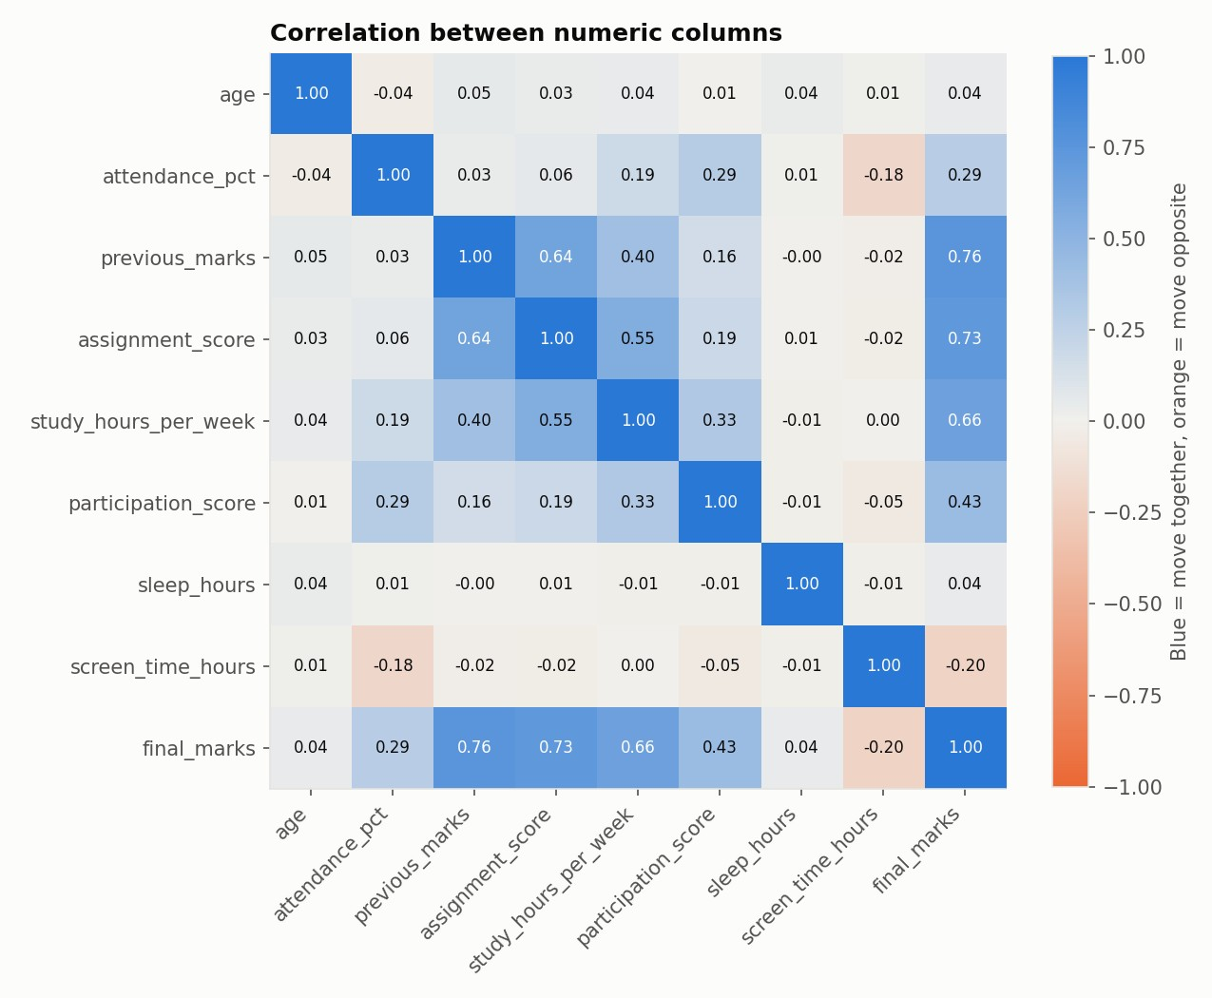
Fig. 4.1: Correlation Heatmap of Numerical Features

4.4.2 Correlation Analysis
The heatmap presents the correlation coefficients among numerical student attributes and final_marks. It helps identify positive and negative associations in the generated dataset. Correlation describes association and does not establish a causal relationship.
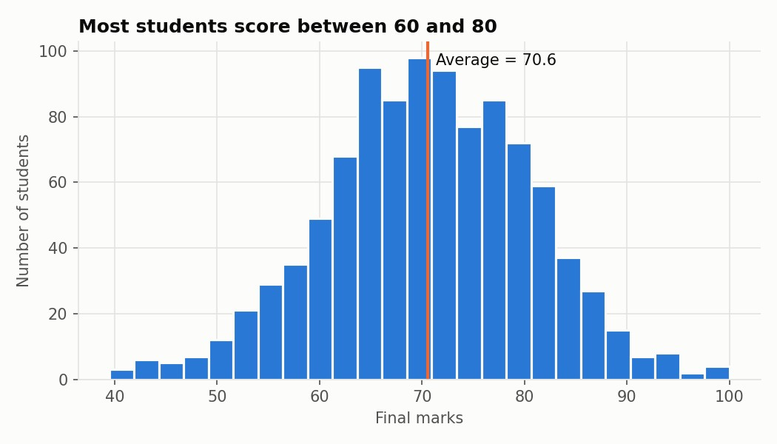
Fig. 4.2: Distribution of Final Marks

4.4.1 Distribution of Final Marks
The histogram displays the frequency distribution of final_marks for the cleaned synthetic dataset. The vertical reference line represents the average final marks. This chart is used to understand the range and spread of the target variable before model training.
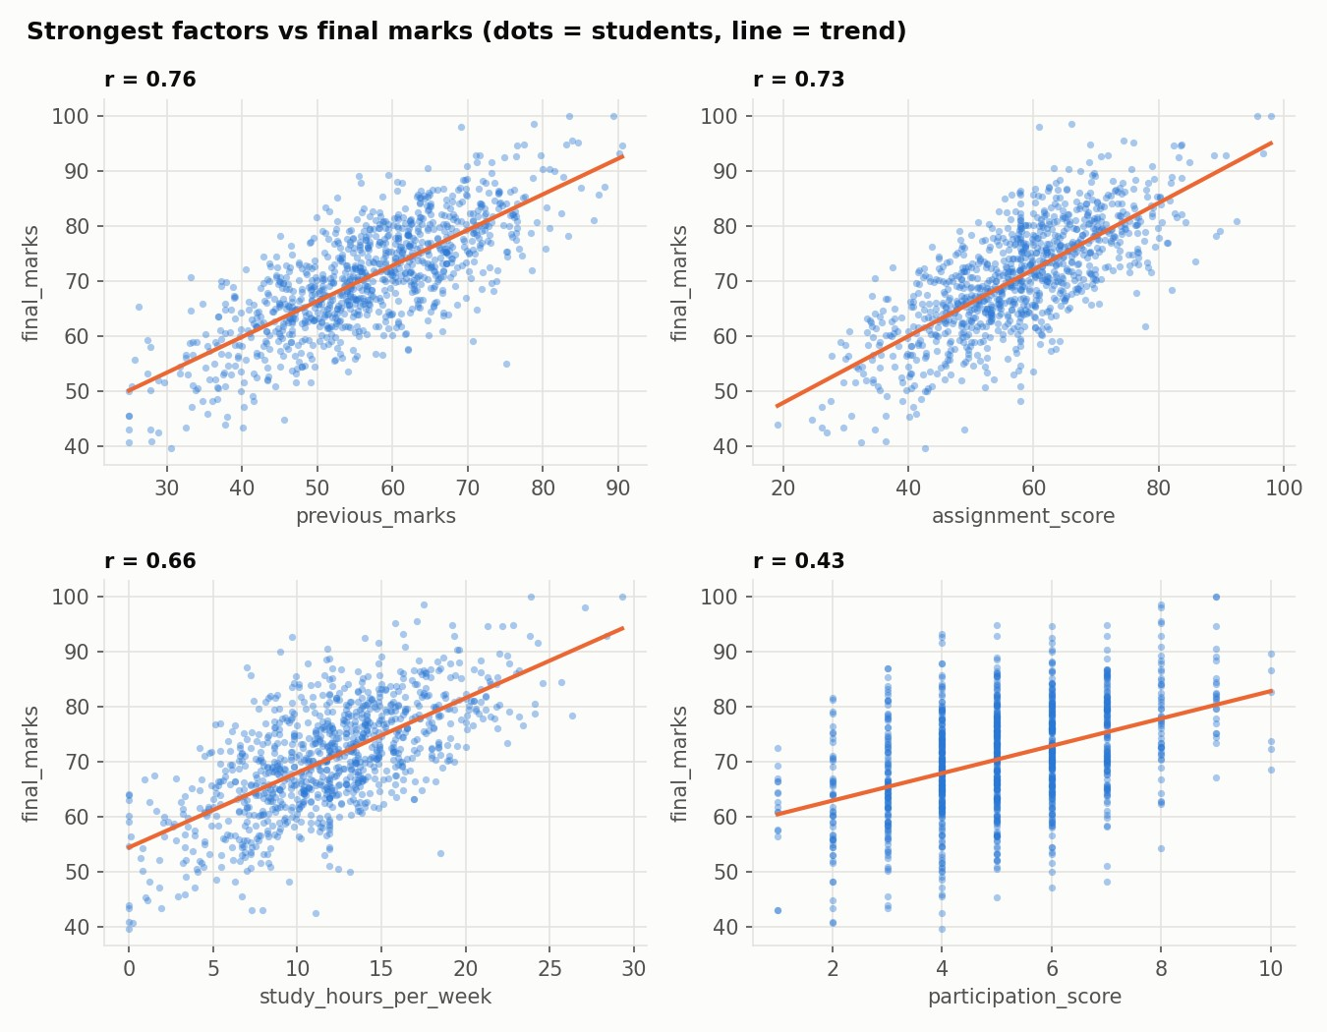
Fig. 4.3: Relationship Between Selected Features and Final Marks

4.4.3 Feature Relationship Analysis
The scatter plots compare the four numerical features with the strongest absolute correlation to final_marks.
Each point represents one generated student record, and the fitted line indicates the overall linear trend.
These visualizations provide a preliminary understanding of the relationships present in the dataset.
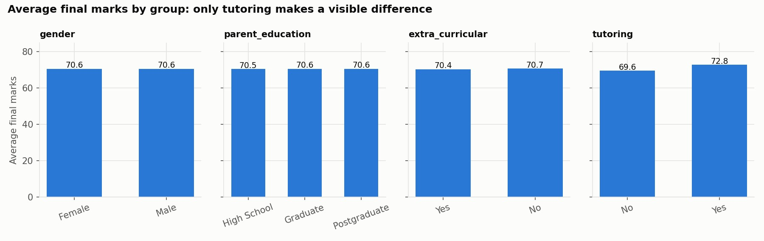
Fig. 4.4: Average Final Marks by Categorical Groups

4.4.4 Categorical Group Analysis
The charts compare the average final marks for gender, parental education, extracurricular participation, and tutoring groups. They help summarize group-level differences in the synthetic dataset. These values should not be generalized to real students without validation on representative data.

4.5 Train-Test Split
After data cleaning and feature preparation, the notebook separates the input variables from the target variable. The categorical columns are converted into indicator variables. The data is divided into 80 percent training records and 20 percent testing records using a fixed random state of 42. In the executed run, 800 records are used for training and 200 records are used for testing.

4.6 Model Building and Evaluation
Three regression algorithms are trained and evaluated using the same training and testing subsets. The models are Linear Regression, Random Forest Regressor, and Gradient Boosting Regressor. Their results are compared using MAE, RMSE, R², and five-fold cross-validation R².
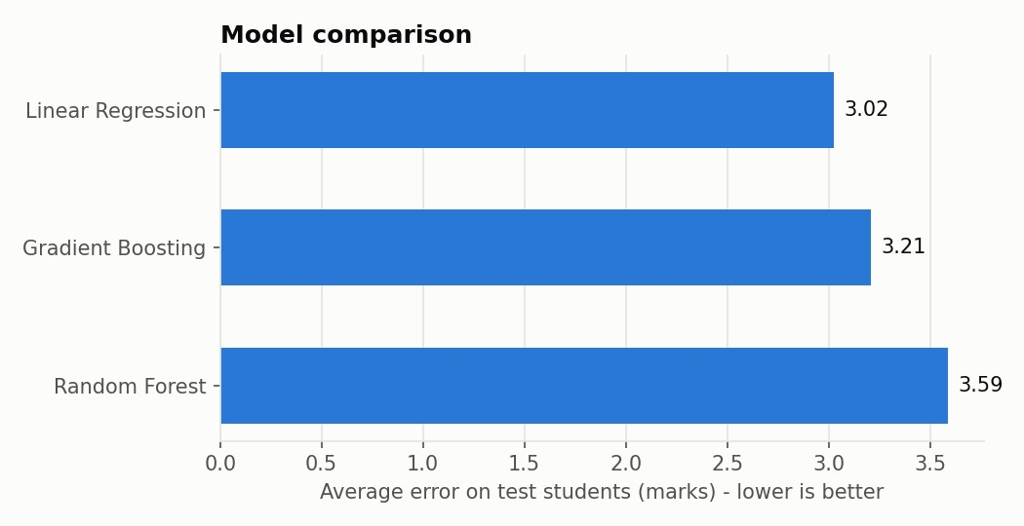
Fig. 4.5: Comparison of Regression Model Performance

4.6.1 Model Comparison Results
Model | MAE | RMSE | R² | CV R² (5-fold)
Linear Regression | 3.025 | 3.705 | 0.851 | 0.866
Random Forest | 3.589 | 4.372 | 0.792 | 0.806
Gradient Boosting | 3.208 | 3.981 | 0.828 | 0.826
In the executed notebook run, Linear Regression achieved the highest test R² score of 0.851 and the lowest MAE of approximately 3.025 marks among the three tested regression models. Its five-fold training cross-validation R² was 0.866. The baseline MAE obtained by always predicting the training-set mean was 7.72 marks. These results describe the generated dataset and are not real-world performance guarantees.
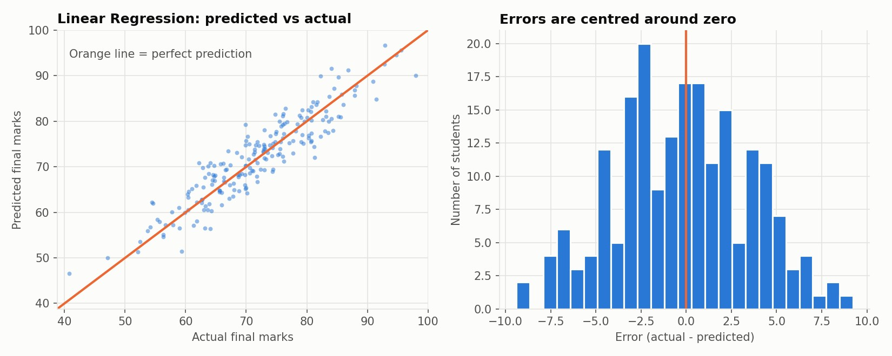
Fig. 4.6: Predicted Versus Actual Marks and Residual Distribution

4.7 Prediction and Visualization
The selected model is used to predict final marks for the test records and for a sample new student. The predicted-versus-actual chart compares the model output with the actual target values. Points closer to the diagonal reference line indicate smaller prediction errors. The residual histogram displays the distribution of actual minus predicted marks.
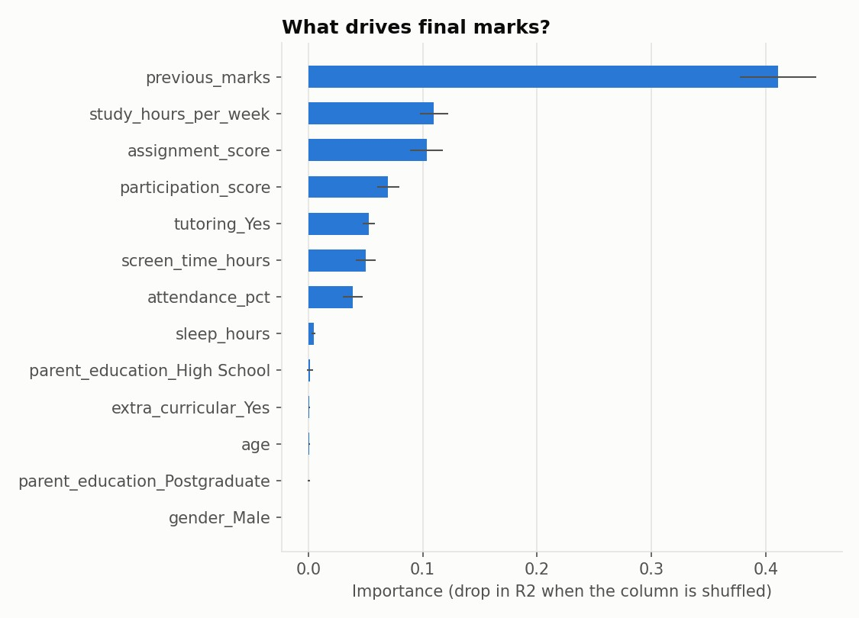
Fig. 4.7: Permutation Feature Importance

4.8 Feature Importance Analysis
Permutation importance measures the reduction in R² when a feature is shuffled. In the executed run, previous_marks has the largest importance value, followed by study_hours_per_week, assignment_score, and participation_score. This indicates that the selected model relies strongly on these variables in the synthetic dataset.
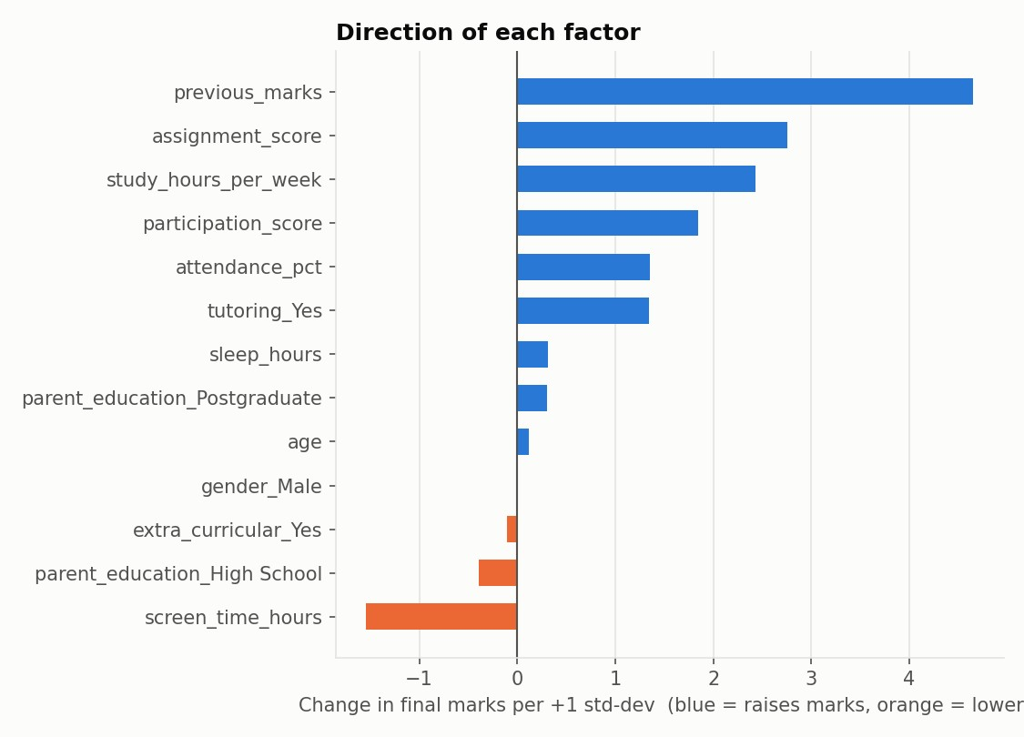
Fig. 4.8: Linear Regression Coefficients

4.8.1 Direction of Feature Relationships
The coefficient chart displays the fitted Linear Regression coefficients after standardization. Positive coefficients indicate a positive fitted relationship with the predicted target, while negative coefficients indicate a negative fitted relationship, holding the other model inputs constant. The coefficients describe the model and should not be interpreted as proof of causal effects.
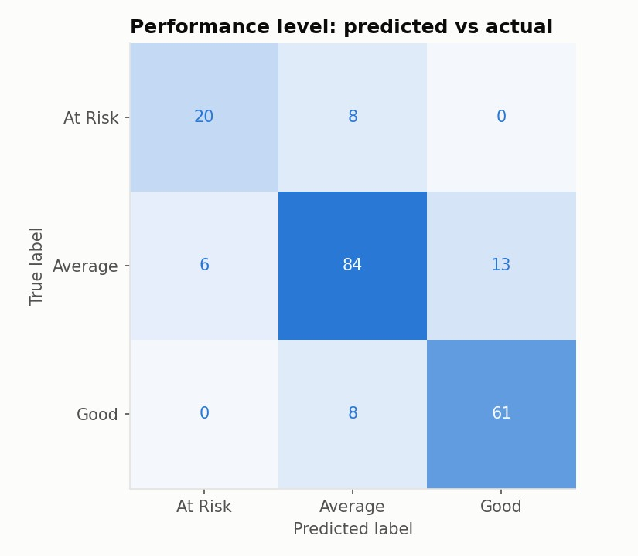
Fig. 4.9: Confusion Matrix for Performance-Level Classification

5. IMPLEMENTATION

5.1 Overview
This chapter describes the implementation of Gradiq – Student Performance Prediction System. The project is implemented as a Python Jupyter Notebook. It includes dataset generation, data cleaning, exploratory data analysis, machine learning model training, model evaluation, classification, and prediction.

5.2 Requirements

5.2.1 Hardware Requirements
- Processor: Intel Core i3 or higher or an equivalent processor.
- RAM: 4 GB minimum; 8 GB recommended.
- Storage: Sufficient available storage for Python packages, datasets, and generated outputs.
- Input/Output Devices: Keyboard, mouse, and monitor.
- Internet Connection: Required when using hosted notebook services or installing packages.

5.2.2 Software Requirements
- Operating System: Windows 10/11 or a compatible operating system.
- Programming Language: Python 3.
- Notebook Environment: Jupyter Notebook, JupyterLab, or Google Colab.
- Data Processing: NumPy and Pandas.
- Machine Learning: Scikit-learn.
- Visualization: Matplotlib.
- Model Saving: Joblib.
5.3 Module Implementation
The notebook is divided into functional sections that work together to complete the machine learning workflow.

Dataset Generation Module
This module creates 1,000 synthetic student records using NumPy. It generates demographic, academic, and behavioural features and calculates final_marks using a predefined formula with random noise. It also inserts missing values, impossible values, and duplicate rows for cleaning practice.

Data Inspection Module
This module loads the raw CSV file and displays the dataset dimensions, missing-value counts, duplicate-row count, attendance values above 100 percent, and study hours above 40 per week.

Data Cleaning and Preprocessing Module
This module removes duplicate rows, converts impossible values into missing values, fills numerical missing values with medians, fills missing parental education with the mode, removes the student_id field, and saves the cleaned CSV file.

Exploratory Data Analysis Module
This module generates a histogram of final marks, a numerical correlation heatmap, scatter plots for the strongest numerical relationships, and bar charts comparing average final marks across categorical groups.

Machine Learning Module
This module prepares the feature matrix and target variable, divides the records into training and testing subsets, and trains Linear Regression, Random Forest Regressor, and Gradient Boosting Regressor. It calculates cross-validation and test-set evaluation metrics.

Feature Importance and Classification Module
This module calculates permutation importance for the selected regression model and displays Linear Regression coefficients. It also creates performance-level labels and trains a Random Forest Classifier to classify records as At Risk, Average, or Good.

Prediction and Model Saving Module
This module saves the selected regression model and its feature-column information using Joblib. It prepares a new student record in the same feature format and generates a predicted final-mark value.

5.4 Execution of the Project
The project can be executed in a local Python environment or a compatible hosted notebook service. The notebook should be opened in Jupyter Notebook, JupyterLab, or Google Colab. Required libraries must be installed before execution.
The notebook is executed from the first cell to the last cell using the Run All option. The dataset-generation cell creates the data folder and raw CSV file. Subsequent cells perform setup, inspection, cleaning, EDA, train-test split, model training, evaluation, classification, and model saving.
The notebook creates data/, outputs/, and models/ directories. The raw and cleaned CSV files are stored in the data folder. Charts, model comparison metrics, feature importance values, and execution logs are stored in the outputs folder. The selected model is stored in the models folder.

5.5 Output
The following outputs were generated by executing the supplied notebook successfully. The figures and metrics included in this report are from that execution run.

5.5.1 Dataset Output
The raw dataset is saved as data/student_performance_raw.csv. After duplicate removal, invalid-value handling, missing-value imputation, and removal of student_id, the cleaned dataset is saved as data/student_performance_clean.csv.

5.5.2 Model Evaluation Output
The model comparison output is saved as outputs/model_comparison.csv. The executed run reports Linear Regression as the best model according to the test R² selection rule. The selected model is saved as models/best_model.joblib.

5.5.3 Feature Importance Output
The permutation importance values are saved as outputs/feature_importance.csv. The chart displays the relative decrease in R² when each feature is shuffled. The result helps explain which variables the selected model relies on most heavily.

5.5.4 Classification Output
The classification module reports an accuracy of 0.825 and a macro F1 score of 0.807 in the executed run.
The classification report and confusion matrix provide details of the performance of the At Risk, Average, and Good categories.

5.5.5 New Student Prediction
The notebook demonstrates prediction for a new student with attendance of 85 percent, previous marks of 72, assignment score of 75, 14 study hours per week, and participation score of 7 out of 10, together with the remaining required features. In the executed run, the selected Linear Regression model predicts 84.8 final marks, corresponding to the Good category under the project's demonstration thresholds.

5.6 Summary
This chapter described the notebook implementation, hardware and software requirements, functional modules, execution procedure, and generated outputs. The implementation demonstrates the complete workflow from synthetic data generation to model evaluation and prediction.

6. TESTING AND DEBUGGING

6.1 Overview
Testing is an important phase of software and machine learning development. It helps verify that each stage of the notebook performs the expected operation and that the complete workflow executes without errors. Debugging is used to identify and correct problems in code, data handling, model preparation, and file operations.
In Gradiq, testing focuses on dataset generation, data inspection, data cleaning, exploratory analysis, feature preparation, model training, evaluation, classification, model saving, and prediction. The notebook was executed from beginning to end in a Python notebook environment to generate the outputs reported in this document.

6.2 Testing Approach
The testing approach checks the output of each notebook stage. The raw dataset is examined to confirm that missing values, duplicate rows, and invalid values are detected. The cleaning stage is checked to confirm that duplicates are removed and missing values are handled. Model training and prediction stages are checked by verifying that evaluation metrics and a numerical prediction are produced.

6.3 Types of Testing

6.3.1 Unit Testing
Unit testing checks individual sections of the notebook separately. The dataset-generation section is checked for creation of the raw CSV file. The inspection section is checked for correct reporting of missing and duplicate values. The cleaning section is checked for duplicate removal, invalid-value handling, and missing-value imputation. The modelling section is checked for successful model fitting and metric calculation.

6.3.2 Integration Testing
Integration testing checks whether the output of one notebook stage is correctly used by the next stage. The raw CSV generated by the data-generation section is loaded by the inspection section. The cleaned dataset is passed to the EDA and feature preparation sections. The feature matrix and target variable are then passed to the train-test split and model-training sections. Finally, the selected model and feature-column information are used by the prediction section.

6.3.3 System Testing
System testing evaluates the complete notebook workflow. The notebook is executed from the first cell to the last cell to verify that dataset generation, data cleaning, EDA, model training, evaluation, feature importance, classification, model saving, and sample prediction are completed in the correct sequence.

6.3.4 Validation Testing
Validation testing checks whether the notebook handles the deliberately introduced data-quality issues. Attendance values greater than 100 percent and study hours greater than 40 per week are treated as invalid. Missing numerical values are filled using medians, and missing parental education values are filled using the mode. The resulting dataset is checked for remaining missing values.

6.4 Debugging
Debugging was considered during notebook execution to identify errors in data generation, file paths, data transformations, model fitting, and prediction.

Data and File Handling
The notebook creates the data, outputs, and models folders before saving generated files. The data-generation cell is executed before loading the raw CSV file so that the required input file is available.

Model Input Preparation
Categorical features are converted into numerical indicator columns using get_dummies(). During new-student prediction, the input record is converted in the same way and reindexed to match the feature columns stored during model training. This avoids a mismatch in the number or order of model input columns.

Model Evaluation
All regression algorithms are evaluated using the same train-test split. Five-fold cross-validation is performed on the training subset. The metrics are calculated using the actual and predicted test values. The model comparison results are stored in a CSV file.

6.5 Test Results
The supplied notebook was executed successfully from beginning to end. The following table summarizes the principal outputs observed in the executed run.
Test Area | Observed Result | Status
Dataset generation | Raw CSV created with 1,008 rows including 8 duplicate rows. | Completed
Data inspection | Missing values, duplicates and impossible values identified. | Completed
Data cleaning | Duplicates removed; invalid values and missing values handled. | Completed
Clean dataset | 1,000 cleaned records saved. | Completed
EDA visualizations | Distribution, heatmap, scatter and group charts generated. | Completed
Train-test split | 800 training records and 200 testing records. | Completed
Regression models | Three regression models trained successfully. | Completed
Model evaluation | MAE, RMSE, R² and cross-validation R² generated. | Completed
Feature importance | Permutation importance and coefficient charts generated. | Completed
Classification | Accuracy 0.825 and macro F1 0.807 generated. | Completed
Model saving | best_model.joblib saved successfully. | Completed
New student prediction | Predicted final marks: 84.8; level: Good. | Completed

6.6 Summary
This chapter discussed the testing and debugging of the Gradiq machine learning notebook. Unit testing, integration testing, system testing, and validation testing were considered for the different stages of the workflow. The notebook was executed successfully and generated the expected datasets, charts, evaluation results, model file, and sample prediction.
The current results are based on synthetic data. Further testing using genuine, properly authorized student records is necessary before the model can be considered for real academic use. Preprocessing should also be improved by fitting imputation and encoding steps only on the training data to avoid data leakage.

7. CONCLUSION
- The main objective of this project was to develop Gradiq – Student Performance Prediction System, amachine learning workflow that estimates student final marks using academic, behavioural, and study-related attributes. The project demonstrates how a structured dataset can be processed and analysed to understand patterns associated with academic performance.
- The notebook generates 1,000 initial synthetic student records containing attributes such as attendance,previous marks, assignment score, study hours, participation, sleep hours, screen time, parental education, extracurricular participation, and tutoring. It deliberately introduces missing values, duplicate records, and impossible values to demonstrate data inspection and preprocessing.
- The data-cleaning stage removes duplicate records, handles invalid attendance and study-hour values, fillsmissing numerical values with medians, fills missing parental education with the mode, and removes the student identifier from the model features. Exploratory data analysis is then performed using a histogram, correlation heatmap, scatter plots, and categorical group comparisons.
- Three regression algorithms—Linear Regression, Random Forest Regressor, and Gradient BoostingRegressor—are trained and compared. In the executed notebook run, Linear Regression achieved a test R² score of 0.851, MAE of 3.025, RMSE of 3.705, and five-fold training cross-validation R² of 0.866.
- The notebook also performs permutation importance analysis and a separate classification task that groupsstudents into At Risk, Average, and Good categories. The executed classification run achieved an accuracy of 0.825 and macro F1 score of 0.807.
- The selected regression model is saved using Joblib and used to generate a sample prediction. In theexecuted run, the sample student received a predicted final mark of 84.8, corresponding to the Good category under the defined project thresholds.
- The project is an academic demonstration based on synthetic data. Its evaluation results do not establishaccuracy on real student records. Genuine and representative academic data, improved leakage-safe preprocessing, independent validation, and responsible data governance are required before real-world use.

8. FUTURE ENHANCEMENT

8.1 Overview
Gradiq demonstrates a complete machine learning workflow for student performance prediction using a synthetic dataset. Several improvements can be introduced in future versions to increase the reliability, usefulness, and practical relevance of the project.

8.2 Proposed Enhancements
Use of Genuine Academic Datasets: Future work can use genuine, representative, properly authorized, and anonymized academic records. Real data can help evaluate whether the patterns learned by the model are relevant to actual students.
Improved Data Preprocessing: Missing-value imputation and categorical encoding can be included inside a Scikit-learn Pipeline. The preprocessing steps should be fitted only on the training data to prevent data leakage.
Improved Model Validation: Cross-validation can be used for model selection, while a separate untouched test dataset can be retained for final evaluation. Repeated or nested cross-validation may also be considered where appropriate.
Additional Machine Learning Algorithms: Further regression methods such as Support Vector Regression, Extra Trees Regressor, and other suitable ensemble models can be evaluated and compared with the existing algorithms.
Prediction Uncertainty: Future versions may provide an estimated range or confidence interval along with the predicted marks, helping users understand that a model output is not an exact result.
Explainable Machine Learning: Techniques such as SHAP or other suitable explanation methods can be explored to provide additional information about the factors influencing a prediction. Such explanations should not be interpreted as proof of cause and effect.
Performance Recommendations: A future version may provide general study-support suggestions based on academic patterns, such as reviewing weak subject areas, improving assignment completion, or seeking academic guidance. Recommendations should be reviewed by educators.
Web Application Integration: The saved model may be integrated into a separately developed web application through a secure backend API. The API should validate input data and use the same feature structure as the trained model.
Privacy and Security: If real student records are used, access controls, data minimization, secure storage, consent, and appropriate institutional approval should be implemented.
Model Monitoring: Future work may monitor changes in input data and prediction errors over time. Retraining should be performed only when new data has been validated and appropriate evaluation has been completed.

8.3 Summary
The proposed future enhancements can improve the reliability and practical usefulness of Gradiq. The most important priorities are using genuine and representative academic data, improving preprocessing and validation, communicating prediction uncertainty, and protecting student information. These improvements can help develop the project further while ensuring that machine learning predictions remain a support tool rather than a replacement for academic judgment.

9. REFERENCES
Al-Barrak, M. A., & Al-Razgan, M. (2016). Predicting students final GPA using decision trees: A case study.
International Journal of Information and Education Technology, 6(7), 528–533. https://doi.org/10.7763/IJIET.2016.V6.745
Cortez, P., & Silva, A. M. G. (2008). Using data mining to predict secondary school student performance. In Proceedings of the 5th Future Business Technology Conference (pp. 5–12).
Hussain, S., Dahan, N. A., Ba-Alwib, F. M., & Ribata, N. (2018). Educational data mining and analysis of students' academic performance using WEKA. Indonesian Journal of Electrical Engineering and Computer
Science, 9(2), 447–459. https://doi.org/10.11591/ijeecs.v9.i2.pp447-459
Kotsiantis, S. B., Pierrakeas, C. J., & Pintelas, P. (2004). Predicting students' dropout-prone using machine learning techniques. Journal of Computer Assisted Learning, 20(5), 374–383. https://doi.org/10.1111/j.1365-2729.2004.00098.x
McKinney, W. (2010). Data structures for statistical computing in Python. In S. van der Walt & J. Millman
(Eds.), Proceedings of the 9th Python in Science Conference (pp. 56–61). https://doi.org/10.25080/Majora-92bf1922-00a
NumPy. (n.d.). NumPy documentation. https://numpy.org/doc/
Romero, C., & Ventura, S. (2010). Educational data mining: A review of the state of the art. IEEE Transactions on Systems, Man, and Cybernetics, Part C (Applications and Reviews), 40(6), 601–618. https://doi.org/10.1109/TSMCC.2010.2053532
Scikit-learn developers. (n.d.). Scikit-learn documentation. https://scikit-learn.org/stable/
The pandas development team. (n.d.). pandas documentation. https://pandas.pydata.org/docs/
Matplotlib Development Team. (n.d.). Matplotlib documentation. https://matplotlib.org/stable/
Joblib developers. (n.d.). Joblib documentation. https://joblib.readthedocs.io/
Python Software Foundation. (n.d.). Python documentation. https://docs.python.org/3/
— END OF REPORT —

