DevLake– Architecture Overview
This document describes the architecture of the DevLake setup deployed on the VM. It explains each component, how data flows from the source tools (GitHub, Jenkins, and Argo CD) into the MySQL database, and how the existing Grafana is used to visualize this data.

Architecture
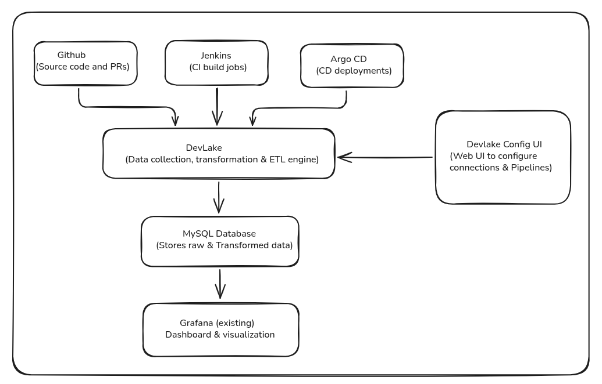

Components
DevLake (Core Engine)
DevLake is a free, open-source tool that helps teams collect and analyze data about their software development process. It connects to tools like GitHub, Jenkins, and Argo CD, pulls data from them, and stores it in an organized format that can be used for reporting and dashboards.
In this setup, DevLake collects data from three sources: GitHub, Jenkins, and Argo CD. It runs as a background service in a container.
DevLake Config UI
The DevLake Config UI is the web-based interface used to set up and manage DevLake. It is used to:
create connections to GitHub, jenkins, and Argo CD (with API tokens / webhook credentials) define the data scope (which repositories, jobs, and applications to collect data for).
MySQL Database
MySQL is used as the central storage layer for DevLake. All data collected from GitHub, Jenkins, and Argo CD – both in its raw form and after DevLake’s transformation step – is stored in this database. MySQL is the required backend for DevLake & provides a structured, queryable schema that Grafana can connect to directly using SQL.
Grafana (Existing )
Grafana is used as the visualization layer. Rather than running a separate Grafana instance for this setup, we use the existing Grafana . A MySQL data source is added in Grafana, pointing to the DevLake MySQL database described above. Dashboards built in Grafana run SQL queries directly against this database to display metrics such as build success rates, deployment frequency, lead time, pull request statistics, and more.

Data Sources
DevLake is currently configured to collect data from the following three sources:
Source | Data collected
GitHub | Repositories, commits, pull requests, reviews, issues, and contributor activity.
Jenkins | CI build jobs, build status, build duration, and pipeline run history.
Argo CD | CD deployment events (success/failure, commit deployed, start and end time) sent via a webhook configured in Argo CD’s notification system.

4. Data Flow
- GitHub and Jenkins: DevLake connects to their APIs (using configured tokens) and periodically pulls data on a schedule .
- Argo CD: instead of DevLake pulling data, Argo CD pushes deployment events to DevLake in real time via a webhook .
- All collected data – from all three sources – is processed and stored in the MySQL database.
- Grafana (existing) connects to this MySQL database as a data source and runs SQL queries to populate dashboard panels.

