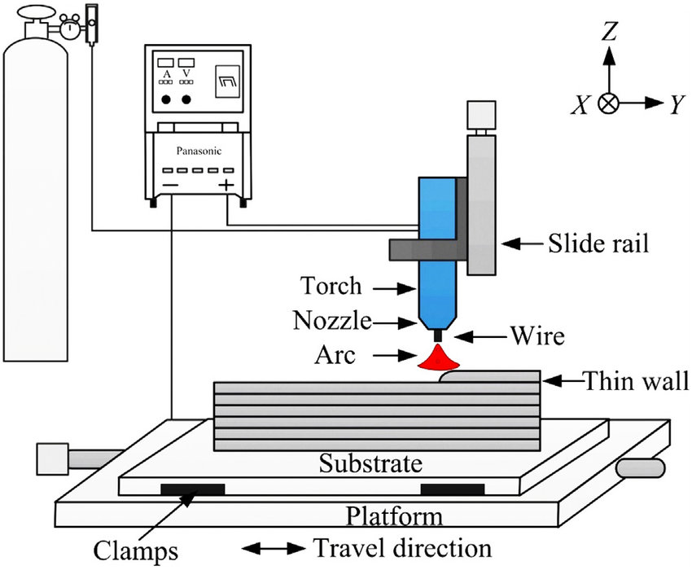

**Figure 1**: Schematic diagram of wire arc additive manufacturing

Collected Data set of Surface Roughness at three different process parameters

|  |  |  |  |  |
| --- | --- | --- | --- | --- |
| **Ex. No** | **WFR(m/min)** | **TS(mm/sec)** | **CTWD(mm)** | **SR(mm)** |
| **1** | 8 | 2.5 | 8 | 0.117402 |
| **2** | 9 | 2.5 | 8 | 0.140716 |
| **3** | 10 | 2.5 | 8 | 0.1398 |
| **4** | 8 | 3 | 8 | 0.101772 |
| **5** | 9 | 3 | 8 | 0.125086 |
| **6** | 10 | 3 | 8 | 0.1273 |
| **7** | 8 | 3.5 | 8 | 0.086142 |
| **8** | 9 | 3.5 | 8 | 0.109456 |
| **9** | 10 | 3.5 | 8 | 0.1148 |
| **10** | 8 | 4 | 8 | 0.070512 |
| **11** | 9 | 4 | 8 | 0.093826 |
| **12** | 10 | 4 | 8 | 0.1023 |
| **13** | 8 | 4.5 | 8 | 0.119846 |
| **14** | 9 | 4.5 | 8 | 0.144076 |
| **15** | 10 | 4.5 | 8 | 0.155254 |
| **16** | 8 | 5 | 8 | 0.11062 |
| **17** | 9 | 5 | 8 | 0.13485 |
| **18** | 10 | 5 | 8 | 0.148523 |
| **19** | 8 | 2.5 | 10 | 0.119662 |
| **20** | 9 | 2.5 | 10 | 0.142976 |
| **21** | 10 | 2.5 | 10 | 0.142875 |
| **22** | 8 | 3 | 10 | 0.104032 |
| **23** | 9 | 3 | 10 | 0.127346 |
| **24** | 10 | 3 | 10 | 0.130375 |
| **25** | 8 | 3.5 | 10 | 0.088402 |
| **26** | 9 | 3.5 | 10 | 0.111716 |
| **27** | 10 | 3.5 | 10 | 0.117875 |
| **28** | 8 | 4 | 10 | 0.131332 |
| **29** | 9 | 4 | 10 | 0.096086 |
| **30** | 10 | 4 | 10 | 0.105375 |
| **31** | 8 | 4.5 | 10 | 0.122106 |
| **32** | 9 | 4.5 | 10 | 0.146336 |
| **33** | 10 | 4.5 | 10 | 0.10377 |
| **34** | 8 | 5 | 10 | 0.11288 |
| **35** | 9 | 5 | 10 | 0.13711 |
| **36** | 10 | 5 | 10 | 0.16134 |
| **37** | 8 | 2.5 | 12 | 0.121922 |
| **38** | 9 | 2.5 | 12 | 0.145236 |
| **39** | 10 | 2.5 | 12 | 0.14595 |
| **40** | 8 | 3 | 12 | 0.106292 |
| **41** | 9 | 3 | 12 | 0.129606 |
| **42** | 10 | 3 | 12 | 0.13345 |
| **43** | 8 | 3.5 | 12 | 0.090662 |
| **44** | 9 | 3.5 | 12 | 0.113976 |
| **45** | 10 | 3.5 | 12 | 0.12095 |
| **46** | 8 | 4 | 12 | 0.075032 |
| **47** | 9 | 4 | 12 | 0.098346 |
| **48** | 10 | 4 | 12 | 0.10845 |
| **49** | 8 | 4.5 | 12 | 0.124366 |
| **50** | 9 | 4.5 | 12 | 0.148596 |
| **51** | 10 | 4.5 | 12 | 0.142826 |
| **52** | 8 | 5 | 12 | 0.11514 |
| **53** | 9 | 5 | 12 | 0.13937 |
| **54** | 10 | 5 | 12 | 0.1336 |
| **55** | 8 | 2.5 | 14 | 0.124182 |
| **56** | 9 | 2.5 | 14 | 0.147496 |
| **57** | 10 | 2.5 | 14 | 0.14472 |
| **58** | 8 | 3 | 14 | 0.108552 |
| **59** | 9 | 3 | 14 | 0.131866 |
| **60** | 10 | 3 | 14 | 0.13222 |
| **61** | 8 | 3.5 | 14 | 0.092922 |
| **62** | 9 | 3.5 | 14 | 0.116236 |
| **63** | 10 | 3.5 | 14 | 0.11972 |
| **64** | 8 | 4 | 14 | 0.077292 |
| **65** | 9 | 4 | 14 | 0.100606 |
| **66** | 10 | 4 | 14 | 0.154312 |
| **67** | 8 | 4.5 | 14 | 0.126626 |
| **68** | 9 | 4.5 | 14 | 0.150856 |
| **69** | 10 | 4.5 | 14 | 0.145086 |
| **70** | 8 | 5 | 14 | 0.1174 |
| **71** | 9 | 5 | 14 | 0.14163 |
| 72 | 10 | 5 | 14 | 0.13586 |

Table 3: Expressions for three performance metrics

|  |  |  |
| --- | --- | --- |
| Sl.No | Performance metrics | Expressions |
| 1 | Mean absolute error (MAE) |  |
| 2 | Mean square error (MSE) |  |
| 3 | Coefficient of determination |  |

This section not only quantifies the predictive accuracy of each model but also analyzes their operational robustness under various scenarios within WAAM, providing a detailed comparative analysis that highlights the strengths and limitations of each approach. The outcomes of this assessment are critical, demonstrating the feasibility and efficiency of applying advanced machine learning techniques to enhance quality control and operational efficacy in industrial manufacturing settings. The performance metrics and hyperparameter tuning collectively contribute to refining the predictive models, ensuring they are robust and reliable for practical deployment in manufacturing processes.

3.6 Hyperparameter Optimization

We emphasize the importance of parameter optimization that is crucial in boosting the performance of every model, which makes predicting the surface roughness in WAAM possible. The customer problems and pain points should be properly diagnosed as to allow for a viable product design through the said problem analysis. The fundamental method is grid search, randomized search, as well as advanced methods like Bayesian optimization, which are important for Life analysis of a given model including Linear Regression, Random Forest, Decision Tree, ANN, Gradient Boosting, XGBoost, Ridge Regression, Lasso Regression

Tuning is very much an important articulation element in achieving optimal fitness, accuracy, and against the danger of overfitting and underfitting, thus, keeping the models robust. While the process is often resource-consuming, it is also undeniably important that the hyperparameter optimization is iteratively carried out with the model to ensure that it is capable of handling the complex new data and at the same remain performance improvement enhanced efficiency. The models have better prediction power and broaden the domain continuum where these models are used in different manufacturing facilities. Therefore, machine learning in this context is not only a feasible but also an indispensable technology.

Chapter 4

# Results and Discussion

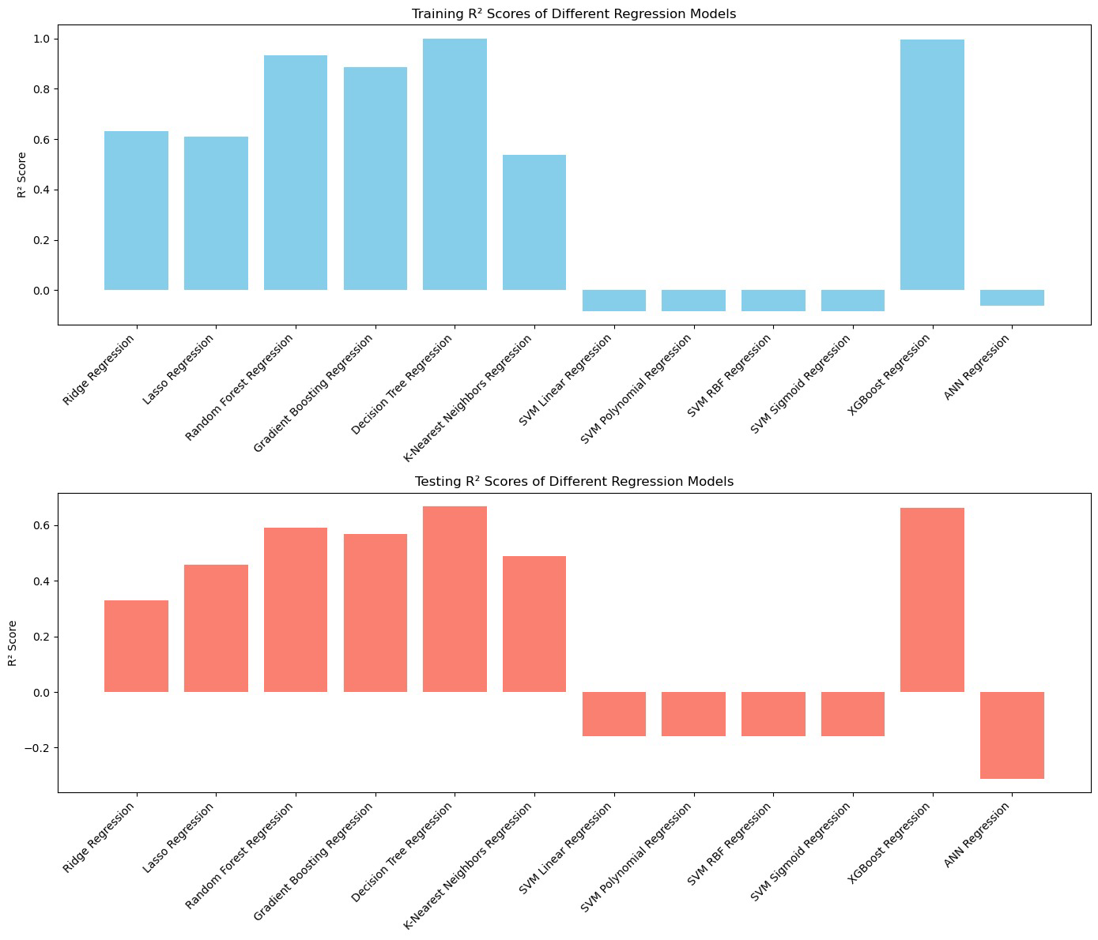

**Figure 6.** Comparison of R2 scores in training and testing for Different Regression Models

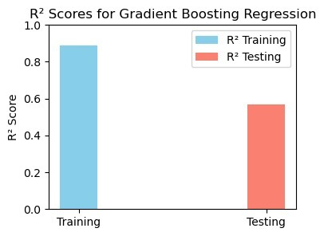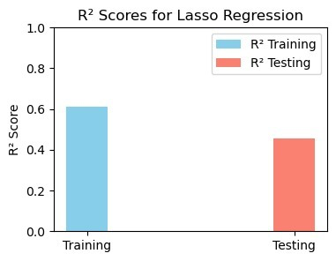

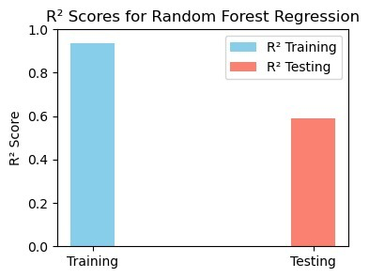

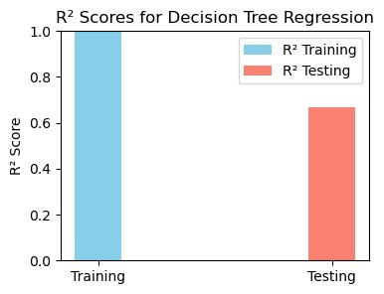 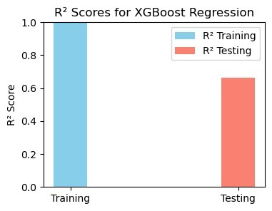

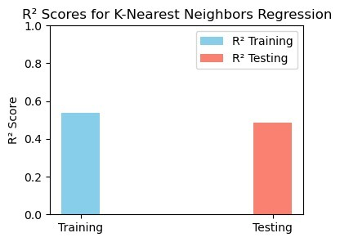

Figure 7: Comparison of R2 scores for both testing and training data of Lasso Regression, Gradient Boosting, Random Forest, XGBoost, KNN, and Decision Tree

## 4.2 Surface roughness Prediction

The To accurately predict the target values, minimizing the error or deviation from the actual values is essential. Hyperparameter tuning played a key role in optimizing the model's performance, as reflected by the R2 score. Additionally, performance metrics such as MSE and MAE were utilized to measure the errors in each machine-learning model.

A total of 58 datasets were utilized for training the proposed ML models, while 14 datasets were reserved for testing. Table 4,5,6 presents both the experimental and predicted values of surface roughness for the testing dataset, using Linear Regression, Decision Tree, Random Forest, ANN, Gradient Boosting, XGBoost, Ridge Regression, Lasso Regression, KNN, SVM(Linear Kernal),SVM(Polynomial),SVM(RBF) and SVM(Sigmoid).

Table 4: Experimental and Predicted Surface Roughness using XGBoost, Random Forest and Decision Tree Regression

|  |  |  |  |  |
| --- | --- | --- | --- | --- |
| **SN** | **Experimental SR values** | **Predicted SR value (XGBoost Regression)** | **Predicted SR value (Random Forest Regression)** | **Predicted SR value (Decision Tree Regression)** |
| 1 | 0.131866 | 0.1291 | 0.1283 | 0.1292 |
| 2 | 0.13222 | 0.1307 | 0.1294 | 0.1292 |
| 3 | 0.092922 | 0.095 | 0.094 | 0.0957 |
| 4 | 0.116236 | 0.1152 | 0.1134 | 0.1069 |
| 5 | 0.11972 | 0.1171 | 0.1141 | 0.1069 |
| 6 | 0.077292 | 0.0909 | 0.0977 | 0.0957 |
| 7 | 0.100606 | 0.1065 | 0.1048 | 0.1069 |
| 8 | 0.154312 | 0.1095 | 0.1062 | 0.1069 |
| 9 | 0.126626 | 0.1184 | 0.1105 | 0.1152 |
| 10 | 0.150856 | 0.1429 | 0.1374 | 0.1417 |
| 11 | 0.145086 | 0.1302 | 0.1362 | 0.1417 |
| 12 | 0.1174 | 0.1143 | 0.1132 | 0.1152 |
| 13 | 0.14163 | 0.1384 | 0.1423 | 0.1417 |
| 14 | 0.13586 | 0.1384 | 0.1427 | 0.1417 |

Table 5: Experimental and predicted surface Roughness using Gradient Boosting, KNN, Lasso Regression

|  |  |  |  |  |
| --- | --- | --- | --- | --- |
| **SN** | **Ex. No Experimental SR values** | **Predicted SR value (Gradient Boosting Regression)** | **Predicted SR value (K-Nearest Neighbors Regression)** | **Predicted SR value (Lasso Regression)** |
| 1 | 0.131866 | 0.1278 | 0.1319 | 0.1212 |
| 2 | 0.13222 | 0.1282 | 0.1385 | 0.1212 |
| 3 | 0.092922 | 0.1008 | 0.1023 | 0.1212 |
| 4 | 0.116236 | 0.1123 | 0.1289 | 0.1212 |
| 5 | 0.11972 | 0.1128 | 0.1343 | 0.1212 |
| 6 | 0.077292 | 0.1008 | 0.0974 | 0.1212 |
| 7 | 0.100606 | 0.108 | 0.117 | 0.1212 |
| 8 | 0.154312 | 0.1085 | 0.1316 | 0.1212 |
| 9 | 0.126626 | 0.1116 | 0.1061 | 0.1212 |
| 10 | 0.150856 | 0.1377 | 0.1256 | 0.1212 |
| 11 | 0.145086 | 0.1377 | 0.1302 | 0.1212 |
| 12 | 0.1174 | 0.1116 | 0.1091 | 0.1212 |
| 13 | 0.14163 | 0.1374 | 0.1262 | 0.1212 |
| 14 | 0.13586 | 0.1381 | 0.1375 | 0.1212 |

Table 6: Experimental and predicted Surface Roughness values using Ridge Regression, SVM, and ANN Regression

|  |  |  |  |  |
| --- | --- | --- | --- | --- |
| **SN** | **Ex. No Experimental SR values** | **Predicted SR value (Ridge Regression)** | **Predicted SR value (SVM Regression)** | **Predicted SR value (ANN Regression)** |
| 1 | 0.131866 | 0.1271 | 0.1159 | 0.0886 |
| 2 | 0.13222 | 0.138 | 0.1159 | 0.1186 |
| 3 | 0.092922 | 0.1158 | 0.1159 | 0.1411 |
| 4 | 0.116236 | 0.1266 | 0.1159 | 0.1307 |
| 5 | 0.11972 | 0.1375 | 0.1159 | 0.1621 |
| 6 | 0.077292 | 0.1153 | 0.1159 | 0.1647 |
| 7 | 0.100606 | 0.1262 | 0.1159 | 0.1638 |
| 8 | 0.154312 | 0.1371 | 0.1159 | 0.1989 |
| 9 | 0.126626 | 0.1148 | 0.1159 | 0.1752 |
| 10 | 0.150856 | 0.1257 | 0.1159 | 0.1855 |
| 11 | 0.145086 | 0.1366 | 0.1159 | 0.2268 |
| 12 | 0.1174 | 0.1144 | 0.1159 | 0.1716 |
| 13 | 0.14163 | 0.1253 | 0.1159 | 0.1944 |
| 14 | 0.13586 | 0.1361 | 0.1159 | 0.2444 |

Figure 8-19 shows the comparison of the actual and predicted values respectively. For training, the lowest value of MSE is found to be 0 using the decision tree regression and XGBoost model followed by gradient boosting and random forest with 0.00001 and 0.00002. For training, the highest value of MSE was found to be 0.00225 for ANN. The MSE values for remaining models like Linear regression are found to be 0.00015, Ridge Regression is found to be 0.00025, Lasso Regression is found to be 0.00041, and KNN is found to be 0.00014. All SVM models like linear, polynomial, RBF, and Sigmoid have the same MSE value for training which is 0.00045. For testing, the lowest value of MSE was found to be in KNN with 0.00016 followed by XGBoost, Random Forest, and Decision Tree with 0.00017,0.00018, and 0.00018 respectively. For testing, the MSE values for different models are as follows for linear regression with 0.00031, ANN with 0.01522, Gradient boosting with 0.00019, Ridge regression with 0.00029, Lasso Regression with 0.00047 and all SVM models having the same MSE testing value of 0.00054 similar to the MSE training in SVM models.

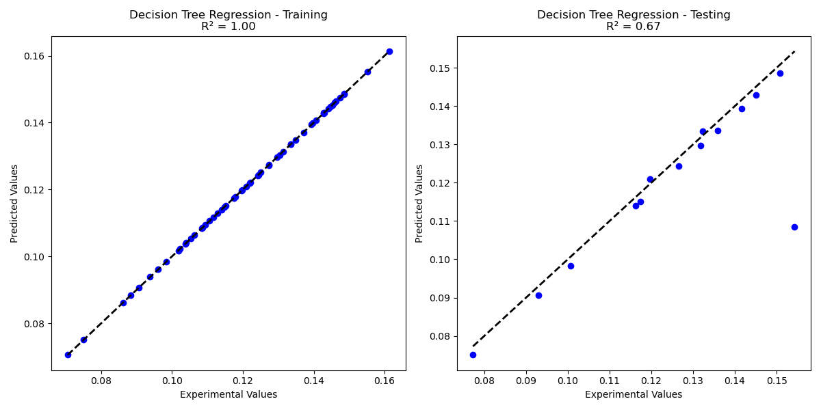

Figure 8. Experimental vs Predicted Values for Training and Testing Dataset in Decision Tree Regression

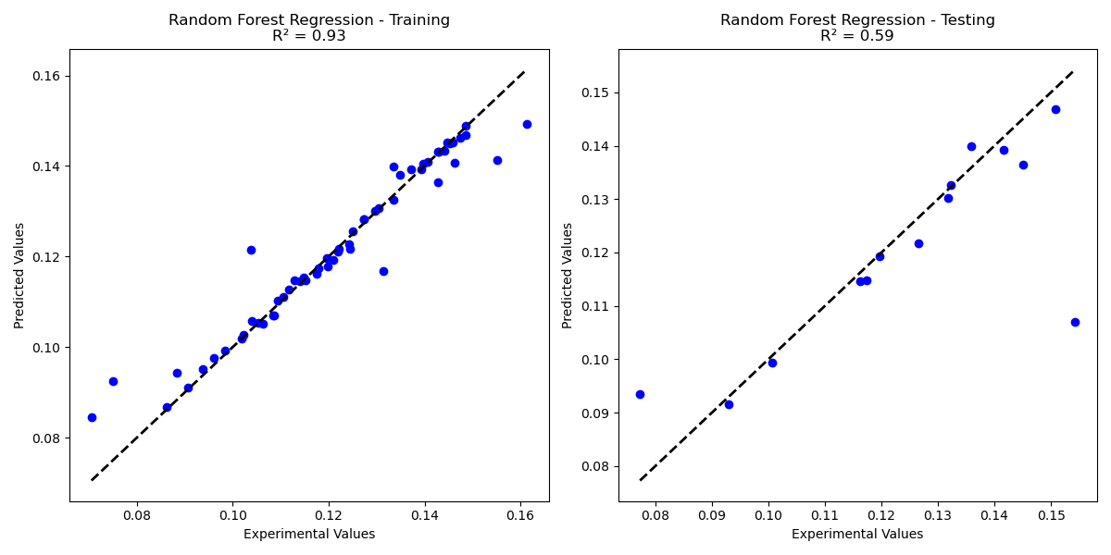

Figure 9. Experimental vs Predicted Values for Training and Testing Dataset in Random Forest Regression

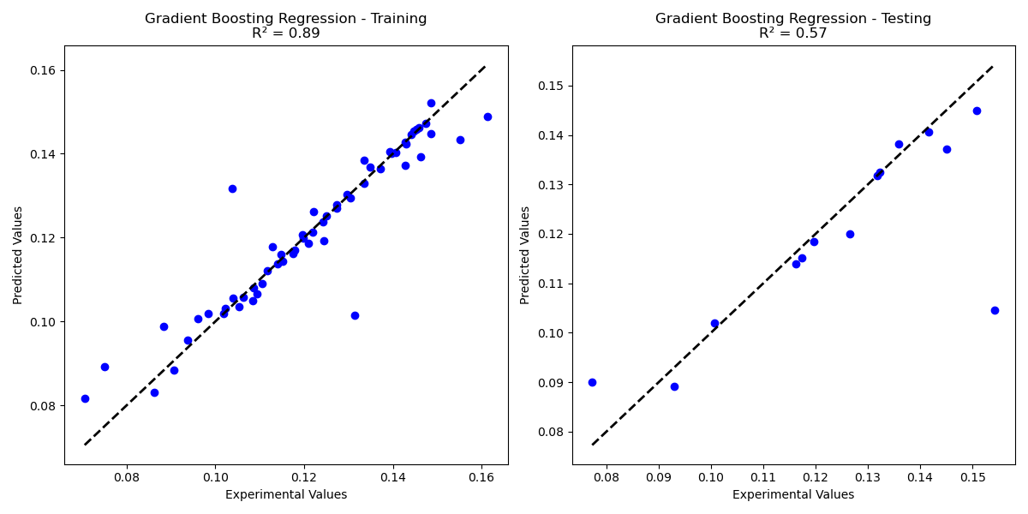

Figure 10. Experimental vs Predicted Values for Training and Testing Dataset in Gradient Boosting Regression

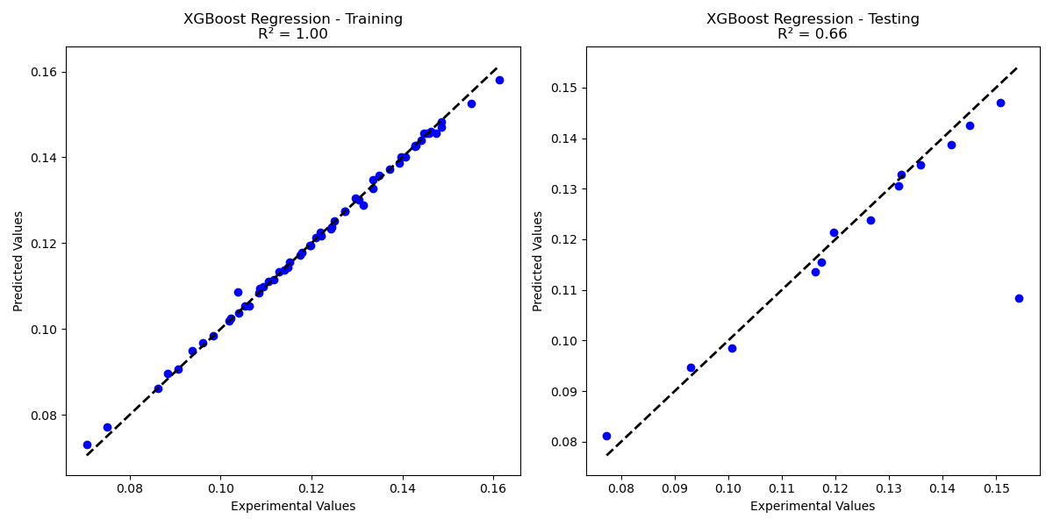

Figure 11. Experimental vs Predicted Values for Training and Testing Dataset in XGBoost Regression

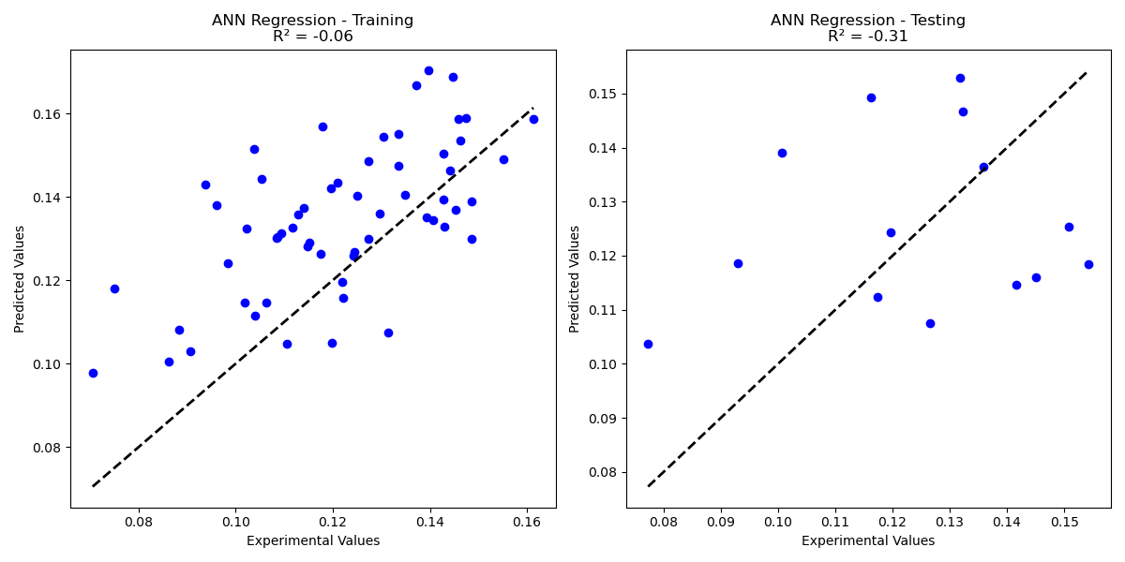

Figure 12. Experimental vs Predicted Values for Training and Testing Dataset in ANN Regression

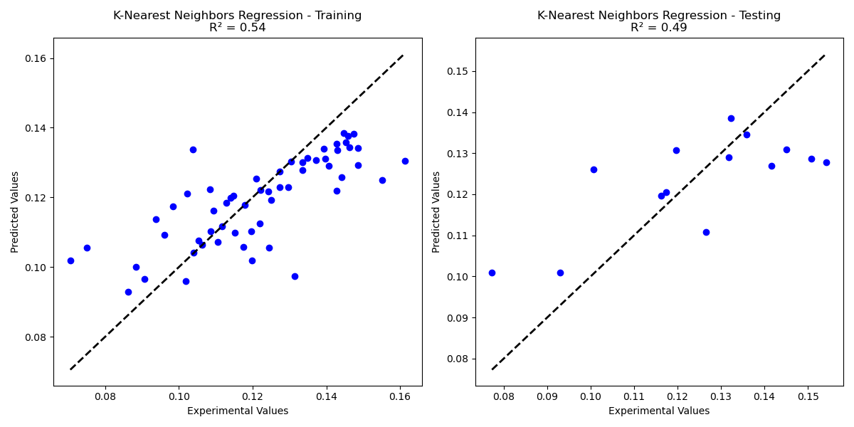

Figure 13. Experimental vs Predicted Values for Training and Testing Dataset in KNN Regression

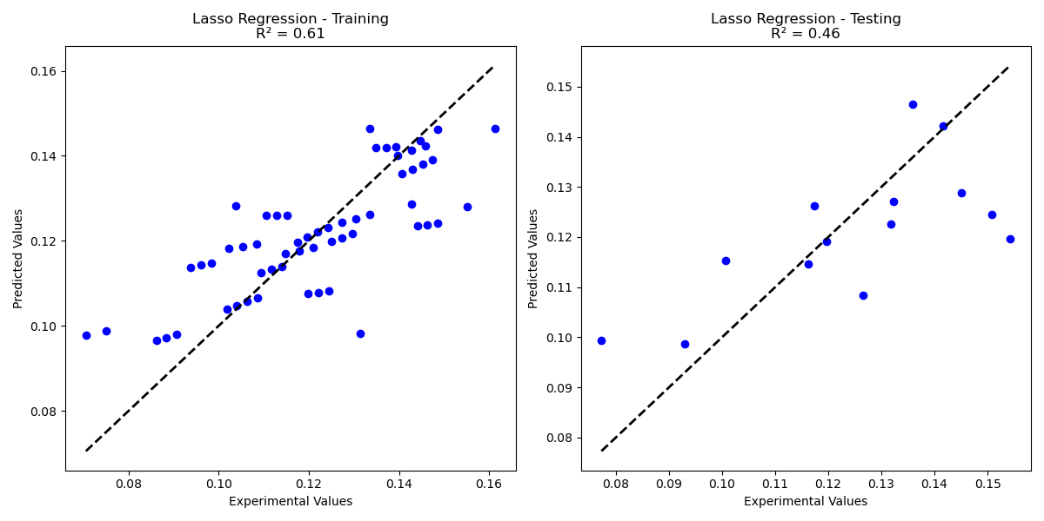

Figure 14. Experimental vs Predicted Values for Training and Testing Dataset in Lasso Regression

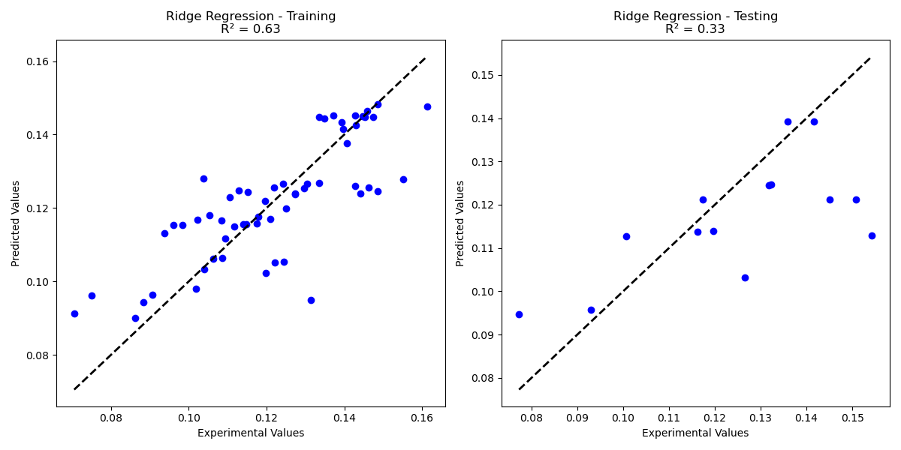

Figure 15. Experimental vs Predicted Values for Training and Testing Dataset in Ridge Regression

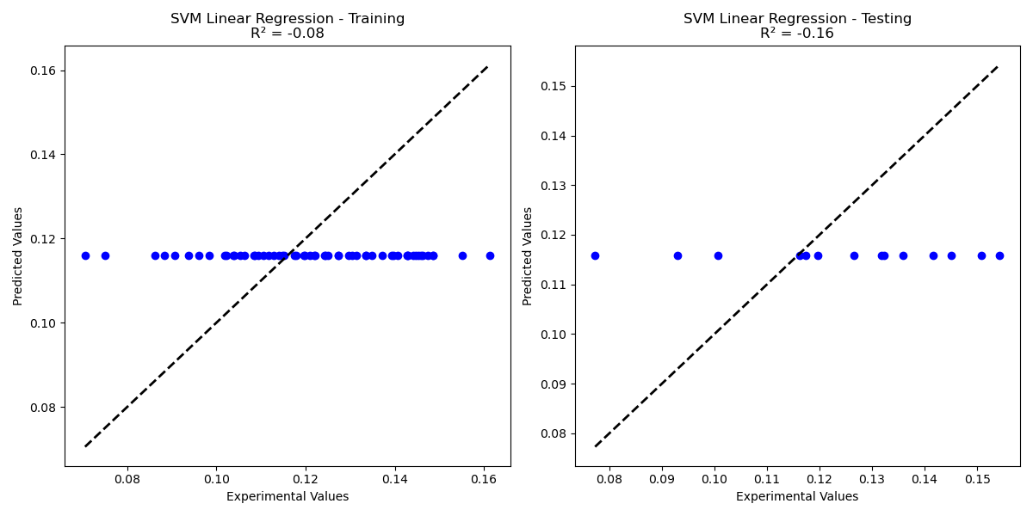

Figure 16. Experimental vs Predicted Values for Training and Testing Dataset in SVM Linear Regression

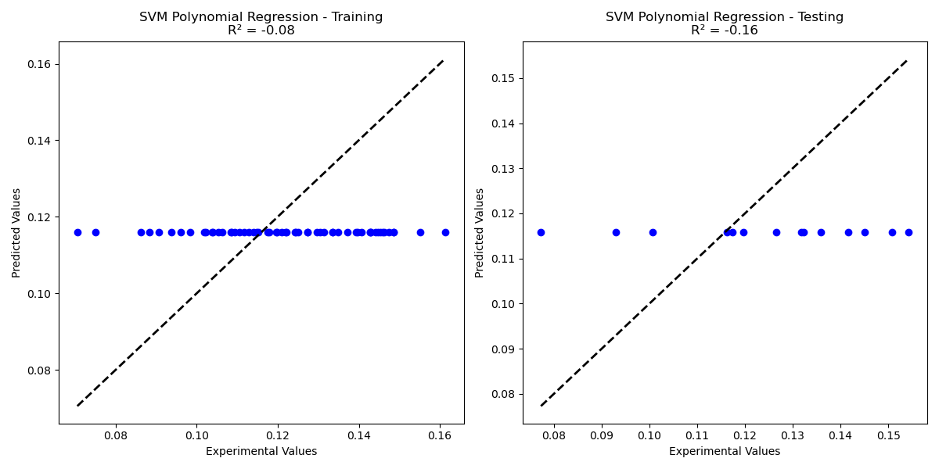

Figure 17. Experimental vs Predicted Values for Training and Testing Dataset in SVM Polynomial Regression

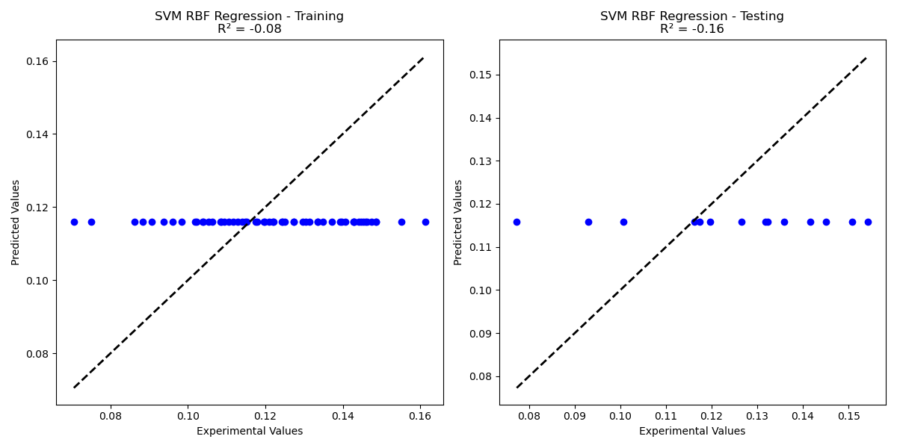

Figure 18. Experimental vs Predicted Values for Training and Testing Dataset in SVM RBF Regression

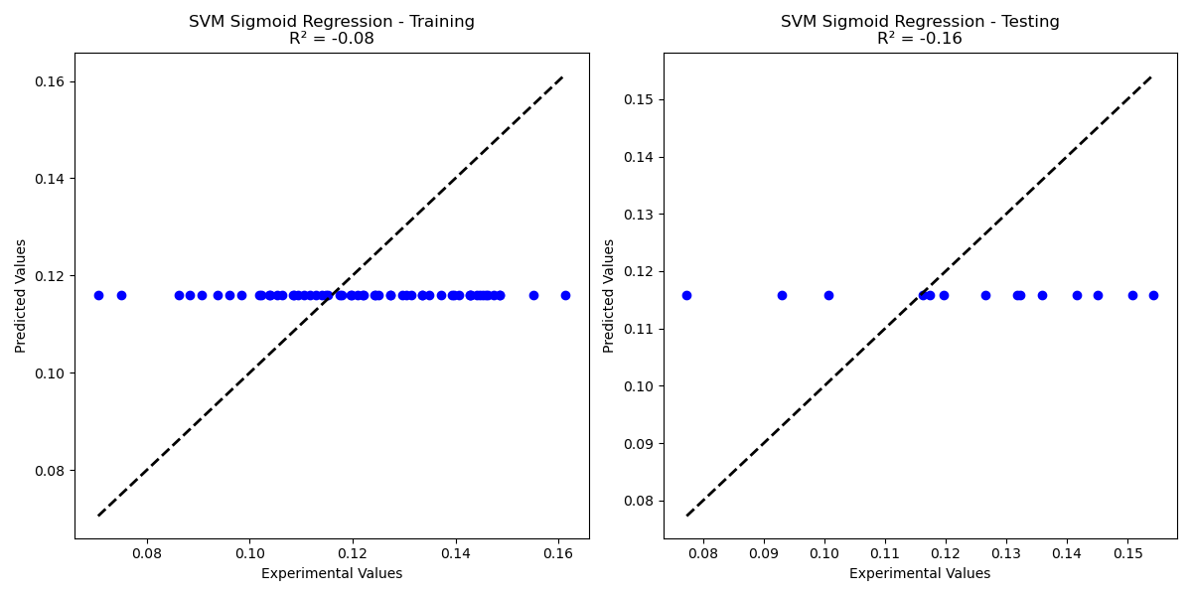

Figure 19. Experimental vs Predicted Values for Training and Testing Dataset in SVM Sigmoid Regression

The MAE value was lowest for Decision Tree regression with 0.0064 followed by Random forest with 0.0065 and XGBoost with 0.0067. The MAE values for different machine learning models like Linear Regression with 0.0118, ANN with 0.0437, Gradient boosting with 0.0086, Ridge regression with 0.0145, Lasso Regression with 0.0123, KNN with 0.0083, and all SVM models are with same MAE value of 0.0140. Table 7 shows the MSE and MAE values for Training and Testing for all Machine Learning Models and Figure 20,21 shows the comparison of MSE and MAE values for training and testing for all Machine Learning Models.

Table 7. MSE and MAE values for Training and Testing for all Machine Learning Models

|  |  |  |  |  |
| --- | --- | --- | --- | --- |
| **Model** | **MSE Training** | **MSE Testing** | **MAE Training** | **MAE Testing** |
| **Random Forest** | 0.0000 | 0.0002 | 0.0029 | 0.0084 |
| **Linear Regression** | 0.0002 | 0.0003 | 0.0089 | 0.0131 |
| **Ridge Regression** | 0.0002 | 0.0003 | 0.0130 | 0.0145 |
| **Lasso Regression** | 0.0004 | 0.0005 | 0.0167 | 0.0179 |
| **Decision Tree** | 0.0000 | 0.0002 | 0.0000 | 0.0063 |
| **KNN** | 0.0001 | 0.0002 | 0.0087 | 0.0102 |
| **Gradient Boosting** | 0.0000 | 0.0002 | 0.0016 | 0.0093 |
| **ANN** | 0.0023 | 0.0152 | 0.0385 | 0.1096 |
| **XGBoost** | 0.0000 | 0.0002 | 0.0005 | 0.0075 |
| **SVM Linear** | 0.0004 | 0.0005 | 0.0175 | 0.0195 |
| **SVM Polynomial** | 0.0004 | 0.0005 | 0.0175 | 0.0195 |

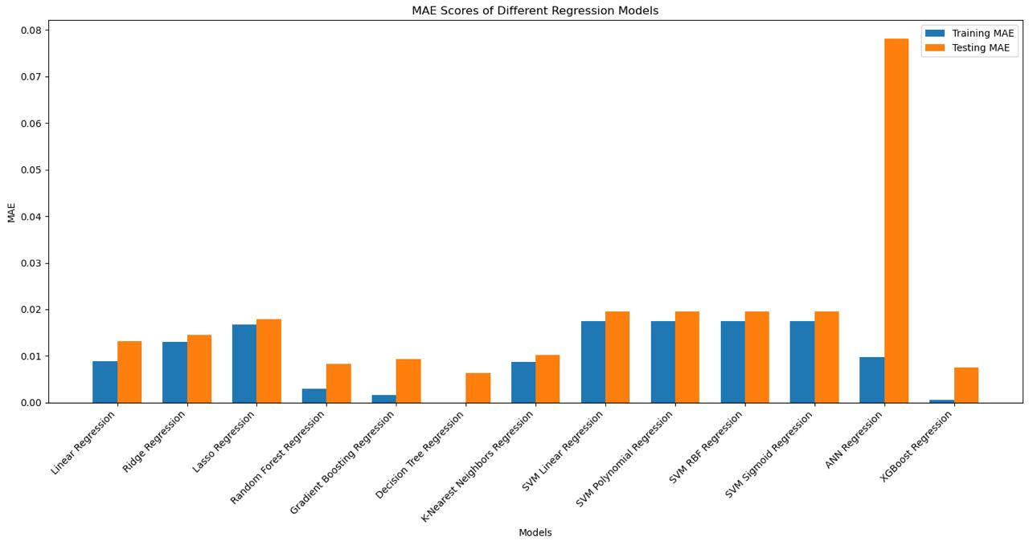

**Figure 20**. MAE scores for All Machine Learning Models

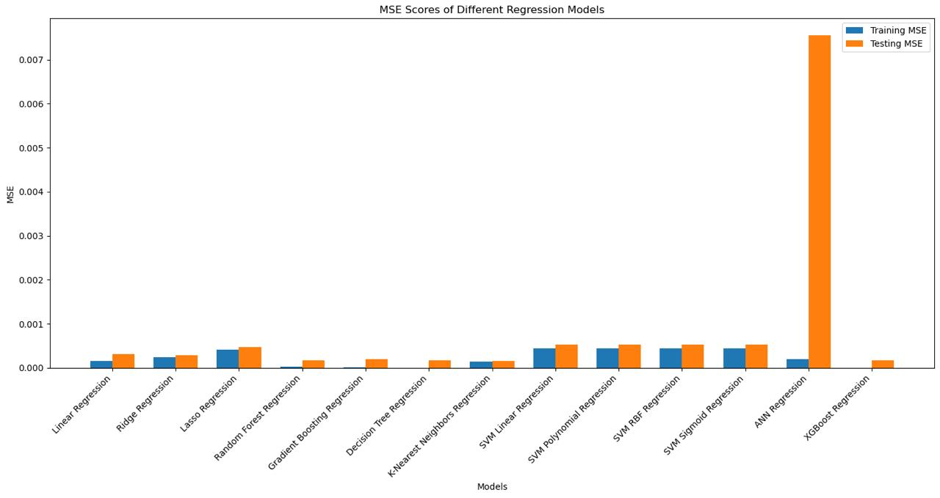

**Figure 21.**  MSE scores for All Machine Learning Models

Chapter 5

# Conclusion

This study introduces machine learning algorithms for predicting the surface roughness of deposited beads in aluminum alloy using WAAM. A labeled dataset was created with wire feed rate, travel speed, and contact tip to work distance as independent variables, and surface roughness as the dependent variable. Surface roughness measurements of single-layer deposited beads were captured using a 3D optical profilometer. The dataset was divided into training and testing sets with an 80:20 ratio for model training and validation. Thirteen different machine learning models like Linear Regression, Random Forest, Decision Tree, ANN, Gradient Boosting, XGBoost, Ridge Regression, Lasso Regression, KNN, SVM(Linear Kernal), SVM(Polynomial), SVM(RBF) and SVM(Sigmoid) are developed to make the prediction of surface roughness and analyze it. To evaluate the models, performance metrics such as R2 score, MAE, and MSE are optimized by adjusting the hyperparameters of the machine learning models.

● The MAE value was lowest for Decision Tree regression with 0.0064 followed by Random forest with 0.0065 and XGBoost with 0.0067.

● The lowest value of MSE was found to be in KNN with 0.00016 followed by XGBoost, Random Forest, and Decision Tree with 0.00017,0.00018, and 0.00018 respectively.

● The XGBoost algorithm appeared to be the best performing with the highest R2 score of 0.86816. Hence, its potential to discover the complexity of the dataset