SDM_Assignment1_BaldrigeData

Srikrishna Krishnarao Srinivasan

January 16, 2020

## R Markdown

This assignment uses part of data from the Baldrige scoring process collected by the National Institute of Standards and Technology (NIST) for years 1990 to 2006. The Malcolm Baldrige National Quality Award (MBNQA) is considered as one of the most powerful catalysts of quality and organizational performance excellence in the United States, and it has had significant influence throughout the world. This data consists of performance evaluation scores of organizations from different sectors (variable “sector”) like (1) manufacturing, (2) services, (3) small business, (4) education, (5) healthcare, and (6) nonprofit from 1990 to 2006. The dataset has scores on 7 categories that include (1) leadership; (2) strategic planning; (3) customer focus; (4) measurement, information and analysis; (5) workforce focus; (6) process management; and (7) results. In turn, these categories may have subcategories and the Criteria has sometimes added, discontinued or modified subcategories over time.

## Import Libraries, Set working directory

## Warning: package 'openxlsx' was built under R version 3.5.3

##   
## Please cite as:

## Hlavac, Marek (2018). stargazer: Well-Formatted Regression and Summary Statistics Tables.

## R package version 5.2.2. https://CRAN.R-project.org/package=stargazer

## Warning: package 'ggplot2' was built under R version 3.5.3

## Import the file

## [1] "File baldridge2011.xlsx imported"

## Observe how the data looks like

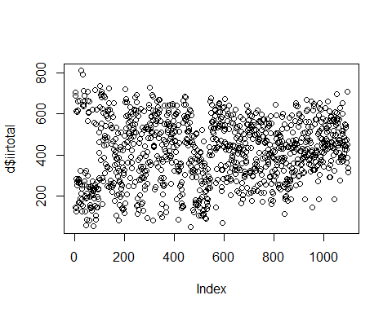

## [1] "Number of NAs in the column: 1"

## Warning in xy.coords(x, y, xlabel, ylabel, log): NAs introduced by coercion

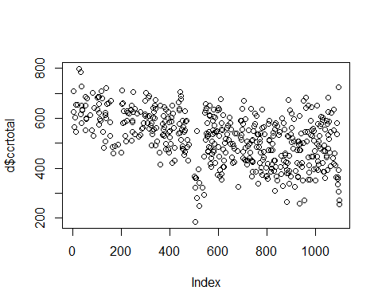

## [1] "Number of NAs in the column: 604"

## 1a.Number of observations, mean, median, standard deviation, min, max and mode

## [1] "Mean, Median, Mode for iirtotal:"

## [1] "Number of observations are: 1099"

## [1] "Mean of observations is: 416.66"

## [1] "Median of observations is: 429.5"

## [1] "Mode of observations is: 430"

## Warning: NAs introduced by coercion

## [1] "---------------------------"

## [1] "Mean, Median, Mode for ccrtotal:"

## [1] "Number of observations are: 1099"

## [1] "Mean of observations is: 520.55"

## [1] "Median of observations is: 532"

## [1] "Mode of observations is: NA"

## [1] "Mean can be used for irrtotal to measure central tendency"

## [1] "Median can be used for ccrtotal to measure central tendency"

## 1b.Number of observations, mean, median, standard deviation, min and max of iirtotal, ccrtotal by Sector

## Warning in calculate_sectorwise(d): NAs introduced by coercion

## secname variable num_of_obs mean median std.dev max min ccrt_var  
## 1 Mfg iirtotal 278 476.96 494 152.92 811 58 NA  
## 2 Mfg ccrtotal 278 568.75 579 92.563 798 338 NA  
## 3 Service iirtotal 158 466.55 509.5 144.06 723 81 20754  
## 4 Service ccrtotal 158 543.67 552 84.774 721 271 NA  
## 5 Small iirtotal 314 353.81 332 153.45 716 51 23548  
## 6 Small ccrtotal 314 536.15 535 83.316 705 352 NA  
## 7 Education iirtotal 134 381.42 392.5 127.26 588 105 16195  
## 8 Education ccrtotal 134 462.31 458.5 83.657 652 325 NA  
## 9 Health iirtotal 205 414.2 432 129.34 694 89 16729  
## 10 Health ccrtotal 205 459.44 459.5 97.287 682 185 NA  
## 11 Non-profit iirtotal 10 454.3 438.5 117.55 706 316 13818  
## 12 Non-profit ccrtotal 10 411.9 361.5 152.06 724 255 23123.66

## 1c. Identify outliers in ccrtotal using boxplot. Compare Mean, Standard deviation of ccrtotal with and without outliers

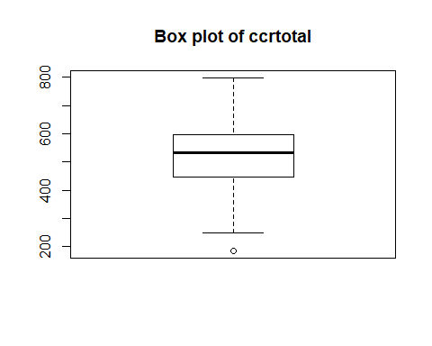

## [1] 185

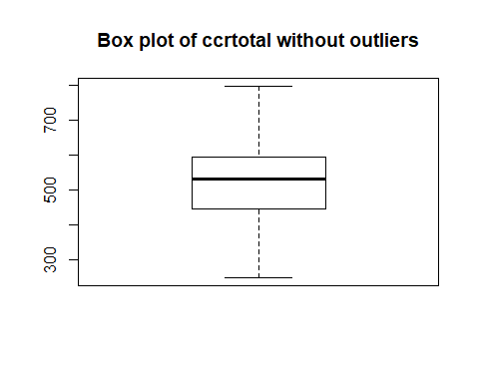

## [1] "Mean of ccrtotal without outliers is: 521.24"

## [1] "Std dev of ccrtotal without outliers is: 101.15"

## [1] "----------------------"

## [1] "Mean of ccrtotal observations with outliers is: 520.55"

## [1] "sd of ccrtotal observations with outliers is: 102.19"

## 1d. Draw a graph between icat4total, ccat7total. Give interpretation of the graph. Calculate correlation between them. Interpret correlation coefficient. Handle unequal number of observations.

## [1] "Type of icat4total is: double"

## [1] "Type of ccat7total is: character"

## icat4total ccat7total   
## Min. : 1.00 Length:1099   
## 1st Qu.: 36.00 Class :character   
## Median : 48.00 Mode :character   
## Mean : 50.07   
## 3rd Qu.: 61.00   
## Max. :112.00   
## NA's :1

## icat4total ccat7total  
## 1 107 180  
## icat4total ccat7total  
## 2 10 <NA>  
## icat4total ccat7total  
## 3 88 241  
## icat4total ccat7total  
## 4 20 <NA>  
## icat4total ccat7total  
## 5 95 176

## Warning: NAs introduced by coercion

## icat4total ccat7total   
## Min. : 26.00 Min. : 37.0   
## 1st Qu.: 47.50 1st Qu.:150.0   
## Median : 56.00 Median :182.5   
## Mean : 62.26 Mean :183.0   
## 3rd Qu.: 77.50 3rd Qu.:216.0   
## Max. :112.00 Max. :304.0   
## NA's :9

## icat4total ccat7total   
## Min. : 26.00 Min. : 37.0   
## 1st Qu.: 47.00 1st Qu.:150.0   
## Median : 56.00 Median :182.5   
## Mean : 62.24 Mean :183.0   
## 3rd Qu.: 78.00 3rd Qu.:216.0   
## Max. :112.00 Max. :304.0

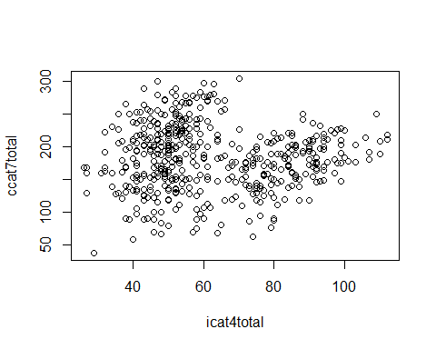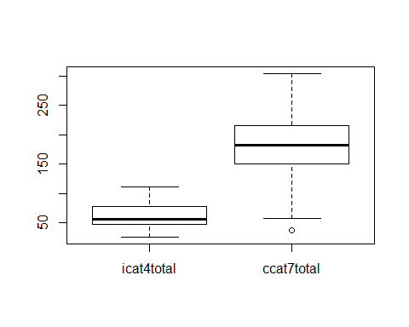

## [1] "Interpretation: The datapoints of icat4total are densely packed between 50 and 60, whereas for ccat7total are densely packed between 150 and 220"

## [1] "The correlation between icat4total and ccat7total is: -0.01"

## [1] "The variables icat4total and ccat7total are negatively correlated and have very low correlation coefficient"

## 1e. Count of organizations (using permanentid) along with their count, exclude ones

## Length Class Mode   
## 1099 character character

## [1] "B-179"  
## [1] NA  
## [1] NA  
## [1] NA  
## [1] NA

## slnoskm17mar11 year sector applicant permanentid i1.1score i1.1max  
## 1 1 1990 1 1 B-179 24 30  
## i1.2score i1.2max i1.3score i1.3max i1.4score i1.4max icat1total  
## 1 16 20 21 30 14 20 75  
## icat1max i2.1score i2.1max i2.2score i2.2max i2.3score i2.3max  
## 1 100 25 35 18 25 NA NA  
## icat2total icat2max i3.1score i3.1max i3.2score i3.2max i3.3score  
## 1 43 60 28 40 15 25 15  
## i3.3max icat3total icat3max i4.1score i4.1max i4.2score i4.2max  
## 1 25 58 90 21 30 32 40  
## i4.3score i4.3max i4.4score i4.4max i4.5score i4.5max icat4total  
## 1 28 40 10 20 16 20 107  
## icat4max i5.1score i5.1max i5.2score i5.2max i5.3score i5.3max i5.4score  
## 1 150 24 30 18 25 10 25 11  
## i5.4max i5.5score i5.5max i5.6score i5.6max i5.7score i5.7max icat5total  
## 1 15 6 10 18 25 16 20 103  
## icat5max i6.1score i6.1max i6.2score i6.2max i6.3score i6.3max i6.4score  
## 1 150 35 50 21 35 25 35 15  
## i6.4max i6.5score i6.5max icat6total icat6max i7.1score i7.1max  
## 1 30 NA NA 96 150 40 50  
## i7.2score i7.2max i7.3score i7.3max i7.4score i7.4max i7.5score i7.5max  
## 1 18 30 6 20 14 20 21 30  
## i7.6score i7.6max i7.7score i7.7max i7.8score i7.8max icat7total  
## 1 35 50 35 50 35 50 204  
## icat7max iirtotal iirmax c1.1score c1.1max c1.2score c1.2max c1.3score  
## 1 300 686 1000 21 30 14 20 21  
## c1.3max c1.4score c1.4max ccat1total ccat1max c2.1score c2.1max  
## 1 30 14 20 70 100 21 35  
## c2.2score c2.2max c2.3score c2.3max ccat2total ccat2max c3.1score  
## 1 18 25 <NA> NA 39 60 24  
## c3.1max c3.2score c3.2max c3.3score c3.3max ccat3total ccat3max  
## 1 40 13 25 15 25 52 90  
## c4.1score c4.1max c4.2score c4.2max c4.3score c4.3max c4.4score c4.4max  
## 1 18 30 28 40 24 40 12 20  
## c4.5score c4.5max ccat4total ccat4max c5.1score c5.1max c5.2score  
## 1 16 20 98 150 21 30 15  
## c5.2max c5.3score c5.3max c5.4score c5.4max c5.5score c5.5max c5.6score  
## 1 25 13 25 11 15 7 10 18  
## c5.6max c5.7score c5.7max ccat5total ccat5max c6.1score c6.1max  
## 1 25 16 20 101 150 35 50  
## c6.2score c6.2max c6.3score c6.3max c6.4score c6.4max c6.5score c6.5max  
## 1 18 35 18 35 15 30 NA NA  
## ccat6total ccat6max c7.1score c7.1max c7.2score c7.2max c7.3score  
## 1 86 150 25 50 15 30 6  
## c7.3max c7.4score c7.4max c7.5score c7.5max c7.6score c7.6max c7.7score  
## 1 20 16 20 18 30 30 50 35  
## c7.7max c7.8score c7.8max ccat7total ccat7max ccrtotal ccrmax  
## 1 50 35 50 180 300 626 1000  
## sector_name  
## 1 Manufacturing

## count_orgs Freq  
## 1 B-001 4  
## 2 B-002 3  
## 3 B-003 2  
## 4 B-004 3  
## 5 B-005 3

## [1] 199

## [1] "integer"

## count_orgs Freq  
## 1 B-001 4  
## 2 B-002 3  
## 3 B-003 2  
## 4 B-004 3  
## 5 B-005 3  
## 6 B-006 2

## [1] 199

## [1] "Count_Orgs_ 2 B-003 B-006 B-007 B-009 B-010 B-011 B-012 B-013 B-014 B-018 B-019 B-020 B-021 B-022 B-027 B-028 B-029 B-032 B-033 B-036 B-038 B-039 B-040 B-041 B-042 B-043 B-044 B-045 B-046 B-047 B-049 B-050 B-051 B-052 B-053 B-056 B-057 B-058 B-061 B-063 B-066 B-067 B-068 B-069 B-070 B-072 B-075 B-077 B-078 B-079 B-080 B-082 B-083 B-086 B-087 B-089 B-090 B-091 B-092 B-093 B-094 B-096 B-098 B-100 B-101 B-102 B-103 B-104 B-105 B-106 B-108 B-110 B-111 B-112 B-113 B-114 B-115 B-116 B-117 B-119 B-121 B-123 B-126 B-127 B-129 B-131 B-132 B-133 B-136 B-138 B-139 B-140 B-144 B-145 B-151 B-152 B-154 B-155 B-158 B-160 B-162 B-164 B-166 B-167 B-168 B-169 B-172 B-174 B-176 B-177 B-178 B-181 B-182 B-183 B-185 B-191 B-192 B-193 B-194 B-196 B-197 B-199 B-200"  
## [1] "-----------------"  
## [1] "Count_Orgs_ 3 B-002 B-004 B-005 B-008 B-016 B-017 B-023 B-024 B-034 B-035 B-048 B-055 B-059 B-060 B-064 B-073 B-076 B-081 B-084 B-088 B-107 B-109 B-124 B-125 B-128 B-130 B-134 B-137 B-141 B-142 B-143 B-146 B-148 B-150 B-153 B-156 B-157 B-161 B-163 B-171 B-179 B-187 B-188 B-190 B-195"  
## [1] "-----------------"  
## [1] "Count_Orgs_ 4 B-001 B-062 B-065 B-074 B-085 B-120 B-122 B-149 B-159 B-165 B-170 B-180 B-184 B-198"  
## [1] "-----------------"  
## [1] "Count_Orgs_ 5 B-026 B-037 B-054 B-095 B-097 B-099 B-147 B-173 B-186"  
## [1] "-----------------"  
## [1] "Count_Orgs_ 6 B-015 B-025 B-135 B-189"  
## [1] "-----------------"  
## [1] "Count_Orgs_ 7 B-071 B-118"  
## [1] "-----------------"  
## [1] "Count_Orgs_ 8 B-030"  
## [1] "-----------------"  
## [1] "Count_Orgs_ 9 B-031"  
## [1] "-----------------"

## 1f. Plot a line graph for icat4total and ccat7total for an interesting company with 6 or more evaluations. Expalain reason for interest. Explain relationship between the variables above.

## [1] "Interesting company with 6 or more evaluations is with permanentid B031"

## [1] "Reason: It is the only company that has been evaluated 9 times"

## [1] "Relationship between icat4total and ccat7total:"

## Warning: NAs introduced by coercion

## icat4total ccat7total permanentid year   
## Min. : 26.00 Min. : 37.0 Length:495 Min. :1990   
## 1st Qu.: 47.50 1st Qu.:150.0 Class :character 1st Qu.:1994   
## Median : 56.00 Median :182.5 Mode :character Median :1998   
## Mean : 62.26 Mean :183.0 Mean :1998   
## 3rd Qu.: 77.50 3rd Qu.:216.0 3rd Qu.:2003   
## Max. :112.00 Max. :304.0 Max. :2006   
## NA's :9

## icat4total ccat7total permanentid year   
## Min. :41.0 Min. :118.0 Length:6 Min. :1993   
## 1st Qu.:43.5 1st Qu.:157.0 Class :character 1st Qu.:1994   
## Median :63.5 Median :190.5 Mode :character Median :1996   
## Mean :64.5 Mean :178.0 Mean :1996   
## 3rd Qu.:85.0 3rd Qu.:200.8 3rd Qu.:1998   
## Max. :90.0 Max. :219.0 Max. :1999

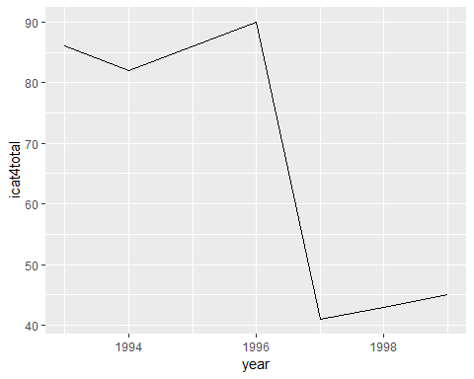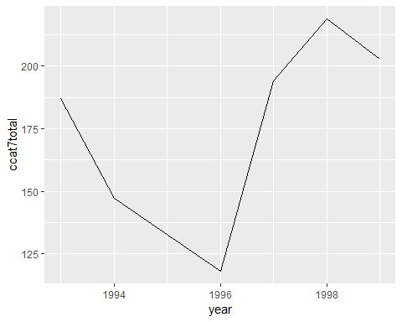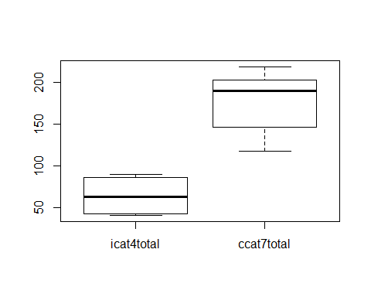

## [1] "The relationship between the variables is that, icat4total has low median and ccat7total has higher median value"

## [1] "Correlation between icat4total and ccat7total is: -0.805"

## [1] "There is a very high negative correlation between icat4total and ccat7total"

## 2a. Histogram (distribution) of icat4total and ccat7total for Healthcare sector. Give three observations

## icat4total ccat7total   
## Min. : 9.00 Length:205   
## 1st Qu.:37.00 Class :character   
## Median :47.00 Mode :character   
## Mean :45.57   
## 3rd Qu.:54.00   
## Max. :80.00

## icat4total ccat7total   
## Min. : 9.00 Min. : 37.0   
## 1st Qu.:37.00 1st Qu.:136.2   
## Median :47.00 Median :180.0   
## Mean :45.57 Mean :174.8   
## 3rd Qu.:54.00 3rd Qu.:220.0   
## Max. :80.00 Max. :297.0   
## NA's :103

## icat4total ccat7total   
## Min. :29.00 Min. : 37.0   
## 1st Qu.:48.00 1st Qu.:136.2   
## Median :52.00 Median :180.0   
## Mean :52.21 Mean :174.8   
## 3rd Qu.:56.00 3rd Qu.:220.0   
## Max. :80.00 Max. :297.0

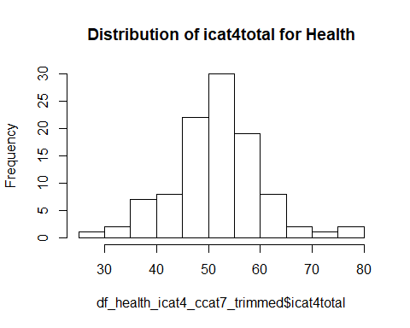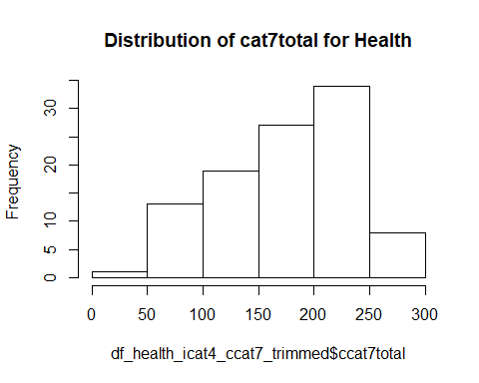

## [1] "Observation 1: There are 103 NAs for ccat7total out of 205 observations, this is around 50% of values"

## [1] "Observation 2: icat4total is normally distributed for Health, ccat7total is not normally distributed"

## [1] "Observation 3: Maximum score of ccat7total is much higher (more than 3 times) than icat4total"

## 2b. Scatter plot (distribution) of icat4total and ccat7total for Manufacturing sector. Give two observations

## icat4total ccat7total   
## Min. : 1.00 Length:278   
## 1st Qu.: 44.00 Class :character   
## Median : 55.00 Mode :character   
## Mean : 58.82   
## 3rd Qu.: 75.00   
## Max. :112.00   
## NA's :1

## icat4total ccat7total   
## Min. : 1.00 Min. : 83.0   
## 1st Qu.: 44.00 1st Qu.:158.5   
## Median : 55.00 Median :183.0   
## Mean : 58.82 Mean :186.8   
## 3rd Qu.: 75.00 3rd Qu.:214.5   
## Max. :112.00 Max. :288.0   
## NA's :1 NA's :135

## icat4total ccat7total   
## Min. : 26.00 Min. : 83.0   
## 1st Qu.: 51.00 1st Qu.:158.5   
## Median : 72.00 Median :183.0   
## Mean : 69.94 Mean :186.8   
## 3rd Qu.: 86.00 3rd Qu.:214.5   
## Max. :112.00 Max. :288.0

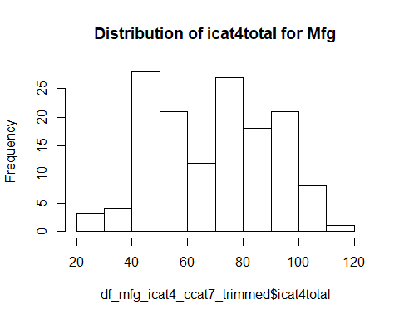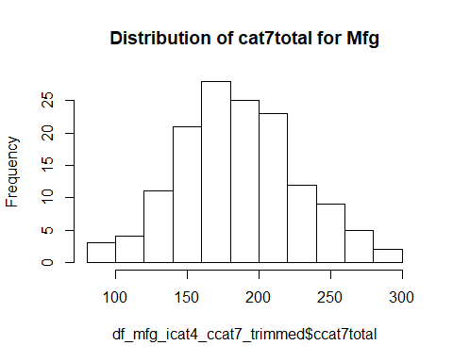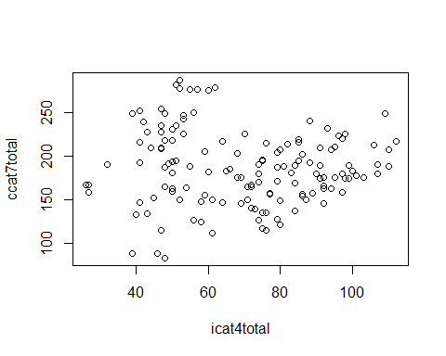

## [1] "Observation 1: There are 135 NAs for ccat7total out of 278 observations, this is around 50% of values"

## [1] "Observation 2: icat4total is not normally distributed for Mfg, ccat7total is normally distributed"

## 2c. Line graph of iirtotal by sector by year (trend). Vertical line at year 1995 and 1998 to visualize trends in 3 parts

## [1] "Trend of iirtotal over years by sectors"

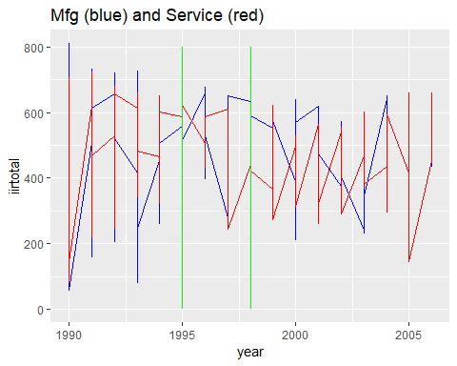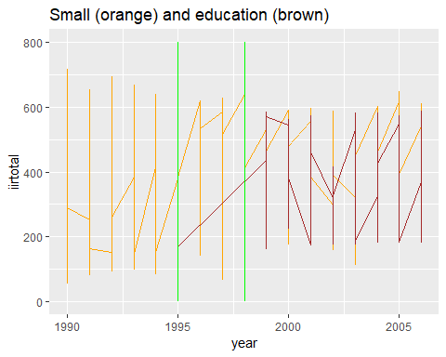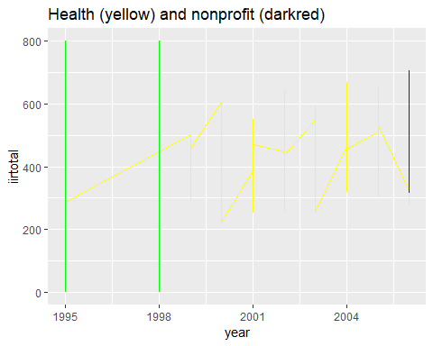

## 2d. Line graph of number of applicants by sector by year (trend). Vertical line at year 1995 and 1998 to visualize trends in 3 parts

## [1] "Trend of applicant over years by sectors"

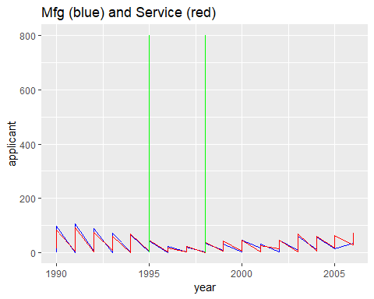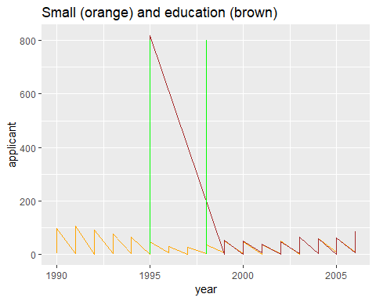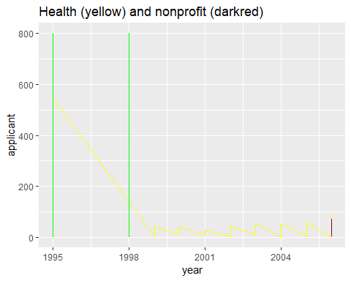

## 2e.Box plot for all individual category totals (icat1total to icat7total) in Manufacturing sector. Identify outlier scores

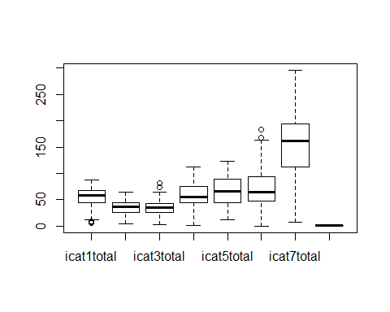

## [1] "Outliers for manufacturing sector icatxtotal are: 8"   
## [2] "Outliers for manufacturing sector icatxtotal are: 9"   
## [3] "Outliers for manufacturing sector icatxtotal are: 6"   
## [4] "Outliers for manufacturing sector icatxtotal are: 82"   
## [5] "Outliers for manufacturing sector icatxtotal are: 74"   
## [6] "Outliers for manufacturing sector icatxtotal are: 183"  
## [7] "Outliers for manufacturing sector icatxtotal are: 168"

## 2f. Scatterplot between icat4total and ccat7total subdivided by timeperiods (1. upto 1994, 2. 1995 to 1998, 3. 1999 and above)

## icat4total ccat7total year time_period  
## Min. : 26.00 Min. : 83.0 Min. :1990 0:65   
## 1st Qu.: 51.00 1st Qu.:158.5 1st Qu.:1992 1:42   
## Median : 72.00 Median :183.0 Median :1995 2:36   
## Mean : 69.94 Mean :186.8 Mean :1996   
## 3rd Qu.: 86.00 3rd Qu.:214.5 3rd Qu.:1998   
## Max. :112.00 Max. :288.0 Max. :2006

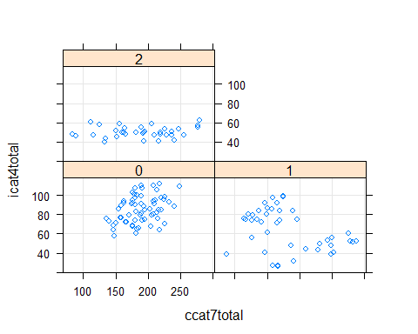

## [1] "Observation 1: Data upto 1994 is tightly packed with central tendency around mean. Even for low or high icat4total, ccat7total could have been high, so other totals influence is displayed"

## [1] "OBservation 2: For data for 1999 and above, ccat7total heavily depends upon icat4total showing less influence on icat7total by other totals"

## [1] "Observation 3: Probablity Density of data between 1995 and 1998 is scattered, making it less reliable to predict icat7total based on icat4total (OLS error will be higher for this compared to other two) "

## 2g. Table of summary stats (N, mean, sd, min, max) for icat1total to icat7total

## [1] "Stargazer does not work well with Rmarkdown. How to solve this issue? SD is represented by 1st Qu and 3rd Qu"

## icat1total icat2total icat3total icat4total   
## Min. : 3.00 Min. : 2.00 Min. : 0.00 Min. : 1.00   
## 1st Qu.:39.00 1st Qu.:22.00 1st Qu.:23.00 1st Qu.: 36.00   
## Median :54.00 Median :34.00 Median :33.00 Median : 48.00   
## Mean :51.43 Mean :32.52 Mean :32.88 Mean : 50.07   
## 3rd Qu.:66.00 3rd Qu.:43.00 3rd Qu.:43.00 3rd Qu.: 61.00   
## Max. :91.00 Max. :64.00 Max. :82.00 Max. :112.00   
## NA's :1 NA's :1 NA's :1 NA's :1   
## icat5total icat6total icat7total sector   
## Min. : 7.00 Min. : 0.00 Min. : 4.0 Min. :1.000   
## 1st Qu.: 36.00 1st Qu.: 34.00 1st Qu.: 90.0 1st Qu.:1.000   
## Median : 46.00 Median : 48.00 Median :143.0 Median :3.000   
## Mean : 51.54 Mean : 54.84 Mean :143.4 Mean :2.873   
## 3rd Qu.: 65.00 3rd Qu.: 67.00 3rd Qu.:191.0 3rd Qu.:4.000   
## Max. :123.00 Max. :183.00 Max. :308.0 Max. :6.000   
## NA's :1 NA's :1 NA's :1

## 2h. Pairwise Pearson coefficients for consensus category totals ccat1total to ccat7total

## ccat1total ccat2total ccat3total   
## Length:1099 Length:1099 Length:1099   
## Class :character Class :character Class :character   
## Mode :character Mode :character Mode :character   
## ccat4total ccat5total ccat6total   
## Length:1099 Length:1099 Length:1099   
## Class :character Class :character Class :character   
## Mode :character Mode :character Mode :character   
## ccat7total   
## Length:1099   
## Class :character   
## Mode :character

## Warning: NAs introduced by coercion

## ccat1total ccat2total ccat3total ccat4total   
## Min. :26.00 Min. :10.0 Min. :13.00 Min. : 20.00   
## 1st Qu.:59.00 1st Qu.:35.0 1st Qu.:34.00 1st Qu.: 45.00   
## Median :65.00 Median :41.0 Median :41.00 Median : 55.00   
## Mean :64.99 Mean :41.1 Mean :41.38 Mean : 60.46   
## 3rd Qu.:73.00 3rd Qu.:48.0 3rd Qu.:49.00 3rd Qu.: 76.00   
## Max. :94.00 Max. :69.0 Max. :80.00 Max. :114.00   
## ccat5total ccat6total ccat7total   
## Min. : 23.0 Min. : 11.00 Min. : 37.0   
## 1st Qu.: 44.0 1st Qu.: 45.00 1st Qu.:150.0   
## Median : 55.0 Median : 56.00 Median :182.5   
## Mean : 61.7 Mean : 67.94 Mean :183.0   
## 3rd Qu.: 82.0 3rd Qu.: 89.00 3rd Qu.:216.0   
## Max. :124.0 Max. :187.00 Max. :304.0

## ccat1total ccat2total ccat3total ccat4total ccat5total  
## ccat1total 1.00 0.67 0.70 0.12 0.09  
## ccat2total 0.67 1.00 0.56 0.27 0.26  
## ccat3total 0.70 0.56 1.00 -0.03 -0.02  
## ccat4total 0.12 0.27 -0.03 1.00 0.83  
## ccat5total 0.09 0.26 -0.02 0.83 1.00  
## ccat6total -0.02 0.20 -0.18 0.79 0.82  
## ccat7total 0.68 0.62 0.63 0.07 0.08  
## ccat6total ccat7total  
## ccat1total -0.02 0.68  
## ccat2total 0.20 0.62  
## ccat3total -0.18 0.63  
## ccat4total 0.79 0.07  
## ccat5total 0.82 0.08  
## ccat6total 1.00 -0.03  
## ccat7total -0.03 1.00

## 3a. 95% confidence interval for icat7total and maximum icat7total

##   
## One Sample t-test  
##   
## data: df_icatxtotal$icat7total  
## t = 71.093, df = 1097, p-value < 2.2e-16  
## alternative hypothesis: true mean is not equal to 0  
## 95 percent confidence interval:  
## 139.4217 147.3361  
## sample estimates:  
## mean of x   
## 143.3789

## [1] "95% confidence interval is 139.42, 147.33 and maximum icat7total with 95% confidence is 147.33"

## 3b. 95% confidence interval for icat7total for healthcare and education: which have higher score?

##   
## One Sample t-test  
##   
## data: df_icatxtotal_education1$icat7total  
## t = 24.087, df = 133, p-value < 2.2e-16  
## alternative hypothesis: true mean is not equal to 0  
## 95 percent confidence interval:  
## 131.2367 154.7185  
## sample estimates:  
## mean of x   
## 142.9776

##   
## One Sample t-test  
##   
## data: df_icatxtotal_health1$icat7total  
## t = 31.348, df = 204, p-value < 2.2e-16  
## alternative hypothesis: true mean is not equal to 0  
## 95 percent confidence interval:  
## 146.8237 166.5323  
## sample estimates:  
## mean of x   
## 156.678

## [1] "95% confidence interval for health (mean: 156.67, max: 166.53) has higher score than education (mean: 142.98, max: 154.72)"