Class_Presentation

Srikrishna Krishnarao Srinivasan

January 22, 2020

## R Markdown

Analysis of Baldrige Evaluation Criteria and Results for the Cateogry 5.Workforce Focus

# 1. The number of items in Workforce Focus category by year

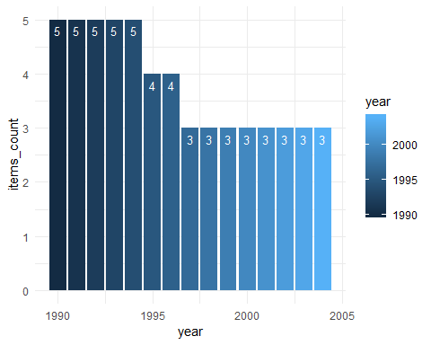

|  |  |  |  |  |
| --- | --- | --- | --- | --- |
| Number | X1990 | X1995 | X1997 | X2003 |
| 1 | Human Resource Management | Human Resource Planning and Evaluation | Work Systems | Work Systems |
| 2 | Employee Involvement | High performance work systems | Employee Education, Training and Development | Employee Learning and Motivation |
| 3 | Quality Education and Training | Employee Education Training and Development | Employee Well Being and Satisfaction | Employee Well Being and Satisfaction |
| 4 | Employee Recognition and Performance Measurement | Employee Well being and Satisfaction | dropped | dropped |
| 5 | Employee Well-being and morale | dropped | dropped | dropped |

# 2. Line chart of average icat5total over years

## Warning: Removed 1 rows containing missing values (geom_point).

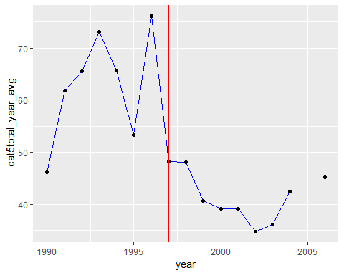

# 3. Line chart of average icat5max over years

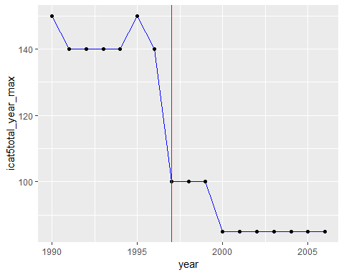

# 4. Hypothesis: The Scoring for Category 5 Workforce Focus was easier after 1997 as the number of items reduced. To verify this, a simple linear regression between the two terms should say if there is significant p-value or not

##   
## Call:  
## lm(formula = icat5total ~ year_before_1997, data = df)  
##   
## Residuals:  
## Min 1Q Median 3Q Max   
## -53.272 -11.062 0.833 12.530 62.728   
##   
## Coefficients:  
## Estimate Std. Error t value Pr(>|t|)   
## (Intercept) 41.0621 0.9045 45.40 <2e-16 ***  
## year_before_19971 19.2100 1.2247 15.69 <2e-16 ***  
## ---  
## Signif. codes: 0 '***' 0.001 '**' 0.01 '*' 0.05 '.' 0.1 ' ' 1  
##   
## Residual standard error: 20.21 on 1096 degrees of freedom  
## (1 observation deleted due to missingness)  
## Multiple R-squared: 0.1833, Adjusted R-squared: 0.1826   
## F-statistic: 246.1 on 1 and 1096 DF, p-value: < 2.2e-16

##   
## Call:  
## lm(formula = icat5total ~ year_before_1997 + I(icat5total - icat5max),   
## data = df)  
##   
## Residuals:  
## Min 1Q Median 3Q Max   
## -40.577 -2.117 -0.590 2.932 16.551   
##   
## Coefficients:  
## Estimate Std. Error t value Pr(>|t|)   
## (Intercept) 81.00751 0.56206 144.12 <2e-16 ***  
## year_before_19971 49.00437 0.55544 88.23 <2e-16 ***  
## I(icat5total - icat5max) 0.87271 0.01006 86.77 <2e-16 ***  
## ---  
## Signif. codes: 0 '***' 0.001 '**' 0.01 '*' 0.05 '.' 0.1 ' ' 1  
##   
## Residual standard error: 7.203 on 1095 degrees of freedom  
## (1 observation deleted due to missingness)  
## Multiple R-squared: 0.8963, Adjusted R-squared: 0.8961   
## F-statistic: 4732 on 2 and 1095 DF, p-value: < 2.2e-16