**To Supply Leftover Food to Poor**

**College Name: Chikkanna Government arts College,Tiruppur.**

**College Code: BRU06**

TEAM ID: NM2025TMID2620

TEAM MEMBERS: 4

Team Leader Name: SABARI KANNAN S

Email:sksabari7m@gmail.com

Team Member: PAVITHRA B

Email: bpavithra30032006@gmail.com

Team Member: GOKULKRISHNAN M

Email:gokulkrishnanm43@gmail.com

Team Member: SEENIVASAN M

Email:seenivasansiva2005@gmail.com

**1.INTRODUCTION**

**1.1 Project Overview**

Utilizing Salesforce, our project streamlines surplus food collection and distribution to the needy, ensuring efficiency and transparency.

# Pupose:

The purpose of this Salesforce-based project is to **efficiently manage the collection and distribution of surplus food** to those in need, ensuring that food reaches the right recipients in a **timely, transparent, and accountable manner**. By streamlining operations and tracking resources digitally, the system **reduces food waste, maximizes outreach, and promotes social responsibility**.

# DEVELOPMENT PHASE

Creating Developer Account: By using this URL - <https://developer.salesforce.com/signup>

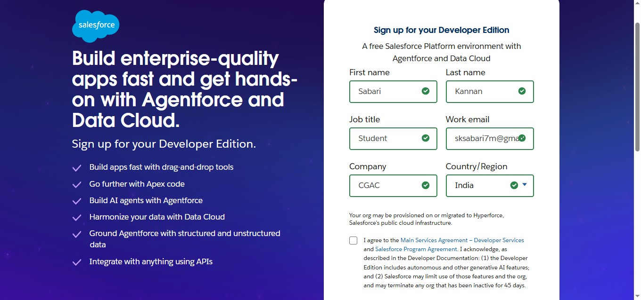

Create object of Venue , Drop off point, Task, Execution details

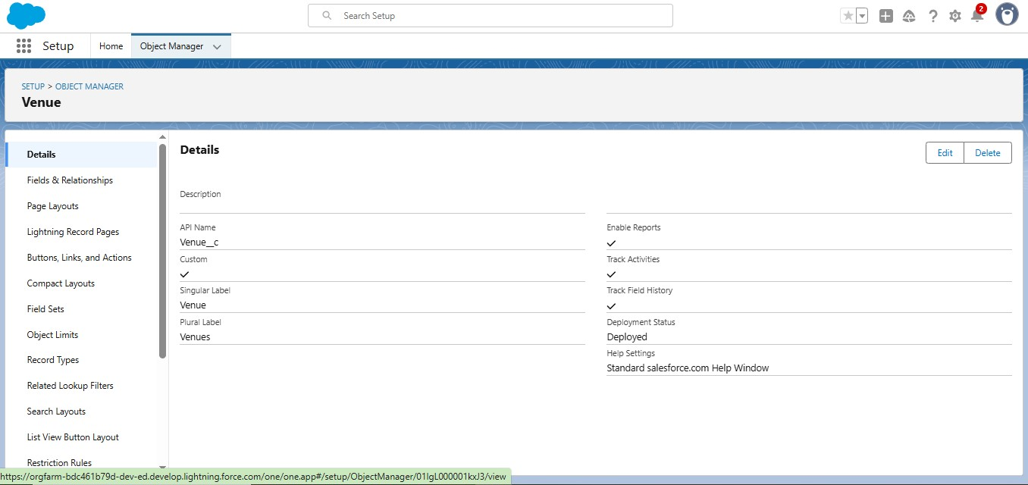

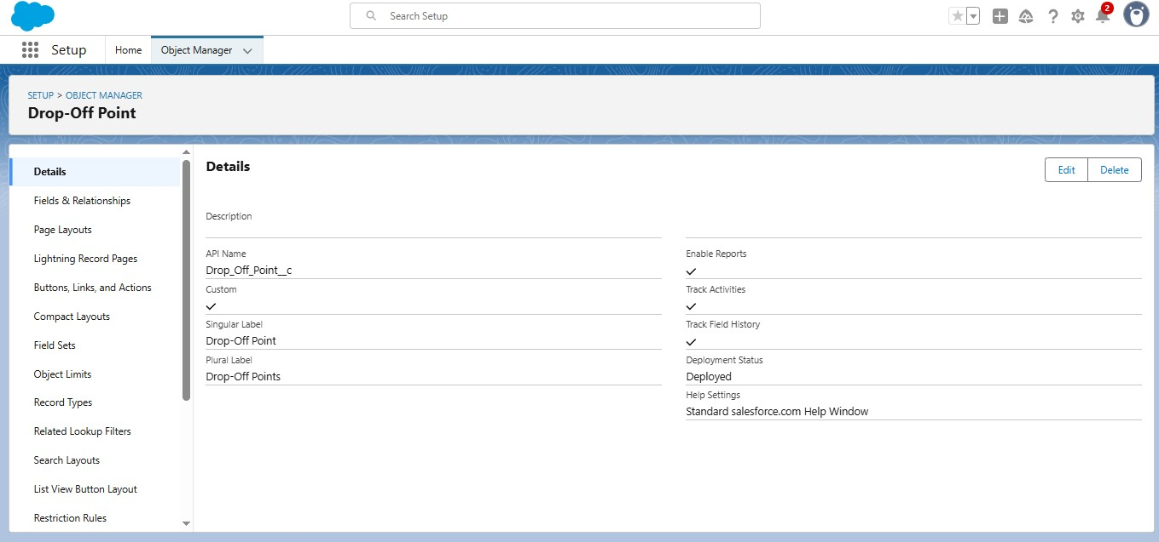

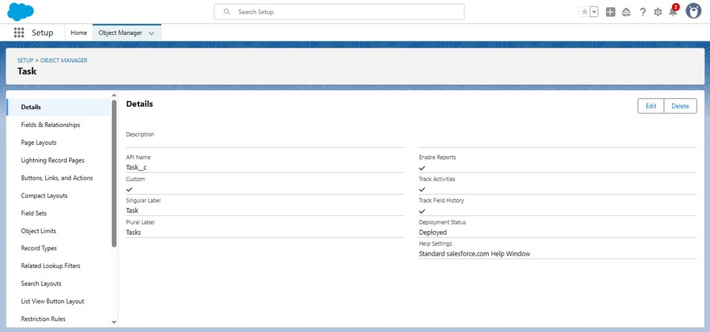

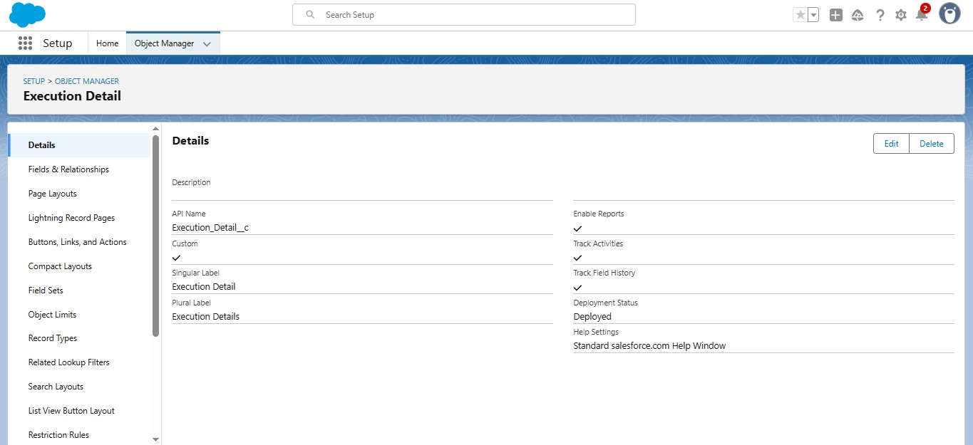

Creating a Custom Tab :Venue, Drop-Off Point, Task, Volunteer, Execution Details

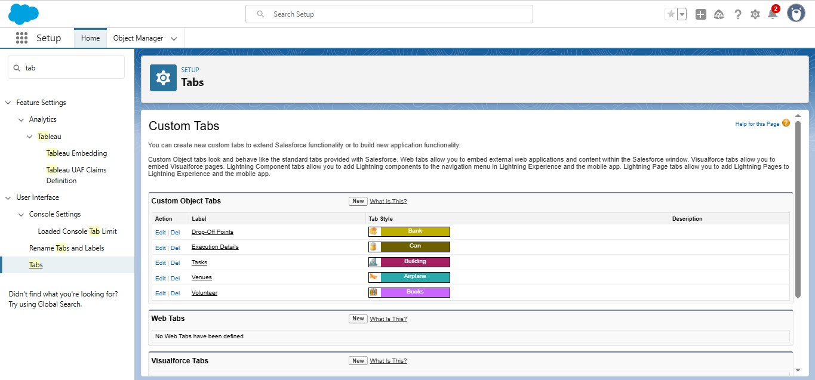

# To creating a lightning app page: Food Connect

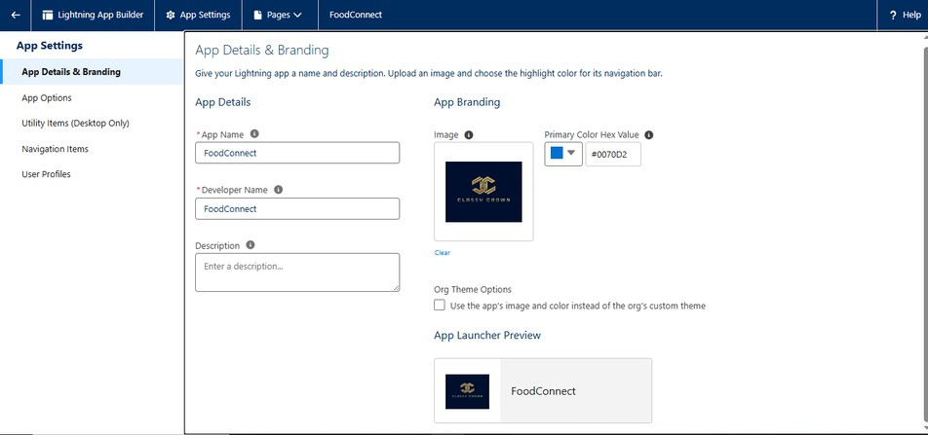

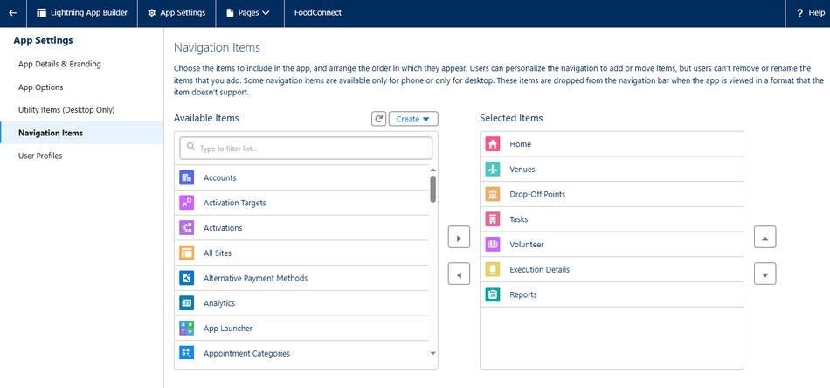

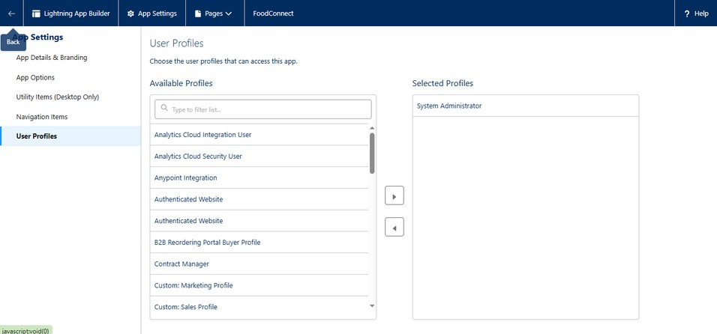

Creation of Relationship fields in objects:

**Creation of Lookup Relationship Field on Volunteer Object :**

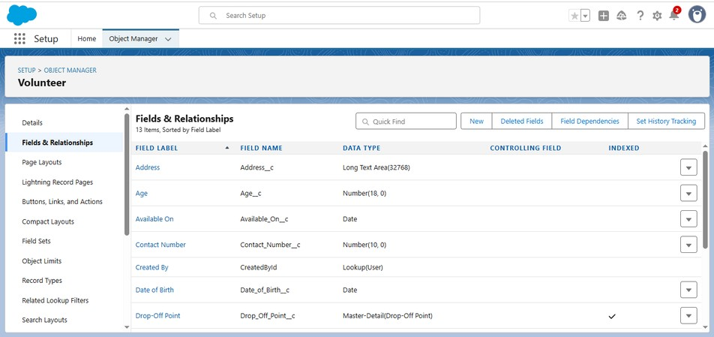

Creation of fields for the Venue object

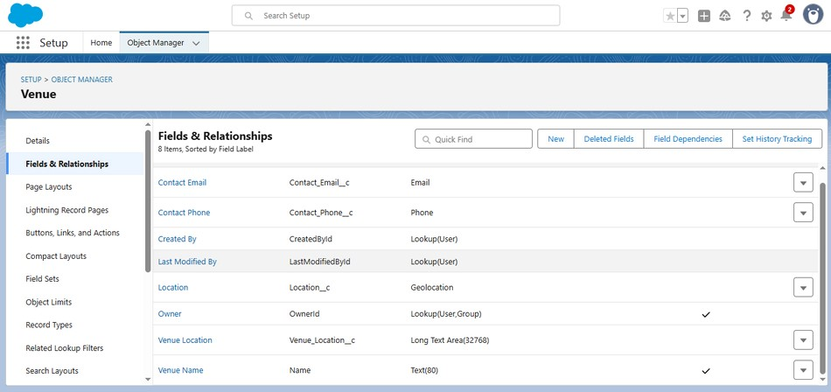

Creation of fields for the Drop-Off point object

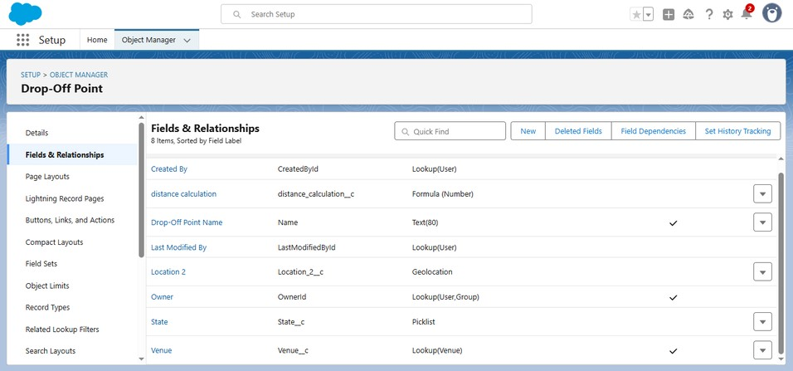

Creation of fields for the Task object

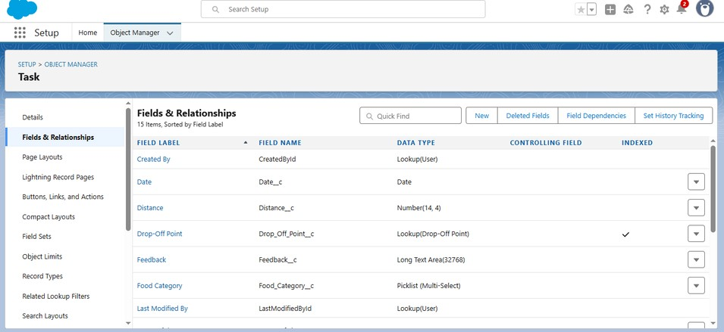

Creation of fields for the Volunteer object

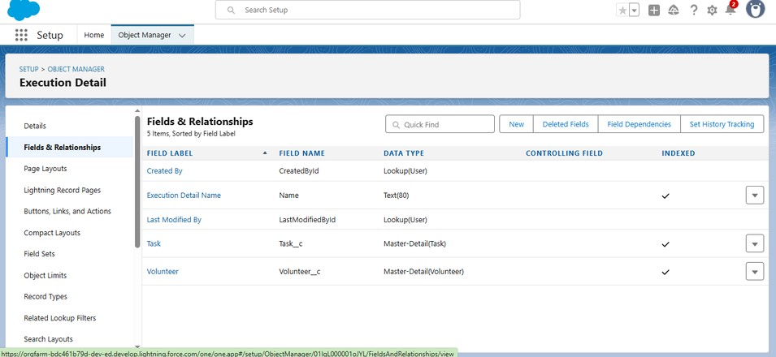

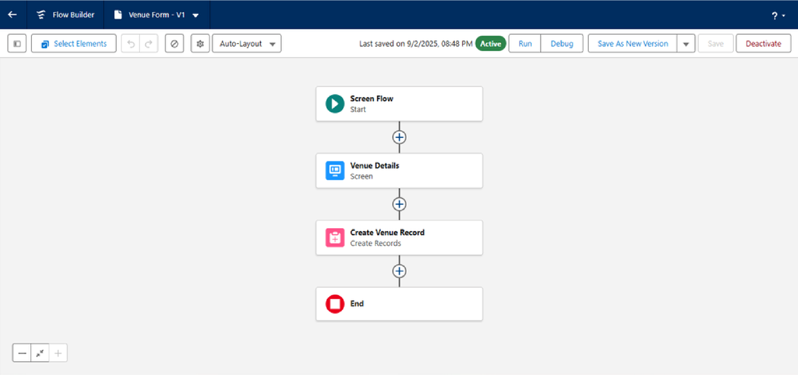Creation of fields for the Execution Details object



Create Flow to create a record in Venue object

Creating a Trigger and coding for distance calculation

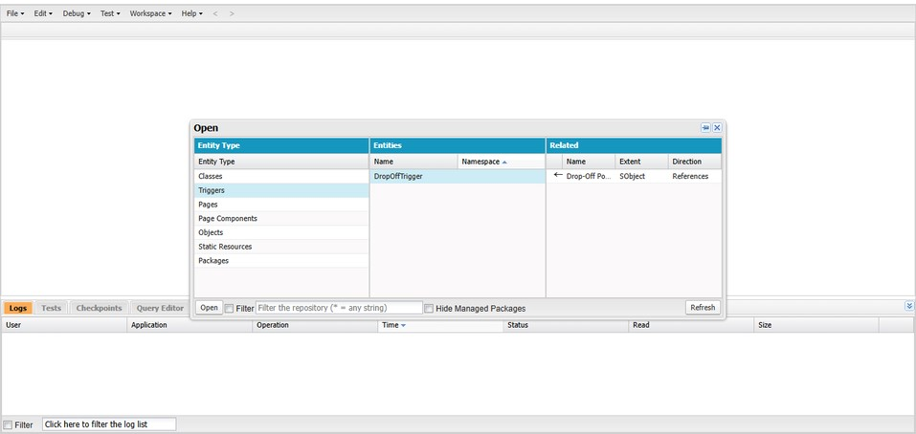

coding part for Trigger that helps to calculate distance.

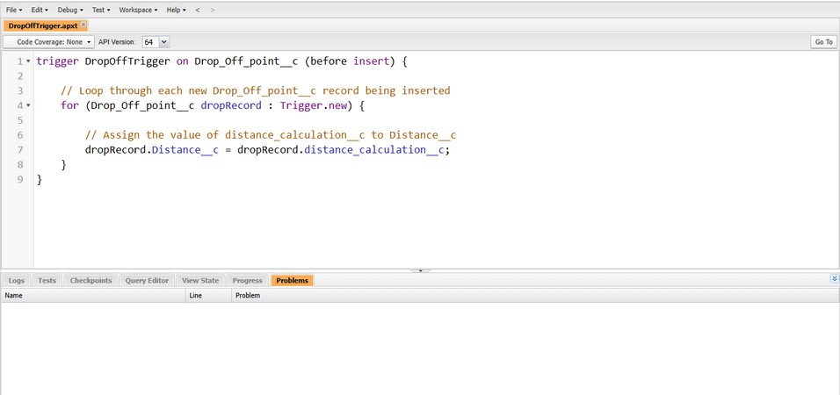

Creating User1 with given details

User1:iksha Foundation

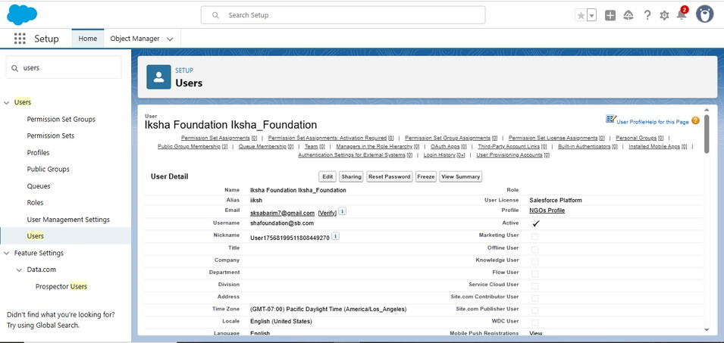

Creating of User2 and User3 by our own names:

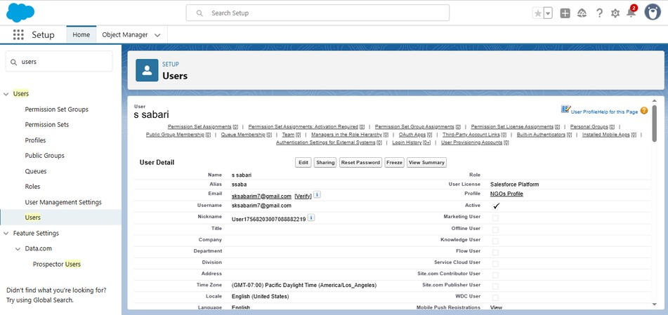

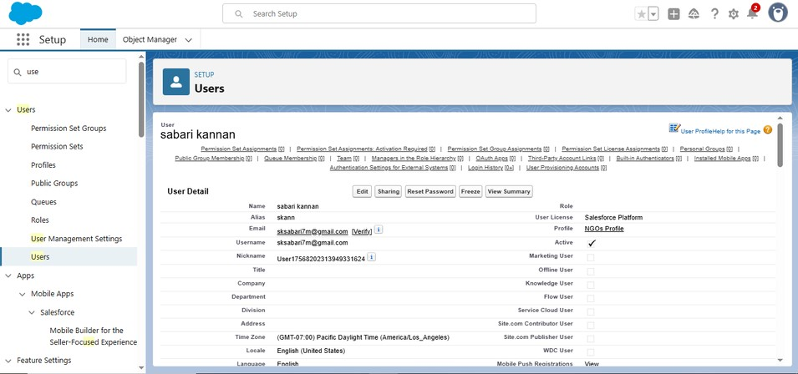

Creation of Public Group 1 with given Name iksha

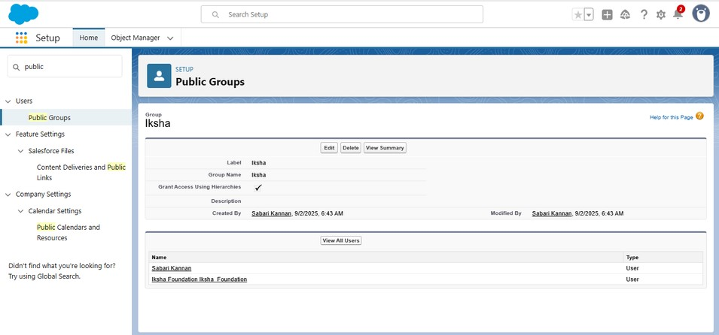

Creation of 2 public group name with our own name of public group

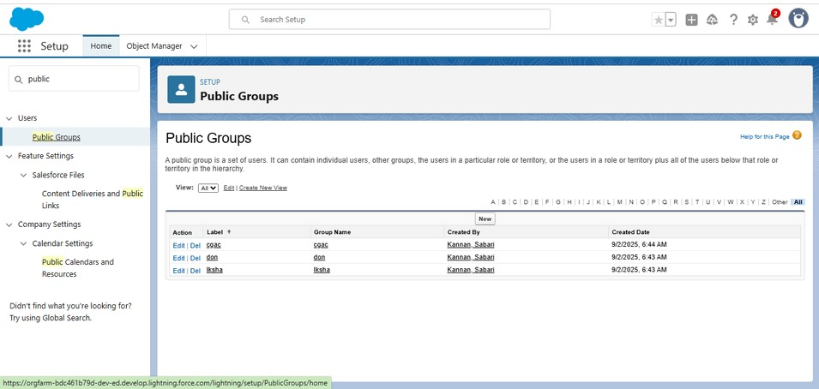

Creation of Report Types

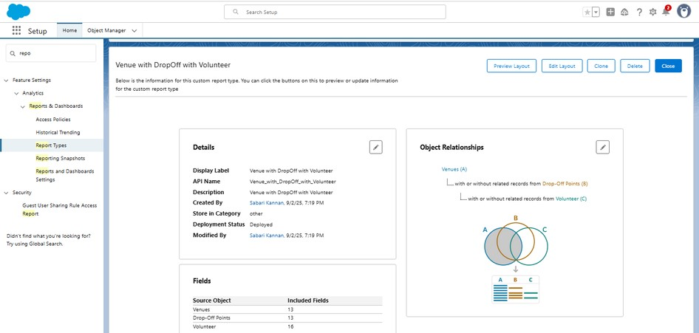

Creation of Report on Venue with Drop Off with

Volunteer

Creation of Report on Volunteers with Execution Details and Tasks

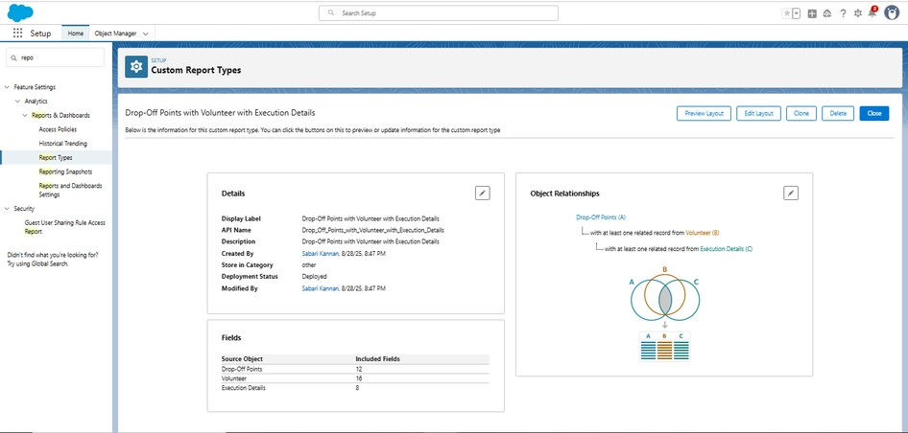

**Adding Dashboard:**

Adding venue and Drop Off point Report to the Dashboard

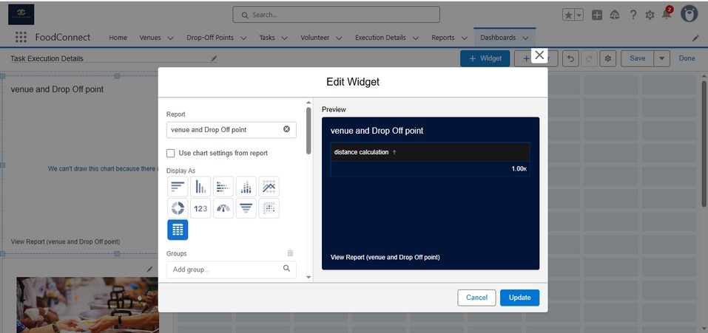

Adding Volunteer Task Report to the Dashboard

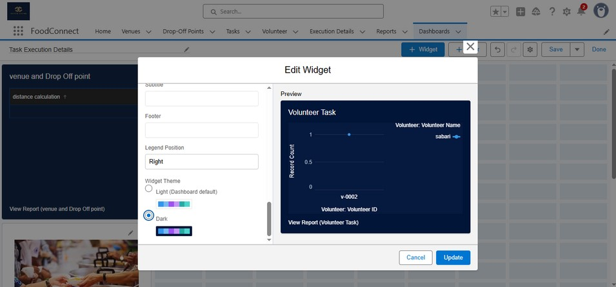

**Adding a image to the dashboard**

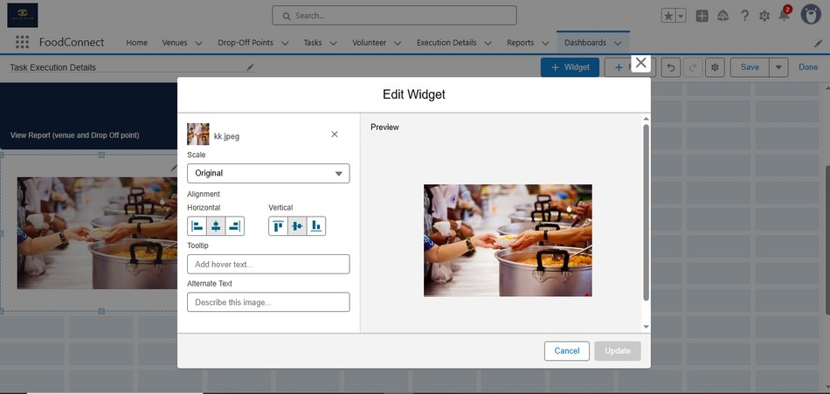

**Creation of sharing rules**

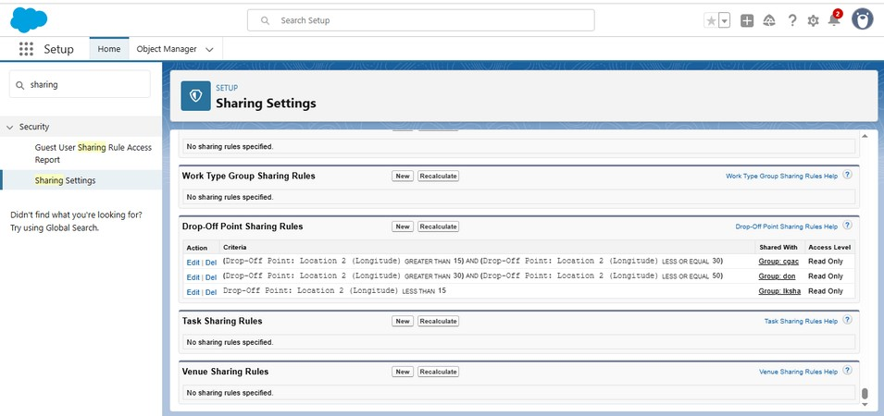

**After complete the all steps creating the Home page**

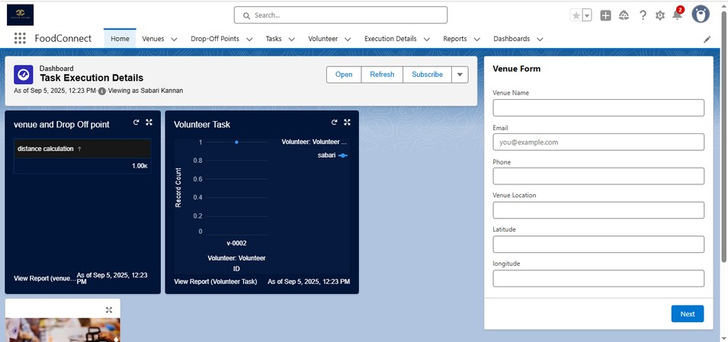

**FUNCTIONAL AND PERFORMANCE TESTING:**

Performance Testing

Trigger validation by entering duplicate tenant-property record.

Entering the details and creating the venue forms

The venue forms created by given details

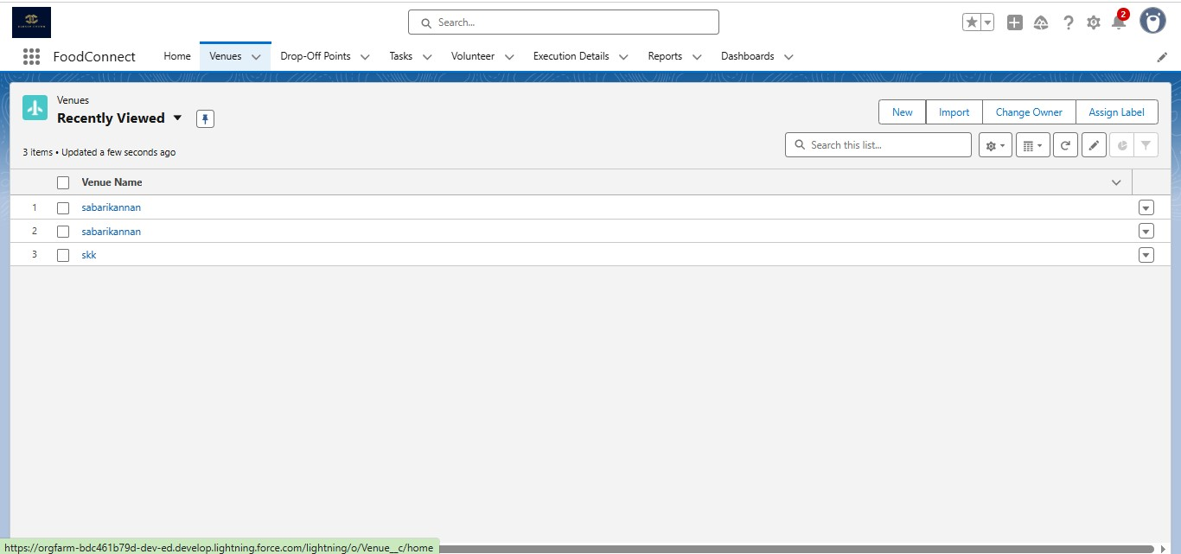

The venue forms are containing Venue Name, Contact Email, Contact Phone, Location of the venue.

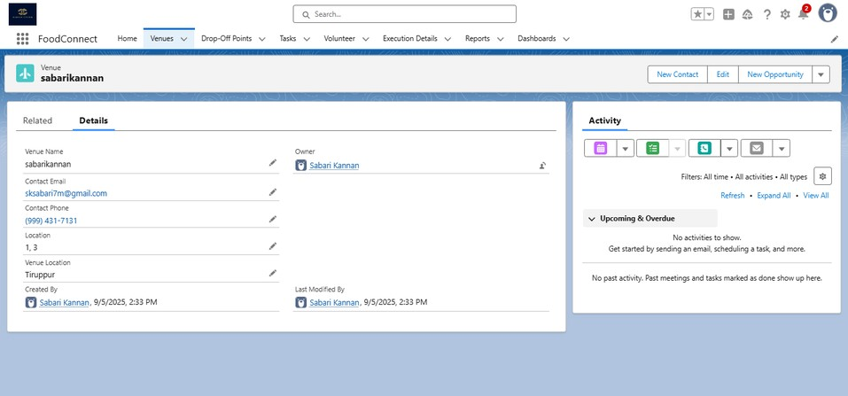

We created total of three venue forms

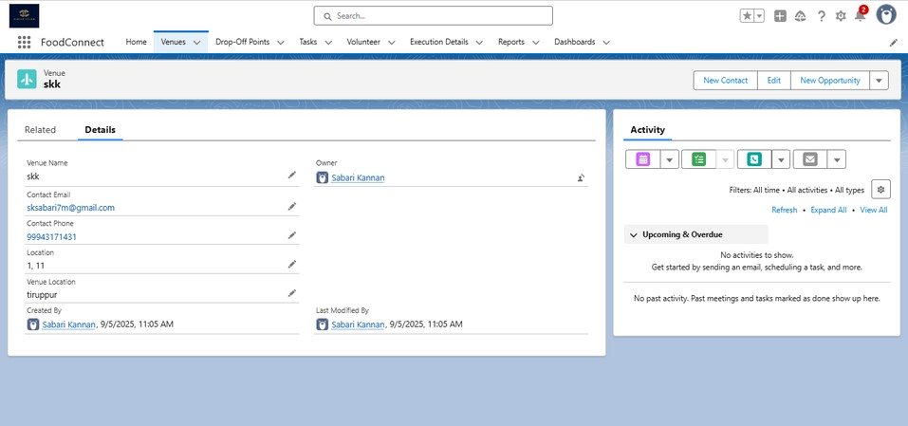

Drop-Off point has running correctly in this which venue

has to create a distance details about venue

In this will used for calculating the distance with two location.

Distance calculation is used for get the distance of two location.

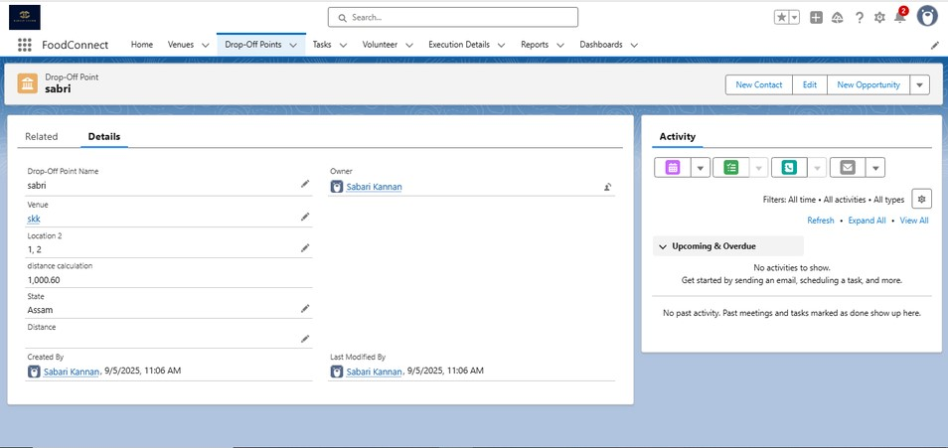

Creating the task that helps to get the details about the venue.

It helps too know who are the sponsors and how many members they can provide food and which type of food (veg,non-veg..eg).

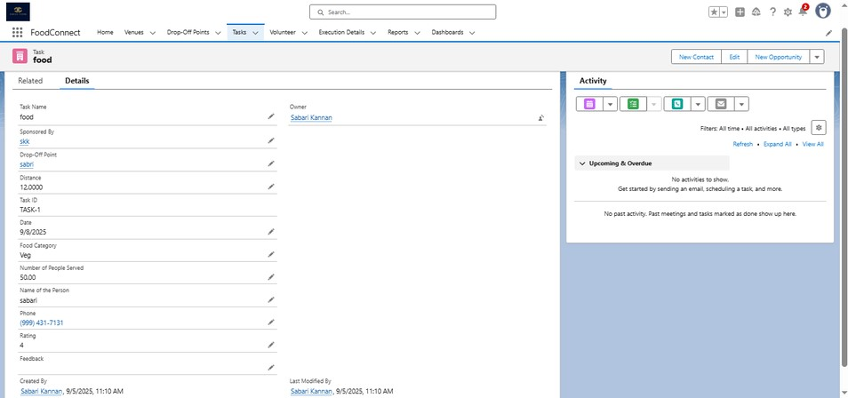

The volunteer option was used for who are the volunteer and their details ,Generating the volunteer ID ,Execution ID.

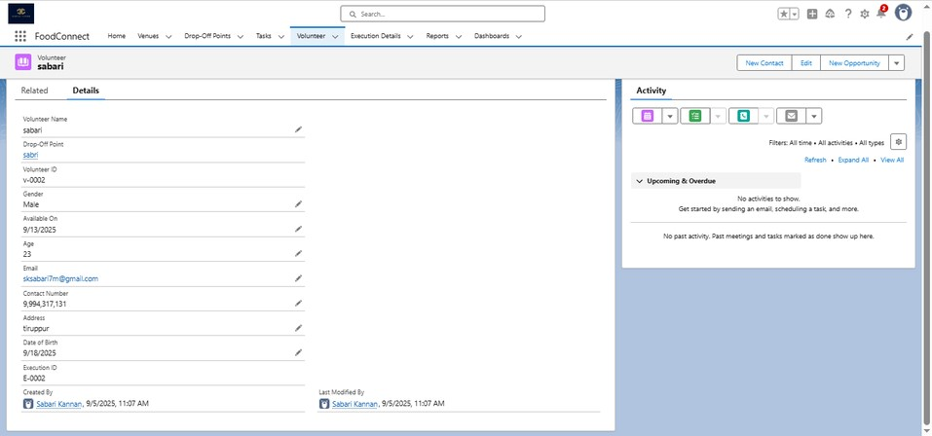

The Execution details have who are the volunteer and the Task

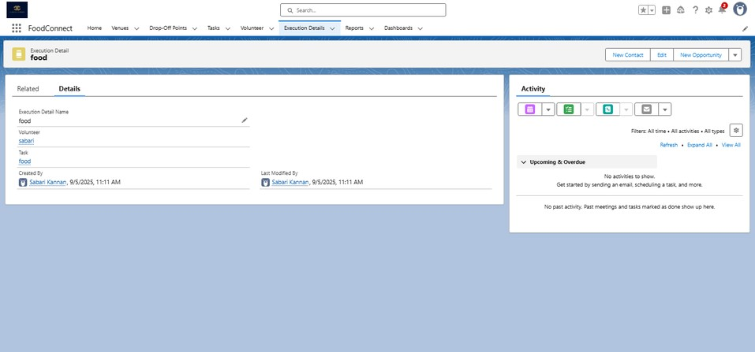

**Reports :**

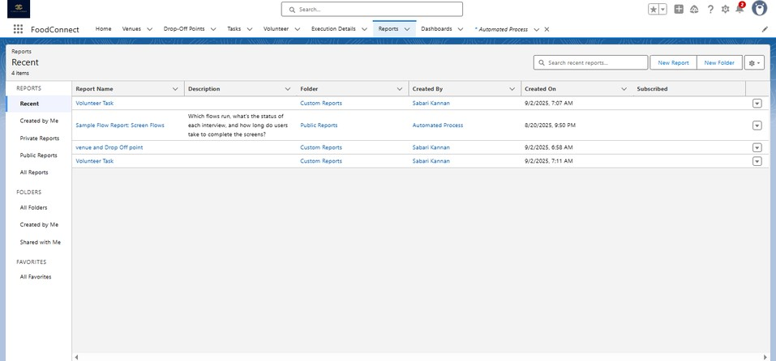

The reports has a view as chart and table format view.

The sample view of the report section.

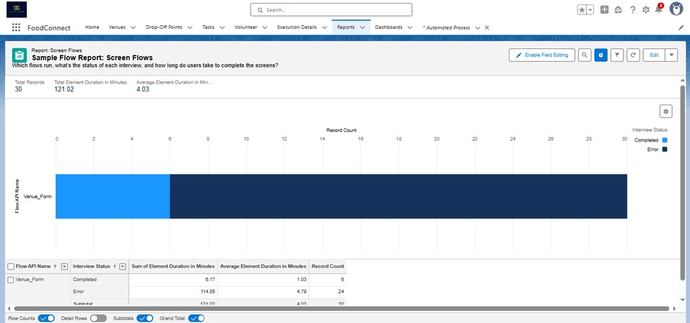

The custom reports created by me is Volunteer Task, Venue and drop Off point.

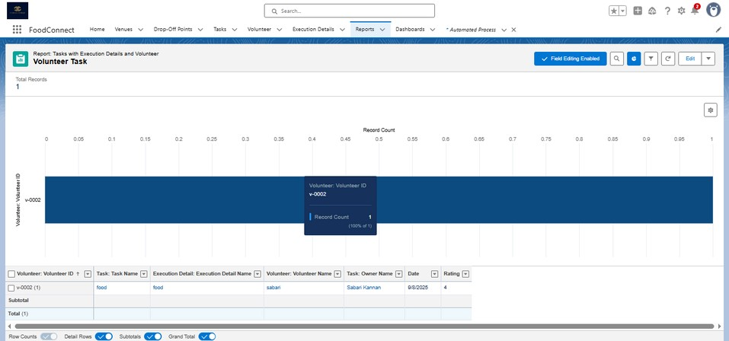

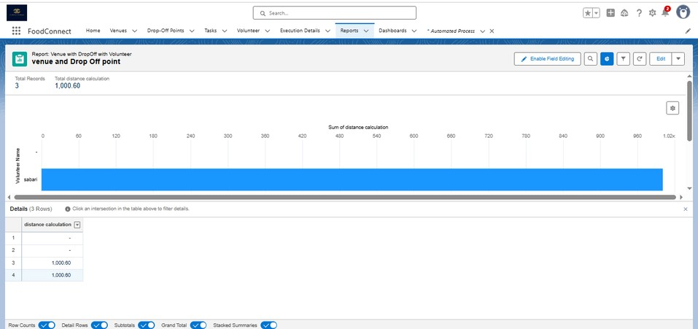

**The Dashboard View:**

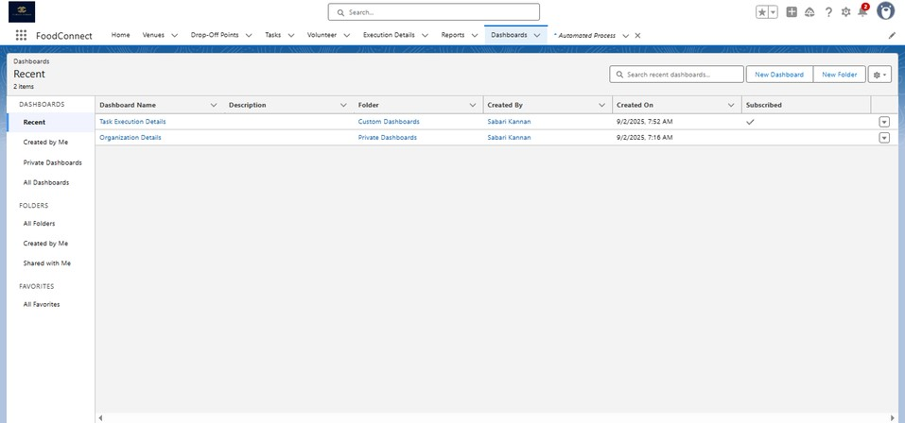

Task Execution Details is about the Dashboard have reports and the process of the food connect app is done here .

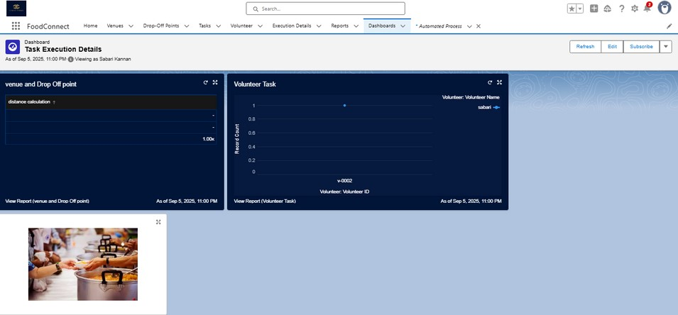

Trigger Code

(This Trigger is to assign Distance field to the Distance Calculation field. So that we can assign the distance in the sharing rules.)

**Code:**

trigger DropOffTrigger on Drop_Off_point__c (before insert) { for(Drop_Off_point__c Drop : Trigger.new){

Drop.Distance__c = Drop.distance_calculation__c;

}

}

Conclusion:

By leveraging the Salesforce platform, the project successfully established a streamlined and transparent system for managing surplus food donations. Through efficient coordination with volunteers and timely delivery to beneficiaries, the project effectively addressed food insecurity while maximizing the utilization of available resources.