Report on Sales Data

MARKEITNG ANALYTICS WITH POWER BI
MGT-273

Team members
AP23110011228 MALEY POOJITHA
poojitha_maley@srmap.edu.in
AP23110011235 SHAIK SADIYA PARVIN
parvin_shaik@srmap.edu.in
AP23110011341 KAVETI PHANEENDRA phaneendra_kaveti@srmap.edu.in
AP23110011347 SARPOOR DHANUSSH SHREKAR dhanussh_sarppor@srmap.edu.in
AP23110011408 VAVILALA SAI PRANATHI saipranathi_vavilala@srmap.edu.in
AP23110011204 SHAIK SHABANA SULTHANAshabanasulthana_shaik@srmap.edu.in

Table of contents:
1.Learning Objectives ----------------------------------------------------------------------- 03
- Data transformation
2.Creating Measures ------------------------------------------------------------------------ 04
4.Visualizations ------------------------------------------------------------------------------- 06
5.Analysis--------------------------------------------------------------------------------------- 10
6.Conclusion ---------------------------------------------------------------------------------- 07

Learning Objectives
Data Transformation:

Data Cleaning:
During the data transformation process, we performed the following steps to clean and manipulate the dataset:
Ø Removed all null and empty values to ensure data completeness.
Ø Assigned appropriate column names to unnamed columns for better clarity and understanding.
Ø Converted data types where necessary, such as transforming the Quantity column into whole numbers, as decimal values are not applicable.
Ø Eliminated duplicate entries based on the InvoiceID column, which is required to be unique.
Ø Filtered and removed invalid values, such as negative entries in the Quantity and Price columns.
Ø Split the DateTime column into separate Date and Time columns for easier analysis.
Ø Removed invalid or irrelevant entries from the StockCode column, such as "D", "BANK CHARGES", and similar non-product-related codes.

Creating New columns :
We created some custom columns
- Age v Calculated by assigning a random number as age between 20 and 60
  - Helps in customer segmentation based on age groups for targeted analysis and marketing strategies.

- Total Sales Value v Computed as Quantity × Selling Price for each transaction.
  - Provides insight into the revenue generated per transaction, useful for sales performance tracking and business reporting.

- Selling Price
  - We assigned a value of selling price as unit*2 as it need to be higher than unit price.
v Helps standardize pricing data and enables consistent calculations of revenue and profit.

- Profit v Calculated using (Selling Price - Cost Price )*quanity
  - Measures profitability of individual sales, aiding in financial performance analysis and decision-making.

- Annual Income v Derived by multiplying total sales into 12 as it will give income for year.
  - Supports and helps in identifying high-value customers for personalized services.

- Spending Score
  - Custom metric calculated using a combination of factors like total sales value and annual income
v Useful in clustering and segmentation and for understanding customer behavior and loyalty.

Creating Measures:
We created some measures using Dax formulae.
1.Average Sales Value:
This measure is used to measure the average sales value.
This measure is created using below Formulae:
avg Sales = AVERAGEX(data,data[selling price]*data[Quantity])

2.Total Sales:
This measure is used to measure sum of total sales
This measure is created using below Formulae:
Total Sales = SUM('data'[total salesvalue])

3.MTD Sales:
This measure is used to measure the month to date sales value,.
This measure is created using below Formulae:
MTD Sales = CALCULATE([Total Sales],
DATESMTD('data'[Invoicedate]))

4.QTD Sales:
This measure is used to measure the Quarter to date sales value.
This measure is created using below Formulae:
QTD Sales = CALCULATE([Total Sales],
DATESQTD('data'[Invoicedate]))

5.YTD Sales:
This measure is used to measure the Year to date sales value.
This measure is created using below Formulae:
YTD Sales = CALCULATE([Total Sales],
DATESYTD('data'[Invoicedate]))
6.Profit
Total Profit = SUM(Sales[Profit])
7.Average Sales per Customer
Average Sales per Customer = DIVIDE([Total Sales], [Total Customers])

Analysis of Data :

Dashboard 1
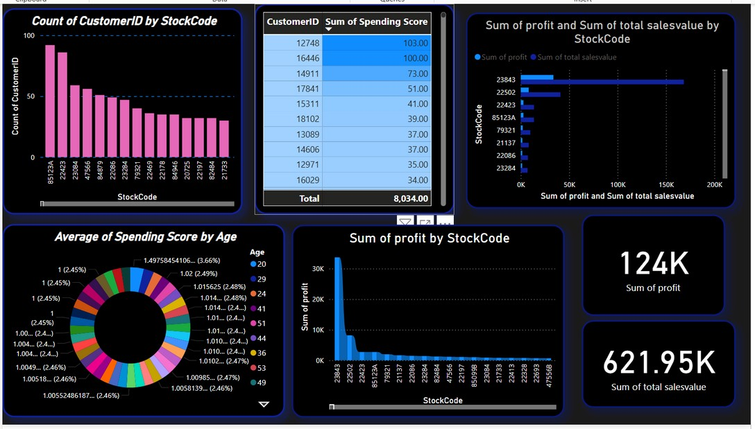

overview
- Bar Chart :
Title: Count of CustomerID by StockCode What it represents:
This chart shows how many unique customers bought each product (represented by StockCode). It helps identify which products are popular based on customer reach.
X-axis: StockCode (product code)
Y-axis: Count of CustomerID (number of customers who purchased that product)
- Table :
Title: CustomerID | Sum of Spending Score What it represents:
A tabular view showing the total spending score for each customer. This metric is likely calculated based on purchase behavior, frequency, or amount.
Shows the CustomerID and their total spending score A grand total at the bottom: 8034
- Clustered Bar Chart :
Title: Sum of profit and Sum of total salesvalue by StockCode What it represents:
This compares profit and total sales value for each product (StockCode). It's useful to identify which products are not only selling but also generating high profit.
Blue bar: Profit
Light blue bar: Total sales value
- Donut Chart :
Title: Average of Spending Score by Age What it represents:
This chart shows the average spending score broken down by age groups. Useful to understand which age demographics are more financially involved.
Inner part: Spending score percentages Outer part: Age labels
- Bar Chart :
Title: Sum of profit by StockCode What it represents:
A focused chart on profit per product (StockCode). This helps identify top profitgenerating products regardless of sales value.
X-axis: StockCode Y-axis: Sum of profit
6. Cards :
124K → Sum of profit
Shows the total profit across all products.
621.95K → Sum of total sales value
Shows the overall total revenue/sales value.

Dashboard 2
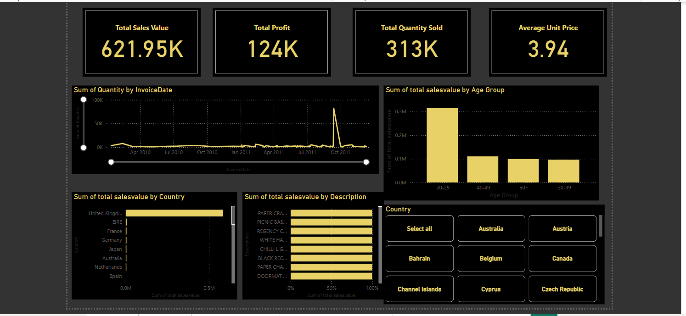

overview
KPI Cards
- Total Sales Value: 621.95K
Represents the cumulative revenue from all sales.
- Total Profit: 124K
Total profit after deducting costs.
- Total Quantity Sold: 313K
Shows the sum of all product quantities sold.
- Average Unit Price: 3.94
Represents the average price per unit sold.
Line Chart :
Title: Sum of Quantity by InvoiceDate Description:
Shows the sales quantity trend over time. This helps in identifying sales spikes or drops, seasonality, or unusual activity (like the spike around Oct 2011).
X-axis: Invoice date (Timeline)
Y-axis: Quantity sold
Bar Chart :
Title: Sum of Total Salesvalue by Age Group Description:
Shows which age group contributes most to the total sales value.
Highest sales: 20–29 age group
Useful for targeting marketing strategies by age demographics.
Bar Chart :
Title: Sum of Total Salesvalue by Country Description:
Displays which countries generate the most revenue.
United Kingdom is the top contributor by a significant margin.
Bar Chart :
Title: Sum of Total Salesvalue by Description Description:
Represents top-selling product descriptions by sales value.
Products like “PAPER CRACKERS” and “PICNIC BASKETS” appear as top performers.
Slicer :
Title: Country Description:
An interactive filter that lets users select one or multiple countries to view their specific sales data. Enhances data exploration and comparison.

Dashboard 3
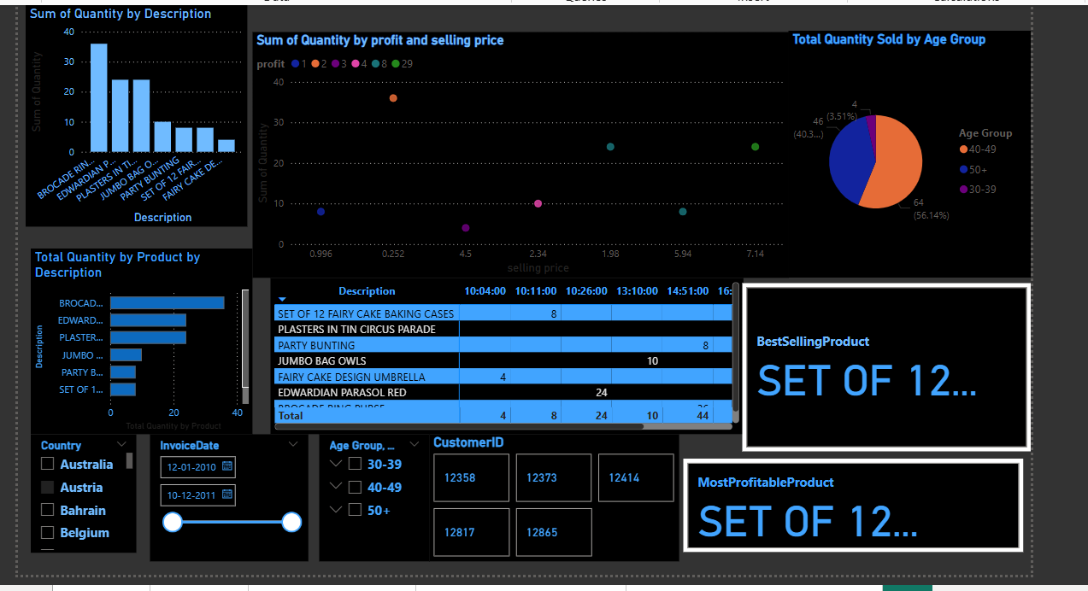
overview
Key KPIs (Right Side Panels)
Best Selling Product: ZINC WIRE...
Indicates this product has the highest quantity sold.
Most Profitable Product: ZINC WIRE...
Same product is generating the most profit, making it a top performer overall.
Charts & Visuals Breakdown
- Bar Chart: Sum of Quantity by Description (Top Left)
Shows which products are sold in the highest quantities. PAPER C... dominates the chart with over 90K units sold.
- Bar Chart: Total Quantity by Product (Bottom Left)
Similar to the previous chart, reinforces the most sold products. Useful for inventory forecasting and restocking decisions.
- Scatter Chart: Quantity by Profit and Selling Price (Top Center)
X-axis: Selling Price
Y-axis: Quantity
Dot color: Profit bracket (e.g., 1 to 19)
Helps identify which price/profit combinations result in higher sales volumes. Dense areas = popular price-profit combos
- Pie Chart: Total Quantity Sold by Age Group (Top Right)
Age group 20–29 leads with 140K units (44.67%)
Important for target audience segmentation and marketing strategies
- Matrix Table (Center)
Shows time-stamped breakdown of product sales.
Can be used to observe patterns over minutes for selected dates or for sales timeline drill-downs.
Filters & Slicers (Bottom Panel)
Country Filter:
Multi-select option for focusing on specific regions (Australia, Austria, etc.) Invoice Date Range Picker:
Adjustable slider for time-based analysis (from Dec 2010 to Dec 2011) Age Group Selector:
Drill down into specific age group behavior.
CustomerID Filter:
Target individual customers to analyze their purchase behavior

Dashboard 4
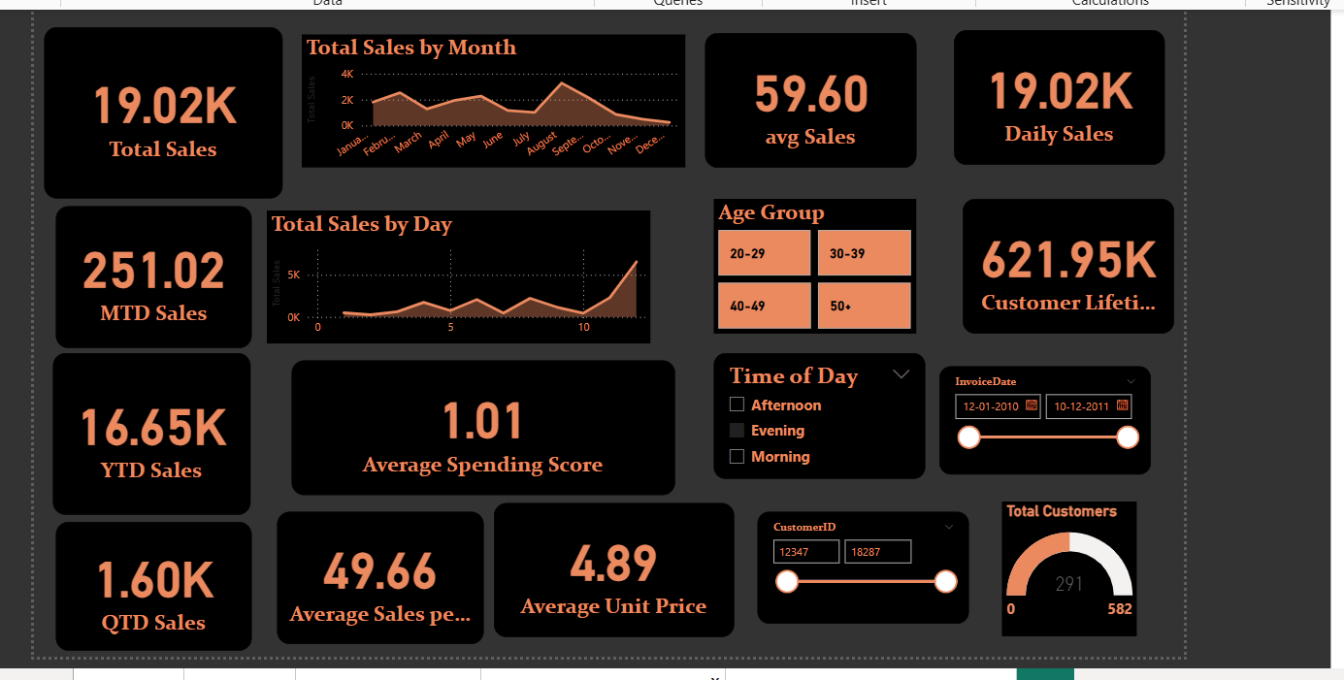
overview
Key Metrics & KPIs (Left Panel)
Total Sales: 621.95K
→ Cumulative sales over the selected period. MTD (Month-To-Date) Sales: 19.05K
→ Sales made in the current month so far.
YTD (Year-To-Date) Sales: 570.45K+
→ Total sales made during the current year. QTD (Quarter-To-Date) Sales: 122.26K → Sales in the current quarter.
Average Spending Score: 1.02
→ Customer behavior indicator (could be a calculated index of frequency + value).
Average Sales per Customer: 79.20
→ Helps evaluate customer purchase strength.
Average Unit Price: 3.94
→ Insights into product pricing trends.
Visuals & Interactive Charts (Center)
Total Sales by Month
Displays monthly trends across the year.
September shows a noticeable sales spike.
Total Sales by Day
Daily sales trends reveal peak sales toward the end of the month.
Customer & Segmentation Filters (Right & Bottom Right)
Age Group Filter:
Segments customers into 20-29, 30-39, 40-49, 50+ for demographic insights.
Time of Day Filter:
Breaks down performance by time slots: Morning, Afternoon, Evening.
Invoice Date Range Slider:
Filter to adjust the period of analysis (from Dec 2010 to Dec 2011).
Customer ID Filter:
Target and analyze specific users (12347, 18287 shown).
Customer Lifetime Value: 621.95K
Shows the overall value of customers across their relationship span.
Total Customers: 2981 (of 5962)
Half of total customers are actively involved in the analysis.

Dahboard 5
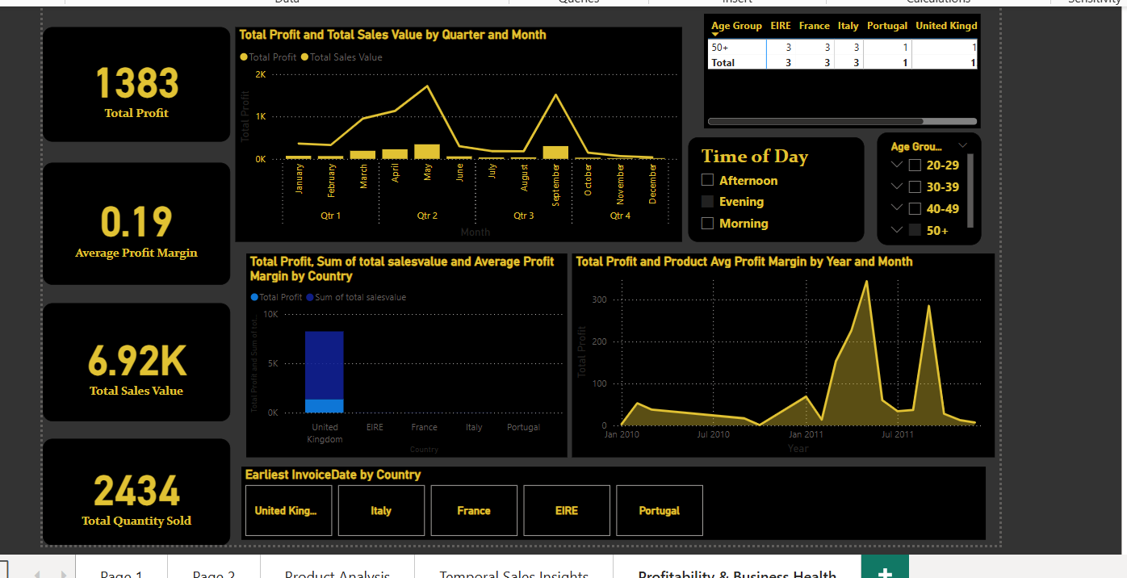

overview
Key Metrics Panel (Left Sidebar)
Total Profit: 124K
→ Overall profit generated during the selected period.
Average Profit Margin: 0.19
→ Profitability ratio (Profit ÷ Sales) indicating low-margin sales.
Total Sales Value: 621.95K
→ Total revenue across all countries and time periods.
Total Quantity Sold: 313K
→ Total number of units sold (used in unit profitability analysis).
Charts & Visuals
Top Center: Profit & Sales Trend by Month and Quarter
Compares Total Profit (bars) vs Sales Value (line) across months.
Highest peak observed in September (Q3).
Seasonality in profitability and revenue can be inferred.
Top Right: Customer Age Group Distribution by Country
A matrix showing customer distribution (counts) per age group and country.
Example:
Australia: 377 customers in the 20–29 range.
Belgium: 170 total customers across age groups. Useful for targeted marketing and segmentation.
Bottom Left: Profit, Sales, and Margin by Country
Bar chart showing:
Blue bars: Total Sales Value
Overlay: Total Profit Highlights:
United Kingdom leads in both sales and profit.
Other countries like Germany, France, and Netherlands have lower figures.
Bottom Right: Profit Margin Over Time (Year & Month)
Line graph showing fluctuations in profit margin and product profit.
Sharp spike around July–September 2011, suggesting either a promotional success or high-margin product launch.

Conclusion:

The data analysis dashboards provide deep insights into customer behavior, product performance, and regional trends. Products like “ZINC WIRE” and “PAPER CRACKERS” emerge as top performers in both quantity and profitability. Age group 20–29 shows the highest engagement, making it ideal for targeted campaigns. Seasonal patterns, especially spikes around September 2011, indicate promotional or market-driven impacts. Overall, the dashboards effectively support strategic decision-making through interactive visuals and comprehensive KPIs.

