Course: Database Management (MIS401)

Section: 2  
Assignment - 1

**Submitted to:**

Nusrat Jahan

Department of Management Information System

School of Business and Entrepreneurship (SBE)

**Submitted By:**

|  |  |  |
| --- | --- | --- |
| Name | ID | Contribution |
| Safwan Sadik | 2210854 | Mother table Members, Child table Resources, and Staff.  Whole Documentation. |
| Ajmain Fayeka Arnob | 2022574 | Child table Borrowing, Fines. |
| Ummay Habiba Anonna | 2210883 | Child table Location, Resource_Location. |

Date of Submission: 13th July 2024

Contents

Proposal: 2

Create Table and Establish Relation: 5

Insert Values into the establish tables: 10

SQL for Queries: 15

# Proposal:

We are creating a complex database schema (company database) for IUB library with one mother table and 6 child tables, and those are Members, Resources, Staff, Borrowing, Fines, Location, Resource_Location, 7 tables in total. Here are the tables:

|  |  |
| --- | --- |
| **Color Labels** | |
|  | Attributes |
|  | Primary key |
|  | Foreign key |
|  | Unique Key |

|  |  |  |  |  |  |  |
| --- | --- | --- | --- | --- | --- | --- |
| **MEMBERS** | | | | | | |
| **Member_Id** | **Name** | **Email** | **Phone_Number** | **Member_Type** | **Fine_Id** | **Resource_Id** |
| 101 | John Doe | [JohnDoe@gmail.com](mailto:JohnDoe@gmail.com) | 1812345678 | Student | 1 | 201 |
| 102 | Jane Smith | [JaneSmith@gmail.com](mailto:JaneSmith@gmail.com) | 1987654321 | Faculty |  | 201 |
| 103 | David Miller | [DavidMiller@gmail.com](mailto:DavidMiller@gmail.com) | 1798563214 | Staff |  | 204 |
| 104 | Sarah Jones | [SarahJones@gmail.com](mailto:SarahJones@gmail.com) | 1612345678 | Student | 2 | 204 |
| 105 | Alice Brown | [AliceBrown@gmail.com](mailto:AliceBrown@gmail.com) | 1456789012 | Student |  | 204 |
| 106 | Michael White | [MichaelWhite@gmail.com](mailto:MichaelWhite@gmail.com) | 1323456789 | Faculty | 3 | 207 |
| 107 | Olivia Garcia | [OliviaGarcia@gmail.com](mailto:OliviaGarcia@gmail.com) | 1298765431 | Staff |  | 207 |

|  |  |  |  |  |  |  |  |
| --- | --- | --- | --- | --- | --- | --- | --- |
| **RESOURCES** | | | | | | | |
| **Resource_Id** | **Title** | **Author** | **Publisher** | **Publication_Year** | **Resource_Type** | **Isbn** | **Call_Number** |
| 201 | Introduction to Algorithms | Thomas H. Cormen et al. | MIT Press | 2022 | Book | 978-0262046300 | QA |
| 202 | The Lord of the Rings trilogy | J.R.R. Tolkien | HarperCollins | 1954-1955 | Book | 978-0261102694 | PR 6039 .Tolkien |
| 203 | Hamlet | William Shakespeare | Various | (Multiple Editions) | Book | N/A | PR 2802 .H2 |
| 204 | Clean Code: A Handbook of Agile Software Craftsmanship | Robert C. Martin | Pearson Education | 2008 | Book | 978-0136695919 | QA 76.6 .M376 2008 |
| 205 | The Catcher in the Rye | J. D. Salinger | Little, Brown and Company | 1951 | Book | 978-0316769482 | PS 3537 .A32 C38 2009 |
| 206 | The Alchemist | Paulo Coelho | HarperCollins | 1988 | Book | 978-0061122413 | PZ 4 .C678 Al 2004 |
| 207 | The Pragmatic Programmer: From Journeyman to Master | Andrew Hunt & David Thomas | Addison-Wesley Professional | 1999 | Book | 0-201-61641-9 | QA 76.6 .H863 1999 |

|  |  |  |  |  |
| --- | --- | --- | --- | --- |
| **STAFF** | | | | |
| **Staff_Id** | **Name** | **Email** | **Phone_Number** | **Staff_Type** |
| 1 | Maria Garcia | [MariaGarcia@gmail.com](mailto:MariaGarcia@gmail.com) | 1598745632 | Librarian |
| 2 | Peter Lee | [PeterLee@gmail.com](mailto:PeterLee@gmail.com) | 1312345678 | Assistant |
| 3 | Emily Jones | [EmilyJones@gmail.com](mailto:EmilyJones@gmail.com) | 1478965432 | Librarian |
| 4 | Charles Brown | [CharlesBrown@gmail.com](mailto:CharlesBrown@gmail.com) | 1256789012 | Assistant |
| 5 | Sarah Miller | [SarahMiller@gmail.com](mailto:SarahMiller@gmail.com) | 1134567890 | Librarian |
| 6 | David White | [DavidWhite@gmail.com](mailto:DavidWhite@gmail.com) | 1987654321 | Assistant |
| 7 | Olivia King | [OliviaKing@gmail.com](mailto:OliviaKing@gmail.com) | 1856789012 | Librarian |

|  |  |  |  |  |  |
| --- | --- | --- | --- | --- | --- |
| **BORROWING** | | | | | |
| **Borrowing_Id** | **Member_Id** | **Resource_Id** | **Borrow_Date** | **Due_Date** | **Return_Date** |
| 1 | 101 | 201 | 2023-07-01 | 2023-07-14 | 2023-07-10 |
| 2 | 102 | 201 | 2023-07-05 | 2023-07-19 | 2023-07-18 |
| 3 | 103 | 204 | 2023-07-07 | 2023-07-21 |  |
| 4 | 104 | 204 | 2023-07-10 | 2023-07-24 |  |
| 5 | 105 | 204 | 2023-07-11 | 2023-07-25 | 2023-07-20 |
| 6 | 106 | 207 | 2023-07-12 | 2023-07-26 | 2023-07-22 |
| 7 | 107 | 207 | 2023-07-13 | 2023-07-27 |  |

|  |  |  |  |
| --- | --- | --- | --- |
| **FINES** | | | |
| **Fine_Id** | **Member_Id** | **Fine_Amount** | **Payment_Date** |
| 1 | 101 | 50 | 2024-01-01 |
| 2 | 104 | 30 |  |
| 3 | 106 | 20.5 | 2024-02-15 |

|  |  |  |
| --- | --- | --- |
| **LOCATION** | | |
| **Location_Id** | **Name** | **Section** |
| 1 | Science Library | QA |
| 2 | Main Library | PR |
| 3 | Commerce Library | PR |
| 4 | Science Library | QA |
| 5 | Main Library | PS |
| 6 | Commerce Library | PZ |
| 7 | Science Library | QA |

|  |  |  |  |
| --- | --- | --- | --- |
| **RESOURCE_LOCATION** | | | |
| **Location_Id** | **Resource_Id** | **Shelf_Number** | **Floor** |
| 1 | 201 | 1A | 2 |
| 2 | 201 | 2B | 1 |
| 3 | 204 | 2C | 1 |
| 4 | 204 | 1B | 2 |
| 5 | 204 | 3A | 1 |
| 6 | 206 | 3B | 1 |
| 7 | 207 | 3C | 1 |

# Create Table and Establish Relation:

Firstly, we create the mother table Members;

After that, we create the Resource table and Fines table which has a relationship with the mother table by Foreign Key resource_id and fine_id respectively;

After that, we created the Borrowing table whom had a relation with the mother table Members and the child table Resources by Foreign Key member_id and resource_id respectively;

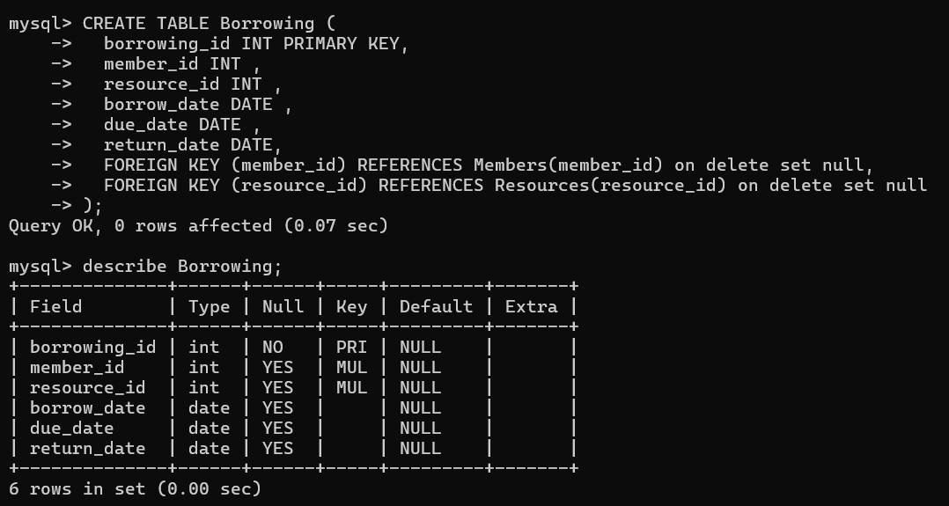

We then created the Location table before the Resource_Location table for establish a relation between these two table by the Foreign Key location_id;

Later, we created the Staff table;

# Insert Values into the establish tables:

Firstly, we insert values in the Resource table for the constraint in relationship between mother and child tables according to the syntax;

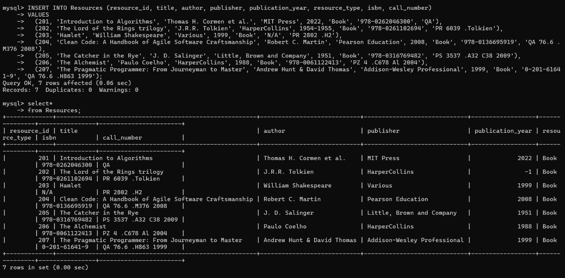

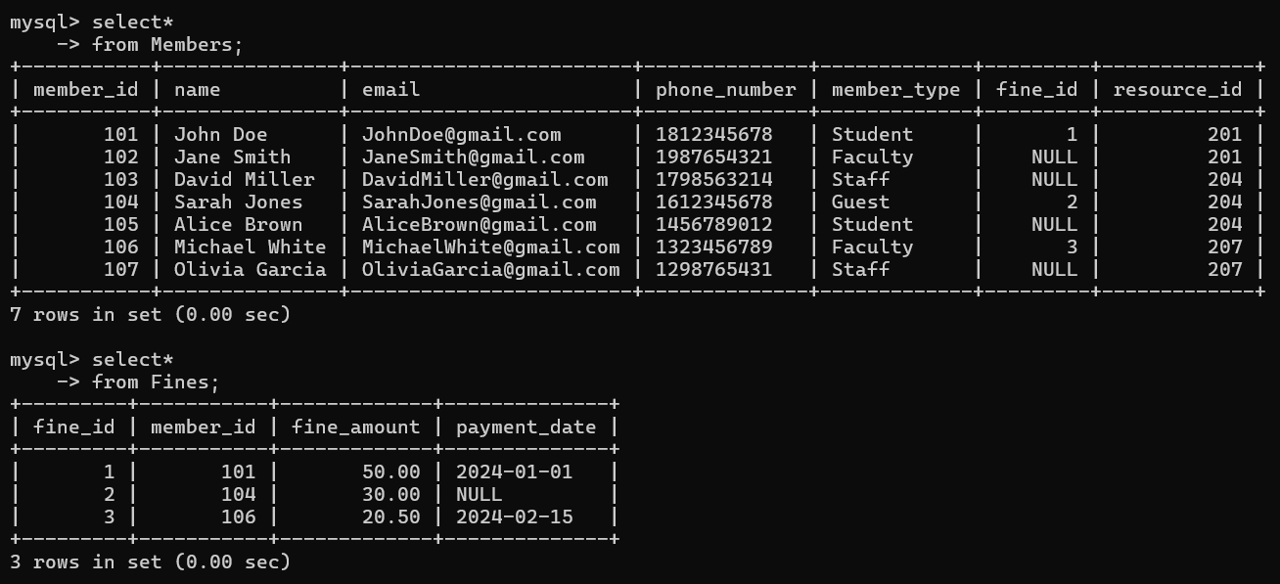

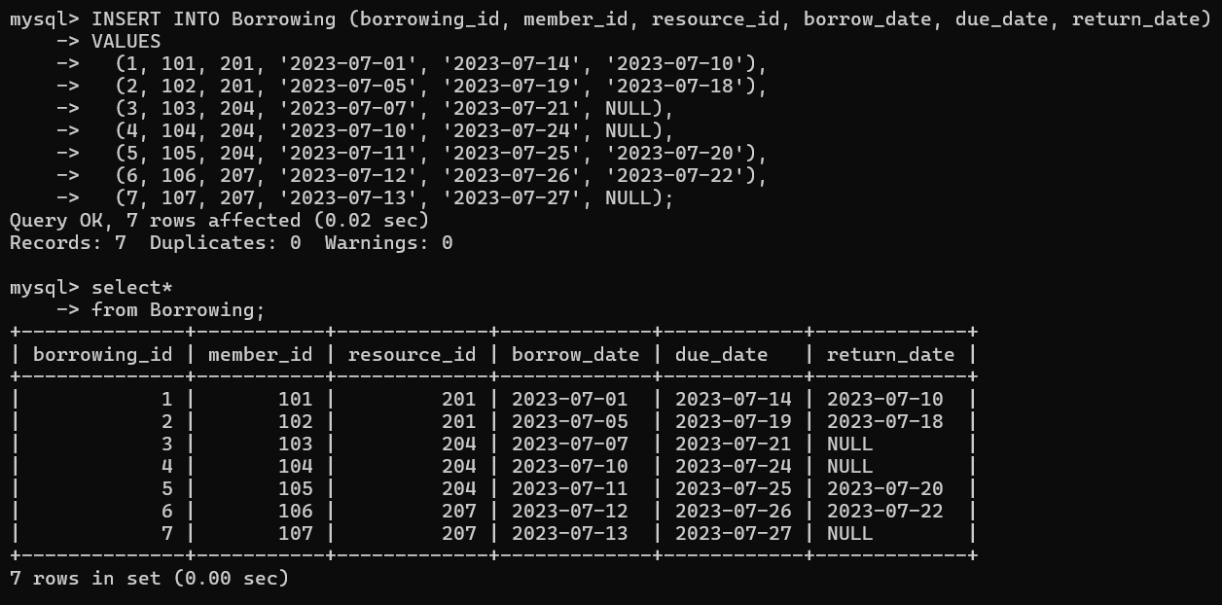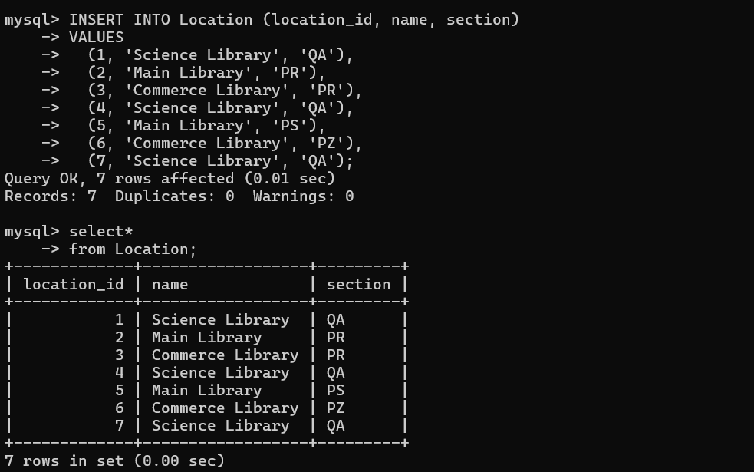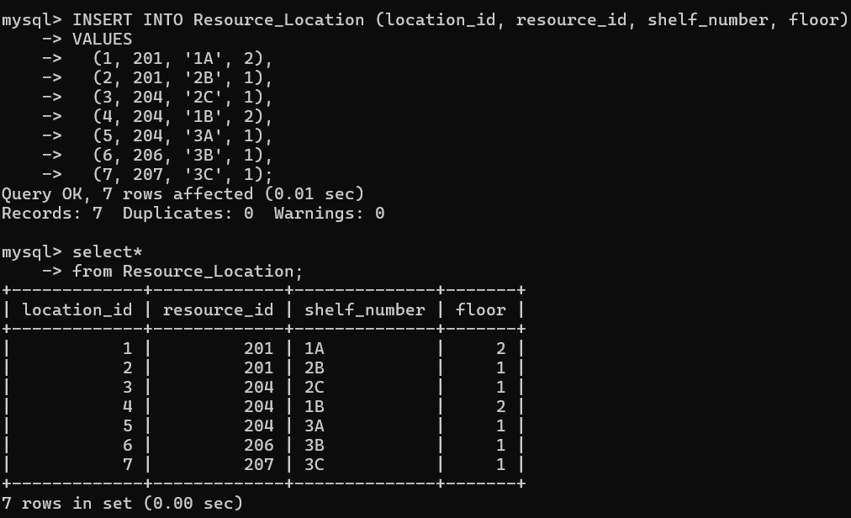

# SQL for Queries:

We did some basic queries using SQL command code; e.g.

