Updates:

So, i am trying to go with a timeless feel - think roman empire. Stoicism. Old timer.
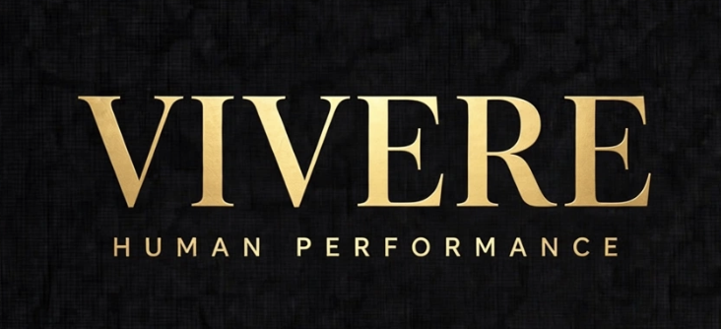

I have 3 coins as well that i want to demonstrate. (Below)

It's not just ‘coaching’ its lifestyle + Health + values

Im not too picky on the UX + Color scheme.

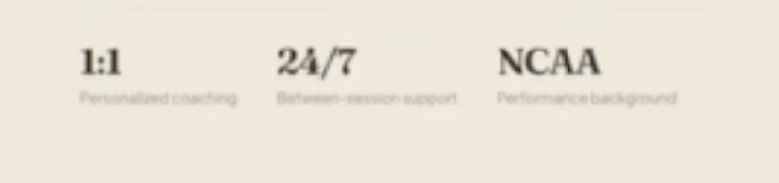

→ Haha the 24/7 and NCAA isnt really needed, i’d say.

→ Buzzwords for this Think: Routine, Habits, Lifestyle, Performance, Health & Wellness, Discipline. Faith, Fitness, Longevity, Motivation, Mindset

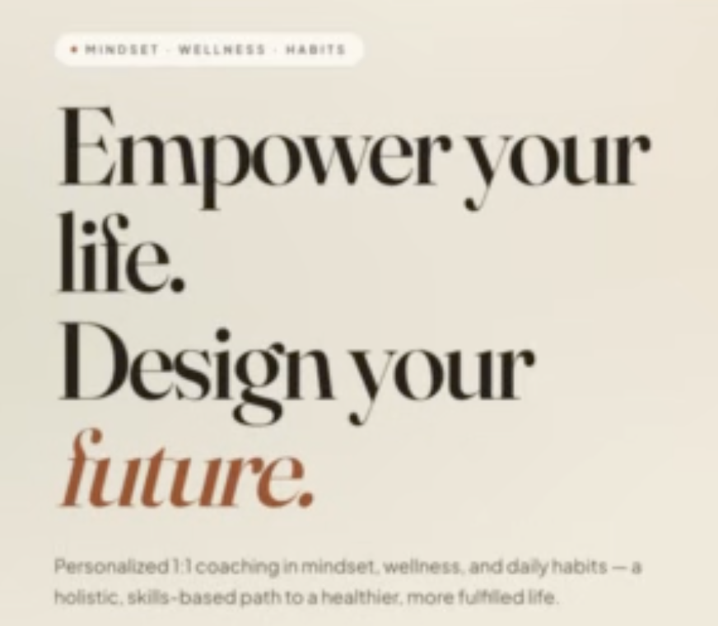

__> Could we have 5 buzzwords? The 2 added being Lifestyle and Faith?

→ How about instead of this tagline above:
Forge your body.
Fortify your mind.
Fuel your future.
Sub: Human performance for others who want to live fully — not just feel better, but become better.
Press on. Stay the Course

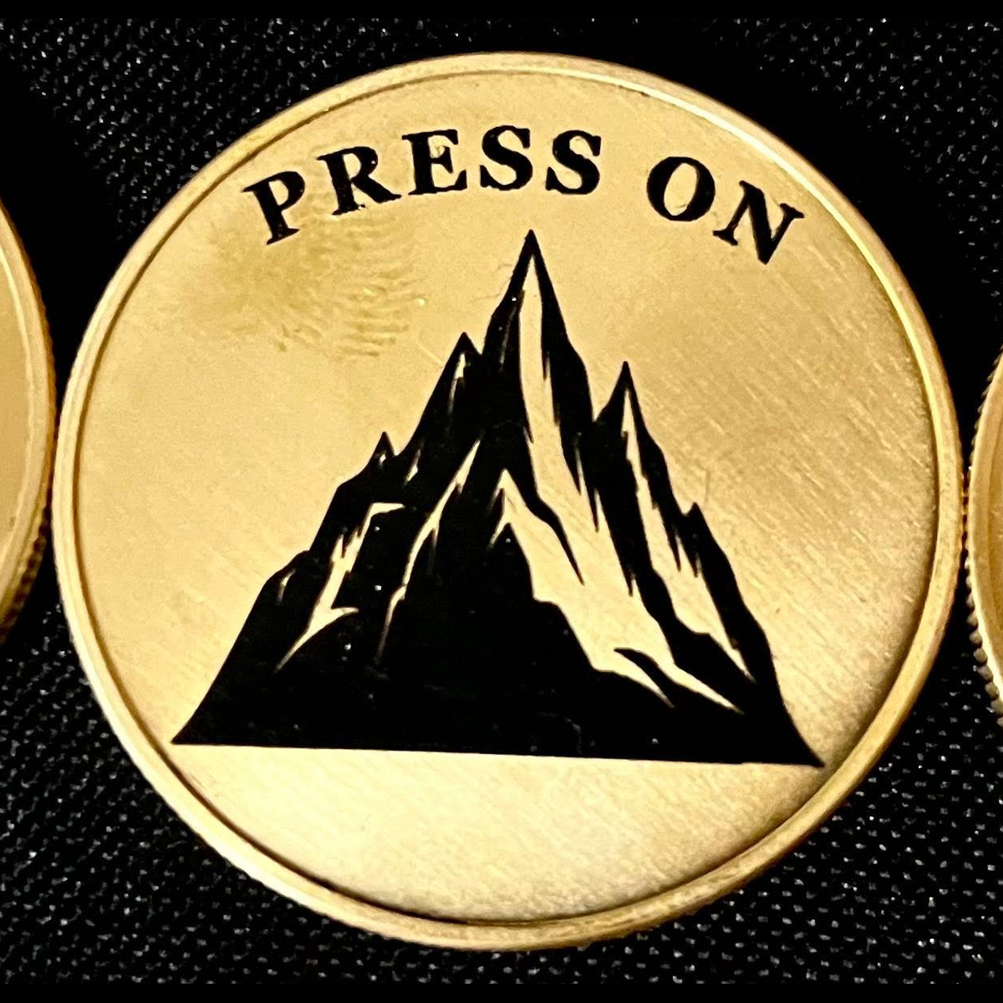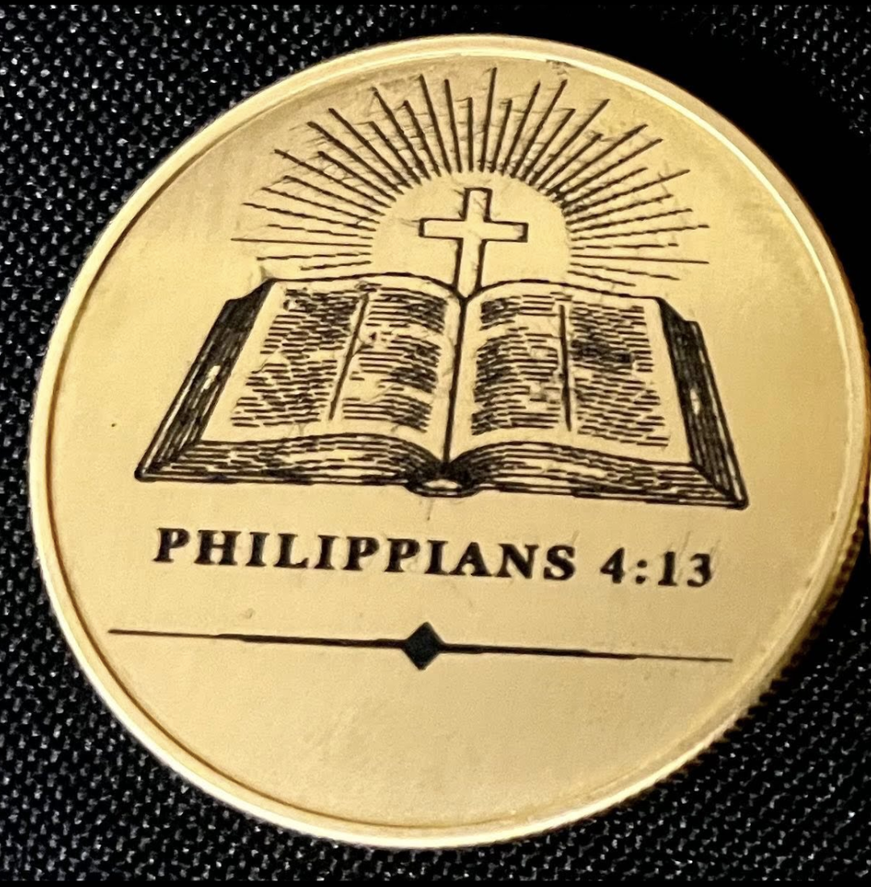
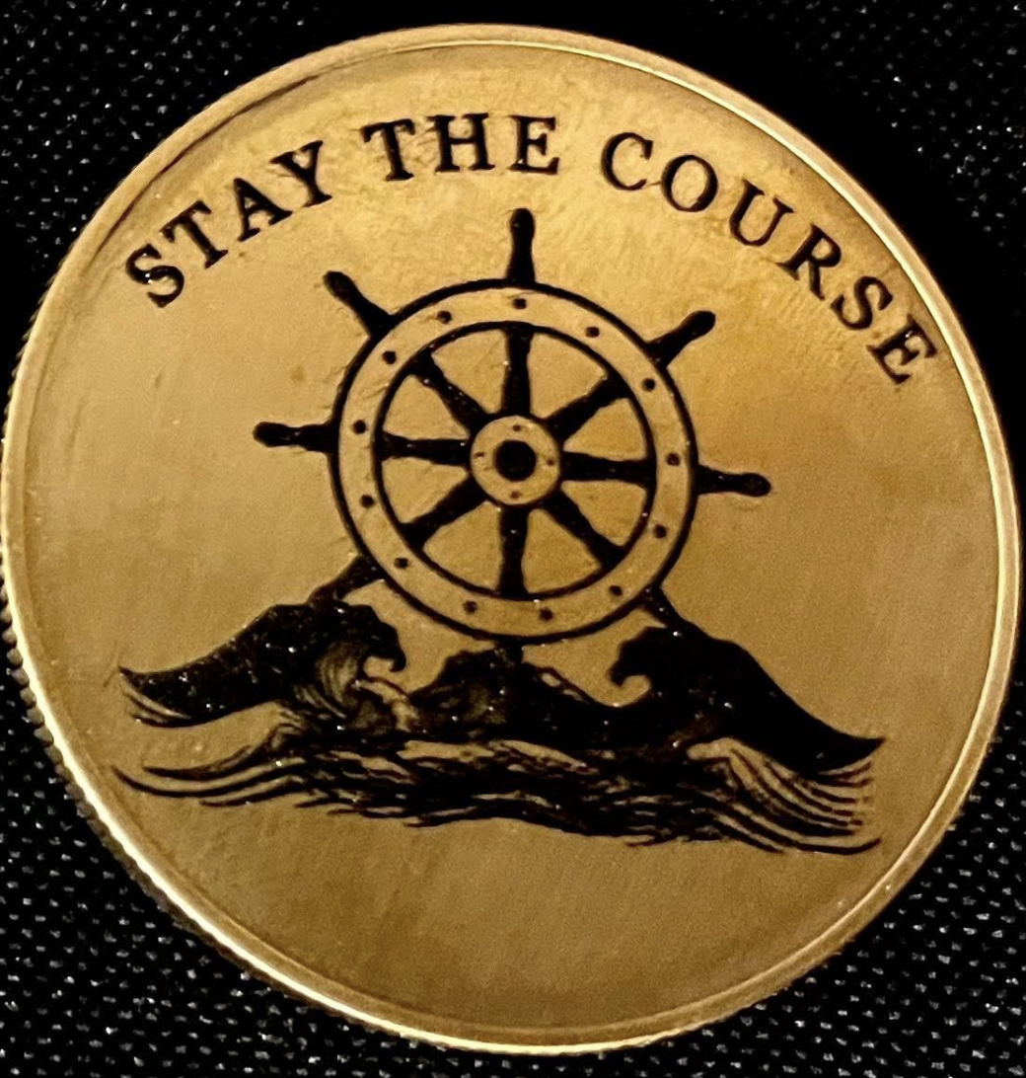

Social Handles somewhere if can?

https://www.linkedin.com/in/samuel-korgi/?skipRedirect=true

https://www.instagram.com/ks_samuel1/

1. Hero — Video 2 at 00:00
Now: FORGE YOUR BODY. FORTIFY YOUR MIND. FUEL YOUR FUTURE.
Change subhead from: Human performance for those who want to live fully...
To: Wellness coaching rooted in discipline and faith — for those who want to build health that lasts, not just look fit.
One line tells me you’re wellness-first.
2. Three Disciplines Section [00:15]
Keep the I / II / III layout, it’s clean. Just rewrite descriptions:
- I. FORGE THE BODY — Wellness-first training. Strength, nutrition, movement, and health habits as the foundation that carries everything else.
- II. FORTIFY THE MIND — Mindset, accountability, and structure. The discipline to stay consistent when motivation fades.
- III. FUEL THE FUTURE — Longevity and purpose. Habits that compound for career, family, and faith — not just 90-day challenges.
That keeps VIVERE’s edge but anchors it in wellness.
3. Coins — Video 2 at 00:20
PRESS ON / STAY THE COURSE / PHILIPPIANS 4:13 is amazing, but feels purely motivational right now. Tie one to health:
- PRESS ON = When you don’t feel like doing the health work — press on.
- STAY THE COURSE = Consistency over intensity. Hold the line on the plan.
- PHILIPPIANS 4:13 = Faith as the anchor.
In your “CARRIED, NOT FRAMED” section, add one line: “Three reminders for the days the wellness work gets heavy.”
4. Ways To Train Together [00:24]
This is where you were losing wellness in VIVERE. Right now it’s: 1:1 Performance, Blueprint, Weekly, Bi-Weekly, Clarity, Speaking — too performance-generic.
Rename to wellness-led offers, using your Video 1 language:
- 01. 1:1 WELLNESS PERFORMANCE COACHING — Your flagship. Keep description but lead with health.
- 02. THE BLUEPRINT — The Wellness Blueprint — a full audit of health, habits, movement, mindset + a plan you can actually run.
- 03. WEEKLY COACHING — For those who need rhythm and accountability to build the habits.
- 04. BI-WEEKLY COACHING — Keep as lighter-touch wellness.
- 05. CLARITY SESSION — Map your health, habits, and where you’re leaking energy. Leave with 3 next steps.
Now it’s 100% wellness, but still VIVERE.
5. Steal From Video 1 and Kill The Rest
From Video 1, steal these 2 things and put them into VIVERE:
- “From first session to self-reliance” 4-step process — That is better than anything in VIVERE’s process section. Use it right under Three Disciplines.
- Testimonial placement — Video 1 had it too low. In VIVERE, put Daniel H.’s quote right after “Ways To Train” — “I wasn’t just given tactics. I was inspired by character... focus was always on my growth, not earning a client.”
Kill from Video 1:
- The beige aesthetic, the “Empower your life. Design your future.” hero, the marquee of “Consistency, Authenticity…” — all generic wellness template stuff. VIVERE’s black/gold already stands out.

TL;DR Blended Brand
Name: VIVERE
Tagline: Wellness & Human Performance
Mission stays: To raise the quality of a life through discipline, faith, and habits built to last.
Positioning sentence: VIVERE is wellness coaching for those who want to stop starting over — we forge the body, fortify the mind, and fuel the future with habits that last.

That way you keep the hard, memorable VIVERE brand you like, but when someone lands, they know in 3 seconds: this guy’s forte is health/wellness, not just motivational performance.
