Predicting Hotel Booking Cancellations and Segmenting Guests
Week 6 Capstone Project: Data Science with Python Internship
Sashi Kant Kumar
YuvaIntern Virtual Internship, 30 July to 10 September 2026
Tools: Python 3, pandas, NumPy, Matplotlib, Seaborn, scikit-learn

Summary
This project follows one question from raw data to a recommendation: which hotel bookings are likely to be cancelled, and what can a hotel do about it? I used the public Hotel Booking Demand dataset, which holds 119,390 bookings from a city hotel and a resort hotel in Portugal. After cleaning, 87,224 bookings remained, and 27.5% of them were cancelled. Exploratory analysis showed that lead time, booking channel and deposit type separate cancelled from kept bookings very clearly. K-Means clustering split the guests into four groups that a revenue manager could treat differently. A Random Forest classifier predicted cancellations with a test ROC-AUC of 0.851, against 0.801 for a logistic regression baseline. The report closes with practical recommendations and an honest list of what the models cannot do.

1. Problem Statement and Objectives
Hotels sell a perishable product. A room that stays empty on a given night cannot be sold the next day to make up for it, so a late cancellation is a direct loss. Hotels try to protect themselves by overbooking, by asking for deposits, or by adding stricter cancellation terms. All three have costs. Overbooking can leave a guest without a room, and strict terms can push customers toward competitors.
A hotel that knows which bookings are risky can respond in a more targeted way. Because I am studying hotel management alongside computer science, this problem sits where both interests meet, which is why I chose it over a generic dataset.
The project has four objectives:
- Build a clean, analysis-ready table from the raw booking records and document every cleaning decision.
- Describe how cancellations vary with lead time, season, market segment, deposit type and hotel type.
- Group bookings into segments with K-Means and describe each segment in plain business terms.
- Train and compare classifiers that predict cancellation, and judge honestly how useful they would be in practice.

2. Methodological Approach
The work followed the same order as the internship weeks, treated as one pipeline. Each stage feeds the next, and decisions made early (such as removing duplicates) change the numbers later on, so I record counts at every step.
Stage | What I did | Main tools
Data acquisition | Downloaded the public CSV and checked its structure | pandas
Cleaning | Handled missing values, duplicates, impossible records and outliers | pandas, NumPy
Feature engineering | Built nights, guest count, revenue, season and room-change features | pandas
Exploratory analysis | Summary statistics, distributions, seasonal and segment comparisons | Matplotlib, Seaborn
Unsupervised learning | K-Means clustering with elbow and silhouette checks, PCA for plotting | scikit-learn
Supervised learning | Logistic Regression and Random Forest with 5-fold cross-validation | scikit-learn
Evaluation | ROC-AUC, F1, confusion matrix, feature importance | scikit-learn

All random operations use random_state=42, so the numbers in this report can be reproduced by running the script in Appendix A.

3. Data Collection
The data is the Hotel Booking Demand dataset described by Antonio, Almeida and Nunes (2019) in the journal Data in Brief. It contains booking records for two hotels in Portugal, a resort hotel in the Algarve region and a city hotel in Lisbon, with arrival dates from July 2015 to August 2017. I downloaded the CSV from the TidyTuesday repository on GitHub (week of 11 February 2020), which republishes the same file.
Each row is one booking. The 32 columns cover the hotel type, the cancellation flag, lead time, arrival date, length of stay, guest counts, meal plan, country, market segment, distribution channel, deposit type, average daily rate (ADR), special requests and the final reservation status. Personal details such as names and contact information were removed by the dataset authors.
import pandas as pd
df = pd.read_csv('hotels.csv')
print(df.shape) # (119390, 32)
print(df.isna().sum()[lambda s: s > 0])
print(df.is_canceled.mean()) # 0.37

The raw file has 119,390 rows and 32 columns, and 37% of the raw bookings were cancelled. That raw figure turns out to be inflated, which I explain in the next section.

4. Data Cleaning and Preprocessing

4.1 Missing values
Four columns contained missing values. I handled each one according to what a missing entry most likely means, rather than applying one rule to all of them.
Column | Missing | Decision and reason
children | 4 | Filled with 0. Only four rows, and a missing child count almost certainly means no children.
country | 488 | Filled with 'Unknown'. A guess would invent information, and 488 rows is too few to matter.
agent | 16,340 | Filled with 'No agent'. A blank means the booking did not come through a travel agent.
company | 112,593 | 94% missing, so the ID itself is useless. Replaced with a 0/1 flag has_company, then dropped.

df['children'] = df['children'].fillna(0)
df['country'] = df['country'].fillna('Unknown')
df['agent'] = df['agent'].fillna(0).astype(int).astype(str).replace('0', 'No agent')
df['has_company'] = (df['company'].fillna(0) != 0).astype(int)
df = df.drop(columns='company')

4.2 Duplicate records
I found 31,994 exact duplicate rows in the raw file, about 27% of the data. After the gaps above were filled, the same step removed 31,998 rows, because a few rows only became identical once their blanks were filled. The cancellation rate fell from 37% to 27.5%, which shows how much the duplicates mattered. Many of the duplicates were cancelled bookings, so leaving them in would have made the hotels look worse than they are and would have taught a model to memorise repeated rows.
This was a judgement call and I want to be upfront about it. The dataset has no booking ID, so a group booking of several identical rooms could look like a duplicate even though it is legitimate. I decided that the risk of inflating results with true duplicates was larger than the risk of dropping a few genuine repeats, and I note it as a limitation in Section 11.
df = df.drop_duplicates()
print(df.shape) # (87392, 32)

4.3 Impossible and extreme values
Three problems showed up in the numeric columns. First, 166 bookings had zero adults, children and babies together, which cannot be real stays, so I removed them. Second, ADR had one negative value and one value of 5,400 euros per night, while the 99th percentile is only 262 euros. Both were removed as data-entry errors, along with anything above 1,000 euros.
Third, ADR was still right-skewed after that. I used the interquartile range rule (upper fence = Q3 + 1.5 × IQR, which is 226.9 euros here) and found 2,507 bookings above it. I did not delete them, because expensive suites during peak season are genuine. Instead I capped them at the fence in a new column, adr_capped, and kept the original ADR column so nothing is lost.
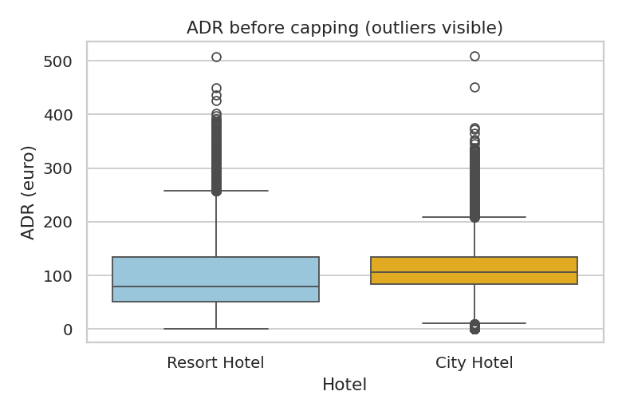
Figure 1. ADR by hotel before capping. Both hotels have a long upper tail of expensive nights.
df = df[(df.adults + df.children + df.babies) > 0]
df = df[(df.adr >= 0) & (df.adr < 1000)]
q1, q3 = df.adr.quantile([.25, .75]); cap = q3 + 1.5*(q3 - q1)
df['adr_capped'] = df.adr.clip(upper=cap)

Lead time reaches 737 days, which is just over two years. That looks odd, but advance bookings for events or corporate contracts exist, so I kept these rows. Tree-based models handle them without trouble, and for the models that need scaling I standardise the feature.

4.4 Cleaning summary
Step | Rows after step
Raw file | 119,390
After removing duplicates | 87,392
After removing zero-guest bookings | 87,226
After removing impossible ADR values | 87,224

Cleaning removed about 27% of the rows. Every later number in this report comes from the remaining 87,224 bookings.

5. Feature Engineering
I added features that a hotel manager would think about naturally, rather than only transforming what was already there.
New feature | How it is built | Why it helps
total_nights | weekend nights + week nights | One measure of stay length
total_guests | adults + children + babies | Party size in one number
revenue | adr_capped × total_nights | Approximate booking value
month_num | arrival month name mapped to 1 to 12 | Lets models and plots use season in order
has_kids | 1 if any children or babies | Family travel behaves differently
room_changed | reserved room type differs from assigned | Used only for EDA, see note below
has_company | 1 if a company ID was present | Replaces a mostly empty ID column

I deliberately kept room_changed out of the prediction model. The assigned room type is only known at check-in, which happens after a cancellation would already have occurred. The same reasoning applies to reservation_status and reservation_status_date, which literally contain the answer. Leaving them in would have given a near-perfect score and a useless model. This is the kind of data leakage that is easy to miss, and removing these columns lowered my accuracy to a figure that is honest.

6. Exploratory Data Analysis

6.1 Hotel type and lead time
The city hotel supplies most of the bookings (53,273 versus 33,951) and also has the higher cancellation rate, 30.1% against 23.5% at the resort. Resort guests stay longer on average (4.4 nights against 3.1), which fits a holiday destination versus a business or short-break city.
Lead time is strongly right-skewed. The median is 49 days, but the mean is 80 because a minority of guests book many months ahead.
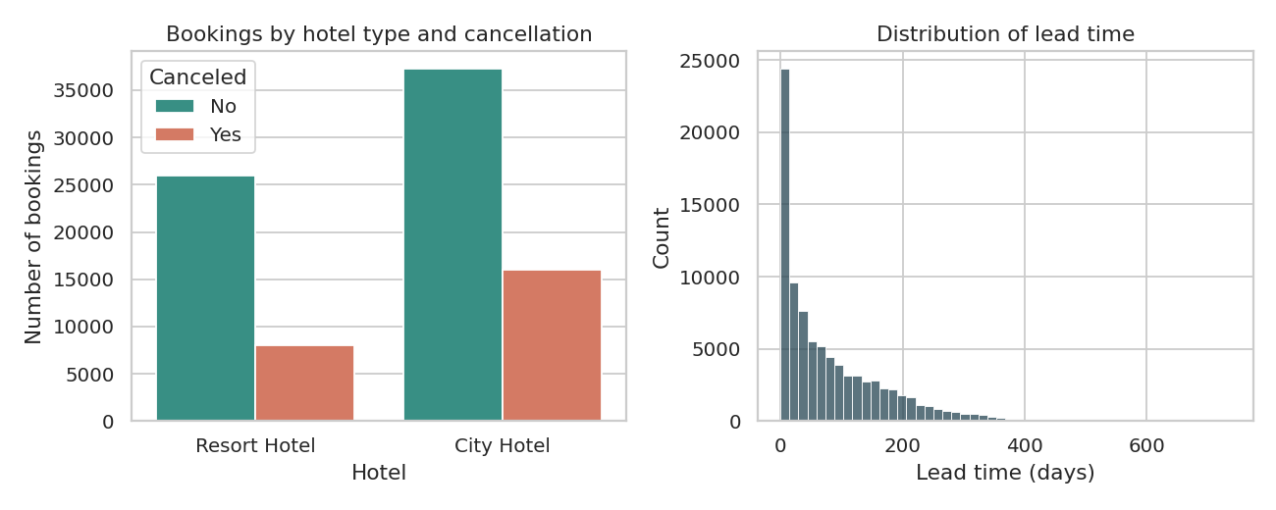
Figure 2. Bookings by hotel type and cancellation status (left) and the distribution of lead time (right).

6.2 Seasonality
Both ADR and booking volume peak in summer. Across the two hotels, August is the most expensive month (146.9 euros on average) and January the cheapest (70.2 euros). The resort drives most of this swing. Its ADR climbs from 49.2 euros in January to 178.6 euros in August, while the city hotel stays within a narrower band of 85.2 to 127.3 euros. That matches the nature of each property: a beach resort has a strong peak season, and a city hotel is used throughout the year.
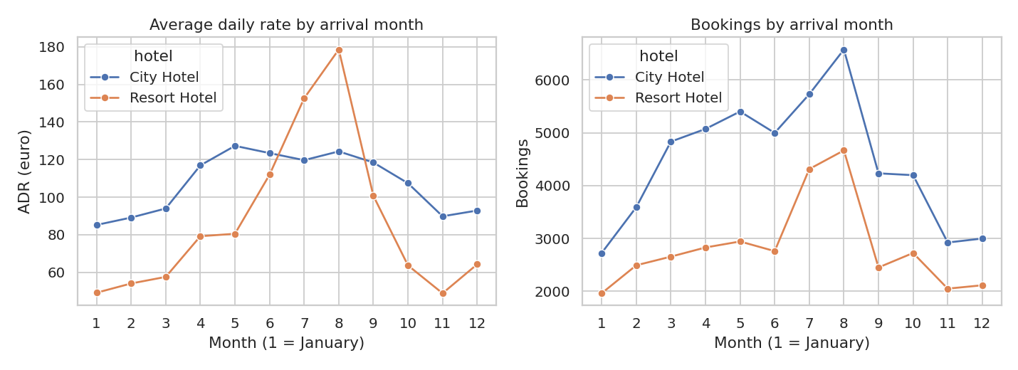
Figure 3. Average daily rate (left) and number of bookings (right) by arrival month for each hotel.

6.3 Who cancels
Market segment is the clearest separator. Online travel agent bookings are cancelled 35.4% of the time, and they make up more than half of all bookings (51,553). Corporate (12.1%), direct (14.7%) and offline agent bookings (14.8%) are far steadier. A plausible reason is that online platforms often offer free cancellation, so a guest can reserve several options and drop the extras.
Deposit type shows an odd result. Bookings with a non-refundable deposit were cancelled 94.7% of the time, while ordinary no-deposit bookings were cancelled 26.7%. My first reaction was that this makes no sense, since people should not abandon money they cannot get back. Only 1,037 bookings fall in this group, and it is concentrated in particular channels, so I read it as a quirk of how those bookings were recorded or sold, probably group or agent contracts that are later released, and not as evidence that deposits fail to work. I would not draw a policy conclusion from it without more data.
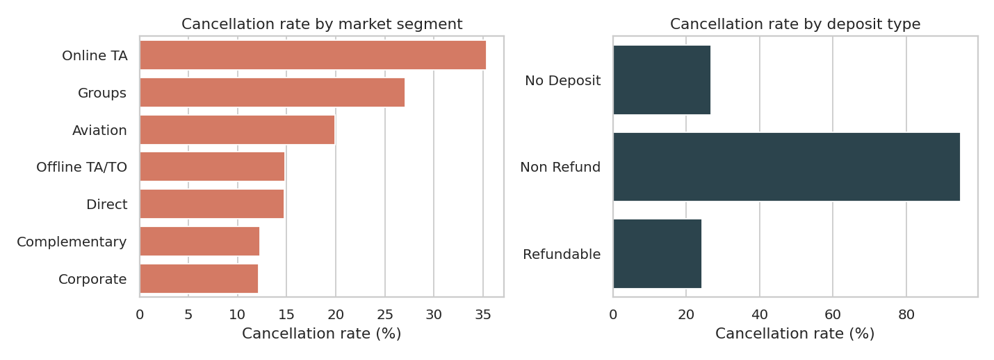
Figure 4. Cancellation rate by market segment (left) and by deposit type (right).
Lead time behaves the way intuition suggests. Bookings made within a week of arrival are cancelled only 8.4% of the time, and the rate rises steadily to 39.7% for bookings made six months to a year ahead. People who book far in advance have more time for their plans to change.
The correlation matrix agrees. Lead time has the largest positive correlation with cancellation (0.185), followed by ADR (0.136). Special requests (-0.121) and required parking spaces (-0.184) are negatively related, so guests who have taken the trouble to ask for something are less likely to cancel. All the correlations are modest, which is a warning that no single variable will predict cancellation well on its own.
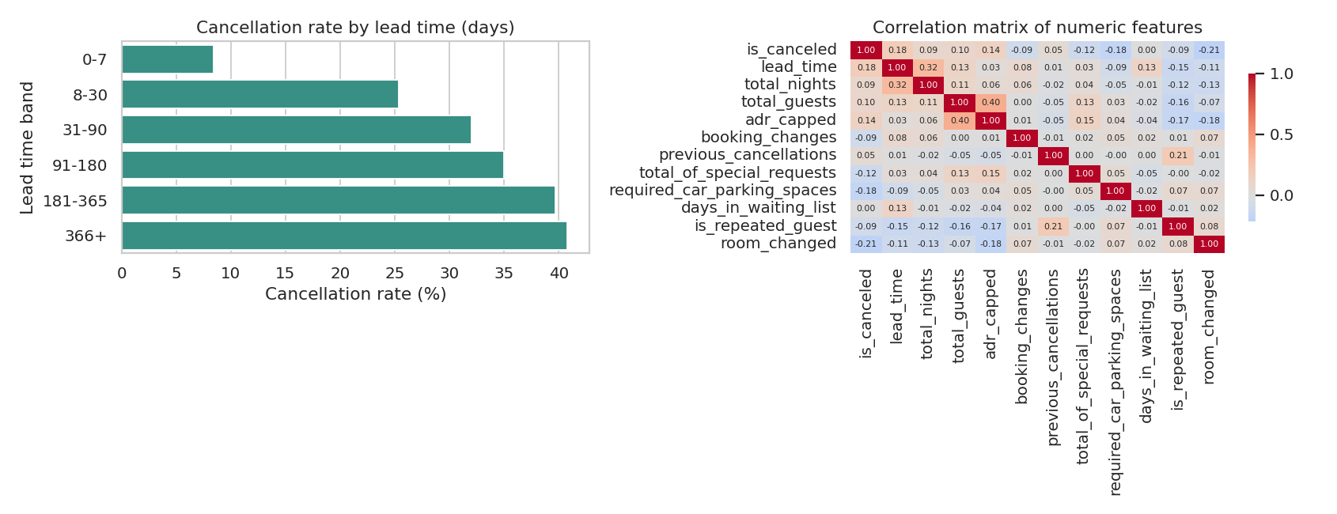
Figure 5. Cancellation rate by lead time band (left) and correlation matrix of numeric features (right).
One country effect is worth noting. Portuguese guests (the largest group at 27,350 bookings) cancel 35.8% of the time, compared with about 19.0% for British and 19.6% for French guests. Part of this is probably the booking channel mix, so I treat it as a hint and not a cause.

7. Unsupervised Learning: Guest Segmentation

7.1 Setup
I clustered on six behavioural features: lead time, total nights, total guests, capped ADR, special requests and booking changes. I left cancellation out of the inputs, so the clusters describe how guests book and I can then check afterwards whether the groups differ in cancellation. The features have very different scales (lead time runs to hundreds, special requests to five), so I standardised them first. Without that step, lead time would dominate the distance calculation.
cf = ['lead_time','total_nights','total_guests','adr_capped',
'total_of_special_requests','booking_changes']
X = StandardScaler().fit_transform(df[cf])
for k in range(2, 9):
km = KMeans(n_clusters=k, n_init=10, random_state=42).fit(X)
inertia.append(km.inertia_)
sil.append(silhouette_score(X[idx], km.labels_[idx])) # 8,000-row sample

7.2 Choosing the number of clusters
The elbow plot bends gently and has no sharp corner. The silhouette score peaks at k = 4 with a value of 0.233, and drops to 0.18 at k = 7. I chose four clusters because it has the best silhouette and still gives groups that are small enough in number to explain to a manager.
I should be clear about the weakness here. A silhouette score of 0.22 is low. Scores near 1 indicate tight, well-separated clusters, and scores around 0.2 mean the groups overlap a lot. Guest behaviour changes smoothly, with no natural gaps, so K-Means is cutting a continuous cloud into regions and not discovering hard boundaries. I used the clusters as a practical way to organise the data, and I would not claim they are naturally occurring species of guest. The silhouette was computed on a random sample of 8,000 rows to keep the run time reasonable.
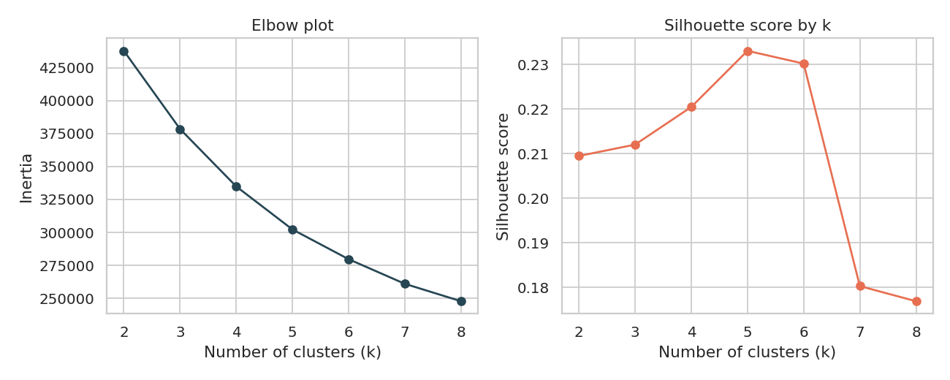
Figure 6. Elbow plot (left) and silhouette scores (right) for k from 2 to 8.

7.3 Cluster profiles
Cluster | Bookings | Lead (days) | Nights | Guests | ADR (euro) | Requests | Changes | Cancelled
0: Premium parties | 22,235 | 63.5 | 3.51 | 2.64 | 158.71 | 1.21 | 0.14 | 30.0%
1: Short-notice budget stays | 41,539 | 34.92 | 2.55 | 1.71 | 81.7 | 0.45 | 0.13 | 22.0%
2: Early planners, long stays | 18,632 | 193.86 | 6.04 | 2 | 94.71 | 0.63 | 0.15 | 38.0%
3: Frequent changers | 4,818 | 103.96 | 4.12 | 2.04 | 107.3 | 0.75 | 2.56 | 19.0%

Cluster 0, premium parties. These bookings have the highest rate (about 158.71 euros), the largest groups (2.64 guests on average) and the most special requests. They are mid-range in lead time and cancel at 30.0%, close to the overall average. A hotel would want to protect this group with good service and flexible upgrades.
Cluster 1, short-notice budget stays. The biggest cluster at 41,539 bookings. Guests book about 35 days ahead, stay 2.55 nights, travel as couples or singles and pay the lowest rate. This group cancels least (22.0%), probably because the short gap between booking and arrival leaves little time for plans to change.
Cluster 2, early planners with long stays. These guests book about 194 days ahead and stay 6.04 nights. They cancel most, at 38.0%. Almost half of them are at the resort, which fits a long summer holiday planned far in advance. For revenue managers this is the segment where overbooking or deposit rules matter most.
Cluster 3, frequent changers. A small group of 4,818 bookings that modified their reservation about 2.56 times on average. They cancel only 19.0%. Changing a booking is a sign of engagement: these guests are adjusting plans, not walking away.
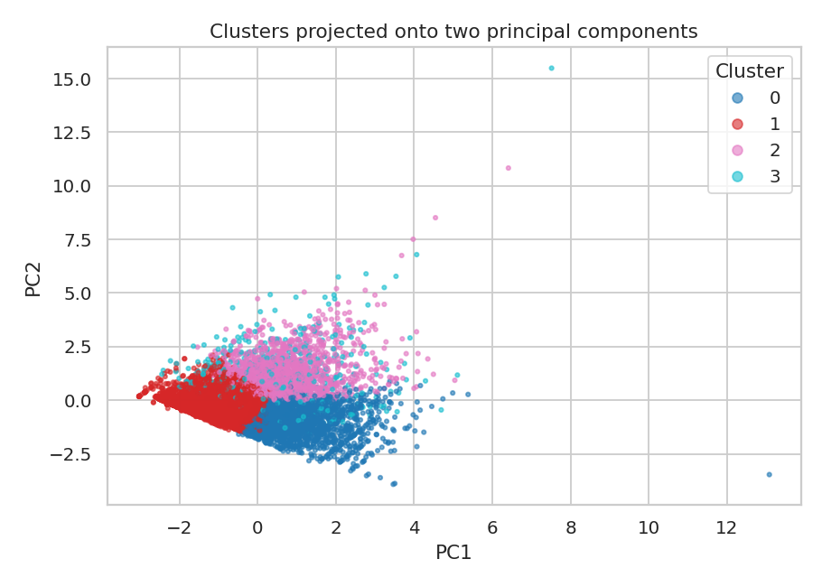
Figure 7. Clusters projected onto the first two principal components (together 47% of the variance, on an 8,000-booking sample).
The overlap in the plot confirms what the silhouette score said. The groups are distinguishable on average but not cleanly separated.

8. Supervised Learning: Predicting Cancellation

8.1 Problem definition and features
The task is binary classification: given what a hotel knows at the moment of booking, predict whether the booking will be cancelled. The features are 14 numeric columns (lead time, nights, guests, capped ADR, previous cancellations, booking changes, special requests, parking, season and others) and 6 categorical columns (hotel, meal, market segment, distribution channel, deposit type, customer type). I split the data 80/20 with stratification, giving 69,779 training and 17,445 test bookings. Numeric columns are scaled and categorical columns are one-hot encoded inside a scikit-learn Pipeline, so the test data never influences the preprocessing.
pre = ColumnTransformer([
('num', StandardScaler(), feat_num),
('cat', OneHotEncoder(handle_unknown='ignore'), feat_cat)])
lr = Pipeline([('pre', pre), ('m', LogisticRegression(max_iter=1000))])
rf = Pipeline([('pre', pre), ('m', RandomForestClassifier(
n_estimators=200, min_samples_leaf=5, n_jobs=-1, random_state=42))])
cv = StratifiedKFold(5, shuffle=True, random_state=42)
scores = cross_val_score(model, Xtr, ytr, cv=cv, scoring='roc_auc')

8.2 Why these two models
Logistic regression is my baseline. It is fast, easy to explain and shows how far a purely linear relationship gets. A Random Forest can capture interactions, such as long lead time mattering more for online agent bookings, without me specifying them. I set min_samples_leaf=5 to stop individual trees from memorising small groups of bookings. I did not run a large hyperparameter search, which I mention under future work.

8.3 Results
Metric | Logistic Regression | Random Forest
5-fold CV ROC-AUC (training data) | 0.796 ± 0.003 | 0.845 ± 0.003
Test ROC-AUC | 0.801 | 0.851
Test accuracy | 0.786 | 0.809
Test F1 (cancelled class) | 0.505 | 0.579
Precision (cancelled) | 0.695 | 0.737
Recall (cancelled) | 0.396 | 0.476

The Random Forest wins on every measure. Its cross-validation and test AUC agree closely (0.845 and 0.851), and the standard deviation across folds is only 0.003, so the result does not depend on one lucky split. A model that always predicts "not cancelled" would score 72.5% accuracy, so the Random Forest's 80.9% is a real but modest improvement. AUC is the fairer headline number here because the classes are imbalanced.
Random Forest, test set | Predicted kept | Predicted cancelled
Actually kept | 11,829 | 814
Actually cancelled | 2,516 | 2,286

The confusion matrix shows the model's main weakness. It catches 47.6% of real cancellations (recall) and is right 73.7% of the time when it flags one (precision). More than half of the cancellations slip through. The model is good at being sure about bookings that will stay and cautious about flagging cancellations, which is the safer direction for a hotel that does not want to turn away or penalise loyal guests.
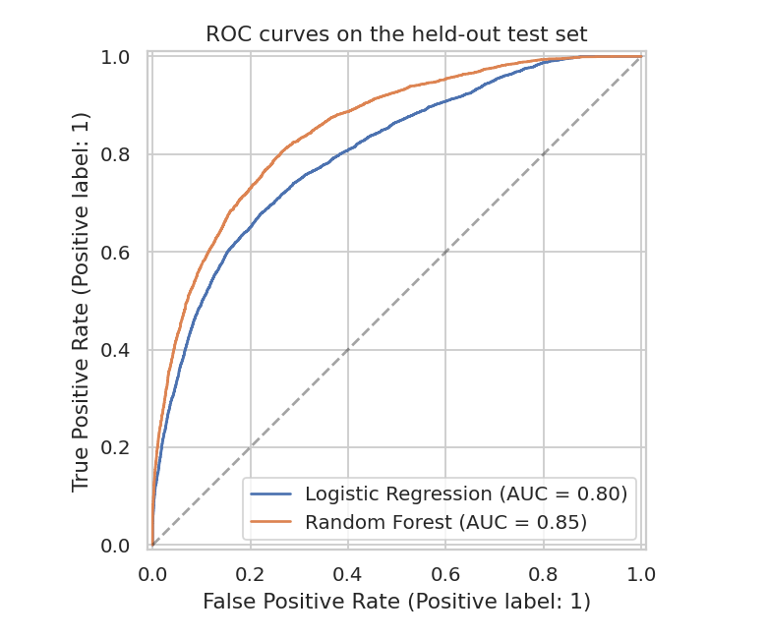
Figure 8. ROC curves on the held-out test set. The Random Forest curve sits above the logistic regression curve across most thresholds.

8.4 What drives the predictions
Lead time is the strongest predictor (importance 0.2), followed by the number of special requests (0.12), ADR (0.099), the online travel agent segment (0.074) and required parking spaces (0.073). This matches the EDA closely, which is reassuring: the model has found the same patterns that the plots showed, not something strange. Importance scores tell us which features the forest used, not which features cause cancellation, so I treat them as a guide for where to look.
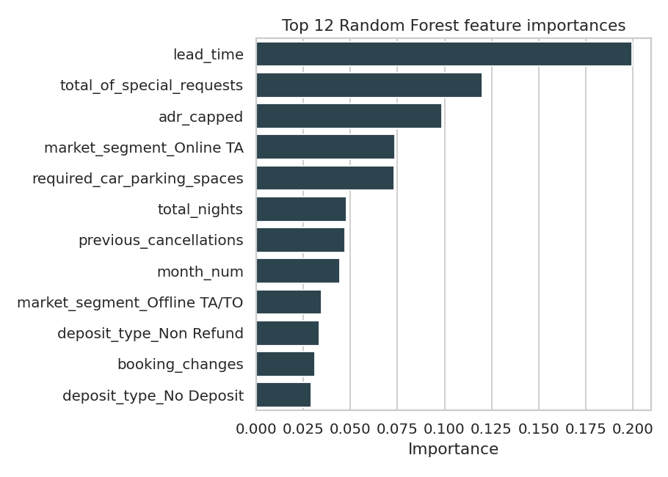
Figure 9. The twelve most important features in the Random Forest.

9. Evaluation of the Whole Pipeline
Looking back across the stages, the decisions that changed the outcome most were not the modelling ones. Removing duplicates moved the cancellation rate by almost ten percentage points. Dropping the leaking columns cut the apparent accuracy to something believable. The choice between logistic regression and a Random Forest changed AUC by about 0.05.
The two modelling halves also say different things. The supervised model works reasonably well (AUC 0.851) and the clustering works only so-so (silhouette 0.22). That is a fair description of the data: cancellation depends on a handful of strong signals that a classifier can use, while guest types blur into each other.
I would not use the classifier to automatically reject or penalise anyone. At 48% recall and 74% precision, it is a screening tool that tells a revenue manager where to look first.

10. Insights and Recommendations
Treat online agent bookings with long lead times as the highest-risk group. Online travel agent bookings cancel at 35.4%, and bookings made more than six months ahead cancel at nearly 40%. A hotel could reconfirm these closer to arrival, or offer a small discount for a non-refundable rate at the time of booking.
Use the risk score to guide overbooking carefully. If a hotel overbooks a little in the weeks where predicted cancellations are highest, it can recover some of the lost revenue. Because recall is under 50%, the overbooking margin should stay small and be checked against the hotel's own history.
Protect the premium cluster. Guests in Cluster 0 pay about 158.71 euros per night, nearly double the budget cluster. They do not cancel much more than average, so the focus should be on service quality and room upgrades and not on tightening policies.
Plan the resort and the city hotel differently. The resort's rate more than triples between January and August, so its pricing and staffing should follow the season closely. The city hotel is steadier and needs promotions to hold occupancy through the winter months, when its ADR is lowest.
Encourage engagement. Guests who add special requests or modify their booking rarely cancel. A pre-arrival email asking about preferences could both improve their stay and give a hotel an early signal of commitment.

11. Challenges, Limitations and Reflection

11.1 Challenges I ran into
The duplicates were the biggest surprise. Left in, they pushed the cancellation rate to 37%, and any model trained on them would have been scored partly on rows it had already seen. Checking for duplicates early settled the numbers. The second challenge was spotting leakage. Reservation status plainly contains the answer, but the assigned room type looks innocent until you think about when the hotel learns it. The third was the non-refundable deposit result, which made no sense at first and taught me that a strange number is a prompt for investigation, not a finding.

11.2 Limitations
- The data covers only two Portuguese hotels over two years, so the patterns may not transfer to other countries or the years since 2017.
- Removing duplicates without a booking ID may have deleted a few genuine group bookings.
- The clustering has a low silhouette score, so the segments are a convenient description and not sharp categories.
- The classifier misses more than half of the cancellations, and I did not tune its hyperparameters or its decision threshold.
- Prediction is not causation. Nothing here shows that changing a deposit rule would change guest behaviour.

11.3 What I would do next
With more time I would tune the Random Forest and compare it with gradient boosting, move the decision threshold to trade precision against recall, and try DBSCAN or a Gaussian mixture model on the segmentation. I would also train on the first year and test on the second, which is a harder and more realistic test than a random split, because a hotel would use the model on future bookings. The full pipeline is in the script in Appendix A, so each of these changes is a small edit.

11.4 Personal reflection
I came into this internship from a computer science background and I am now studying hotel management, so this project was the first time the two felt like one subject. The most useful lesson was that the business question shapes every technical choice, from which columns count as leakage to which error is more costly. I also learned to report weak results plainly, such as the low silhouette score, instead of hoping nobody checks.

References
- Antonio, N., de Almeida, A. and Nunes, L. (2019). Hotel booking demand datasets. Data in Brief, 22, 41-49.
- Hunter, J. D. (2007). Matplotlib: A 2D graphics environment. Computing in Science and Engineering, 9(3), 90-95.
- McKinney, W. (2010). Data structures for statistical computing in Python. Proceedings of the 9th Python in Science Conference, 56-61.
- Pedregosa, F. et al. (2011). Scikit-learn: Machine learning in Python. Journal of Machine Learning Research, 12, 2825-2830.
- Rousseeuw, P. J. (1987). Silhouettes: a graphical aid to the interpretation and validation of cluster analysis. Journal of Computational and Applied Mathematics, 20, 53-65.
- Breiman, L. (2001). Random forests. Machine Learning, 45(1), 5-32.
- Waskom, M. L. (2021). seaborn: statistical data visualization. Journal of Open Source Software, 6(60), 3021.
- TidyTuesday (2020). Hotel bookings, week of 2020-02-11. https://github.com/rfordatascience/tidytuesday

Appendix A. Complete Reproducible Code
Save the script as capstone.py in the same folder as hotels.csv and run python capstone.py. It reproduces every number and figure in this report and writes the figures to a figs folder. Python 3.10 or newer is needed with pandas, numpy, matplotlib, seaborn and scikit-learn installed.
import pandas as pd, numpy as np, json, warnings
import matplotlib; matplotlib.use("Agg")
import matplotlib.pyplot as plt, seaborn as sns
from sklearn.preprocessing import StandardScaler
from sklearn.cluster import KMeans
from sklearn.metrics import silhouette_score, roc_auc_score, classification_report, confusion_matrix, RocCurveDisplay, accuracy_score, f1_score
from sklearn.model_selection import train_test_split, cross_val_score, StratifiedKFold
from sklearn.linear_model import LogisticRegression
from sklearn.ensemble import RandomForestClassifier
from sklearn.pipeline import Pipeline
from sklearn.compose import ColumnTransformer
from sklearn.preprocessing import OneHotEncoder
warnings.filterwarnings("ignore")
sns.set_theme(style="whitegrid"); R = {}

# 1. LOAD
df = pd.read_csv("hotels.csv")
R["raw_shape"] = df.shape
R["missing"] = df.isna().sum()[lambda s: s > 0].to_dict()
R["cancel_rate_raw"] = round(df.is_canceled.mean()*100, 1)
R["dups"] = int(df.duplicated().sum())

# 2. CLEAN
df["children"] = df["children"].fillna(0)
df["country"] = df["country"].fillna("Unknown")
df["agent"] = df["agent"].fillna(0).astype(int).astype(str).replace("0", "No agent")
df["company"] = df["company"].fillna(0)
df["has_company"] = (df["company"] != 0).astype(int)
df = df.drop(columns="company")
df = df.drop_duplicates()
R["after_dups"] = df.shape[0]
guests0 = int(((df.adults + df.children + df.babies) == 0).sum())
df = df[(df.adults + df.children + df.babies) > 0]
R["zero_guests_removed"] = guests0
R["adr_neg"] = int((df.adr < 0).sum())
R["adr_q99"] = float(df.adr.quantile(.99)); R["adr_max"] = float(df.adr.max())
R["adr_gt1000"] = int((df.adr > 1000).sum())
df = df[(df.adr >= 0) & (df.adr < 1000)]
q1, q3 = df.adr.quantile([.25, .75]); iqr = q3-q1
cap = q3 + 1.5*iqr; R["adr_iqr_cap"] = float(cap); R["adr_above_cap"] = int((df.adr > cap).sum())
df["adr_capped"] = df.adr.clip(upper=cap)
R["lead_max"] = int(df.lead_time.max())
R["clean_shape"] = df.shape
R["cancel_rate"] = round(df.is_canceled.mean()*100, 1)

# 3. FEATURES
months = ["January","February","March","April","May","June","July","August","September","October","November","December"]
df["month_num"] = df.arrival_date_month.map({m:i+1 for i,m in enumerate(months)})
df["total_nights"] = df.stays_in_weekend_nights + df.stays_in_week_nights
df["total_guests"] = df.adults + df.children + df.babies
df["revenue"] = df.adr_capped * df.total_nights
df["room_changed"] = (df.reserved_room_type != df.assigned_room_type).astype(int)
df["has_kids"] = ((df.children + df.babies) > 0).astype(int)

# 4. EDA
R["by_hotel"] = df.groupby("hotel").agg(bookings=("is_canceled","size"), cancel_rate=("is_canceled","mean"), adr=("adr_capped","mean"), lead=("lead_time","mean"), nights=("total_nights","mean")).round(3).to_dict("index")
R["lead_stats"] = df.lead_time.describe().round(1).to_dict()
R["adr_stats"] = df.adr_capped.describe().round(1).to_dict()

fig, ax = plt.subplots(1, 2, figsize=(10,4))
sns.countplot(data=df, x="hotel", hue="is_canceled", ax=ax[0], palette=["#2a9d8f","#e76f51"])
ax[0].set_title("Bookings by hotel type and cancellation"); ax[0].set_xlabel("Hotel"); ax[0].set_ylabel("Number of bookings"); ax[0].legend(title="Canceled", labels=["No","Yes"])
sns.histplot(df.lead_time, bins=50, ax=ax[1], color="#264653"); ax[1].set_title("Distribution of lead time"); ax[1].set_xlabel("Lead time (days)")
plt.tight_layout(); plt.savefig("figs/fig1_hotel_lead.png", dpi=130); plt.close()

m = df.groupby(["month_num","hotel"]).agg(adr=("adr_capped","mean"), bookings=("is_canceled","size")).reset_index()
fig, ax = plt.subplots(1, 2, figsize=(11,4))
sns.lineplot(data=m, x="month_num", y="adr", hue="hotel", marker="o", ax=ax[0]); ax[0].set_xticks(range(1,13)); ax[0].set_title("Average daily rate by arrival month"); ax[0].set_xlabel("Month (1 = January)"); ax[0].set_ylabel("ADR (euro)")
sns.lineplot(data=m, x="month_num", y="bookings", hue="hotel", marker="o", ax=ax[1]); ax[1].set_xticks(range(1,13)); ax[1].set_title("Bookings by arrival month"); ax[1].set_xlabel("Month (1 = January)"); ax[1].set_ylabel("Bookings")
plt.tight_layout(); plt.savefig("figs/fig2_seasonality.png", dpi=130); plt.close()
R["adr_by_month"] = df.groupby("month_num").adr_capped.mean().round(1).to_dict()
R["bookings_by_month"] = df.groupby("month_num").size().to_dict()
R["adr_hotel_month"] = {h: df[df.hotel==h].groupby("month_num").adr_capped.mean().round(1).to_dict() for h in df.hotel.unique()}

seg = df.groupby("market_segment").agg(n=("is_canceled","size"), cr=("is_canceled","mean")).query("n>100").sort_values("cr", ascending=False)
R["seg"] = seg.round(3).to_dict("index")
dep = df.groupby("deposit_type").agg(n=("is_canceled","size"), cr=("is_canceled","mean")).round(3)
R["deposit"] = dep.to_dict("index")
fig, ax = plt.subplots(1, 2, figsize=(11,4))
sns.barplot(x=seg.cr*100, y=seg.index, ax=ax[0], color="#e76f51"); ax[0].set_title("Cancellation rate by market segment"); ax[0].set_xlabel("Cancellation rate (%)"); ax[0].set_ylabel("")
sns.barplot(x=dep.cr*100, y=dep.index, ax=ax[1], color="#264653"); ax[1].set_title("Cancellation rate by deposit type"); ax[1].set_xlabel("Cancellation rate (%)"); ax[1].set_ylabel("")
plt.tight_layout(); plt.savefig("figs/fig3_cancel_segment.png", dpi=130); plt.close()

df["lead_bin"] = pd.cut(df.lead_time, [-1,7,30,90,180,365,800], labels=["0-7","8-30","31-90","91-180","181-365","366+"])
lb = df.groupby("lead_bin").is_canceled.mean()*100
R["lead_bin"] = lb.round(1).to_dict()
num = ["is_canceled","lead_time","total_nights","total_guests","adr_capped","booking_changes","previous_cancellations","total_of_special_requests","required_car_parking_spaces","days_in_waiting_list","is_repeated_guest","room_changed"]
corr = df[num].corr()
R["corr_cancel"] = corr["is_canceled"].drop("is_canceled").round(3).sort_values().to_dict()
fig, ax = plt.subplots(1, 2, figsize=(13,5))
sns.barplot(x=lb.values, y=lb.index.astype(str), ax=ax[0], color="#2a9d8f"); ax[0].set_title("Cancellation rate by lead time (days)"); ax[0].set_xlabel("Cancellation rate (%)"); ax[0].set_ylabel("Lead time band")
sns.heatmap(corr, annot=True, fmt=".2f", cmap="coolwarm", center=0, ax=ax[1], annot_kws={"size":6}, cbar_kws={"shrink":.7}); ax[1].set_title("Correlation matrix of numeric features")
plt.tight_layout(); plt.savefig("figs/fig4_lead_corr.png", dpi=130); plt.close()

ctry = df.groupby("country").agg(n=("is_canceled","size"), cr=("is_canceled","mean")).sort_values("n", ascending=False).head(8)
R["country"] = ctry.round(3).to_dict("index")
fig, ax = plt.subplots(figsize=(6,4)); sns.boxplot(data=df, x="hotel", y="adr", ax=ax, palette=["#8ecae6","#ffb703"]); ax.set_title("ADR before capping (outliers visible)"); ax.set_ylabel("ADR (euro)"); ax.set_xlabel("Hotel")
plt.tight_layout(); plt.savefig("figs/fig5_adr_box.png", dpi=130); plt.close()

# 5. CLUSTERING
cf = ["lead_time","total_nights","total_guests","adr_capped","total_of_special_requests","booking_changes"]
sub = df[df.is_canceled==0].copy() if False else df.copy()
X = StandardScaler().fit_transform(sub[cf])
rng = np.random.RandomState(42); idx = rng.choice(len(X), 8000, replace=False)
ks = range(2,9); inertia=[]; sil=[]
for k in ks:
km = KMeans(n_clusters=k, n_init=10, random_state=42).fit(X)
inertia.append(km.inertia_); sil.append(silhouette_score(X[idx], km.labels_[idx]))
R["inertia"] = [round(i) for i in inertia]; R["sil"] = [round(s,3) for s in sil]
fig, ax = plt.subplots(1, 2, figsize=(10,4))
ax[0].plot(list(ks), inertia, marker="o", color="#264653"); ax[0].set_title("Elbow plot"); ax[0].set_xlabel("Number of clusters (k)"); ax[0].set_ylabel("Inertia")
ax[1].plot(list(ks), sil, marker="o", color="#e76f51"); ax[1].set_title("Silhouette score by k"); ax[1].set_xlabel("Number of clusters (k)"); ax[1].set_ylabel("Silhouette score")
plt.tight_layout(); plt.savefig("figs/fig6_elbow.png", dpi=130); plt.close()
K = 4
km = KMeans(n_clusters=K, n_init=10, random_state=42).fit(X); sub["cluster"] = km.labels_
R["k"] = K; R["sil_k"] = round(silhouette_score(X[idx], km.labels_[idx]),3)
prof = sub.groupby("cluster").agg(size=("cluster","size"), lead=("lead_time","mean"), nights=("total_nights","mean"), guests=("total_guests","mean"), adr=("adr_capped","mean"), requests=("total_of_special_requests","mean"), changes=("booking_changes","mean"), cancel=("is_canceled","mean"), resort_share=("hotel", lambda s:(s=="Resort Hotel").mean())).round(2)
R["clusters"] = prof.to_dict("index")
from sklearn.decomposition import PCA
p = PCA(2, random_state=42).fit(X); Z = p.transform(X[idx]); R["pca_var"] = [round(v,3) for v in p.explained_variance_ratio_]
fig, ax = plt.subplots(figsize=(7,5))
sc = ax.scatter(Z[:,0], Z[:,1], c=km.labels_[idx], cmap="tab10", s=6, alpha=.6); ax.set_title("Clusters projected onto two principal components"); ax.set_xlabel("PC1"); ax.set_ylabel("PC2"); ax.legend(*sc.legend_elements(), title="Cluster")
plt.tight_layout(); plt.savefig("figs/fig7_clusters.png", dpi=130); plt.close()

# 6. SUPERVISED
feat_num = ["lead_time","total_nights","total_guests","adr_capped","previous_cancellations","previous_bookings_not_canceled","booking_changes","days_in_waiting_list","required_car_parking_spaces","total_of_special_requests","is_repeated_guest","has_company","month_num","has_kids"]
feat_cat = ["hotel","meal","market_segment","distribution_channel","deposit_type","customer_type"]
y = df.is_canceled; Xd = df[feat_num+feat_cat]
Xtr, Xte, ytr, yte = train_test_split(Xd, y, test_size=.2, stratify=y, random_state=42)
pre = ColumnTransformer([("num", StandardScaler(), feat_num), ("cat", OneHotEncoder(handle_unknown="ignore"), feat_cat)])
lr = Pipeline([("pre", pre), ("m", LogisticRegression(max_iter=1000))])
rf = Pipeline([("pre", pre), ("m", RandomForestClassifier(n_estimators=200, min_samples_leaf=5, n_jobs=-1, random_state=42))])
cv = StratifiedKFold(5, shuffle=True, random_state=42)
res = {}
for name, mdl in [("Logistic Regression", lr), ("Random Forest", rf)]:
s = cross_val_score(mdl, Xtr, ytr, cv=cv, scoring="roc_auc", n_jobs=1)
mdl.fit(Xtr, ytr); pr = mdl.predict(Xte); pp = mdl.predict_proba(Xte)[:,1]
res[name] = dict(cv_auc_mean=round(s.mean(),3), cv_auc_std=round(s.std(),3), acc=round(accuracy_score(yte,pr),3), f1=round(f1_score(yte,pr),3), auc=round(roc_auc_score(yte,pp),3), cm=confusion_matrix(yte,pr).tolist(), rep=classification_report(yte,pr,output_dict=True))
R["models"] = res
R["baseline_acc"] = round(1-yte.mean(),3)
R["train_test"] = [len(Xtr), len(Xte)]
fig, ax = plt.subplots(figsize=(6,5))
for name, mdl in [("Logistic Regression", lr), ("Random Forest", rf)]:
RocCurveDisplay.from_estimator(mdl, Xte, yte, ax=ax, name=name)
ax.plot([0,1],[0,1],"k--",alpha=.4); ax.set_title("ROC curves on the held-out test set")
plt.tight_layout(); plt.savefig("figs/fig8_roc.png", dpi=130); plt.close()
names = rf.named_steps["pre"].get_feature_names_out(); imp = pd.Series(rf.named_steps["m"].feature_importances_, index=names).sort_values(ascending=False).head(12)
imp.index = [i.replace("num__","").replace("cat__","") for i in imp.index]
R["importance"] = imp.round(3).to_dict()
fig, ax = plt.subplots(figsize=(7,5)); sns.barplot(x=imp.values, y=imp.index, ax=ax, color="#264653"); ax.set_title("Top 12 Random Forest feature importances"); ax.set_xlabel("Importance"); ax.set_ylabel("")
plt.tight_layout(); plt.savefig("figs/fig9_importance.png", dpi=130); plt.close()
json.dump(R, open("results.json","w"), indent=1, default=str)
df.to_csv("hotels_clean.csv", index=False)
print(json.dumps(R, indent=1, default=str))

Appendix B. Data Source
hotels.csv: https://raw.githubusercontent.com/rfordatascience/tidytuesday/master/data/2020/2020-02-11/hotels.csv

