WEEK 2 TASK
Exploratory Data Analysis and Visualization
A reproducible analysis of the UCI Wine Recognition dataset
Internship: Virtual Data Science with Python Trainee
Organization: YuvaIntern
Student Name: Sashi kant Kumar
Tools: Python, Pandas, Matplotlib, Seaborn, scikit-learn

Executive Summary
This report explores the Wine Recognition dataset, a public multivariate dataset commonly used for statistical analysis and machine-learning demonstrations. The analysed table contains 178 observations and 13 numerical chemical features, plus a class label representing one of three wine cultivars. The dataset contains 0 missing feature values and 0 exact duplicate rows, so the first checks indicate that the supplied data can be analysed without imputation or duplicate-row removal.
The class counts are class_0: 59, class_1: 71, class_2: 48. The groups are not perfectly balanced, but no class is absent or extremely small. The strongest observed linear feature relationships include total_phenols with flavanoids (r=0.86), flavanoids with od280/od315_of_diluted_wines (r=0.79), total_phenols with od280/od315_of_diluted_wines (r=0.70). Correlation is useful for identifying redundancy, but it does not prove causation.
The report uses summary statistics, distribution plots, class-wise boxplots, a correlation heatmap, a two-feature scatter plot, and a standardized class-profile heatmap. Each figure is paired with an interpretation and a note about its analytical limitations. The accompanying Python script reproduces the tables and figures from the scikit-learn copy of the public dataset.

1. Introduction and Objectives
Exploratory Data Analysis (EDA) is the process of inspecting a dataset before formal modelling. It helps an analyst understand the structure and quality of the data, find patterns, identify possible anomalies, and generate hypotheses that can be checked later. A graph is not valuable simply because it looks attractive: it should answer a question, make the evidence visible, and be interpreted in the context of the data.
The goal of this task is to conduct a reproducible EDA using Pandas for data manipulation and summary statistics, Matplotlib and Seaborn for visualization, and scikit-learn to load the public dataset. The analysis focuses on how the 13 chemical measurements vary across three wine classes.

2. Dataset Selection and Description
Dataset: Wine Recognition. The dataset originates from chemical analysis of wines grown in the same region in Italy but derived from three different cultivars. The features are continuous measurements such as alcohol, malic acid, ash, magnesium, phenols, flavonoids, color intensity, hue, and proline. The target label identifies the class. The analysis uses the dataset distributed with scikit-learn, which avoids relying on a changing external download at run time.
The working data frame has 178 rows and 15 columns including the target. The 13 feature columns are numerical. The target values are encoded as 0, 1, and 2 in the source; the report maps them to the descriptive class names class_0, class_1, class_2.
Scope note: this is a small, historical benchmark dataset. It is useful for demonstrating EDA techniques, but it should not be treated as a representative sample of all modern wine production, consumers, prices, or quality ratings.

3. Tools and Reproducible Workflow
- Python: execution environment and analytical logic.
- Pandas: loading the data frame, grouping, missing-value checks, descriptive statistics, and correlations.
- Matplotlib and Seaborn: labelled plots and visual summaries.
- scikit-learn: access to the bundled public dataset.
The code follows a reproducible sequence: load data; inspect dimensions and types; check missing values and duplicates; calculate summary statistics; examine class balance; create plots; calculate correlations and IQR-based outlier flags; and save the figures and a text summary. A fixed random seed is not needed for the descriptive statistics because no random sampling is used.

4. Initial Inspection and Data Quality
The dataset has 178 observations and 13 predictor features. There are 0 missing values across the feature columns. There are 0 exact duplicate rows. Therefore, no missing-value imputation or duplicate deletion was performed. This is a deliberate choice: transformations should be based on evidence, not added automatically.
The class distribution is not identical across groups. Class 1 is the largest group and class 2 is the smallest. The imbalance is moderate, so class-wise plots and comparisons are more informative than relying only on a pooled summary. If a classification model were trained later, class-specific metrics would be worth checking alongside overall accuracy.

5. Descriptive Statistics
Descriptive statistics summarize typical values and spread. The mean can be affected by extreme observations, while the median is more resistant. The standard deviation measures spread in the feature’s original units, so values should not be compared across features without considering their different scales.
Alcohol: mean 13.001, median 13.050, standard deviation 0.812, minimum 11.030, and maximum 14.830. The range is 3.800. These figures describe the observed dataset and do not establish a universal range for all wines.
Malic Acid: mean 2.336, median 1.865, standard deviation 1.117, minimum 0.740, and maximum 5.800. The range is 5.060. These figures describe the observed dataset and do not establish a universal range for all wines.
Color Intensity: mean 5.058, median 4.690, standard deviation 2.318, minimum 1.280, and maximum 13.000. The range is 11.720. These figures describe the observed dataset and do not establish a universal range for all wines.
Proline: mean 746.893, median 673.500, standard deviation 314.907, minimum 278.000, and maximum 1680.000. The range is 1402.000. These figures describe the observed dataset and do not establish a universal range for all wines.

6. Visual Analysis and Interpretation

6.1 Class distribution
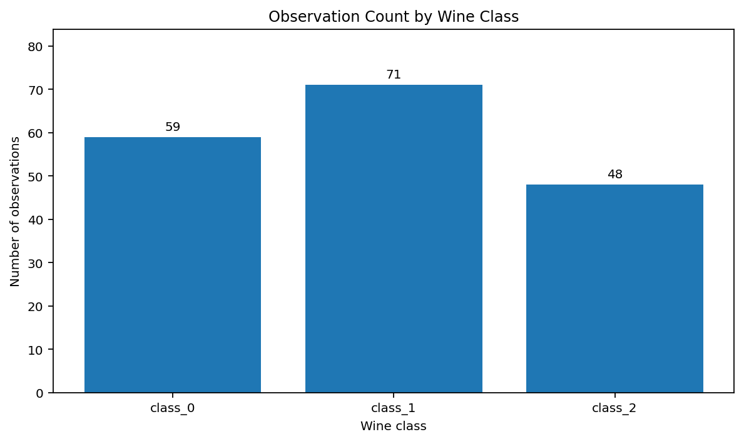
Figure 1. Number of observations in each target class.
Interpretation: class counts are class_0: 59, class_1: 71, class_2: 48. Class 1 contributes the largest share (39.9%), while class 2 contributes the smallest (27.0%). This is a moderate imbalance, not an extreme one. It matters because pooled averages may be influenced more by the largest group. Class-wise summaries reduce this risk.
Limitations: the plot describes the dataset composition only. It does not show the real-world prevalence of these cultivars outside the sample.

6.2 Distribution of alcohol
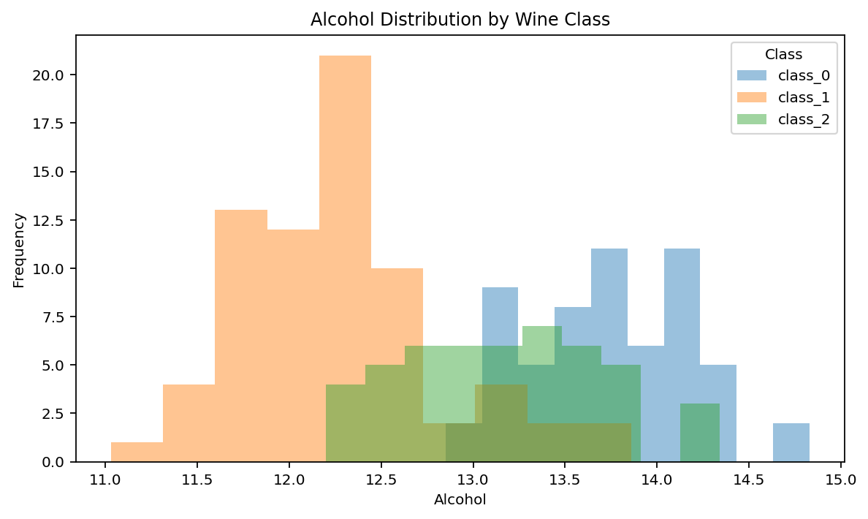
Figure 2. Overlaid alcohol histograms, grouped by wine class.
Interpretation: alcohol values occupy a relatively compact range overall (minimum 11.03, maximum 14.83). The class-specific distributions overlap, but their centres differ. Class-wise means are: class_0 13.74, class_1 12.28, class_2 13.15. This suggests alcohol may help distinguish some groups, but overlap means alcohol alone cannot reliably identify every observation.
The semi-transparent histograms make overlap visible. Their appearance depends on bin width, so the plot should be read together with numerical summaries rather than as a precise probability estimate.

6.3 Boxplots: spread and potential outliers
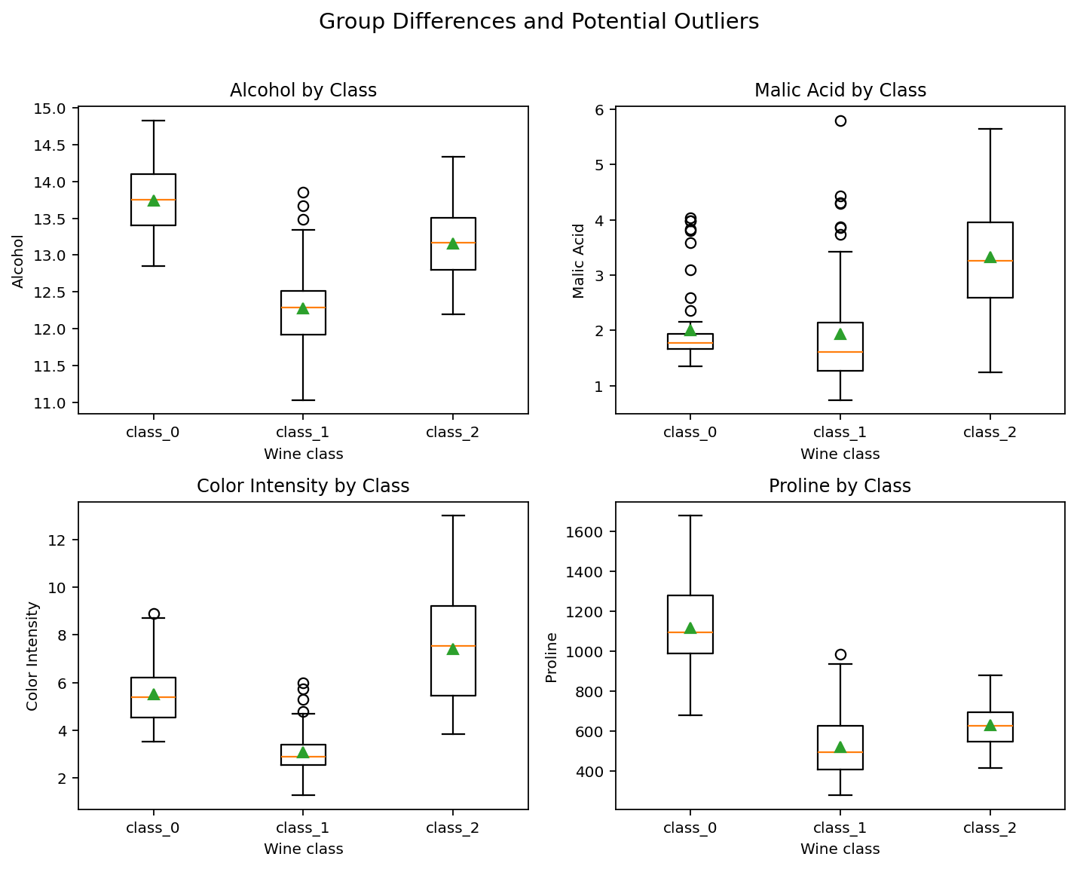
Figure 3. Boxplots for four selected features, separated by class. Points beyond whiskers are potential outliers under the plotting convention.
Interpretation: boxplots compare medians, interquartile ranges, and potential extreme observations. The selected variables were chosen to show both central tendency and spread, not because they are the only useful features. Proline has a much larger numerical scale than alcohol or malic acid; the different units mean that raw box heights cannot be compared directly across panels.
The IQR rule (values below Q1 − 1.5×IQR or above Q3 + 1.5×IQR) flags potential outliers rather than confirmed errors. The features with the most IQR flags in this dataset are magnesium (4), alcalinity_of_ash (4), color_intensity (4), malic_acid (3). These observations should be checked for plausibility and source context before any removal. In chemical datasets, extreme measurements can be genuine signals.

6.4 Correlation heatmap
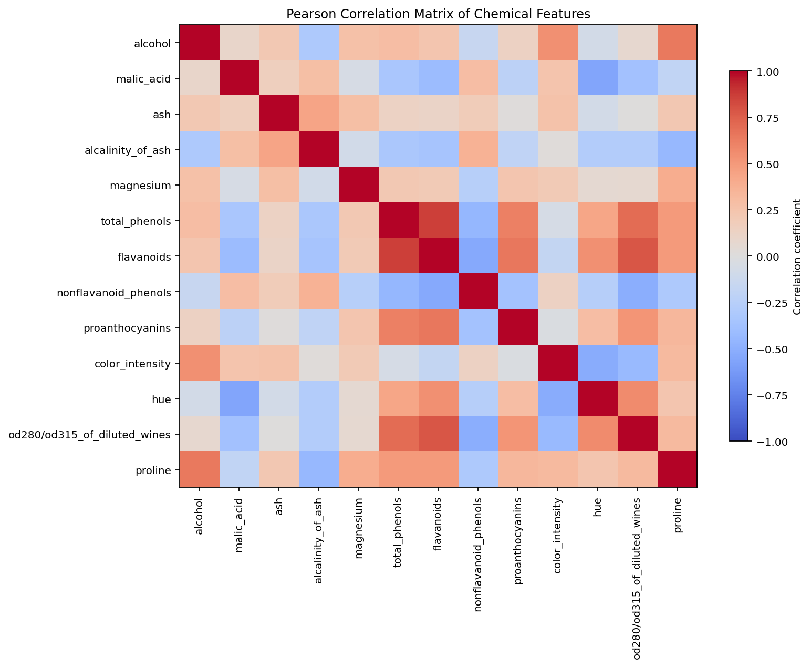
Figure 4. Pearson correlation coefficients between the 13 numerical features.
Interpretation: the most strongly correlated pairs include total_phenols and flavanoids (r=0.86), flavanoids and od280/od315_of_diluted_wines (r=0.79), total_phenols and od280/od315_of_diluted_wines (r=0.70), flavanoids and proanthocyanins (r=0.65), alcohol and proline (r=0.64). Positive correlations indicate that two features tend to increase together in this sample; negative correlations indicate that higher values of one tend to accompany lower values of the other. Strong correlations may indicate overlapping information and can affect the stability or interpretability of some models.
A correlation coefficient only measures linear association. A weak correlation does not rule out a nonlinear relationship, and correlation does not demonstrate causality. Also, correlations across all classes can partly reflect differences between classes rather than a relationship that exists equally within each class.

6.5 Alcohol versus colour intensity
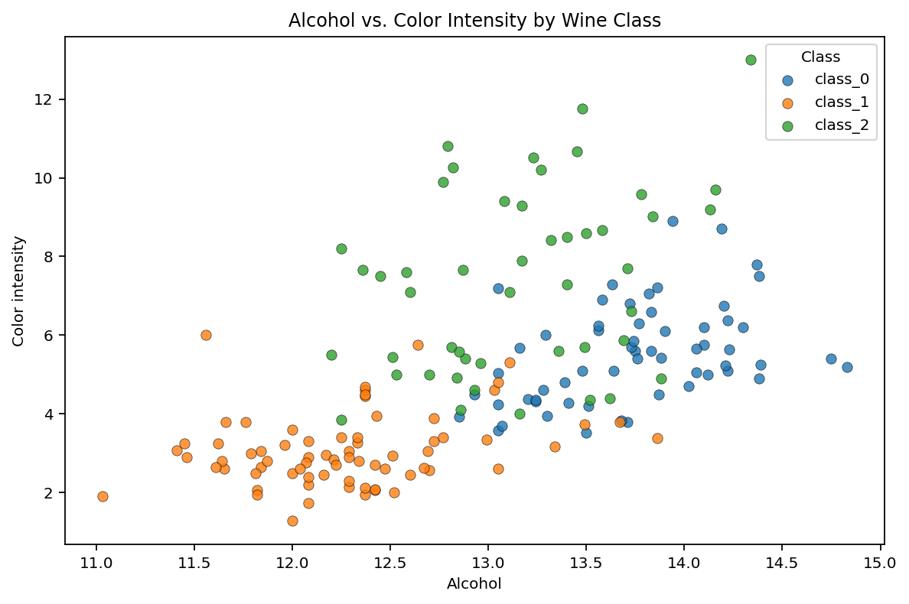
Figure 5. Scatter plot of alcohol against colour intensity, with class labels.
Interpretation: a scatter plot reveals joint patterns that separate histograms cannot show. Points are coloured by class, allowing the reader to inspect whether groups occupy different regions and where they overlap. The graph suggests that the pair of measurements provides some class separation, but overlapping points demonstrate that a two-feature rule would make mistakes.
The plot is descriptive and does not estimate a causal effect. It also omits 11 other features, so the visible overlap does not mean the full feature set lacks useful information.

6.6 Standardized class profiles
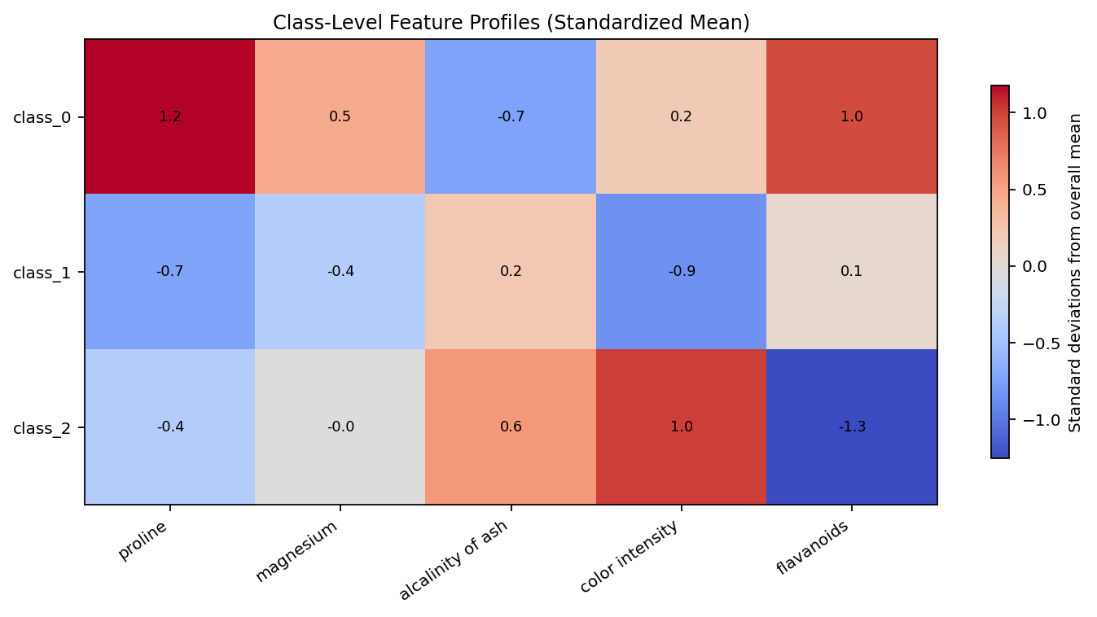
Figure 6. Standardized class means for features with the largest difference between class means.
Interpretation: features are standardized relative to each feature’s overall mean and standard deviation, making patterns easier to compare despite different measurement units. Positive cells indicate a class mean above the overall mean for that feature; negative cells indicate a mean below it. The profiles show that the three classes do not share one uniform chemical signature.
This heatmap is a summary of group averages, not an observation-level view. A class mean can hide considerable variation among individual samples. The selected features were chosen from the observed difference in class means; this is a descriptive ranking, not a formal statistical significance test.

6.7 Proline distribution
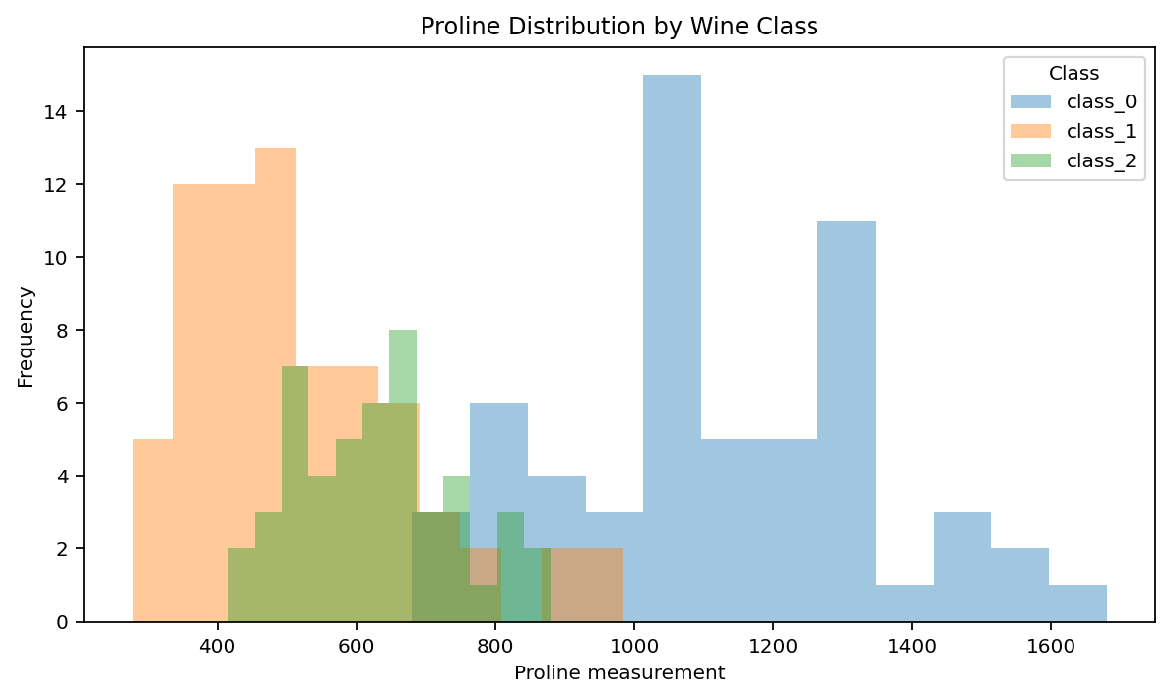
Figure 7. Proline distribution by class.
Interpretation: the class-wise proline means are class_0 1115.7, class_1 519.5, class_2 629.9. The distributions differ in their centres and ranges, suggesting proline may be informative for distinguishing the classes. However, a difference in averages does not guarantee clean separation for every sample, and the histogram overlap should be considered.

7. Transformations and Aggregations
- Target mapping: integer labels 0, 1, and 2 were mapped to the descriptive class names supplied by scikit-learn. The original encoded target remains available in the working data frame.
- Grouped summaries: groupby(class_name) was used to calculate class-specific counts, means, medians, standard deviations, and feature profiles.
- Correlation: Pearson correlation was calculated for the 13 numerical features only; the class label was excluded because it is categorical.
- Outlier screening: the IQR rule was used to flag potential extremes. No rows were removed on the basis of this rule.
- Standardized profile: class means were expressed in standard-deviation units relative to the overall feature mean and standard deviation. This was used for visualization only.
No feature scaling was applied to the raw descriptive plots. If a distance-based method or clustering model is applied later, scaling becomes important because variables such as proline have a much larger numerical range than variables such as hue.

8. Key Findings and Practical Meaning
- The dataset is complete for the analysed features: 0 missing feature values and 0 duplicate rows were found. This reduces the need for quality-repair steps, although it does not prove that every measurement is error-free.
- The three classes have class_0: 59, class_1: 71, class_2: 48 observations. Class-wise analysis is necessary because the groups are not exactly equal in size.
- Alcohol, proline, colour intensity, and other measurements show class-level differences. These variables are reasonable candidates for further modelling, but EDA alone does not establish which combination will predict class labels most accurately.
- Several feature pairs are strongly correlated. This may indicate overlapping information; future modelling should compare model performance and interpretability rather than dropping features solely because they are correlated.
- IQR flags identify values worth inspecting, not values that should automatically be deleted. Removing valid extreme chemistry measurements could erase useful differences between classes.
Potential application: a laboratory could use multivariate chemical measurements to support cultivar identification. This report does not validate an operational system, assess costs, or establish that the dataset generalizes to new regions, vintages, or measurement instruments. Any real deployment would require external validation and careful measurement-quality controls.

9. Limitations and Critical Reflection
- Small sample: 178 observations are sufficient for learning EDA methods but limited for broad generalization.
- Historical and narrow context: the dataset represents a specific collection of wines and should not be assumed to represent current commercial products.
- No causal claims: descriptive patterns and correlations cannot explain why a chemical measurement differs between classes.
- Plot choices matter: histogram bins and axis ranges affect visual impressions. Multiple summaries should be used to avoid overinterpreting one graph.
- Outlier detection is rule-based: IQR flags depend on distribution shape and are not proof of recording errors.
- No independent validation in this EDA: the report is exploratory, not a final predictive model evaluation.
The main improvement over a superficial EDA is linking each visualization to a question, numerical evidence, an interpretation, and a limitation. A useful next step would be to pre-register a small set of hypotheses, test them with appropriate statistical methods, and then validate any predictive claims on held-out data.

10. Reproducibility Instructions
Install the packages in a Python environment, save the accompanying script as week2_eda_analysis.py, and run it. The script loads the Wine dataset from scikit-learn, performs the checks described in this report, writes figures to a figures folder, and prints a summary of key results. The data are bundled with scikit-learn, so a separate CSV download is not required.
Recommended commands:
python -m pip install pandas numpy matplotlib seaborn scikit-learn
python week2_eda_analysis.py
Record the Python and package versions used for submission. If the internship portal asks for screenshots, capture the executed notebook/script and key output plots from your own run. Do not claim that a figure or analysis was run on your machine unless you have actually executed it.

11. Conclusion
This EDA examined the quality, distributions, class balance, group differences, potential outliers, and pairwise relationships in the Wine Recognition dataset. The strongest findings are that the classes show different chemical profiles and that several features are correlated, while class overlap remains visible in individual feature plots. These observations support further multivariate analysis but do not by themselves prove predictive accuracy or causal explanations. The attached code is intended to make the workflow transparent and reproducible.

References
- Aeberhard, S., Coomans, D., & de Vel, O. (1994). The classification performance of RDA. Journal of Chemometrics, 8(6), 463–471. Dataset context is commonly associated with the UCI Wine Recognition dataset.
- UCI Machine Learning Repository. Wine Recognition Data Set. https://archive.ics.uci.edu/dataset/109/wine
- scikit-learn developers. load_wine — Wine recognition dataset. https://scikit-learn.org/stable/modules/generated/sklearn.datasets.load_wine.html
- pandas development team. pandas documentation. https://pandas.pydata.org/docs/
- Matplotlib development team. Matplotlib documentation. https://matplotlib.org/stable/
- Waskom, M. L. (2021). seaborn: statistical data visualization. Journal of Open Source Software, 6(60), 3021. https://doi.org/10.21105/joss.03021

