Promatics Technologies Private Limited **Date**: Jan 11, 2012

Click here to go to cms page.

Click here to edit cms page

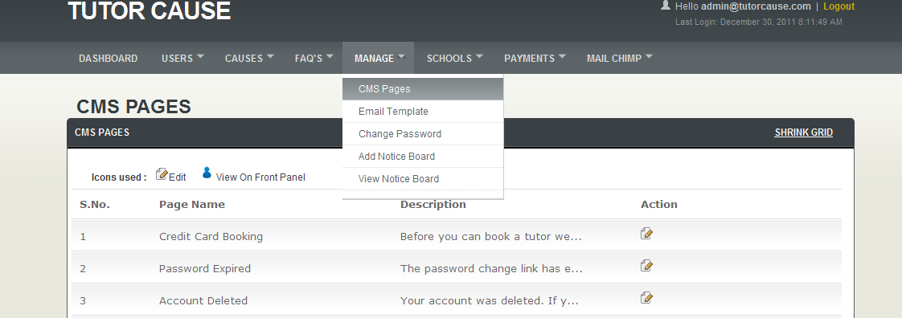

Enter any text you want

But do not change variables ({[tutorname]}, {[tutorfee]})

Then click on submit button

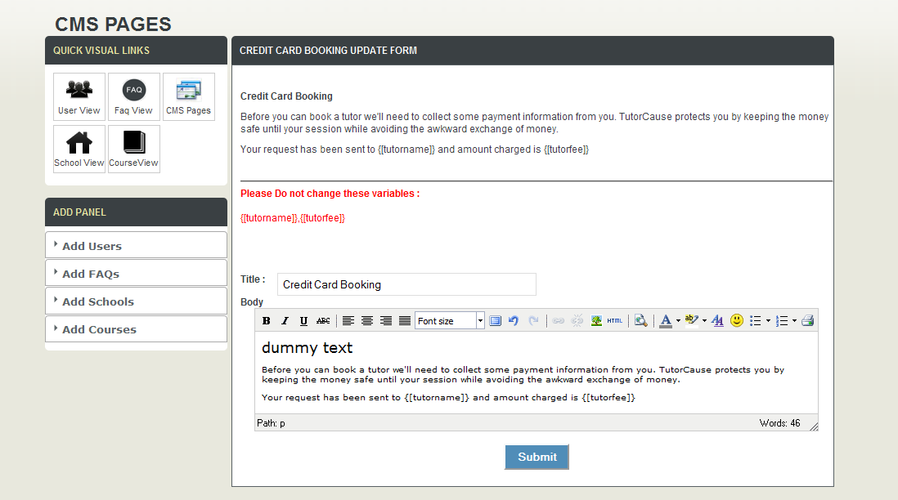

Our inserted text is shown here.

