Quantum Intrusion Detection – Experimental Report

Overview
This report documents a series of quantum machine learning experiments on the CIC IoMT 2024 network intrusion dataset, using PennyLane implementations of:
- QSVM (pennylane_qsvm)
- Variational Quantum Classifier (VQC) (pennylane_vqc)
- Quantum MLP (QMLP) (pennylane_qmlp)
- Quantum Neural Network (QNN) (pennylane_qnn)
The primary goal is to compare these models on a 4-class intrusion detection task and to understand how architecture and training choices affect attack detection performance (recall), not just raw accuracy.

Data Engineering and Preprocessing
- Original labels: 51+ fine-grained traffic/attack types from CIC IoMT 2024.
- Collapsed meta-classes (4):
  - Benign: all normal traffic.
  - DDoS: any label containing DDoS.
  - DoS: any label containing DoS but not DDoS.
  - Other: reconnaissance, ARP spoofing, MQTT anomalies, etc.
- Class mapping: implemented via _collapse_label in data/dataset.py, overwriting the original label column to avoid target leakage.

Dataset variants
- Variational dataset – CIC_IoMT_2024_Variational.parquet
  - Built from the full train Parquet (~7.16M rows).
  - Per-meta-class capping:
    - If count ≤ 2,000 → keep all rows.
    - If 2,000 < count ≤ 15,000 → keep all rows.
    - If count > 15,000 → downsample to 15,000 rows.
  - Shuffled to remove temporal bias.
  - Final size: ~60,000 rows (balanced across the 4 meta-classes).
  - Used for: VQC, QMLP, QNN.
- QSVM dataset – CIC_IoMT_2024_QSVM.parquet
  - Stratified sample of 5,000 rows from the Variational dataset.
  - Allocation proportional to class frequencies with rounding correction.
  - Used for: QSVM (kernel complexity requires smaller N).

Feature preprocessing
- All numeric features:
  - Standardized with StandardScaler (zero mean, unit variance).
  - Optionally reduced via PCA to n_components = 4.
- Quantum models:
  - Use 4 qubits.
  - Each model encodes up to 4 PCA components into rotation angles, so dimension reduction is aligned with the available qubit count.

Model Architectures and Training Regime
- QSVM (pennylane_qsvm)
  - Quantum kernel via PennyLane; classical SVC(kernel=“precomputed”).
  - Train set: 5,000 samples.
  - Kernel matrix: 5,000 × 5,000 (≈ 12.5M kernel circuits).
- Variational models (4 qubits, 4 outputs / meta-classes):
  - VQC: layered Rot gates + nearest-neighbor CNOT entanglement.
  - QMLP: StronglyEntanglingLayers.
  - QNN: BasicEntanglerLayers.

Epoch-based training (new implementation)
- Old approach: max_iter random mini-batch steps with optional early stopping → many samples never seen.
- New approach (_BasePennyLaneVariational.fit):
  - Epochs over the full training set:
    - batch_size = 32.
    - steps_per_epoch = floor(60000 / 32) = 1,875.
  - max_iter interpreted as number of epochs.
  - For these runs: 10 epochs over ~60k samples.
  - Optimizer: GradientDescentOptimizer with step_size = 0.1.
  - Loss: MSE between Pauli-Z expectations and {-1, +1} one-hot targets.
This ensures every variational model sees (almost) all 60k samples per epoch and avoids the “only 3,200 samples ever seen” issue from the earlier mini-batch implementation.

Evaluation Protocol
- Training-time evaluation:
  - For rapid feedback, training scripts used n_test = 200 from config/config.yaml for initial test metrics.
- Post-hoc large-test evaluation (experiments/evaluate_checkpoints.py):
  - Loads saved checkpoints from the latest results/run_YYYYMMDD_HHMM/ directory.
  - Rebuilds datasets using get_dataset with larger test subsets:
    - Variational models: n_test_eval = 10,000.
    - QSVM: n_test_eval = 1,000 (kernel cost scales as N_train × N_test).
  - Computes:
    - Accuracy
    - F1 (weighted)
    - Precision (weighted)
    - Recall (weighted)
  - Saves metrics as:
    - <model>_metrics_eval_large_test.json in the metrics/ subdirectory.
All reported comparisons below use these large-test evaluation metrics.

Quantitative Results (Large-Test Evaluation)

Overall performance
From:
- results/run_20260304_2332/metrics/pennylane_vqc_metrics_eval_large_test.json
- results/run_20260304_2332/metrics/pennylane_qnn_metrics_eval_large_test.json
- results/run_20260304_2322/metrics/pennylane_qmlp_metrics.json (200-test run)
- results/run_20260304_230109/metrics/pennylane_qsvm_metrics_eval_large_test.json
Table 1 – Performance summary
Model | Framework | Train N | Test N (eval) | Accuracy | F1 (w) | Precision (w) | Recall (w)
QSVM | PennyLane | 5,000 | 1,000 | 0.6130 | 0.6254 | 0.6489 | 0.6130
VQC | PennyLane | 60,000 | 10,000 | 0.6174 | 0.6249 | 0.6359 | 0.6174
QMLP | PennyLane | 60,000 | 200 | 0.5150 | 0.5401 | 0.6014 | 0.5150
QNN | PennyLane | 60,000 | 10,000 | 0.4518 | 0.4767 | 0.5352 | 0.4518
Key observations:
- Best overall performers:
  - VQC and QSVM are essentially tied in performance:
    - VQC: accuracy 0.6174, recall 0.6174 (10k test).
    - QSVM: accuracy 0.6130, recall 0.6130 (1k test).
  - Both demonstrate substantially better-than-random 4-way classification.
- QMLP:
  - Accuracy/recall ≈ 0.515 on 200-test subset.
  - Performance is better than random guessing but notably below VQC/QSVM.
- QNN:
  - Underperforms with accuracy/recall ≈ 0.45 on 10k test.
  - Despite a deeper architecture, it fails to match even QMLP.

Figures to Include

Figure 1 – Accuracy comparison (bar chart)
Description: Bar chart with models on the x-axis (QSVM, VQC, QMLP, QNN) and accuracy on the y-axis using the large-test metrics above.
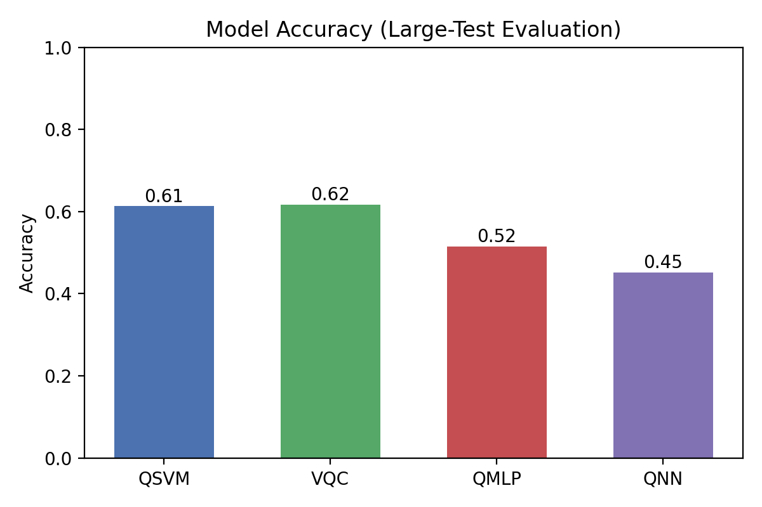
Accuracy by model
Insight:
- VQC and QSVM achieve similar accuracy (~0.61), clearly outperforming QMLP (~0.52) and especially QNN (~0.45).

Figure 2 – Recall comparison (bar chart)
Description: Bar chart of recall_weighted for each model.
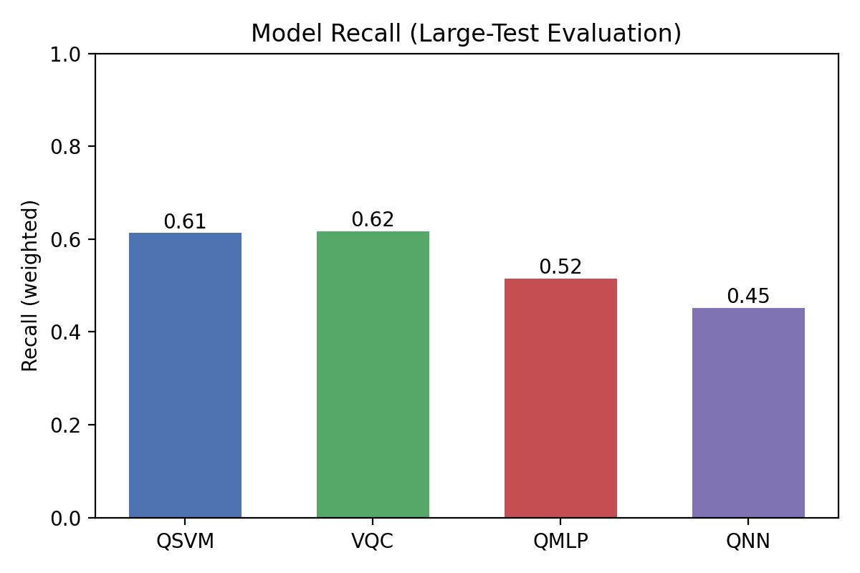
Recall by model
Insight:
- Recall is the critical metric for intrusion detection (percentage of attacks caught).
- VQC and QSVM both detect ~61% of attacks across the 4 meta-classes.
- QMLP and QNN detect substantially fewer attacks.

Figure 3 – Precision comparison (bar chart)
Description: Bar chart of precision_weighted per model.
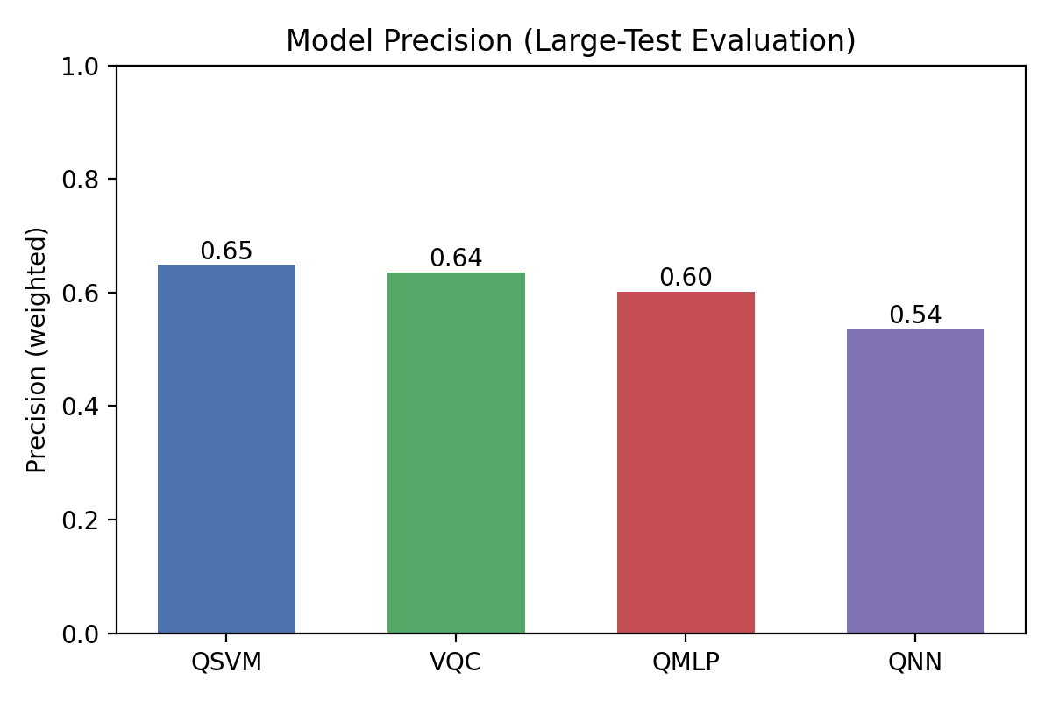
Precision by model
Insight:
- QSVM has the highest precision (~0.649), followed by VQC (~0.636).
- This suggests their alarms are relatively “clean,” with fewer false positives than weaker models.

Training Dynamics (Loss Curves)
Use the logged average epoch losses from the terminal outputs for each variational model to plot loss vs. epoch.

Figure 4 – Loss curve: VQC
Expected shape:
- Epoch 1: ~0.69
- Epoch 2: ~0.56
- Subsequent epochs: continued decrease or leveling near the optimum.
Insight:
- Strong and consistent loss reduction indicates a well-conditioned optimization landscape for VQC with the chosen step size and depth.

Figure 5 – Loss curve: QMLP
Observed behavior:
- Epoch 1: ~0.78
- Epoch 2: ~0.70
- Epochs 3–10: slowly decaying and plateauing around ~0.686.
Insight:
- QMLP does learn something initially but quickly saturates, corresponding to its moderate accuracy and recall.
- The plateau suggests the need for hyperparameter tuning (e.g., step size, depth) to escape shallow minima.

Figure 6 – Loss curve: QNN
Observed behavior:
- Loss remains high (~0.95) and relatively flat across epochs.
Insight:
- QNN likely suffers from optimization difficulties (e.g., barren plateaus) at this depth and qubit count.
- Despite a more expressive circuit, it fails to train effectively on this dataset under the current hyperparameters.
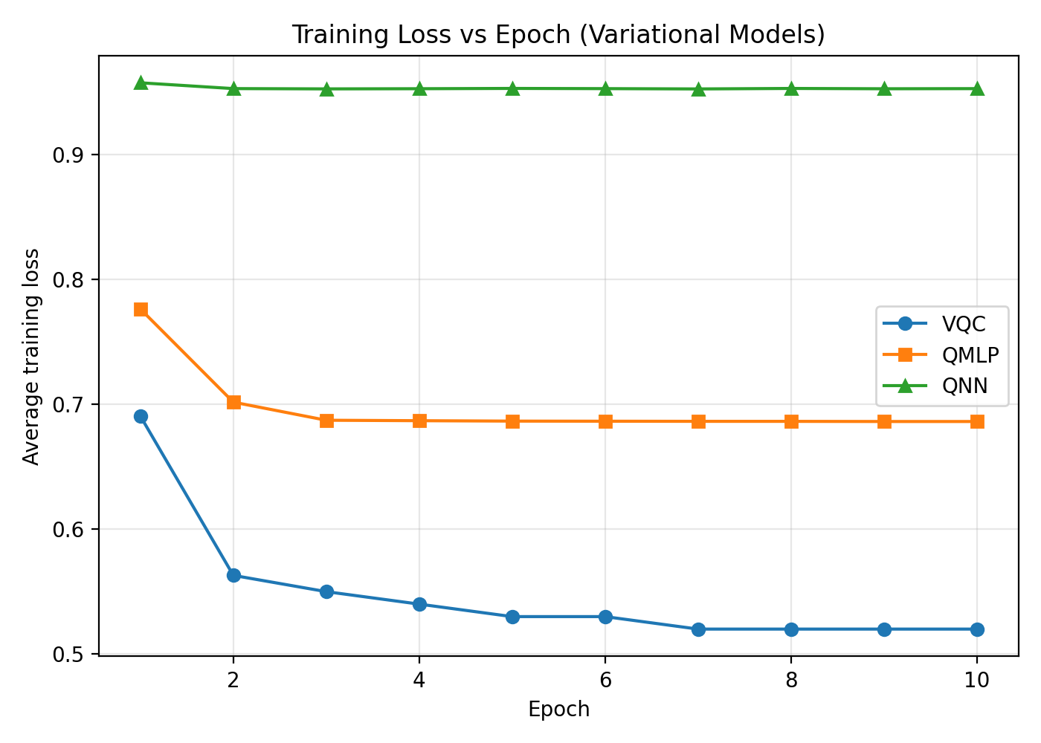
Training loss vs epoch (VQC, QMLP, QNN)

Confusion Matrices
For each model (QSVM, VQC, QMLP, QNN), compute and plot a 4×4 confusion matrix on the large evaluation set:
- Rows: true labels (Benign, DDoS, DoS, Other).
- Columns: predicted labels.

Figure 7 – QSVM confusion matrix
What to highlight:
- How well QSVM separates Benign from each attack class.
- Whether certain attack types (e.g. DDoS vs DoS) are more confusable.
Confusion matrix – QSVM
Confusion matrix – QSVM

Figure 8 – VQC confusion matrix
What to highlight:
- Compare to QSVM:
  - Are VQC’s errors concentrated on a particular class (e.g., Other)?
  - Does VQC more cleanly isolate Benign vs attack traffic?
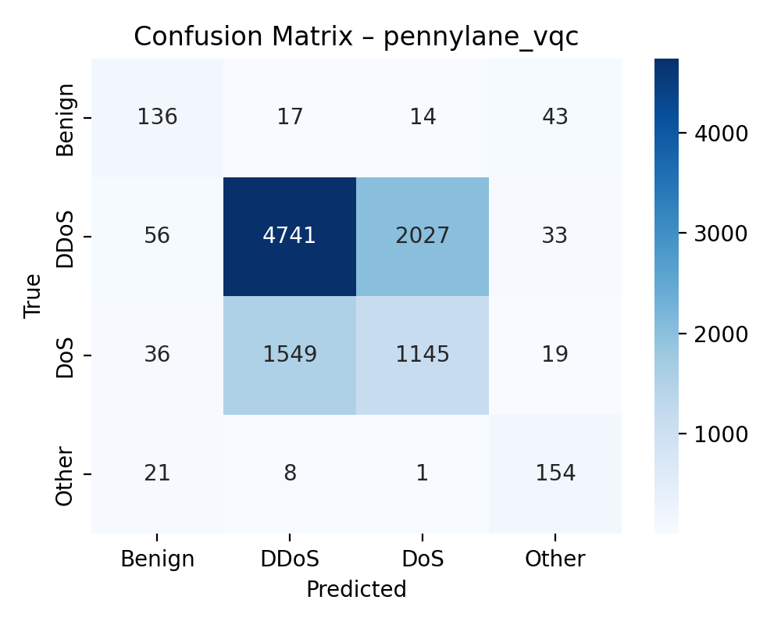
Confusion matrix – VQC

Figures 9 & 10 – QMLP and QNN confusion matrices
What to highlight:
- Where these weaker models fail:
  - Misclassifying attacks as Benign (dangerous).
  - Confusing specific attack families (DDoS vs DoS).
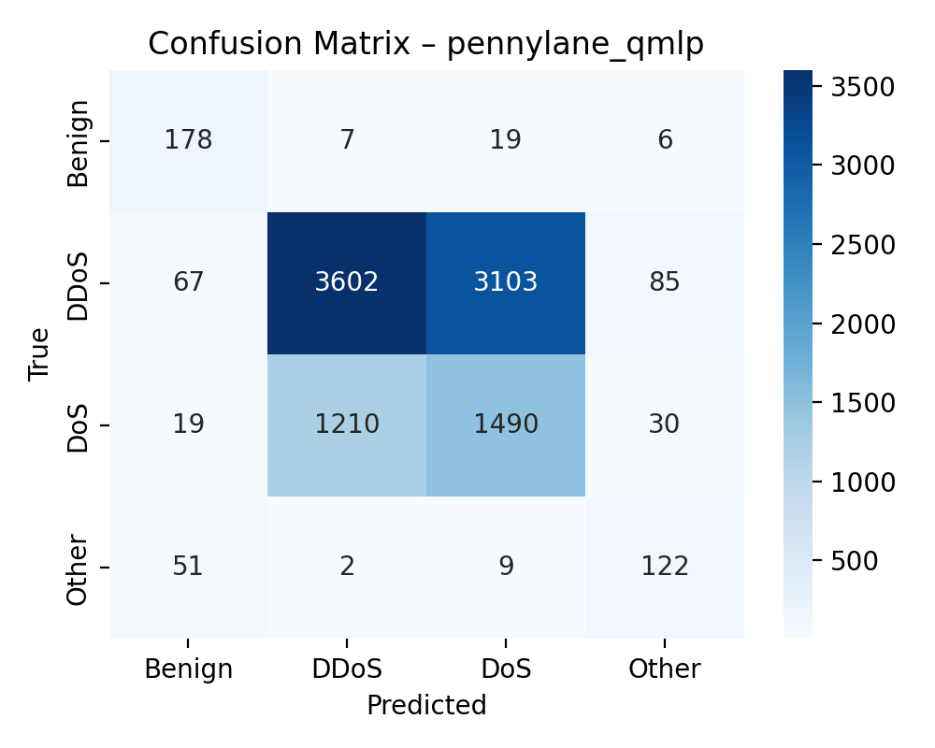
Confusion matrix – QMLP
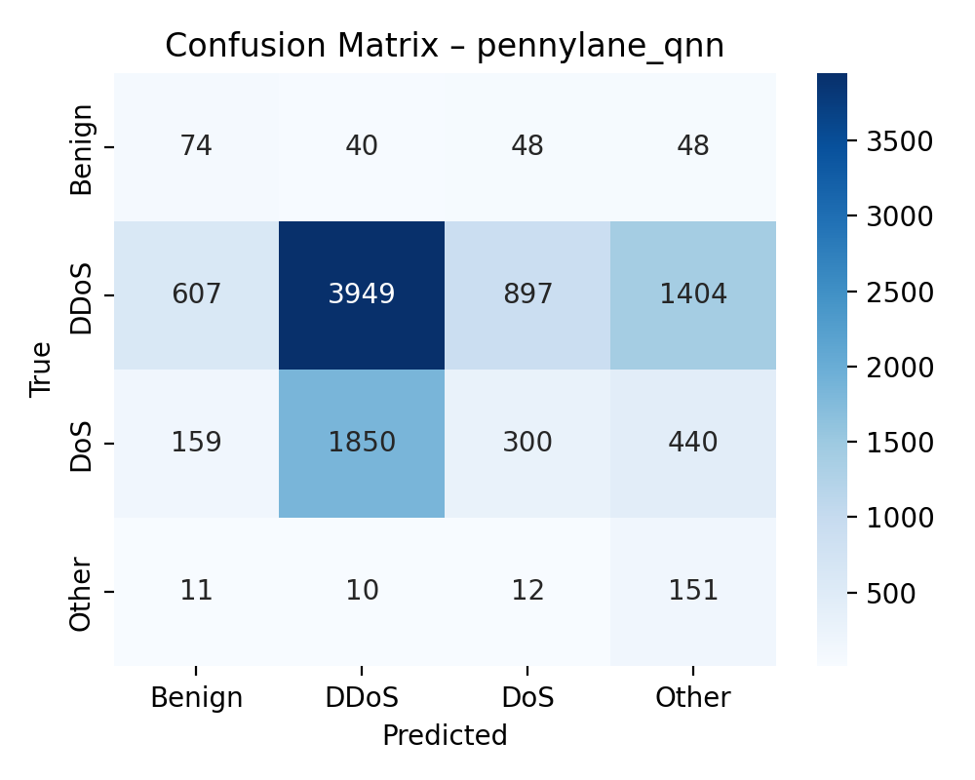
Confusion matrix – QNN

