Idea & Technology Proposal

Proposal title
RSSI/PDR-Based Automatic WiFi Mesh-Cellular Failover for Multi-Robot Communication at Construction Sites

Applicant / Team
[NEEDS INPUT]: applicant name(s) and affiliation (reporting group: PIC Lab, KIT).

1. Idea Description
Overview. This project delivers a self-switching network that keeps a team of construction-site robots continuously connected. Each robot's connection is moved automatically between a local WiFi mesh and a cellular network (LTE, Long Term Evolution, or 5G), always following whichever link performs better at that moment, and it does so without manual reconnection and without dropping the robot's active session.
Background and need. Construction sites increasingly rely on several robots that must behave as a single coordinated team rather than as isolated machines, and coordination on that scale demands near-real-time synchronization, which this project targets at less than 200ms end-to-end. No single on-site network can guarantee that on its own: a WiFi mesh is fast and inexpensive to deploy yet fades behind concrete and steel, while cellular reaches the whole site but is slower and costlier to depend on continuously. Combining the two, using WiFi where it is strong and cellular where it is not, and switching quickly enough to preserve coordination, overcomes the limits of either technology alone.
Problem solved. The system keeps every robot reliably connected as obstacles, distance, and interference shift from moment to moment across a busy site, so the fleet never loses coordination and never needs manual network reconfiguration.
Target customers. The primary users are construction robotics companies and general contractors operating multi-robot fleets, together with the manufacturers of robot network gateways who want this automatic-switching capability built into their products.
Product direction. In the near term the output is the switching engine itself, embedded in the network gateway each robot already carries. In the longer term it becomes a stand-alone offering: either a licensable software module for gateway makers or a connectivity-reliability service that any site operator can add to a robot fleet.

2. Implementation: Technology & Service
Core technology. The heart of the system is a hybrid path controller that continuously decides, for each robot, whether its traffic should travel over the WiFi mesh or the cellular link. It fuses two independent trigger signals rather than relying on signal strength alone: an EWMA-smoothed (Exponentially Weighted Moving Average) WiFi signal strength (RSSI, Received Signal Strength Indicator) and a 1-second sliding-window packet delivery ratio (PDR). Combining the two avoids false switches when the radio momentarily dips but packets still arrive. To stop the controller from oscillating between links near the decision boundary, it applies hysteresis: the threshold to return to WiFi is set 3 dB above the threshold that triggered the move to cellular, and recovery must hold for two consecutive checks. A separate staleness detector forces failover if no WiFi frame is heard for more than 3 seconds, covering the case where the signal degrades too gradually for the threshold logic to react. Every path change is executed as make-before-break routing, meaning the new route is installed before the old one is removed, so an active TCP (Transmission Control Protocol) session survives the switch and the service interruption stays in the millisecond range instead of forcing a full socket timeout and retry.
Main features and service structure. From the operator's point of view the system provides four concrete capabilities:
- Always-connected robots. Each robot keeps a single, continuous network identity; the system decides which underlying link carries its traffic, with no manual reconnection.
- Automatic, seamless failover. Traffic moves to cellular when WiFi degrades and back when it recovers, without dropping the active session.
- Per-robot connection assurance. Every switch is measured and logged, so the operator can see, per robot, how reliably the coordination-latency target is met.
- Technology-neutral fallback. The same design works with either LTE or 5G, fitting sites with different cellular coverage.
The capability is delivered in two complementary forms: an embedded switching module built into the network gateway each robot already carries, and an operator-facing connectivity-assurance layer that turns the per-switch measurements into fleet-level reliability reporting.
System architecture. A 4-node 802.11s WiFi mesh with dual-band hotspot access points (5 GHz 802.11ac and 2.4 GHz 802.11n, sharing one SSID for roaming) serves the robot clients, backed by a single macro LTE or 5G base station whose core gateway shares the same service IP address as the WiFi path. Because both paths lead to the same destination address, a handover is an internal routing change rather than a reconnection to a new endpoint, which is what allows sessions to survive. Propagation is modeled with a building-aware loss model applied consistently across WiFi, LTE, and 5G on a fixed 400×400m, 7-building site, so the comparison between technologies is like-for-like.
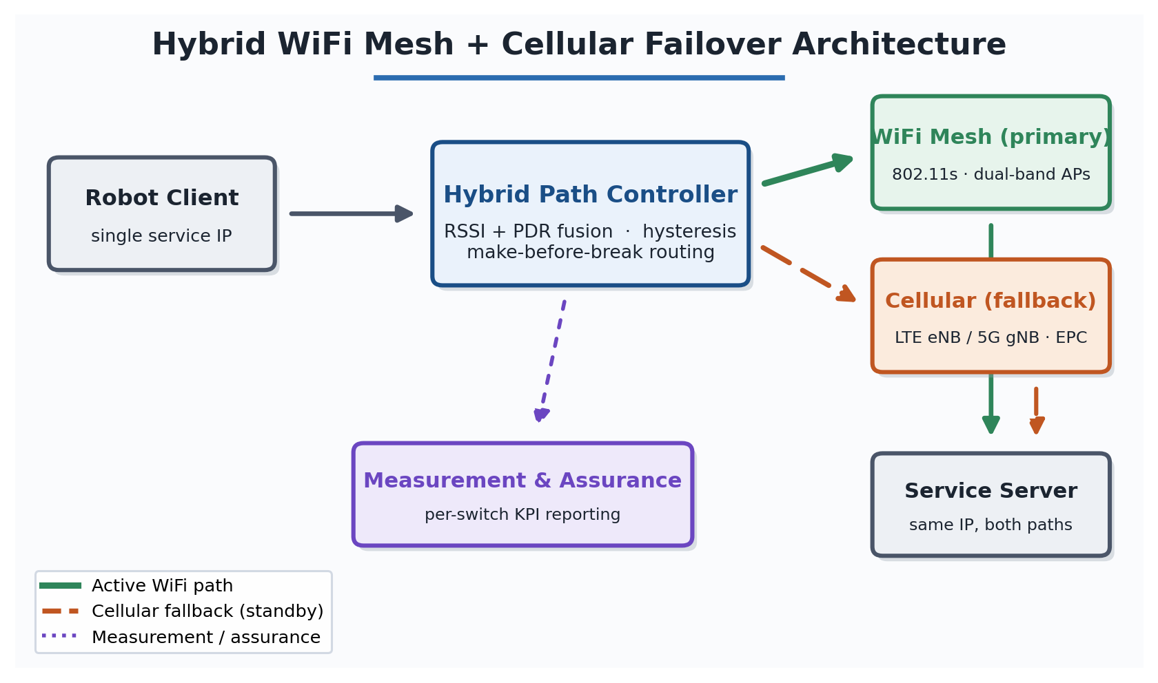
Figure 1. System architecture. Because both paths reach the same service address, a handover is a routing change rather than a reconnection.
How a handover works. On every evaluation cycle the controller repeats four steps for each robot. It senses the smoothed signal strength, the recent delivery, and the time since the last WiFi frame; it decides according to the thresholds in the table below; it acts through make-before-break routing; and it records the switch together with its measured interruption for later reporting.
Condition observed | Decision | Purpose
WiFi below trigger threshold, or delivery degraded | Move to cellular | Preserve connectivity before the link fails
No WiFi frame for several seconds | Force move to cellular | Catch gradual signal loss thresholds miss
WiFi recovers above higher return threshold for consecutive checks | Move back to WiFi | Return only once genuinely stable
Signal near the threshold | Hold current path (hysteresis) | Prevent back-and-forth switching

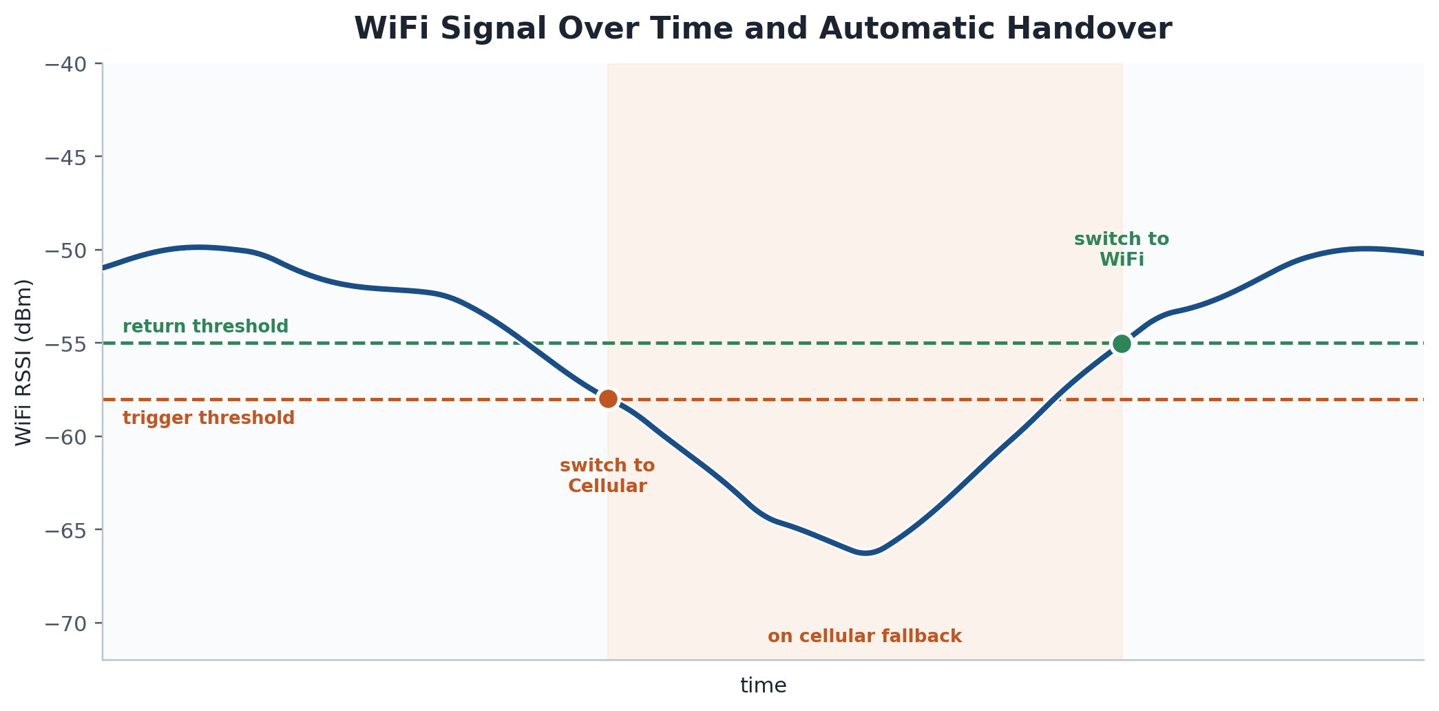
Figure 2. One handover cycle. The gap between trigger and return thresholds prevents oscillation while the signal hovers near the edge.
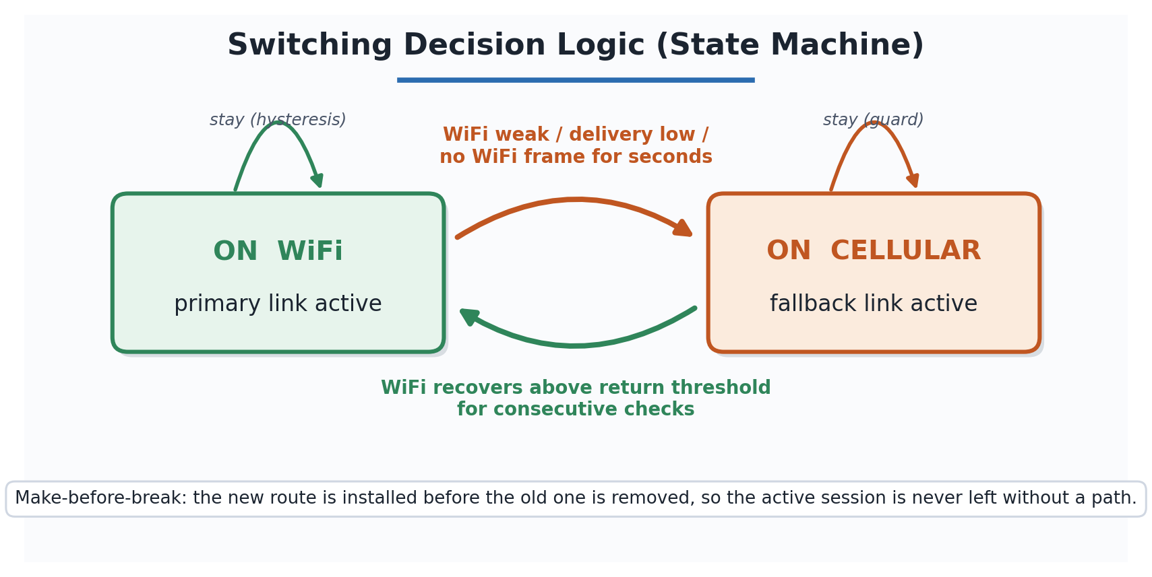
Figure 3. The controller as a two-state machine. Transitions are asymmetric by design: leaving WiFi is triggered by any degradation condition, while returning requires a stronger, sustained recovery, biasing the system toward the preferred WiFi link without allowing unstable switching.
Differentiation and technical strengths.
- Joint, environment-tuned switching. Unlike generic multipath solutions such as Multipath TCP (MPTCP), the controller reasons about signal strength and delivery together and applies hysteresis tuned to a specific propagation environment. It is validated against real vendor access-point hardware profiles (TP-Link EAP225, Netgear Orbi 960, ASUS ZenWiFi XT8) rather than idealized radios.
- A measurable coordination guarantee. It reports a quantified per-switch service-interruption metric against a less-than-200ms coordination budget, which is the number a robotics customer actually needs, not just aggregate throughput.
- Head-to-head LTE vs. 5G. It evaluates both cellular technologies in the same fallback role and topology, a direct comparison that few public studies provide for a construction-robotics use case.
Current implementation stage. The work is at the proof-of-concept and simulation-validation stage. Phase 1 (completed through March 2026) produced an NS-3 (Network Simulator 3) comparison of WiFi Mesh+LTE against WiFi Mesh+5G across multiple random seeds and node counts, which established both the switching controller and the performance-measurement pipeline. The system was then scaled to as many as 20 mobile robot clients and continued to switch automatically in both directions, including reliable cellular-to-WiFi return, while every client still met the less-than-200ms end-to-end target. Further simulation runs are planned to strengthen the statistical basis of the comparison. The technology has not yet undergone a hardware field trial.

3. Commercialization Potential & Market
Target market and customer segments. The technology serves three connected segments along the construction-connectivity value chain:
- Primary: construction robotics fleet operators (general contractors and specialist automation firms) that run multiple robots on one site and need them to operate as a coordinated system rather than as isolated machines. These are the customers who feel the coordination-latency problem directly.
- Secondary: robot and gateway equipment manufacturers that need a connectivity-assurance capability built into the network gateway their robots already carry, as a differentiating feature of their product.
- Enabling: telecom operators and private-network integrators deploying private LTE/5G at construction and industrial sites, for whom automatic WiFi-cellular failover is a value-adding layer on top of their connectivity.
Market size and demand. The idea sits at the intersection of two fast-growing markets, both propelled by the same forces: acute construction-labor shortages, jobsite-safety pressure, and the Industry 4.0 push toward automated, always-connected operations.
Market | 2025 | 2026 | Forecast | CAGR
Construction robotics | USD 6.55 B | USD 7.79 B | USD 15.39 B by 2030 | ~18.6%
Private 5G network | USD 3.89 B | USD 5.88 B | USD 150.66 B by 2033 | ~58.9%

CAGR (Compound Annual Growth Rate) is the average annual growth needed to reach the forecast value.
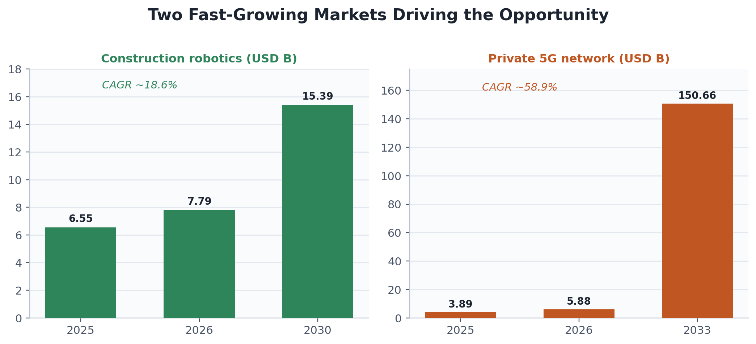
Figure 4. Both underlying markets show sustained, strong growth over the forecast horizon.
Estimates vary with how analysts scope each sector: narrow robotic-systems definitions run smaller, while broad definitions that include integrated industrial machinery run into the hundreds of billions. Every major source, however, agrees on sustained double-digit growth. On the demand side the driver is concrete: the United States construction sector alone was estimated to need on the order of 546,000 additional workers in 2023, with comparable shortages in Germany, Japan, and South Korea. As sites deploy more autonomous machines to close this gap, reliable multi-robot coordination becomes a prerequisite rather than an optional feature, and that is exactly the problem this technology solves.
Business model and revenue generation. Revenue is generated through three complementary streams that can be phased in as the technology matures:
- Technology / IP licensing. License the switching controller (the RSSI/PDR fusion algorithm and its make-before-break routing) to robot and gateway manufacturers on a per-unit royalty or annual license-fee basis.
- Connectivity-assurance subscription. Offer site operators a recurring (per-site or per-robot, per-month) service that turns the per-switch measurement pipeline into fleet-level reliability dashboards and reporting.
- Integration and technology-transfer fees. One-time engineering and technology-transfer engagements with telecom operators and system integrators embedding the capability into private-network offerings.
Early revenue is expected from licensing and integration engagements, with the subscription service building recurring revenue as deployments scale, which diversifies income across one-time and repeatable sources.
Competitive landscape and competitive advantage. The relevant competitors fall into two groups: proprietary heterogeneous-network stacks from telecom and networking vendors (private 5G combined with WiFi-offload), and general-purpose open multipath tooling such as Multipath TCP (MPTCP). Both were designed for generic enterprise or consumer connectivity rather than for coordinated robot fleets on obstruction-heavy sites. This technology's advantages are:
- Environment-tuned joint switching using both signal strength and delivery, validated against real access-point hardware rather than idealized radios.
- An explicit coordination-latency guarantee with a quantified per-switch interruption metric, measured against a less-than-200ms budget, which general-purpose failover products neither target nor report.
- Technology-neutral fallback that works with either LTE or 5G, so it fits sites with different cellular coverage without redesign.
Sources: The Business Research Company, Construction Robotics Global Market Report 2026; Grand View Research, Private 5G Network Market Report 2033; IMARC Group, Construction Robots Market Report (2026 editions).

4. Future Plans
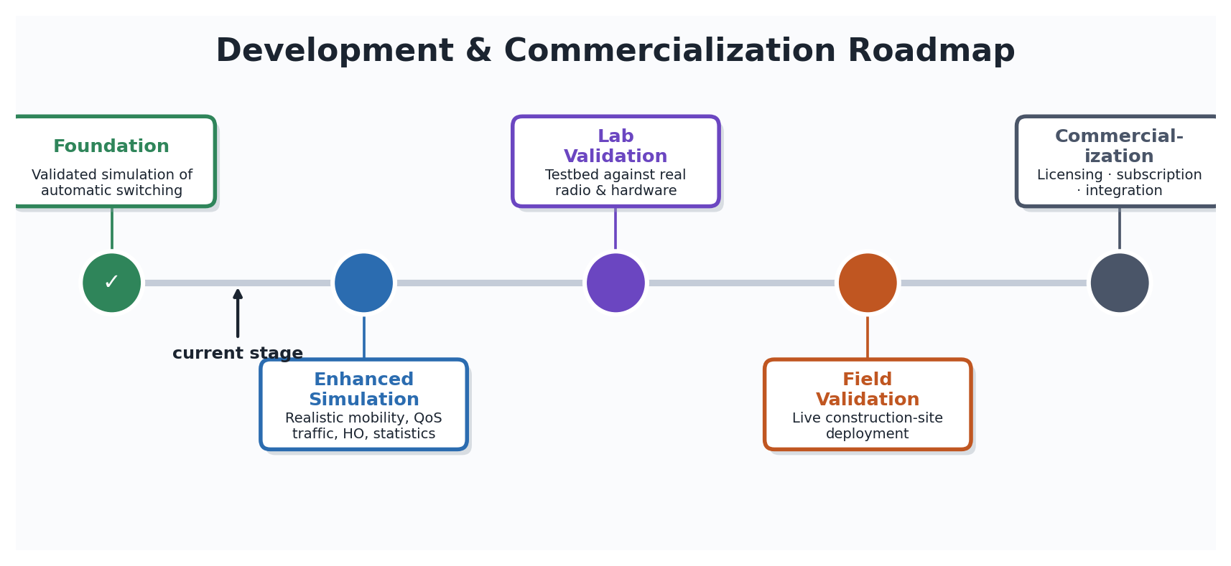
Figure 5. Staged roadmap from validated simulation to commercialization.
Phased R&D.
- Foundation (complete): validated simulation of the automatic switching controller and its measurement pipeline.
- Enhanced simulation (in progress): realistic waypoint mobility, per-flow QoS (Quality of Service) traffic, WiFi-mesh internal-handover modeling, and statistical reinforcement (more seeds, confidence intervals, significance tests).
- Laboratory validation: confirm behavior against a testbed under real radio and hardware conditions.
- Field validation: validate seamless failover and the latency target on an operating construction site.
Commercialization pathway (1 to 3 years). The plan is to protect the RSSI/PDR fusion method through an intellectual-property filing, license the controller to robot-gateway makers and telecom integrators, and offer a connectivity-assurance service on top. Progress is judged against clear success criteria at each stage: meeting the less-than-200ms target under realistic load, reproducing that result in the lab and then in the field, and securing a first licensing or integration partner. The final pathway is confirmed as the technology matures through validation.

5. Revisions & Supplementary Content
This is a new submission. If any element was previously submitted to a past ICT Challenge event, the revisions would be summarized here; otherwise this section is left blank.

