Idea & Technology Proposal: Draft (based on wifi_hybrid_try_2.cc project)
Draft answers to Idea_Technology_Proposal_Template.docx, grounded in what the NS-3 hybrid-network project (Phase 1, PIC Lab / KIT) can actually substantiate. Items marked [NEEDS INPUT] require facts this repo doesn't contain (applicant names, market data, business decisions). Do not submit those as-is.

Proposal title
RSSI/PDR-Based Automatic WiFi Mesh-Cellular Failover for Multi-Robot Communication at Construction Sites (working title, adjust to house style)

Applicant / Team
[NEEDS INPUT]: applicant name(s) and affiliation. The reporting group is PIC Lab, KIT; confirm the individual applicant names before submission.

1. Idea Description
Key focus: Why is this idea / technology needed?
Overview. This project builds a self-switching network system for multi-robot teams working on construction sites. Robots on a site, such as survey drones, materials-handling units, and safety-monitoring robots, need to talk to each other and to a central controller constantly and reliably. Our idea is a "hybrid" network that automatically moves each robot's connection between a local WiFi mesh and a cellular network (LTE, Long Term Evolution, or 5G), whichever is working better at that moment, without the robot ever losing its connection or needing to manually reconnect.
Background. Construction sites are increasingly deploying several robots that must work together rather than independently: for example a survey drone, a materials robot, and a safety-monitoring unit all coordinating on the same job. For robots to act as one team instead of separate machines, they need to stay in near-real-time sync, which is why this project targets an end-to-end synchronization delay of less than 200ms. We started this project because no single network technology available on a construction site can guarantee that on its own. A WiFi mesh is fast and cheap to deploy but loses signal behind concrete walls, steel framing, and heavy equipment; cellular (LTE/5G) reaches everywhere on-site but is slower and more costly to rely on all the time. Rather than pick one, we set out to test whether a system could automatically use WiFi when it's strong and fall back to cellular when it's not, and prove that the switch itself happens fast enough that the robot fleet never loses coordination. We tested this first through a detailed NS-3 (Network Simulator 3) network simulation (Phase 1, PIC Lab research completed by March 2026) rather than building physical hardware right away, so the switching logic could be proven and tuned safely and cheaply before committing to expensive real-robot field trials.
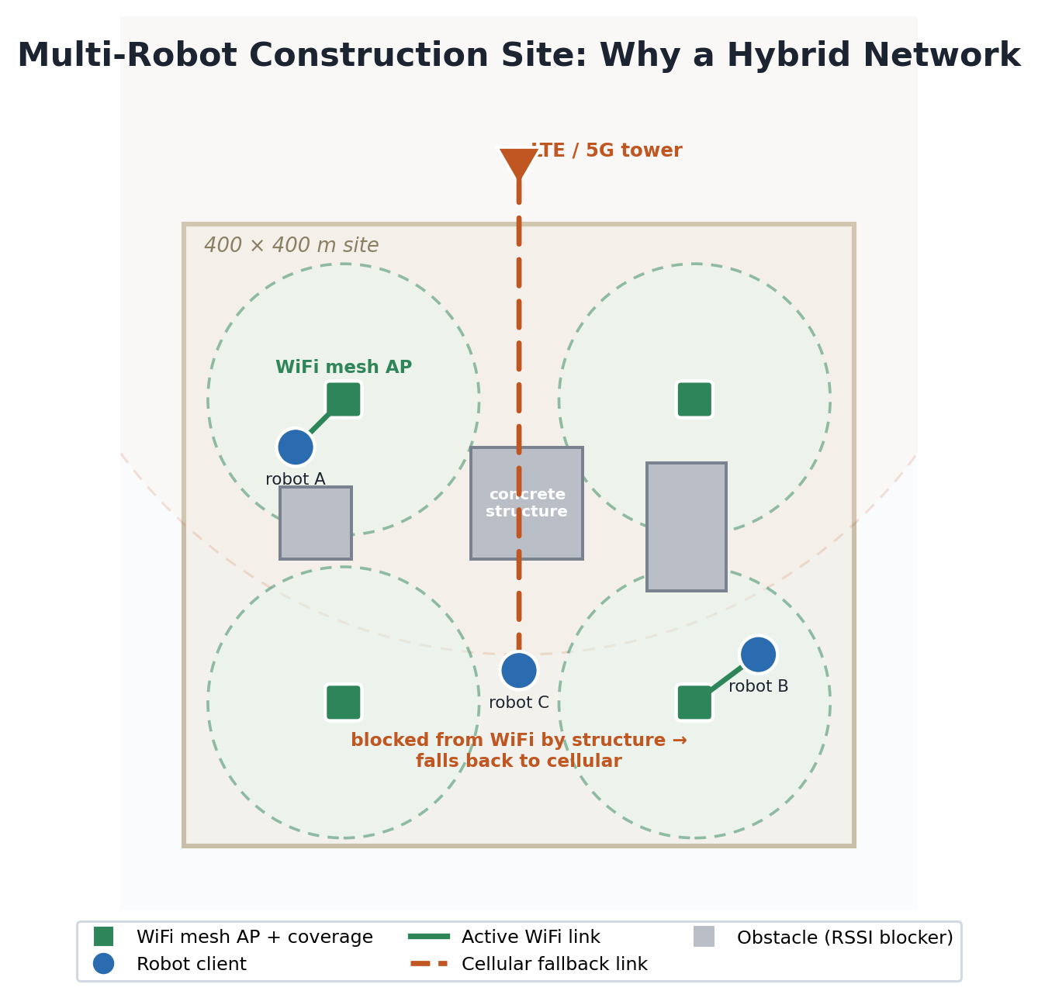
Figure 1. The problem the technology addresses. On a real site, obstacles such as concrete structures block WiFi coverage in unpredictable places. Robots A and B stay on the WiFi mesh, while robot C, shadowed by a central structure, is automatically moved to the cellular fallback so it never loses coordination with the fleet.
Problem solved. The technology solves the "seamless failover" problem for multi-robot construction connectivity: keeping every robot continuously and reliably connected to the network and to each other as physical obstacles, distance from the WiFi mesh, and radio interference change moment to moment on a busy job site, without robots losing coordination or needing manual network reconfiguration.
Target customers. Construction robotics companies and general contractors who deploy multiple robots on the same site and need them to operate as one coordinated system; and makers of robot network hardware ("edge gateways") who need this automatic-switching capability built into their products.
Product direction. The near-term output is the switching decision engine itself, proven in simulation, designed to be built into the network hardware ("gateway") each robot already carries. The longer-term direction is to turn this into a stand-alone product: either software licensed to companies that build robot gateways, or a network-reliability service that construction companies can add to any job site's robot fleet.

2. Implementation: Technology & Service
Core technology: a hybrid path controller that fuses two independent trigger signals, EWMA-smoothed (Exponentially Weighted Moving Average) WiFi RSSI (Received Signal Strength Indicator, α=0.6) and a 1-second sliding-window packet delivery ratio (PDR), with hysteresis (return threshold = trigger threshold + 3dB, requiring 2 consecutive good checks) to prevent oscillation, plus a staleness detector (forces failover if no WiFi frame heard for over 3s, catching the case where RSSI degrades too gradually for threshold logic to notice). Path changes are executed as make-before-break routing (a new IPv4 (Internet Protocol version 4) host route is installed before the old one is removed), so an active TCP (Transmission Control Protocol) session survives the switch without reconnecting. This keeps interruption to the millisecond range instead of forcing a full socket timeout and retry.
Main features and service structure: from the operator's point of view, the system delivers a small set of concrete capabilities:
- Always-connected robots. Each robot keeps a single, continuous network identity; the system decides which underlying link (WiFi or cellular) carries its traffic at any moment, with no manual reconnection.
- Automatic, seamless failover. When WiFi quality degrades, traffic moves to cellular, and back to WiFi when it recovers, without dropping the active session, keeping service interruption in the millisecond range.
- Per-robot connection assurance. Every switch event is measured and logged, so the fleet operator can see, per robot, how reliably the coordination-latency target is being met.
- Technology-agnostic fallback. The same architecture supports either LTE or 5G as the fallback link, so it fits sites with different cellular coverage.
The capability is structured to be delivered in two complementary forms: an embedded switching module built into the network gateway each robot already carries, and an operator-facing connectivity-assurance layer that turns the per-switch measurements into fleet-level reliability reporting.
System architecture: a 4-node 802.11s WiFi mesh backbone with dual-band hotspot APs (access points; 5GHz 802.11ac / 2.4GHz 802.11n, shared SSID [Service Set Identifier] for roaming) serving robot clients, backed by a single macro LTE eNB (evolved Node B) or 5G gNB (next-generation Node B) whose EPC (Evolved Packet Core) gateway shares the same service IP as the WiFi path, so failover is a routing change, not a different destination. Propagation uses a building-aware propagation loss model applied consistently across WiFi, LTE, and 5G against a fixed 7-building, 400×400m site layout, so the comparison between technologies is like-for-like.
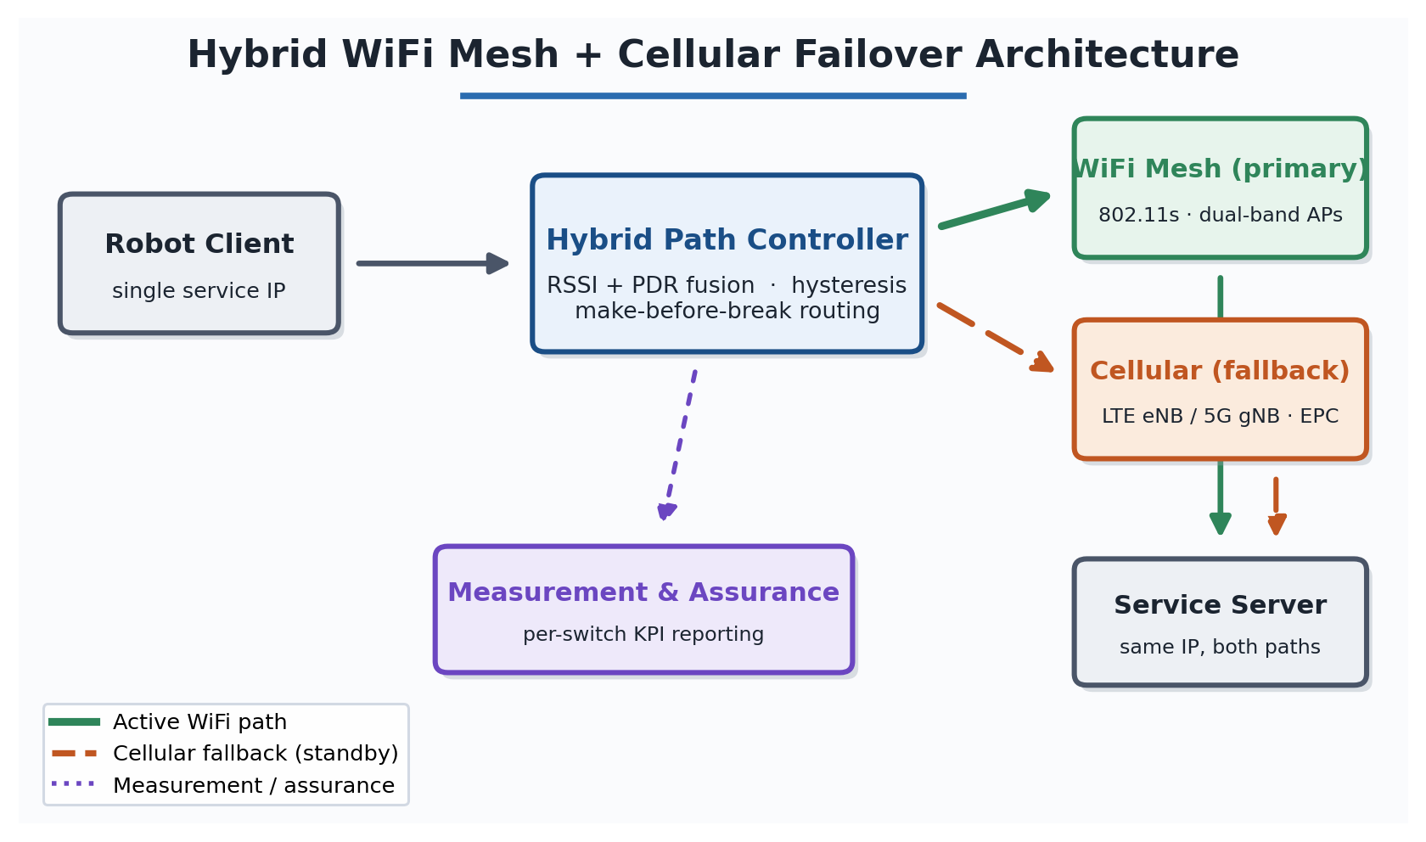
Figure 2. System architecture. The robot client holds a single, stable service identity. The hybrid path controller sits between the client and the two access technologies and moves traffic between the primary WiFi mesh and the cellular fallback. Because both paths reach the same service address, a handover is an internal routing change rather than a reconnection to a new destination.
How a handover happens (step by step). The controller runs a short periodic evaluation cycle for every robot:
- Sense. It reads the smoothed WiFi signal strength and the recent packet-delivery ratio for that robot, and checks when the last WiFi frame was heard.
- Decide. It compares these against the trigger thresholds. If WiFi has weakened past the threshold, delivery has dropped, or no WiFi frame has been heard for several seconds, the robot is a candidate to move to cellular. To return to WiFi, the signal must recover past a higher threshold and stay there for consecutive checks.
- Act. When a switch is warranted, the controller installs the new path before removing the old one (make-before-break), so the robot's active session is never left without a route.
- Record. The controller timestamps the switch, measures how long service was interrupted, and logs the event for per-robot reliability reporting.
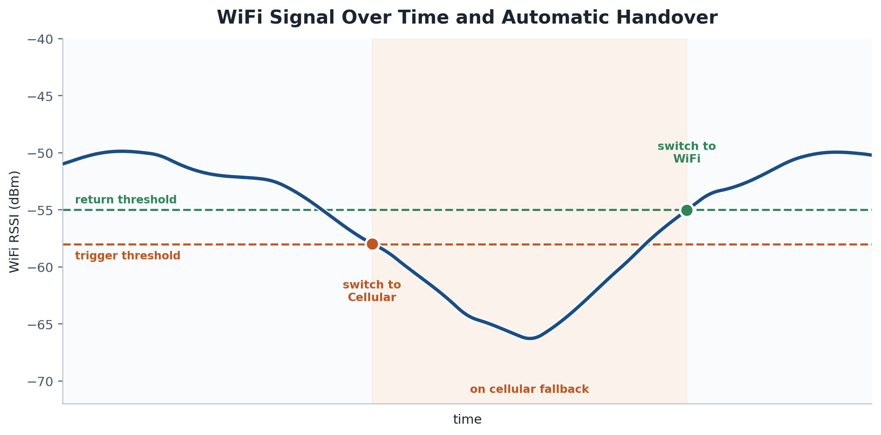
Figure 3. A single handover cycle. Traffic moves to cellular when WiFi drops below the trigger threshold and returns to WiFi only after the signal recovers above a higher return threshold and stays there, so the robot does not oscillate between links while the signal hovers near the edge.
The following table summarizes the switching decision logic:
Condition observed | Controller decision | Purpose
WiFi signal below trigger threshold, or delivery degraded | Move traffic to cellular fallback | Preserve connectivity before the link fails
No WiFi frame heard for several seconds | Force move to cellular | Catch gradual signal loss that thresholds miss
WiFi signal recovers above the higher return threshold for consecutive checks | Move traffic back to WiFi | Return to the preferred link only once it is genuinely stable
Signal fluctuating near the threshold | Hold current path (hysteresis) | Prevent rapid back-and-forth switching

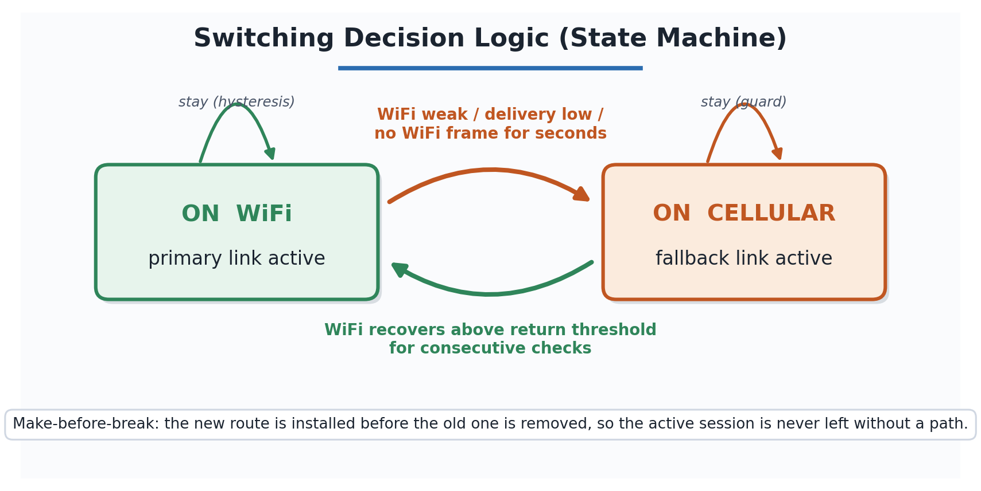
Figure 4. The controller as a two-state machine. Transitions are asymmetric by design: leaving WiFi is triggered by any of several degradation conditions, while returning requires a stronger, sustained recovery, which biases the system toward the preferred WiFi link without allowing unstable switching.
Differentiation and technical strengths:
- Generic multipath solutions such as Multipath TCP (MPTCP) do not reason about signal strength and delivery jointly, nor apply hysteresis tuned to a specific propagation environment. This project's controller is validated against real vendor access-point hardware profiles (TP-Link EAP225, Netgear Orbi 960, ASUS ZenWiFi XT8) rather than idealized radios.
- It produces a quantified per-switch service-interruption metric (measured in milliseconds), not just aggregate throughput. That is the number a robotics customer actually needs against a less-than-200ms coordination budget.
- It evaluates LTE and 5G in the same fallback role and the same topology, a direct head-to-head comparison that few public studies provide for a construction-robotics use case.
Current implementation stage: proof-of-concept / simulation validation. Phase 1 (through Mar 2026) is complete: an NS-3.45 comparison of WiFi Mesh+LTE vs. WiFi Mesh+5G technology across multiple random seeds and node configurations, establishing the switching controller and the performance-measurement pipeline. Subsequent work has extended the system to a higher-density scenario of up to 20 mobile robot clients, in which the controller performs automatic switching in both directions, including reliable cellular-to-WiFi return, while every client continues to meet the less-than-200ms end-to-end coordination-latency target. Additional simulation runs are planned to strengthen the statistical basis of the mode comparison. This is not yet a hardware field trial.

3. Commercialization Potential & Market
Target market and customer segments. The technology serves three connected segments along the construction-connectivity value chain:
- Primary: construction robotics fleet operators (general contractors and specialist automation firms) who run multiple robots on one site and need them to operate as a coordinated system rather than as isolated machines.
- Secondary: robot and gateway equipment manufacturers (Original Equipment Manufacturers) who need a connectivity-assurance capability built into the network gateway their robots already carry.
- Enabling: telecom operators and private-network integrators deploying private LTE/5G at construction and industrial sites, for whom automatic WiFi-cellular failover is a value-adding feature of their offering.
Market size and demand. The idea sits at the intersection of two fast-growing markets, both driven by the same underlying forces: acute construction-labor shortages, jobsite-safety pressure, and the Industry 4.0 push toward automated, always-connected operations.
Market | 2025 | 2026 | Forecast | CAGR | Source
Construction robotics | USD 6.55 B | USD 7.79 B | USD 15.39 B by 2030 | ~18.6% | The Business Research Company, 2026
Private 5G network | USD 3.89 B | USD 5.88 B | USD 150.66 B by 2033 | ~58.9% | Grand View Research, 2026

CAGR (Compound Annual Growth Rate) is the average year-over-year growth rate a market would need to expand from its starting value to its forecast value over the given period.
Estimates vary with how analysts scope each sector (narrow robotic-systems definitions run smaller, while broad definitions that include integrated industrial machinery run into the hundreds of billions), but every major source agrees on sustained double-digit growth. On the demand side, the labor gap is concrete: the United States construction sector alone was estimated to need on the order of 546,000 additional workers in 2023, with comparable shortages in Germany, Japan, and South Korea, which is a direct economic driver for multi-robot deployment. As sites deploy more autonomous machines, reliable multi-robot coordination becomes a prerequisite rather than an optional feature, and that is precisely the problem this technology addresses.
Figures are drawn from third-party market reports (The Business Research Company / Grand View Research, 2026) and are cited for context; a formal addressable-market estimate for the specific WiFi-cellular failover niche should be commissioned before commercial launch.
Business model and revenue generation. Revenue is generated through three complementary streams that can be phased in as the technology matures:
- Technology / IP licensing. License the switching controller (the RSSI/PDR fusion algorithm and its make-before-break routing) to robot and gateway manufacturers on a per-unit royalty or annual license-fee basis.
- Connectivity-assurance subscription. Offer site operators a recurring (per-site or per-robot, per-month) service that turns the per-switch measurement pipeline into fleet-level reliability dashboards and reporting.
- Integration and technology-transfer fees. One-time engineering and technology-transfer engagements with telecom operators and system integrators embedding the capability into private-network offerings.
Early revenue is expected from licensing and integration engagements, with the subscription service providing recurring revenue as deployments scale.
Competitive landscape and competitive advantage. The relevant competitors fall into two groups: proprietary heterogeneous-network stacks from telecom and networking vendors (private 5G combined with WiFi-offload), and general-purpose open multipath tooling such as Multipath TCP (MPTCP). Both were designed for generic enterprise or consumer connectivity rather than for coordinated robot fleets on obstruction-heavy sites. This technology's advantages are:
- Joint RSSI and delivery-based switching, environment-tuned. Unlike generic multipath, the controller reasons about signal strength and packet delivery together and applies hysteresis tuned to a specific radio environment, and it has been validated against real vendor access-point hardware profiles rather than idealized radios.
- A coordination-latency guarantee that competitors do not target. The system is built and measured against a less-than-200ms end-to-end robot-coordination budget, with a quantified per-switch service-interruption metric, which is the number a robotics customer actually needs and which general-purpose failover products do not report.
- Technology-neutral fallback. The same architecture works with either LTE or 5G, so it fits sites with different cellular coverage without redesign.
Sources. Market figures and demand indicators in this section are drawn from the following third-party reports (2026 editions; accessed July 2026):
- Construction robotics market size and CAGR: The Business Research Company, Construction Robotics Global Market Report 2026 (https://www.giiresearch.com/report/tbrc1619533-construction-robotics-global-market-report.html; also distributed via https://www.researchandmarkets.com/reports/6035262/construction-robotics-market-report).
- Private 5G network market size and CAGR: Grand View Research, Private 5G Network Market Size, Industry Report, 2033 (https://www.grandviewresearch.com/industry-analysis/private-5g-network-market).
- Construction labor-shortage and automation demand indicators: IMARC Group, Construction Robots Market Report (https://www.imarcgroup.com/construction-robots-market).

4. Future Plans
The technology follows a staged development path that moves from validated simulation toward laboratory testing and, ultimately, construction-site field deployment and commercialization.
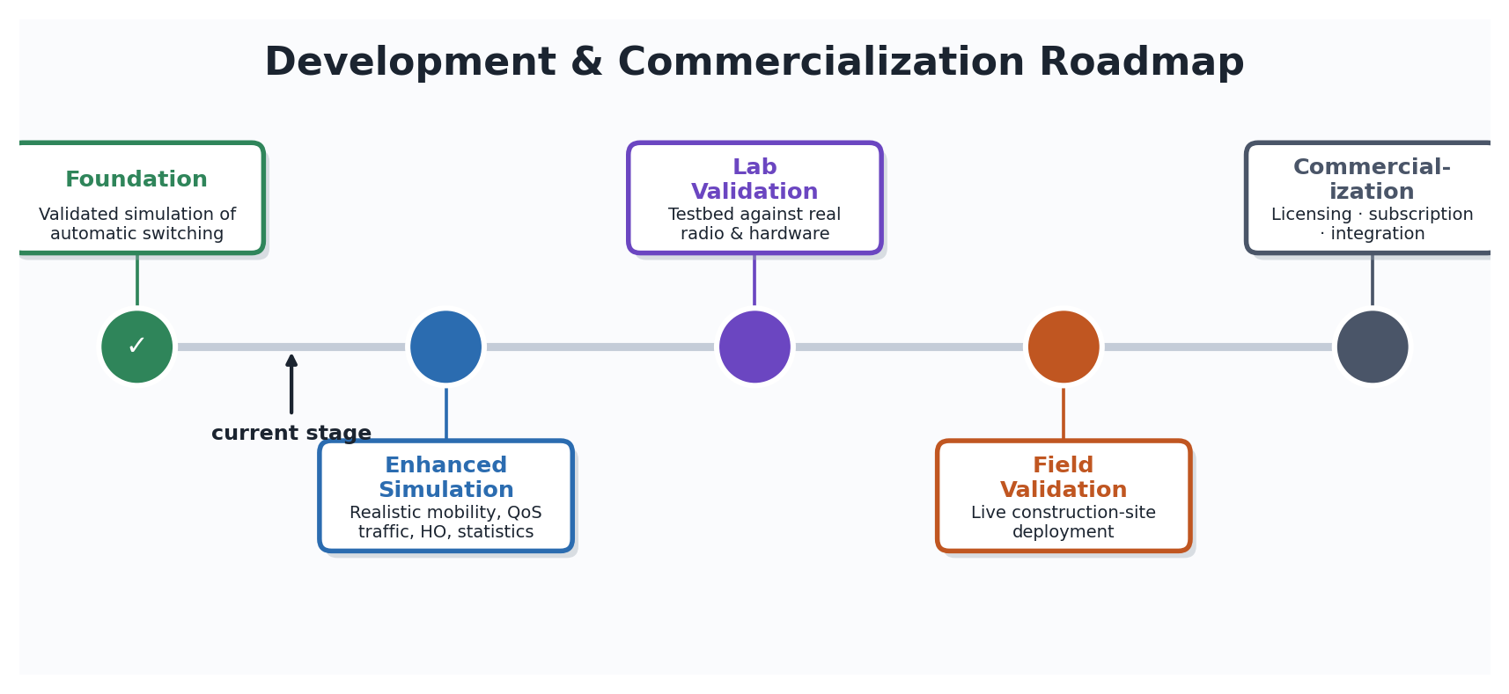
Figure 5. Staged roadmap from validated simulation to commercialization. The foundation stage is complete; work is currently advancing into the enhanced-simulation stage, with laboratory and field validation and commercialization to follow.
Completed foundation. The first development stage delivered a validated simulation of the automatic WiFi+LTE / WiFi+5G technology switching controller, establishing the core switching logic and the performance-measurement pipeline.
Planned technical development. The next stage raises the realism of the model so that its results transfer reliably to physical environments. Four improvements are planned:
- Realistic mobility modeling. Replace random node movement with structured construction-site movement patterns (patrol loops, path movement between obstacles, and work stops with dwell time) so that signal-variation and switching behavior match real robot operation.
- Per-flow Quality of Service (QoS) traffic modeling. Separate robot control commands, sensor telemetry, and video streams into distinct flows so that latency-critical control traffic can be measured on its own against the latency target, rather than through an aggregate average.
- WiFi mesh internal handover modeling. Explicitly model access-point boundary crossings within the WiFi mesh and add a guard mechanism, so that brief in-mesh handovers are not mistaken for cellular switching events.
- Statistical reinforcement. Expand the number of simulation runs and apply confidence-interval estimation and significance testing, so that performance differences between the WiFi+LTE and WiFi+5G technology modes can be reported with statistical rigor.
Laboratory validation. Following the enhanced simulation, the switching controller will be validated against a laboratory testbed to confirm behavior under real radio and hardware conditions before moving to a live site.
Field validation and deployment. The final technical stage is validation on an operating construction site, confirming seamless failover and the coordination-latency target under real-world obstacles, mobility, and interference.
Commercialization pathway (1 to 3 years). Candidate routes include protecting the RSSI/PDR fusion switching method through intellectual-property filing, licensing the switching controller to robot-gateway manufacturers and telecom system integrators, and offering a connectivity-assurance service built on the project's performance-measurement pipeline. The specific pathway, timing, and partnership model will be selected as the technology matures through laboratory and field validation.

5. Revisions & Supplementary Content
This is submitted as a new proposal. If any element of this idea was previously submitted to a past ICT Challenge event, summarize here what has changed since that submission; otherwise this section may be left blank.

What still needs your input before this is submission-ready
- Applicant name(s) and affiliation.
- Confirm/refresh the cited market figures (Section 3) against the latest report editions, and, if the competition requires it, commission a formal addressable-market estimate for the specific WiFi-cellular failover niche.
- Final commercialization-pathway decision (licensing vs. subscription vs. spinout emphasis; Sections 3-4).
- Confirm whether this is a new submission or a revision of a prior one (Section 5).

