Cross-Technology Network Performance Analysis: 4G, 5G, and WiFi Mesh
Reported by: Sheikh Sayed Bin Rahman

Simulation Approach
Simulations were conducted using NS-3 network simulator across three technologies (WiFi Mesh, 4G LTE, and 5G NR) following a systematic matrix approach. STA/UE nodes were positioned using uniform random distribution across the 400×400×30 m stage, avoiding building obstacles. A comprehensive scenario matrix was generated covering all combinations of: 3 RNG seeds (6, 7, 8), 3 node counts (5, 10, 15), and 3 payload sizes (10KB, 50KB, 1MB), with WiFi Mesh additionally varying across 2 frequency bands (2.4 GHz and 5 GHz).
Each simulation executed for 30 seconds with Gauss-Markov 3D mobility model for STA/UE movement. Network performance metrics (PDR, Throughput, Delay, Jitter) were collected using FlowMonitor and aggregated across seeds to compute mean values, standard deviations, and statistical distributions. Results were analyzed to compare technology performance across scalability (node count variation), traffic load impact (payload size variation), and overall reliability metrics. - Scenarios analyzed: 108

Common Configuration
Metric | WiFi Mesh | 4G | 5G
Stage Structure: 400×400×30 m | ✓ | ✓ | ✓
Building Obstacles: 7 buildings | ✓ | ✓ | ✓
Propagation Loss Model:HybridBuildingsPropagationLossModel | ✓ | ✓ | ✓
RNG Seeds: 6, 7, 8 | ✓ | ✓ | ✓
Simulation Time: 30.0 s | ✓ | ✓ | ✓
Node Counts: 5, 10, 15 | ✓ | ✓ | ✓
Payload Size: 10KB, 50KB, 1MB | ✓ | ✓ | ✓
UE/STA Mobility: Gauss-Markov 3D movement | ✓ | ✓ | ✓
UE/STA TX Power: 15.0 dBm | ✓ | ✓ | ✓
Traffic Flows:HTTP, HTTPS, Video (TCP),VoIP (UDP), Mixed | ✓ | ✓ | ✓

WiFi Mesh Network Visualization
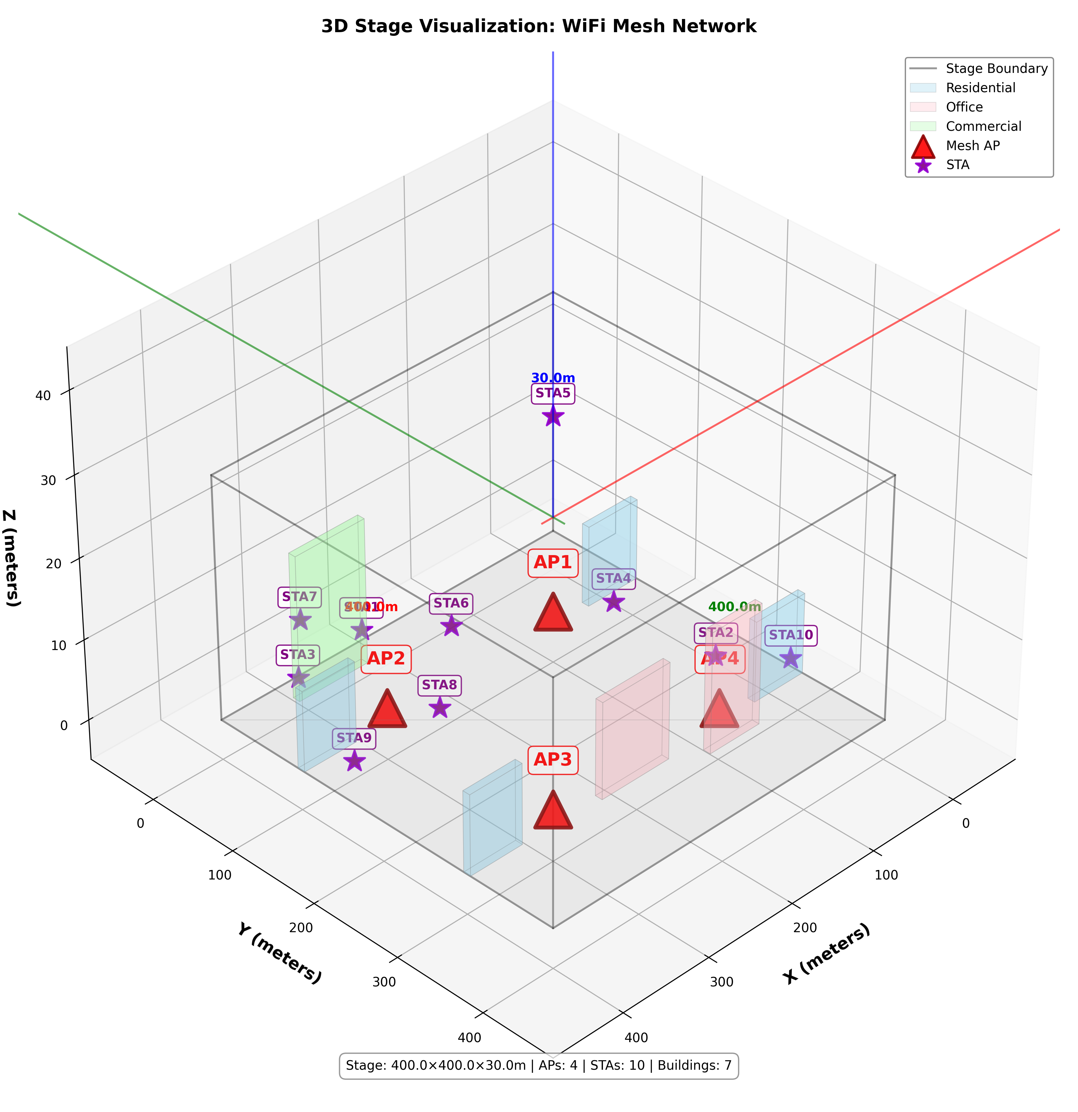
WiFi Mesh 3D Stage Visualization

WiFi Mesh Configuration
Parameter | Value
Mesh Protocol | 802.11s (Dot11sStack)
WiFi Standard (Mesh Backhaul) | 802.11n @ 2.4 GHz
Data Mode | HtMcs7
TX Power (Mesh Backhaul) | 23.0 dBm
TX Power (Hotspot/AP) | 22.0 dBm @ 5 GHz
RX Sensitivity | -90.0 dBm
Antenna Gain (RX/TX) | 5.0 dB / 5.0 dB
Number of Mesh Interfaces | 1
Hotspot Band | 5 GHz (802.11ac)
Reference: Values sourced from the TP-Link EAP225-Outdoor specifications at https://www.tp-link.com/us/business-networking/omada-sdn-access-point/eap225-outdoor/v1/#specifications.

5G Network Visualization
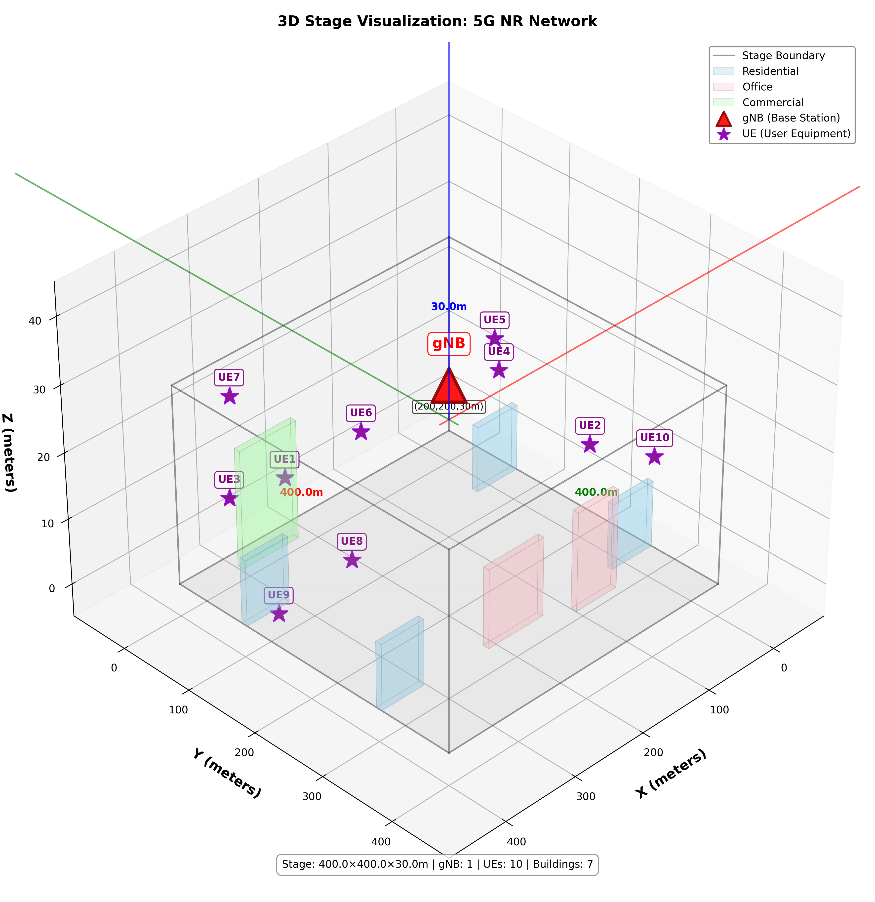
5G 3D Stage Visualization

5G NR Configuration
Parameter | Value
Central Frequency | 3.5 GHz
Bandwidth | 100 MHz
Channel Model | RMa (Rural Macro)
Channel Model Type | ThreeGpp
Beamforming Algorithm | IdealBeamformingHelper (DirectPathBeamforming)
gNB TX Power | ~43 dBm (macro cell)
Number of Component Carriers | 1
Number of Bandwidth Parts | 1
Reference: Values derived from the NS-3 default NR configuration.

4G Network Visualization
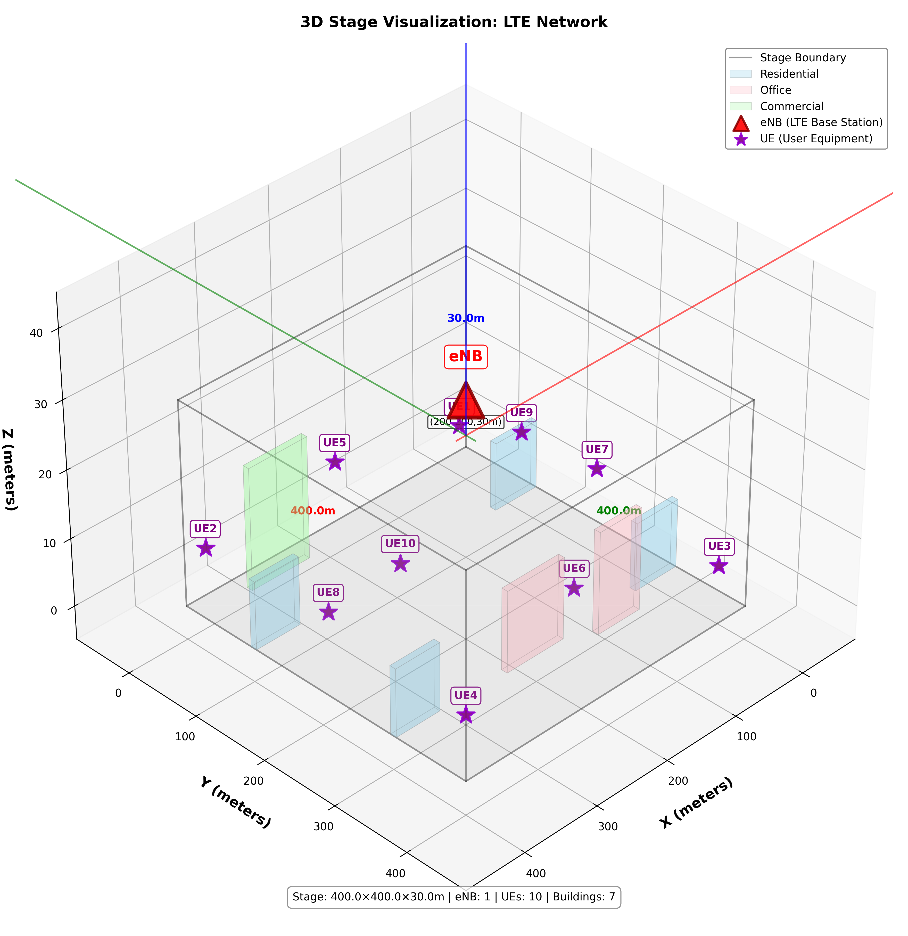
4G 3D Stage Visualization

4G LTE Configuration
Parameter | Value
Frequency | 2.0 GHz
eNB TX Power | 43.0 dBm
Handover Algorithm | A3RsrpHandoverAlgorithm
Handover Hysteresis | 3.0 dB
Time To Trigger | 160 ms
Reference: Values derived from the NS-3 default LTE configuration.

1. Cross-Technology Performance
- 5G achieves the highest Throughput (Mbps) (2.95).
- WIFI Mesh (2.4 GHz) achieves the highest PDR (%) (93.99).
- 5G achieves the lowest Avg Delay (ms) (11.74).
Technology | Mean PDR (%) | Mean Throughput (Mbps) | Mean Delay (ms) | Mean Jitter (ms)
WIFI Mesh (2.4 GHz) | 93.99 | 1.63 | 53.10 | 4.81
WIFI Mesh (5 GHz) | 92.95 | 1.56 | 46.68 | 3.11
4G | 91.15 | 1.99 | 31.70 | 3.97
5G | 88.47 | 2.95 | 11.74 | 1.85
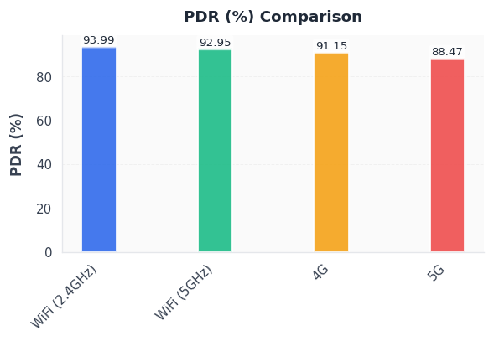
PDR (%) Comparison
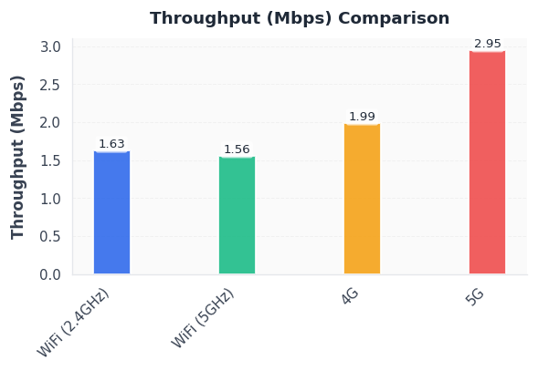
Throughput (Mbps) Comparison
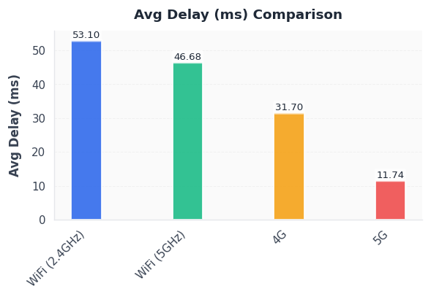
Avg Delay (ms) Comparison
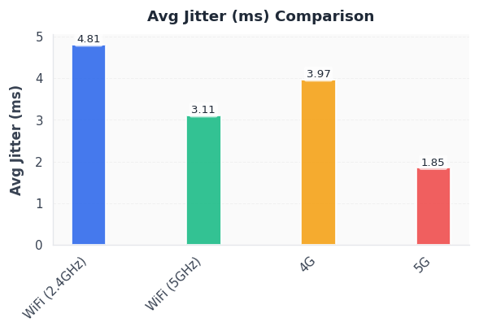
Avg Jitter (ms) Comparison

2. Scalability Trends
- WIFI Mesh (2.4 GHz) loses 9.04 percentage points of PDR and adds 44.18 ms delay between 5 and 15 nodes.
- WIFI Mesh (5 GHz) loses 10.79 percentage points of PDR and adds 55.19 ms delay between 5 and 15 nodes.
- 4G loses 7.52 percentage points of PDR and adds 27.67 ms delay between 5 and 15 nodes.
- 5G gains 7.17 percentage points of PDR and adds 1.34 ms delay between 5 and 15 nodes.
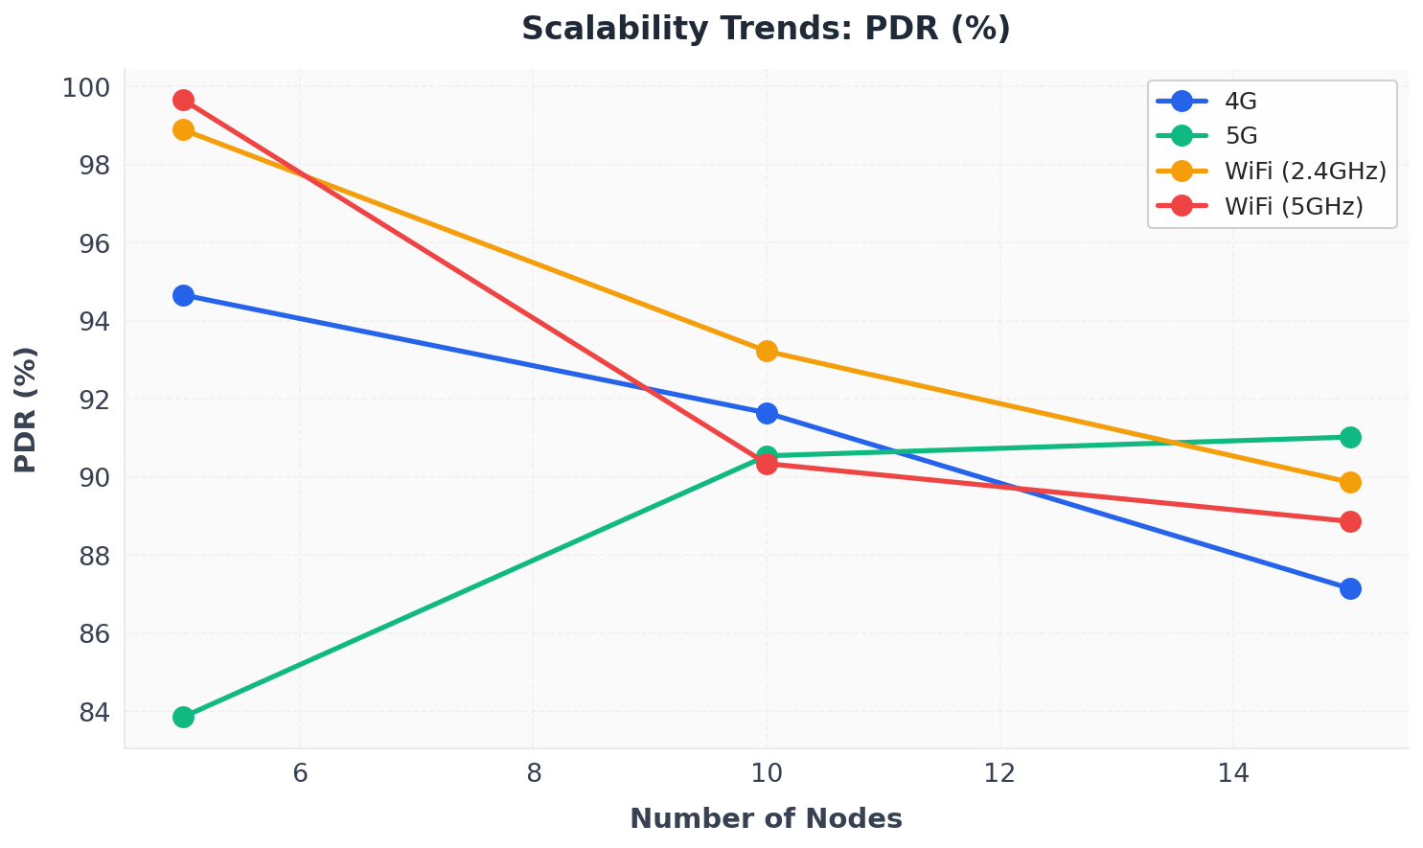
Scalability Trends: PDR (%)
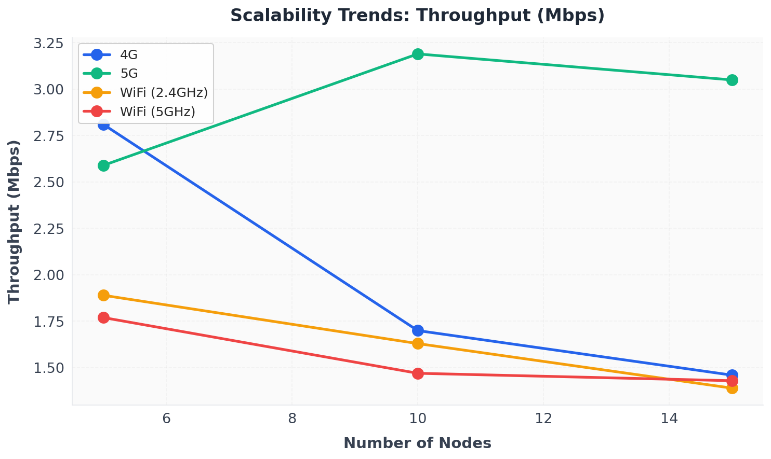
Scalability Trends: Throughput (Mbps)
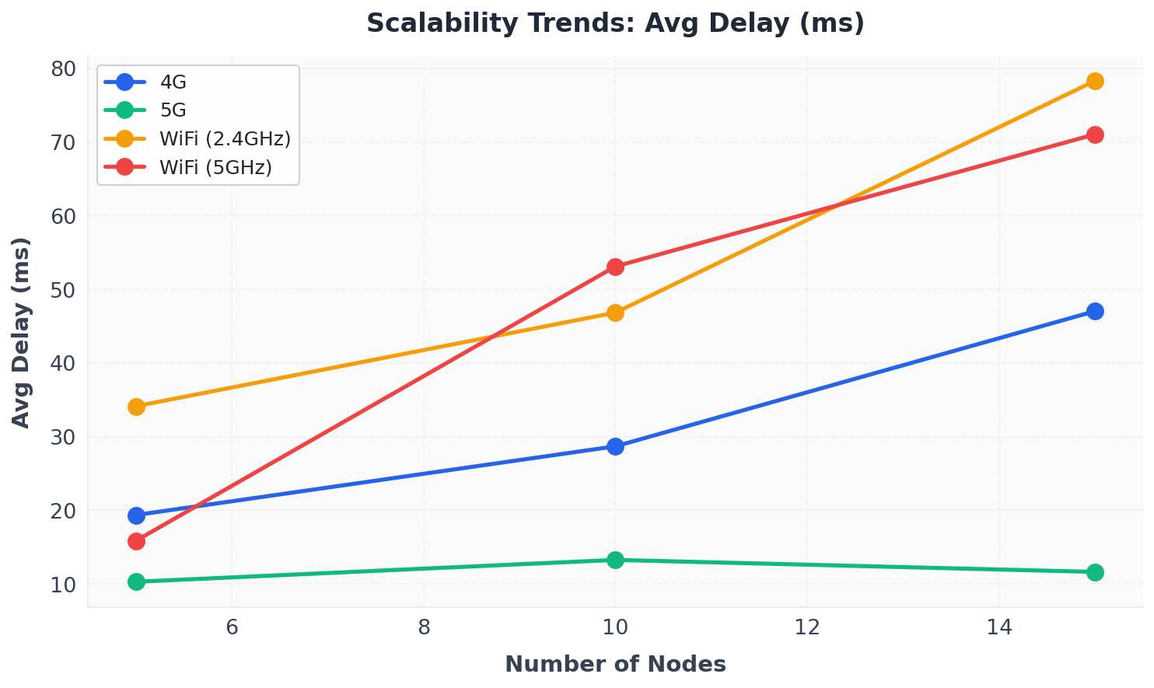
Scalability Trends: Avg Delay (ms)

5 Nodes
Technology | Mean PDR (%) | Mean Throughput (Mbps) | Mean Delay (ms)
WIFI Mesh (2.4 GHz) | 98.89 | 1.89 | 34.13
WIFI Mesh (5 GHz) | 99.66 | 1.77 | 15.86
4G | 94.66 | 2.81 | 19.36
5G | 83.85 | 2.59 | 10.30

10 Nodes
Technology | Mean PDR (%) | Mean Throughput (Mbps) | Mean Delay (ms)
WIFI Mesh (2.4 GHz) | 93.22 | 1.63 | 46.84
WIFI Mesh (5 GHz) | 90.34 | 1.47 | 53.11
4G | 91.64 | 1.70 | 28.69
5G | 90.54 | 3.19 | 13.27

15 Nodes
Technology | Mean PDR (%) | Mean Throughput (Mbps) | Mean Delay (ms)
WIFI Mesh (2.4 GHz) | 89.86 | 1.39 | 78.31
WIFI Mesh (5 GHz) | 88.86 | 1.43 | 71.05
4G | 87.14 | 1.46 | 47.04
5G | 91.02 | 3.05 | 11.64

3. Statistical Summary
- Tables below summarize distribution of core KPIs across seeds, node counts, and flow scales.
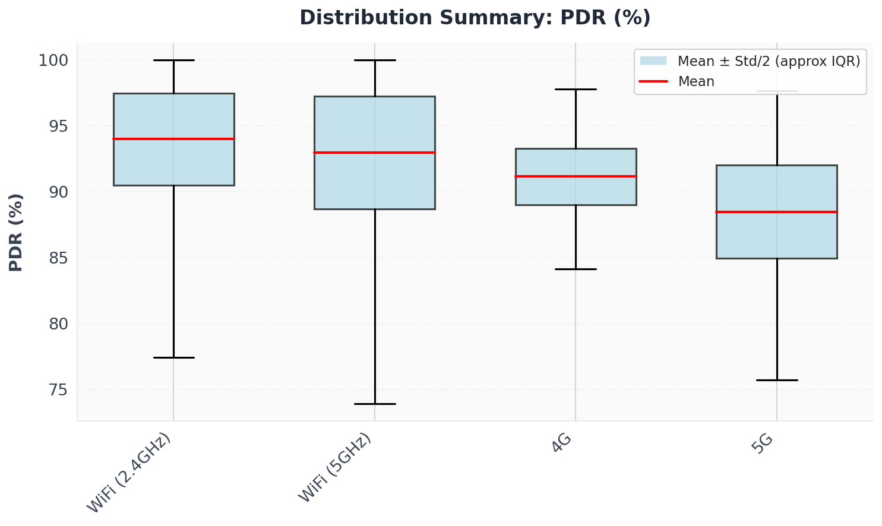
Distribution Summary: PDR (%)
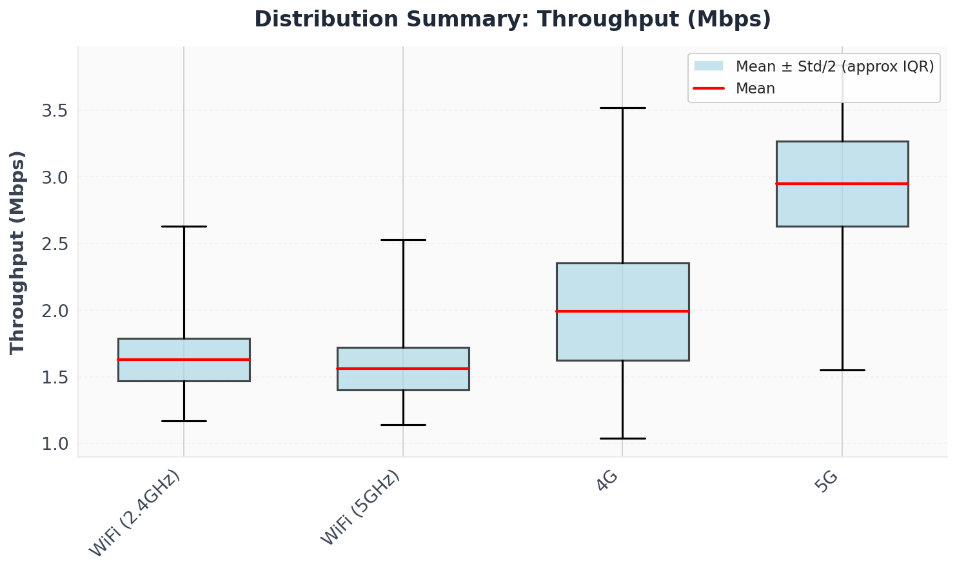
Distribution Summary: Throughput (Mbps)
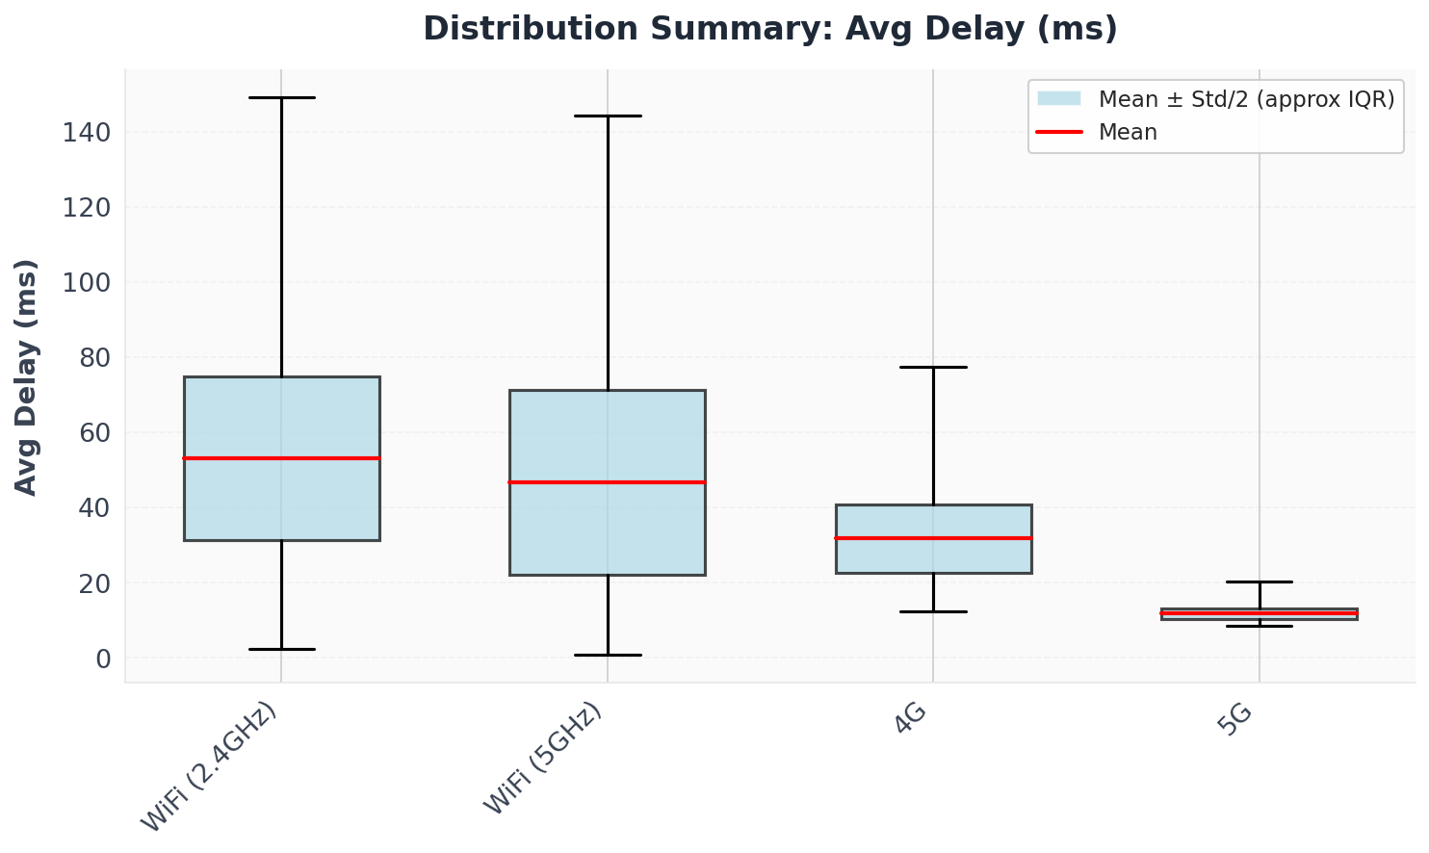
Distribution Summary: Avg Delay (ms)
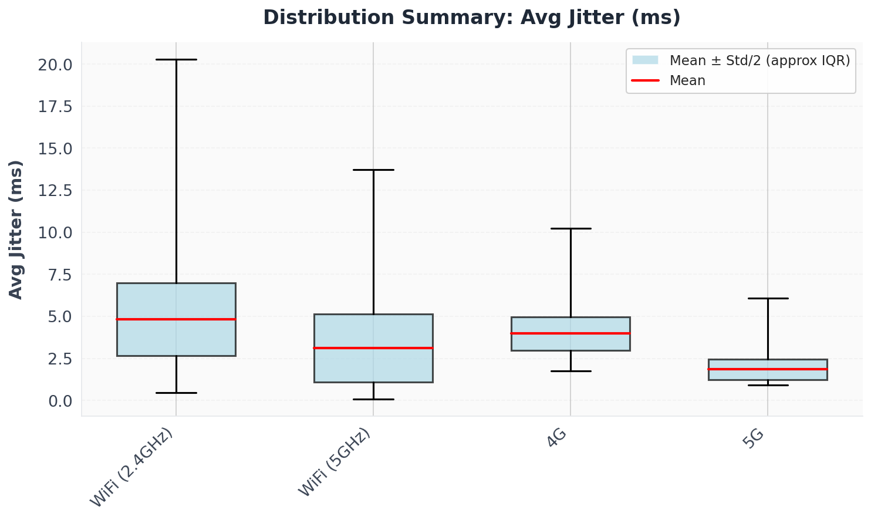
Distribution Summary: Avg Jitter (ms)

PDR (%)
Technology | Mean | Std Dev | Min | Max
WIFI Mesh (2.4 GHz) | 93.99 | 6.99 | 77.41 | 100
WIFI Mesh (5 GHz) | 92.95 | 8.56 | 73.92 | 100
4G | 91.15 | 4.26 | 84.15 | 97.77
5G | 88.47 | 7.08 | 75.72 | 97.66

Throughput (Mbps)
Technology | Mean | Std Dev | Min | Max
WIFI Mesh (2.4 GHz) | 1.63 | 0.32 | 1.17 | 2.63
WIFI Mesh (5 GHz) | 1.56 | 0.32 | 1.14 | 2.53
4G | 1.99 | 0.73 | 1.04 | 3.52
5G | 2.95 | 0.64 | 1.55 | 3.84

Avg Delay (ms)
Technology | Mean | Std Dev | Min | Max
WIFI Mesh (2.4 GHz) | 53.10 | 43.39 | 2.31 | 149.15
WIFI Mesh (5 GHz) | 46.68 | 49.11 | 0.90 | 144.11
4G | 31.70 | 18.29 | 12.32 | 77.35
5G | 11.74 | 2.96 | 8.53 | 20.21

Avg Jitter (ms)
Technology | Mean | Std Dev | Min | Max
WIFI Mesh (2.4 GHz) | 4.81 | 4.33 | 0.45 | 20.29
WIFI Mesh (5 GHz) | 3.11 | 4.06 | 0.09 | 13.73
4G | 3.97 | 1.96 | 1.74 | 10.25
5G | 1.85 | 1.22 | 0.91 | 6.08

4. Traffic Load Impact
- WIFI Mesh (2.4 GHz) loses 9.81 percentage points of PDR and adds 75.22 ms delay from 10KB to 1MB payload.
- WIFI Mesh (5 GHz) loses 8.92 percentage points of PDR and adds 72.08 ms delay from 10KB to 1MB payload.
- 4G gains 2.15 percentage points of PDR and adds 24.87 ms delay from 10KB to 1MB payload.
- 5G gains 5.36 percentage points of PDR and reduces 0.04 ms delay from 10KB to 1MB payload.
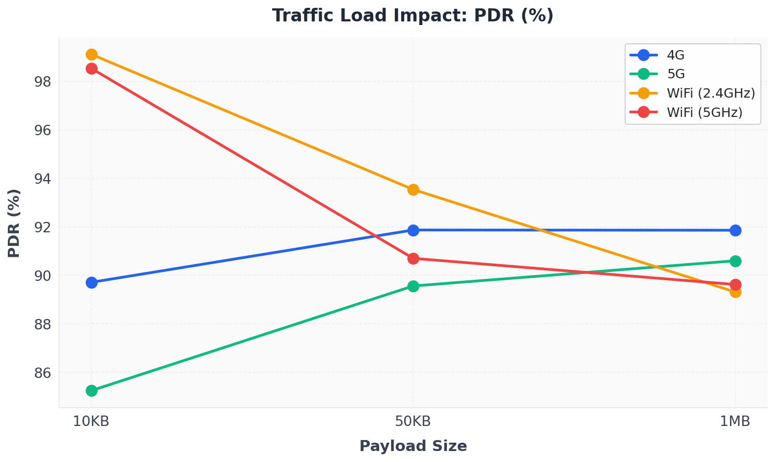
Traffic Load Impact: PDR (%)
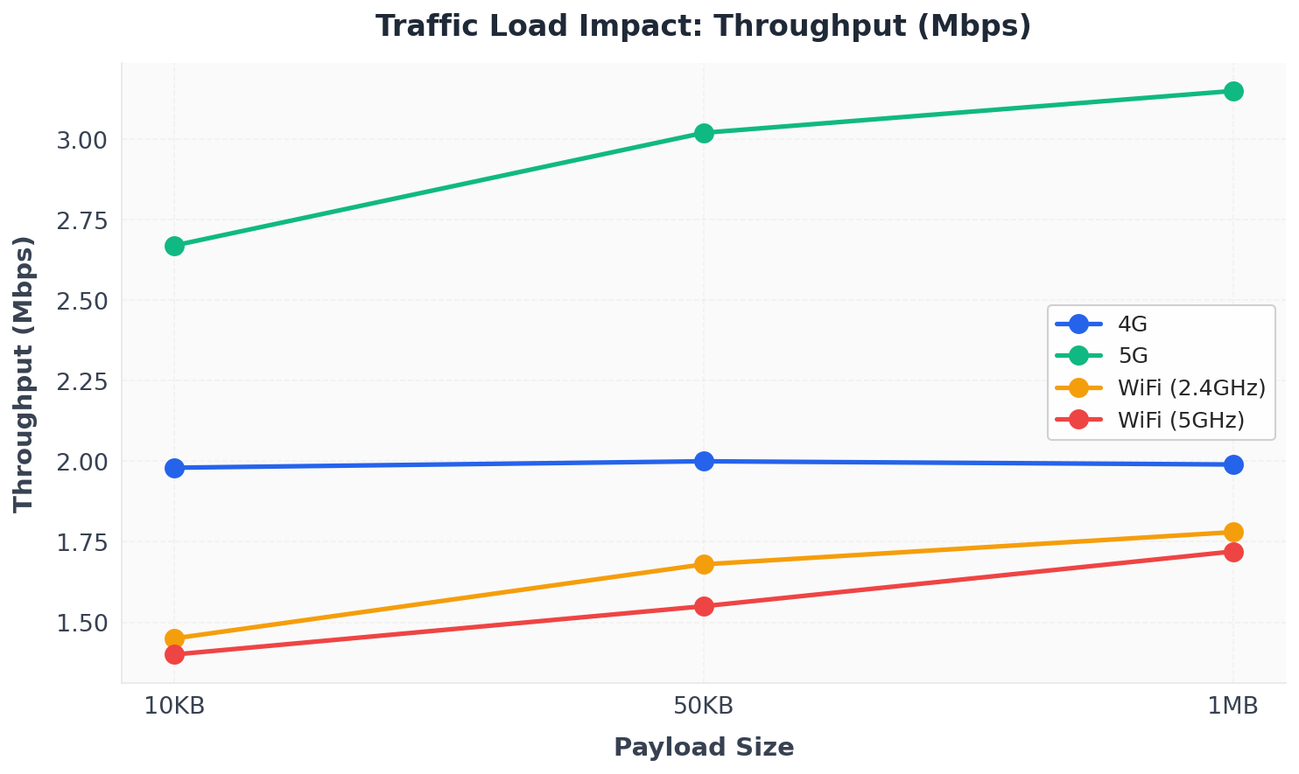
Traffic Load Impact: Throughput (Mbps)
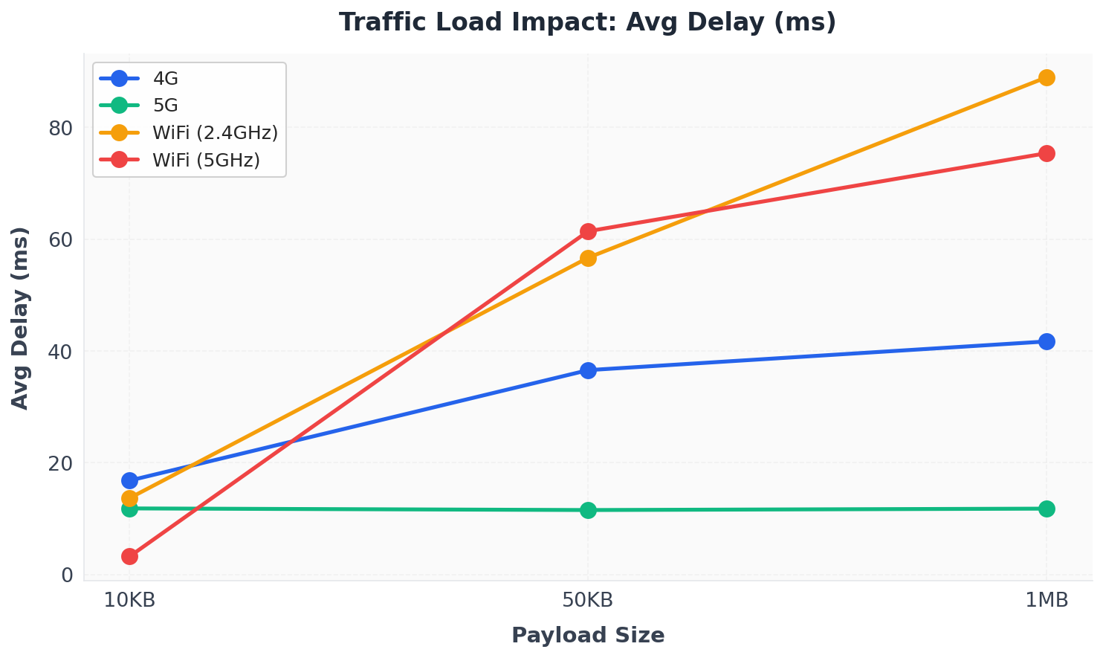
Traffic Load Impact: Avg Delay (ms)

10KB Payload
Technology | Mean PDR (%) | Mean Throughput (Mbps) | Mean Delay (ms)
WIFI Mesh (2.4 GHz) | 99.12 | 1.45 | 13.70
WIFI Mesh (5 GHz) | 98.54 | 1.40 | 3.27
4G | 89.71 | 1.98 | 16.83
5G | 85.24 | 2.67 | 11.85

50KB Payload
Technology | Mean PDR (%) | Mean Throughput (Mbps) | Mean Delay (ms)
WIFI Mesh (2.4 GHz) | 93.54 | 1.68 | 56.67
WIFI Mesh (5 GHz) | 90.70 | 1.55 | 61.40
4G | 91.87 | 2.00 | 36.57
5G | 89.56 | 3.02 | 11.56

1MB Payload
Technology | Mean PDR (%) | Mean Throughput (Mbps) | Mean Delay (ms)
WIFI Mesh (2.4 GHz) | 89.31 | 1.78 | 88.92
WIFI Mesh (5 GHz) | 89.62 | 1.72 | 75.35
4G | 91.86 | 1.99 | 41.70
5G | 90.60 | 3.15 | 11.81

Summary
This analysis of 108 simulation scenarios demonstrates that WiFi Mesh performs well and offers a cost-effective alternative to 4G and 5G technologies.
WiFi Mesh (2.4 GHz) achieves the highest Packet Delivery Ratio (PDR) of 93.99%, indicating superior reliability. While 5G leads in throughput (2.95 Mbps) and latency (11.74 ms), WiFi Mesh maintains competitive performance with 1.63 Mbps throughput and shows robust scalability across different node counts.
WiFi Mesh is highly cost-effective compared to cellular technologies. It uses unlicensed spectrum (2.4 GHz and 5 GHz), requires no spectrum licensing fees, and can be deployed with standard commercial equipment. The mesh protocol (802.11s) enables self-organizing networks, reducing deployment complexity and operational costs.
Conclusion: WiFi Mesh is feasible and cost-effective for implementation in scenarios prioritizing reliability and cost-efficiency. Its strong PDR performance, combined with significantly lower deployment and operational costs compared to 4G and 5G, makes it a compelling choice for many network deployment scenarios.

