**NodeMCU Board**

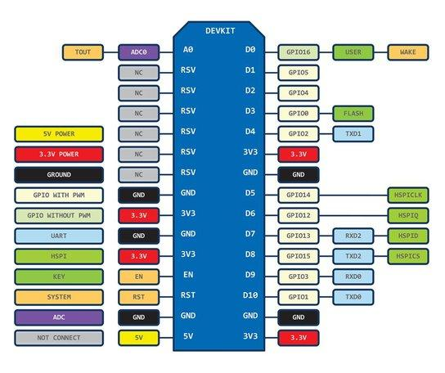

NodeMCU Board is an Open-source, Interactive, Programmable, Low cost, Simple, Smart, WI-FI enabled board which can help you to build IOT projects with ultra fast prototyping.

The Development Kit based on ESP8266, integrates GPIO, PWM, IIC, 1-Wire and ADC all in one board. Power your development in the fastest way with NodeMCU Firmware! .

Cost: Around 8$ you can have this powerful board at your command

The Only thing that will disappoint is you that , it works on 3V logic and you have to make arrangements when connecting sensors which work on 5V

This board has 30 Pins and refer the Pin diagram for better understanding.

**Getting to Know the BLYNK app**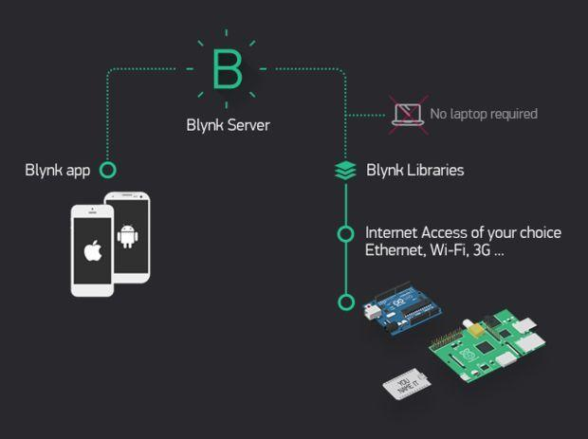

Blynk is a Platform with iOS and Android apps to control Arduino, Raspberry Pi and the likes over the Internet.

Blynk was designed for the Internet of Things. It can control hardware remotely, it can display sensor data, it can store data, vizualize it and do many other cool things.

It's a digital dashboard where you can build a graphic interface for your project by simply dragging and dropping widgets. It's really simple to set everything up and you'll start tinkering in less than 5 mins. Blynk is not tied to some specific board or shield. Instead, it's supporting hardware of your choice. Whether your Arduino or Raspberry Pi is linked to the Internet over Wi-Fi, Ethernet or this new ESP8266 chip, Blynk will get you online and ready for the Internet Of Your Things.

**HOW DOES IT WORK?** There are three major components in the platform:  
**Blynk App** - allows to you create amazing interfaces for your projects using various widgets we provide.

**Blynk Server** - responsible for all the communications between the smartphone and hardware. You can use our Blynk Cloud or run your private Blynk server locally. It’s open-source, could easily handle thousands of devices and can even be launched on a Raspberry Pi.

**Blynk Libraries** - for all the popular hardware platforms - enable communication with the server and process all the incoming and outcoming commands.

**Its features:**

*Supports majority of development boards like Arduino ,RPI, esp8266

* Easy to use

* Awesome widgets like LCD, push buttons, labelled value, graphs

* Not restricted to local Wifi network

*Direct pin manipulation with no code writing

*Easy to integrate and add new functionality using virtual pins

**Materials Required**

Now that we have some insights about the hardware and the app, we require the following components

1. **NodeMCU ESP8266 12E** development board

2. Smart Phone with Blynk App installed

3. Led with an 330 ohm resistor

4. Breadboard

5. Arduino IDE v1.6.6

Circuit Connections:

1. Now According to the Pin mapping diagram of Esp8266 board, D7 pin is the 13th pin. So we would program the pin as 13 in the arduino code which we will shortly upload to the board. Similarly take any three digital pins and write in code accordingly.

2. The connection is pretty simple just connect the LEDs to desired digital pins via 330/220Ohm resistors .(refer the diagram)

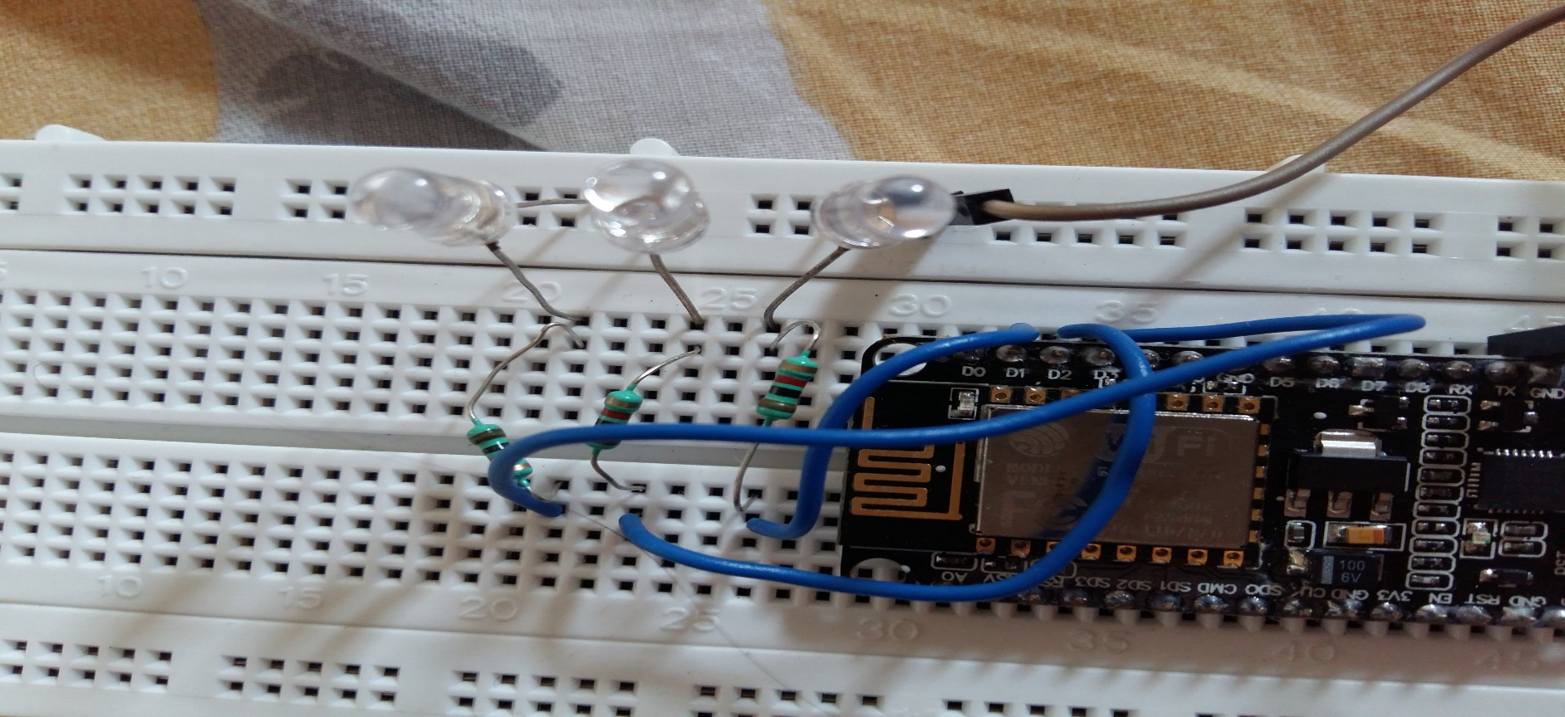

This blynk app has set of library files which have to be included in the Arduino IDE environment before the project is executed

1. Follow the link to install libraries

<http://www.blynk.cc/getting-started/>

2. Once the Zip file is downloaded ,extract it and individually copy all the folder to your libraries folder of your arduino

3. Once done just open Arduino IDE and go to **Sketch-> Include libraries** and you would see blynk in the menu

4. If you see that then libraries have been included successfully

**\*Now it is time to include the board configuration in the Arduino IDE**

**What is board configuration?**

Ok , a simple answer is that it contains all the essential parameters which required to get the board booted and configured.

for example in if you go to Tools->Board Menu you would see a list of boards . All this boards listed have different configuration settings. Therefore we should also include NodeMCU's board configurations which typically contain the board architecture , clock speed, baud rate etc.

Lets start. In the Arduino IDE go to **File->Preferences**

Now Copy the below link and paste it in the Additional Boards Manager Url text box

[**http://arduino.esp8266.com/stable/package_esp8266c...**](http://arduino.esp8266.com/stable/package_esp8266com_index.json)

Restart the Arduino IDE after that.

Now after restarting the Arduino IDE , go to **Tools->Boards** and select Node MCU board

How to use Blynk?

1. First install the Blynk app from google play store and then sign in

2. After that Press on click on New Project and you will get a screen (**Refer Screen shots**)

*Enter the name of your project, I have given it as **led**

*Then Select the Board as **ESP8266**

and then you will see below the authentication token no. If you want it in your email you can send it through email also

*And then Finally click on to the create button

3. Now you will get your dashboard screen. Just click on the the top most button "+" on the right corner to add widgets to your project.

4. In this project we add a simple button and then configure its settings as Digital GP13 pin.(**Refer Screen Shots**)

5. Its your choice you can either have the button set as push type or as a switch

6. Then label the Button as ON and OFF in the settings

**Note**that since Blynk is free only to an extend, you have to choose your widgets wisely

1. After uploading the code

2. Open the Blynk app in the Phone

3. Let it connect to the internet

4. Then you would see your dashboard with a button

5. Press Play button on the top most right corner of the app

6. Then Alas!! Press the Button and you would see the LED Turn ON!!!:)

Now that you have got the basics , you can try some cool stuffs with this awesome board !! See the video to know how it looks like when executed.

Have fun :)

Wanna try the same with a Raspberry Pi? Check my another repository. ☺