**Release Notes 29th September 2017**

**New Features In FreightBazaar**

1. **Front end- Ordering for cashless cards**

Now we have added order cashless cards functionality in front end. Supplier can order cashless cards for Drivers.

Step 1: Open FreightBazaar Website.

Step 2: Select **For Supplier** from home.

Step 3: Click on **Cashless cards** **for Drivers** slider from slider.

Step 4: Fill Enquiry form and submit.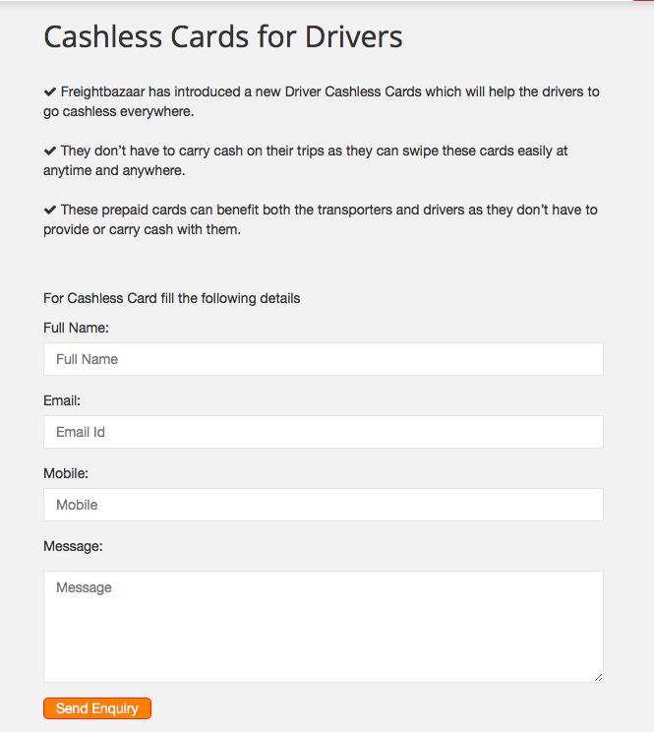

**2. FreightBazaar App- Trip Feedback App notification**

Now we have added Feedback notification from App with email functionality, On unloading completed app notification goes to Shipper for Supplier Performance feedback and after full payment submission notification goes to supplier for Shipper feedback with email. Notification sms also sent to shipper and supplier.

Step 1: Click on Feedback notification from notification tray.

Step 2: Select Rating Range and submit FeedBack Form.

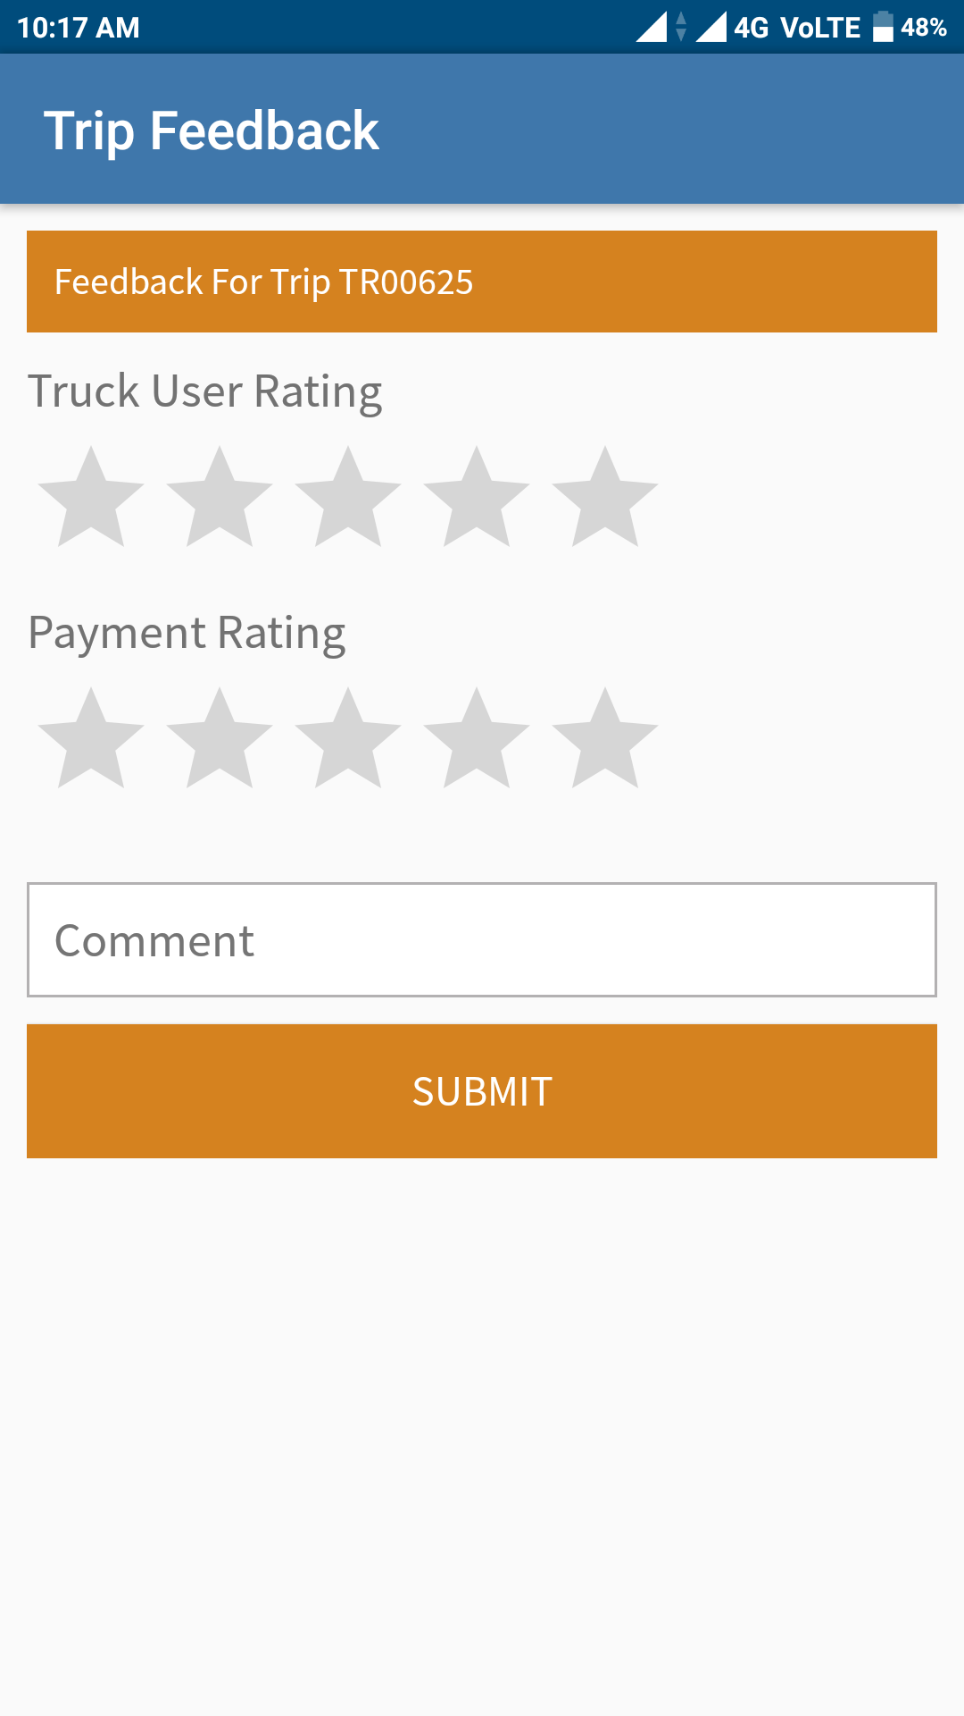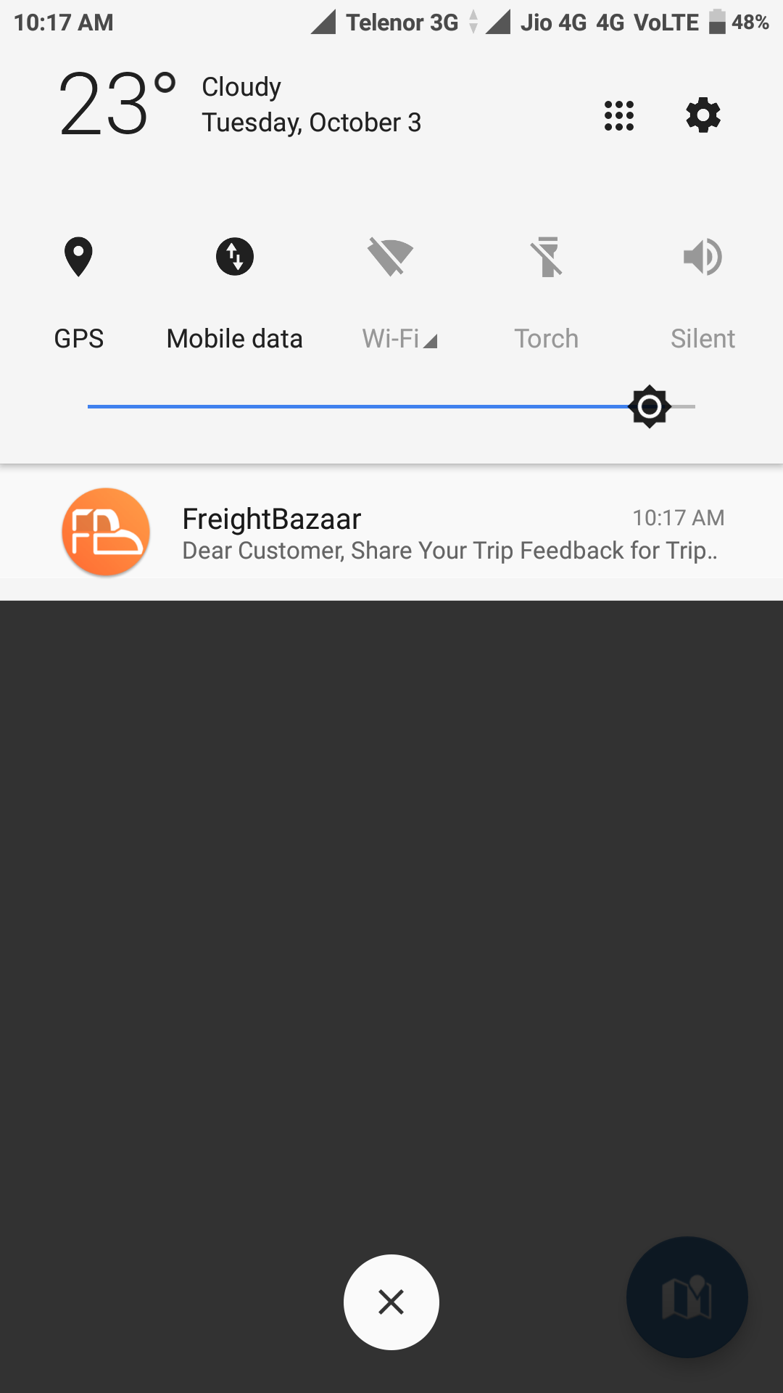

**3. Front end- Implement new keywords.**

We have added new keyword for search engine optimization.

**4. Front end- Over speeding alert**

Now we are sending sms for vehicle over speed. if vehicle speed limit is set to 50 Km/hr and it goes beyond limit then one alert sms automatically sent to supplier.

**5. Front end- Rating/Review Email/SMS**

Now we are sending feedback Email, Notification, SMS to Supplier and Shipper on Trip Status update.

Step 1: If feedback mail is received click on link.

Step2: Add rating and submit.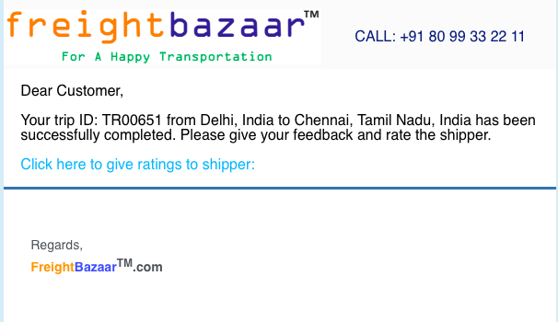

**6. Backend- DAILY Summary Report**

Now we did some changes in daily summary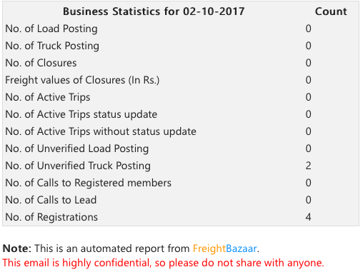 report. Added autodial call report in daily summery report.

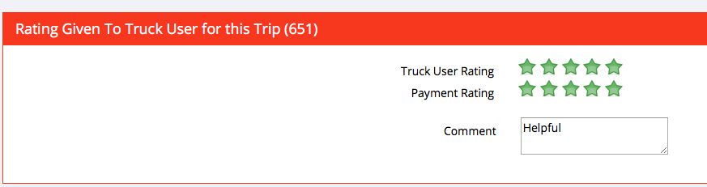

**7. Backend- CCE Work Station III**

Now in backend CCE workstation we have added supplier and leads in autodialer against load. Supplier will be visible in load list if supplier is within 100 km range from load location.

Step 1: Log in to admin panel.

Step 2: Click on **CCE workstation** from left Manu.

Step 3: Click on **process load** from Load details.

Step 4: Select **Reg. Sup** tab for supplier and **Lead** tab for Lead.

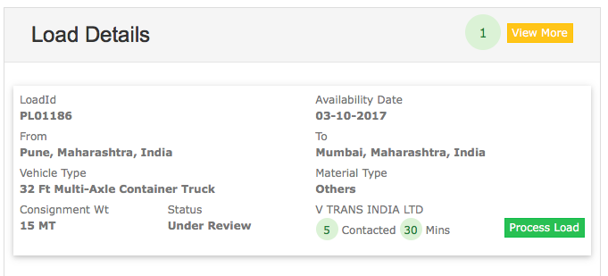

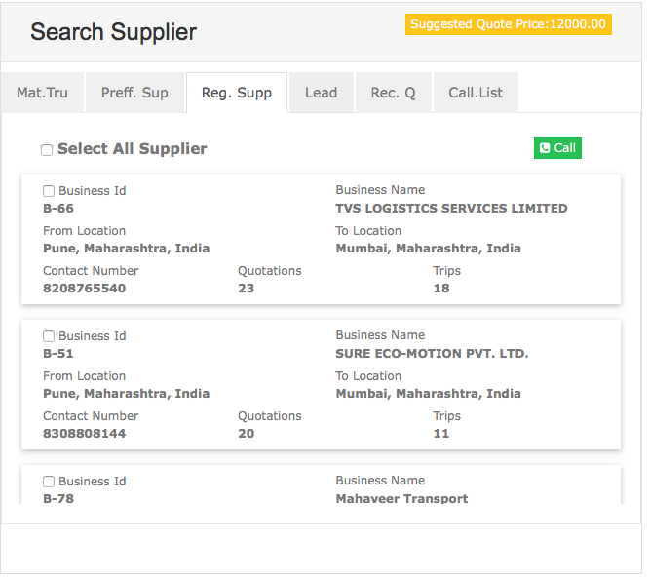

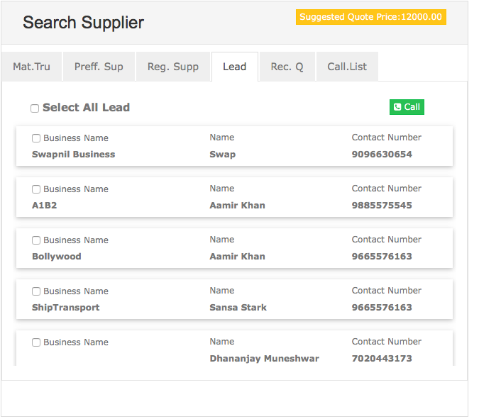

**8. Backend- Assign routes to team**

Now admin can add routes to team from admin panel or edit route for already created team.

Step 1: Login to admin panel as Admin user.

Step 2: Click on **CRM** from left panel.

Step 3: Select **Team management** option.

Step 4: Add new team with route or edit team for route or add new route team against team.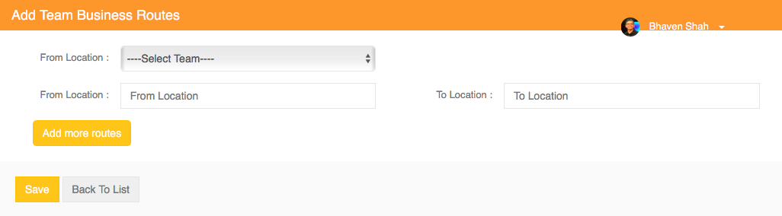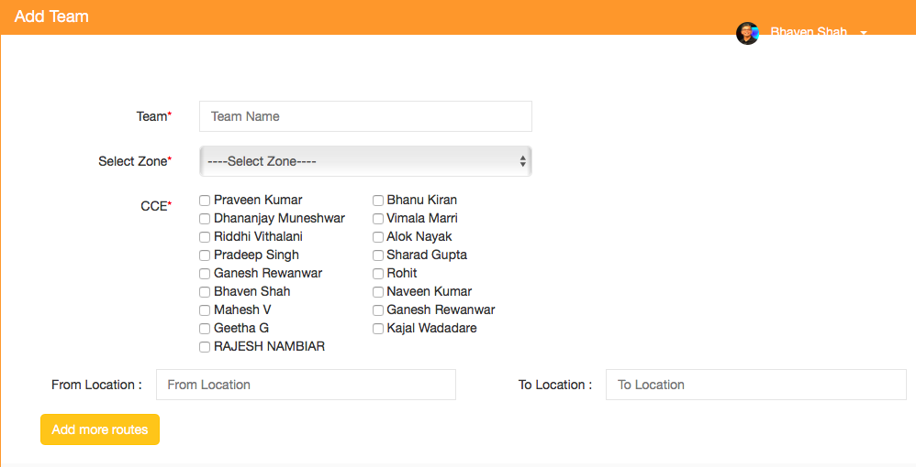

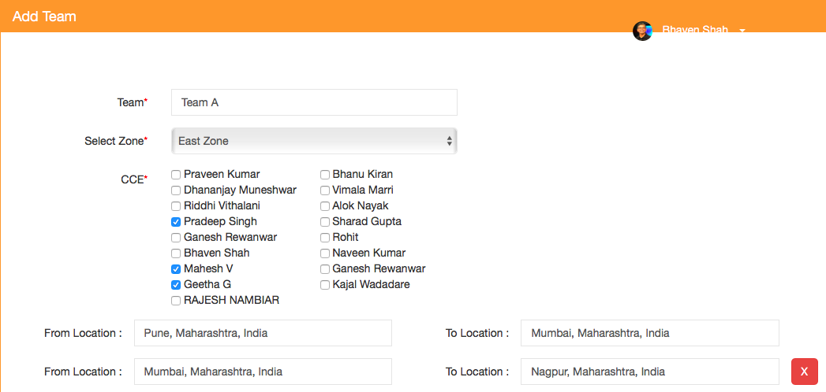

**9. Backend- Filter option in enquiry search suppliers**

Now new filter is added in enquiry search supplier. we have added vehicle filter based on matching vehicle.

Step 1: Log in to admin panel.

Step 2: Select **Quantum** from left menu.

Step 3: Select **Quantum Inquiry** from options.

Step 4: Click on **view routs** from action column.

Step 5: Select **Search supplier** from Action.

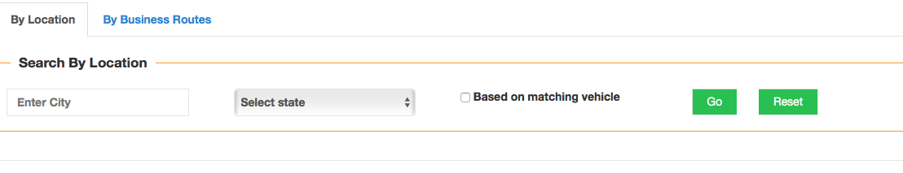

**10. Android App- Favorite Users Auto Dial**

Now we have added auto dial in favorite users. All call from auto dial will be added in call log and call report.