1. **Terms & Privacy link - Fixed**

* Click on terms & Privacy, hide the registration form, IT’S okay, but when close the terms & privacy please show the registration form again.
* The 3 LINKS inside the terms windows not works, and please use the same way when mouseover the links ( Tomato color / Under line).

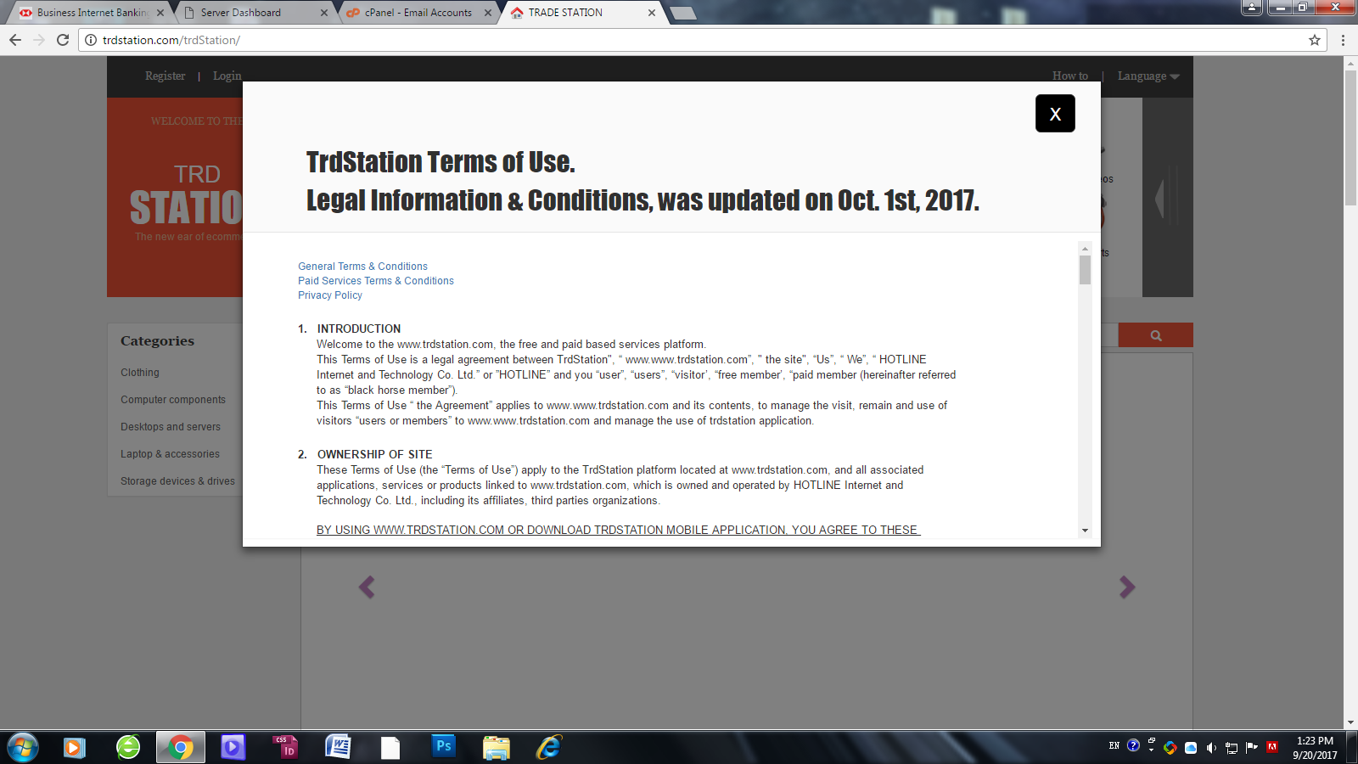

* Please increase the height of the Terms & Privacy popup window, to down or align in the center/middle of the page.



1. **My Station: - Fixed**

* The get started button still missing, please don’t publish it as an image, but publish as ( CSS3).

Is there any problem for this? it always DONE at your end but not showing for me..!!

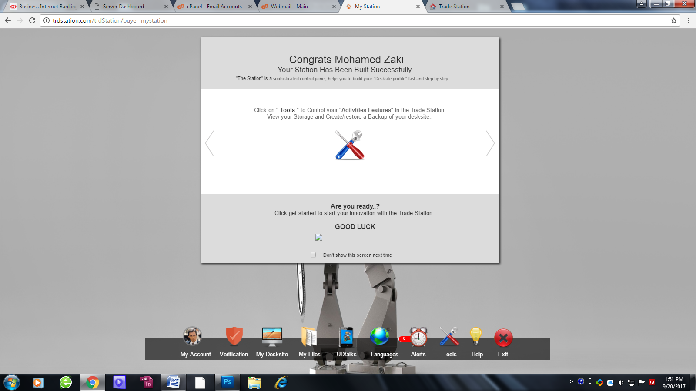

1. **My Account | View / sub-users: - Fixed**

Please delete the **second browser message** when suspend or delete sub-user.

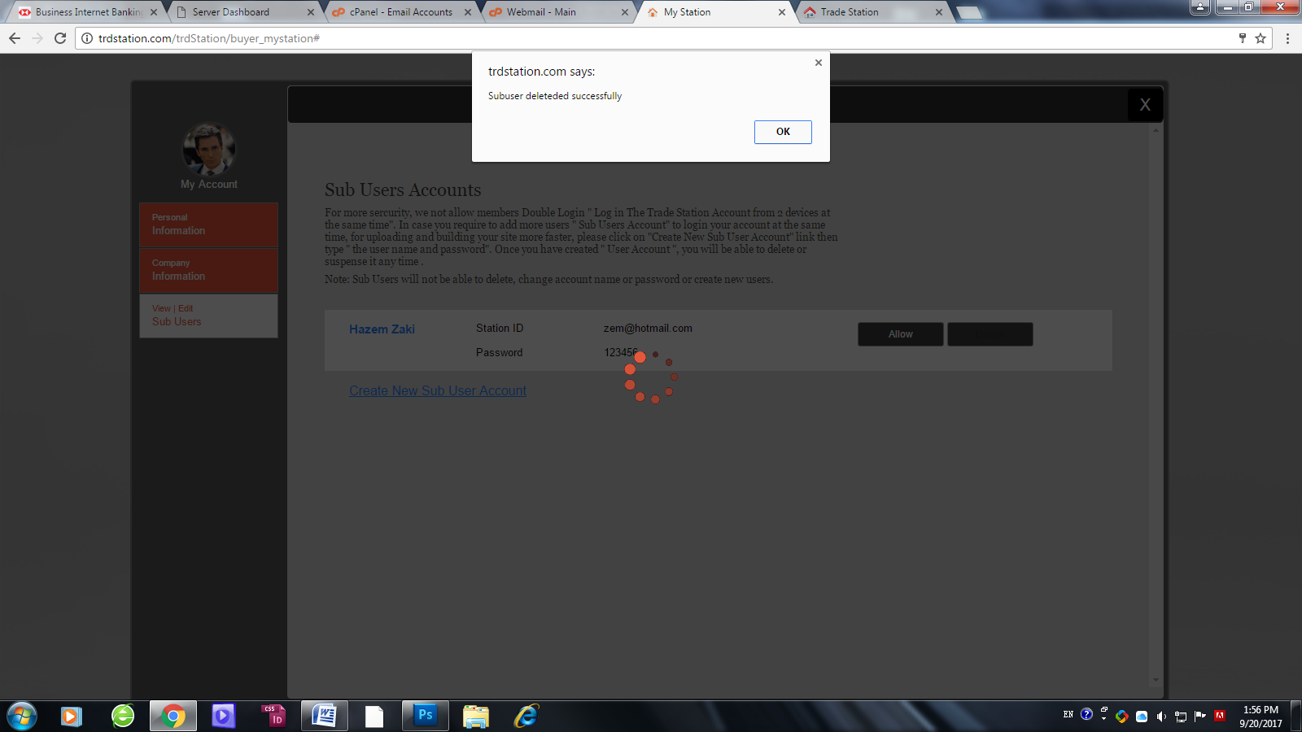

1. **My Account - Fixed**

**Personal Information in Edit screen:**

Please add the Hand click icon when mouse over the profile image.

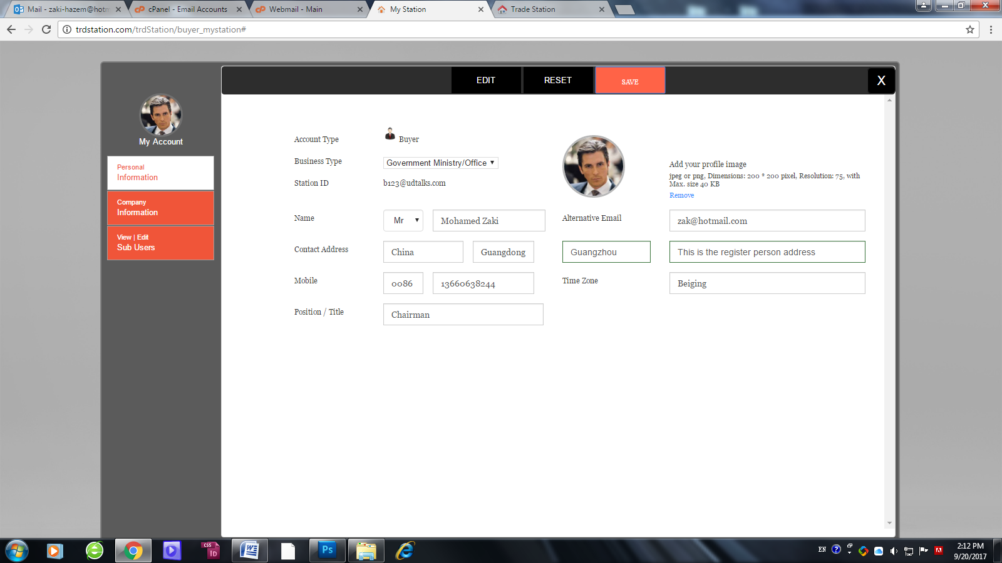

**Company Information:** - Fixed

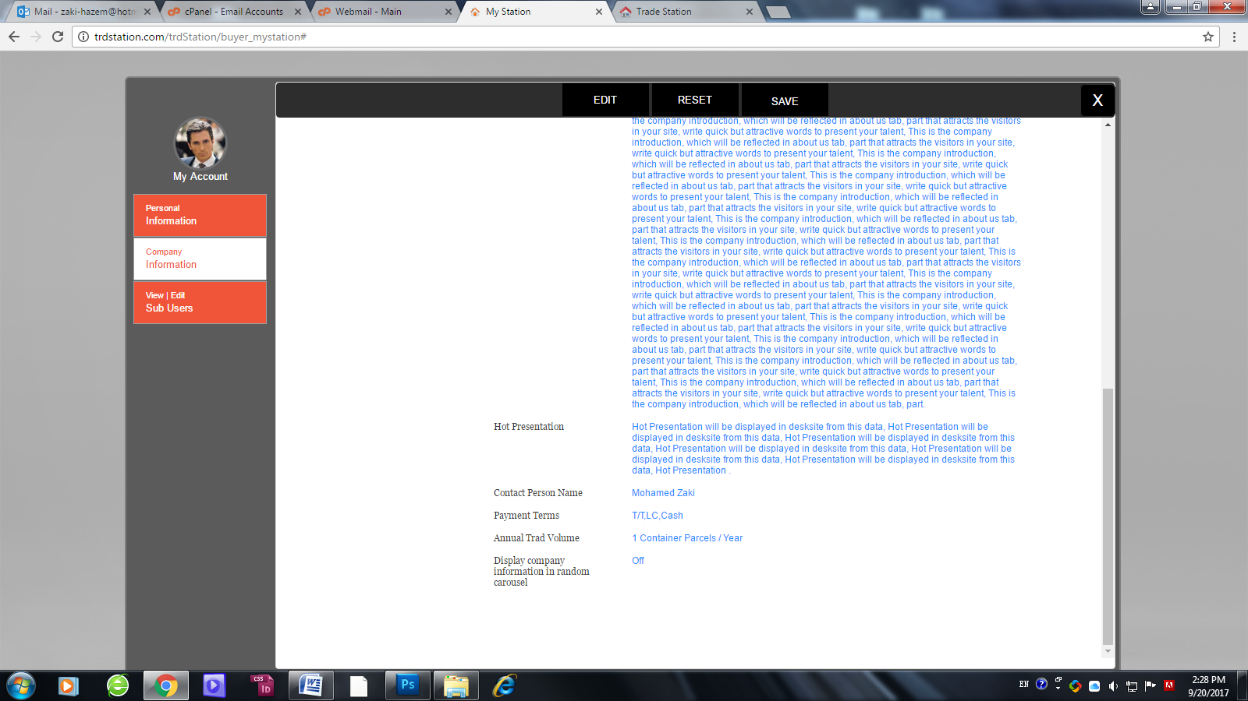The text **“ Parcels “** is added by default for the company information PLEASE REMOVE IT, just what I need is ( / Year), And please correct the text “Trad” to be “Trade”.

**In Edit screen/ add contact person:** - Fixed

* Please add the hand click icon when mouse over the contact person profile.
* **Adding contact person has error ( not saved and not added in view company profile screen nor my account main screen. - Fixed**

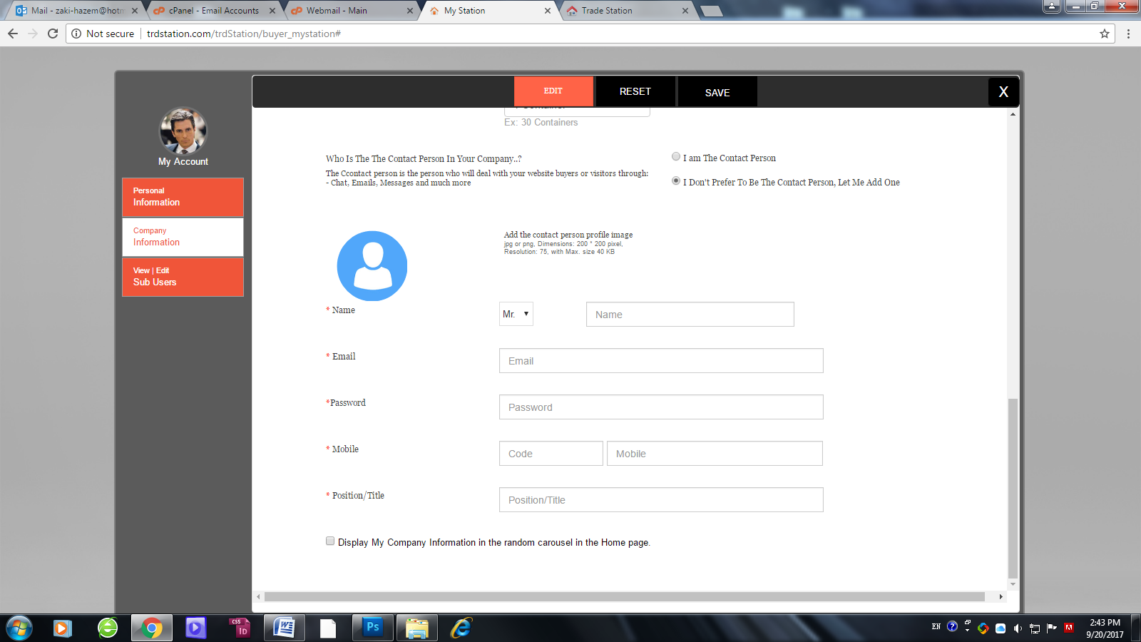

**And over company logo too.** - Fixed

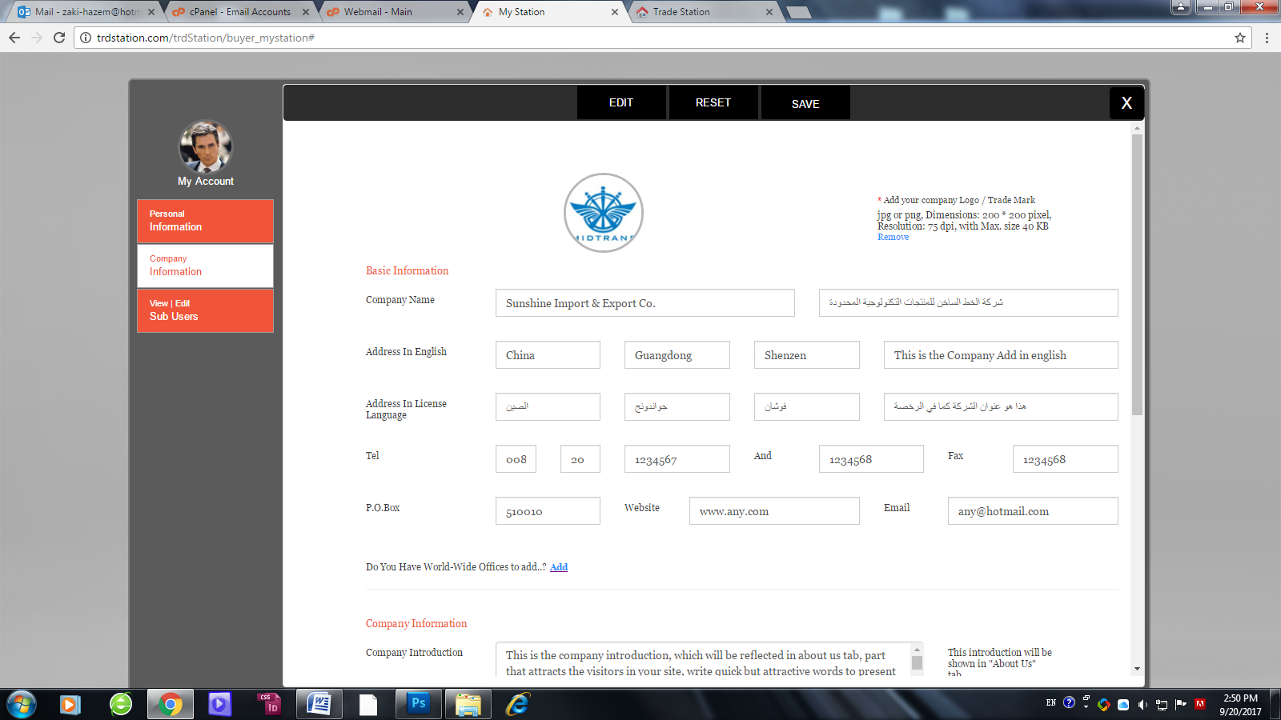

**View / sub-users:**

Please delete the **second browser message** when suspend or delete sub-user. - Fixed

**General note for all my account tabs to be apply for all Members stations:**

when open in view mode and if click save without edit, is closed the screen this is not proper, please make it as ( not actions) or non clickable ( disabled) in view screen or even remove it from view screen..

**My Desksite**:

**First step**:

* Please note that Upload link has specific function which is ( when click it opens the file selections location to add 2 images at the same time) that’s all, if this function not applied so remove it from this screen.. from all the members my station.. - Fixed
* 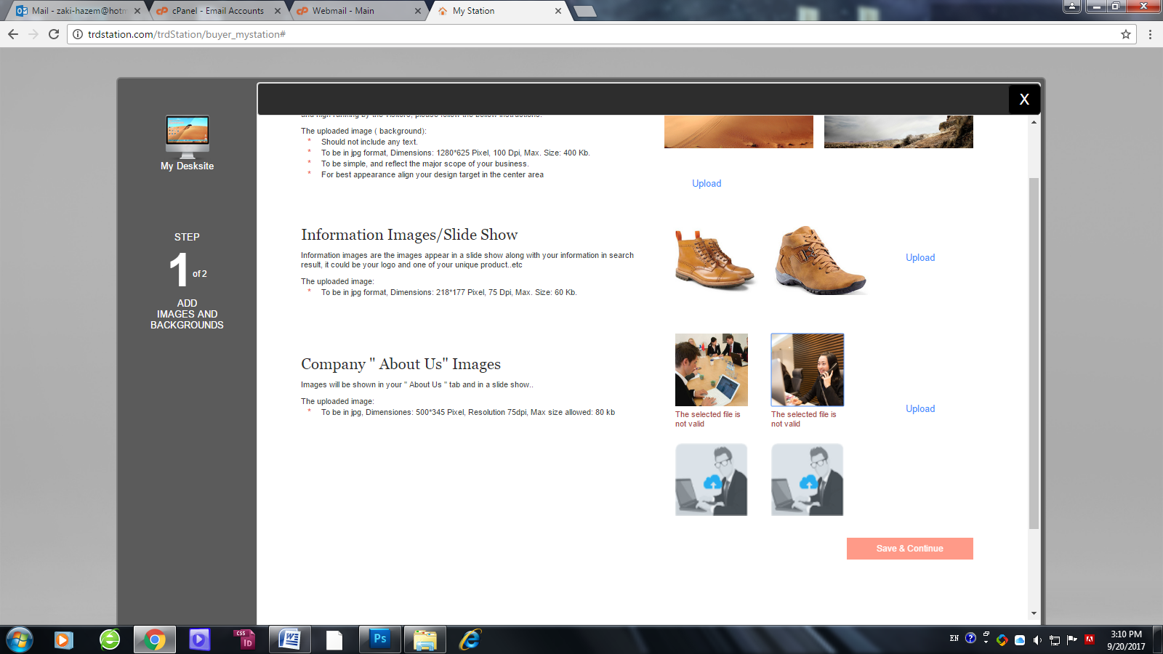what happened I can not add the same size image in the 4 about us images, it gives error and cannot go for second step. - Fixed

**UDtalks:**

* click on **add** without choose a file, stuck the page and keeps it loading forever. - Fixed

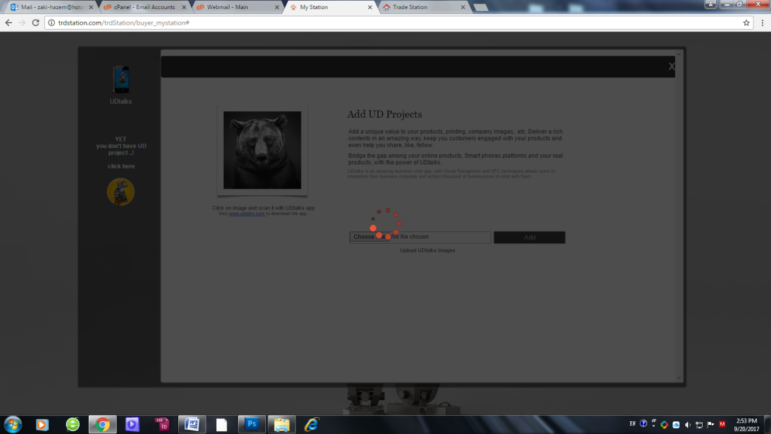

* The bear image not opened in Image Gallery view. - Fixed
* View image in Gallery view notes ( please find attached file ( Image Gallery view.docx) to be apply for all members - Fixed

**Alerts:** - Fixed

Please find attached ( **Alerts.docx**) just to be applied for all members.

**My Files:** - Fixed (As per your current UI)

Nothing showing change at my end, still not works.

**Tools/ Storage:**

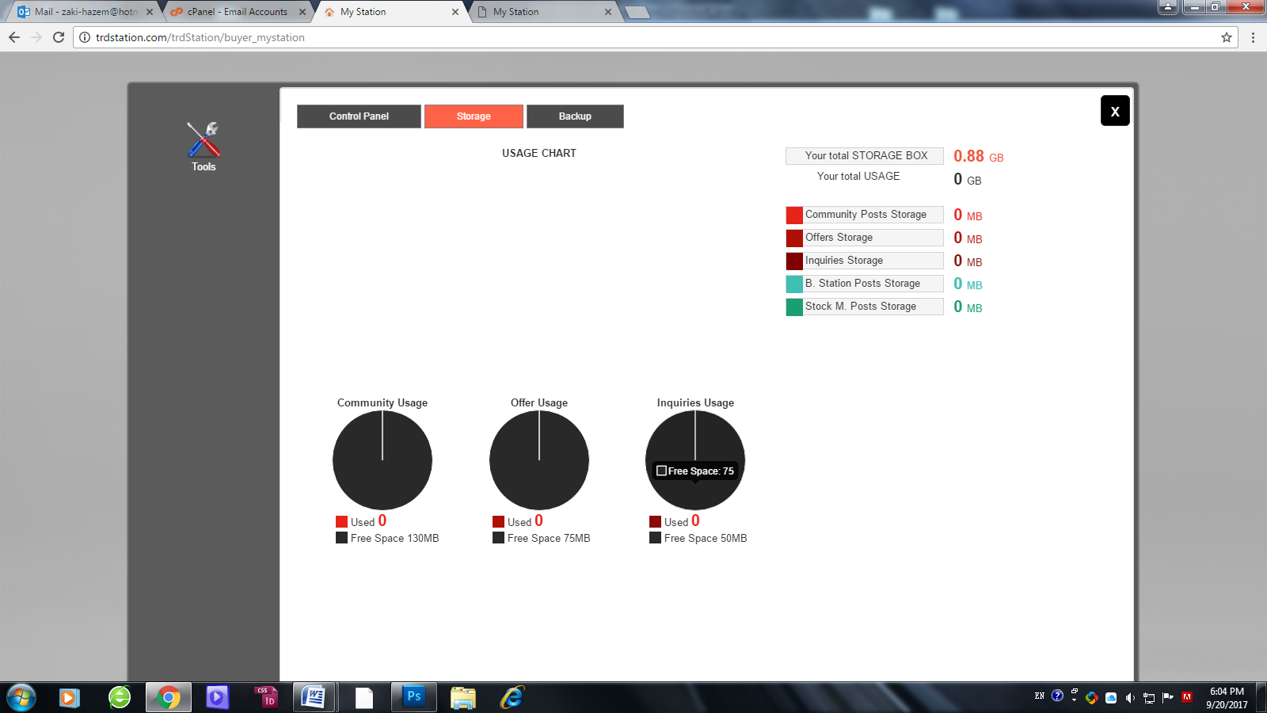

I still not understand what this reflected Mega bytes here refer to, because:

1. 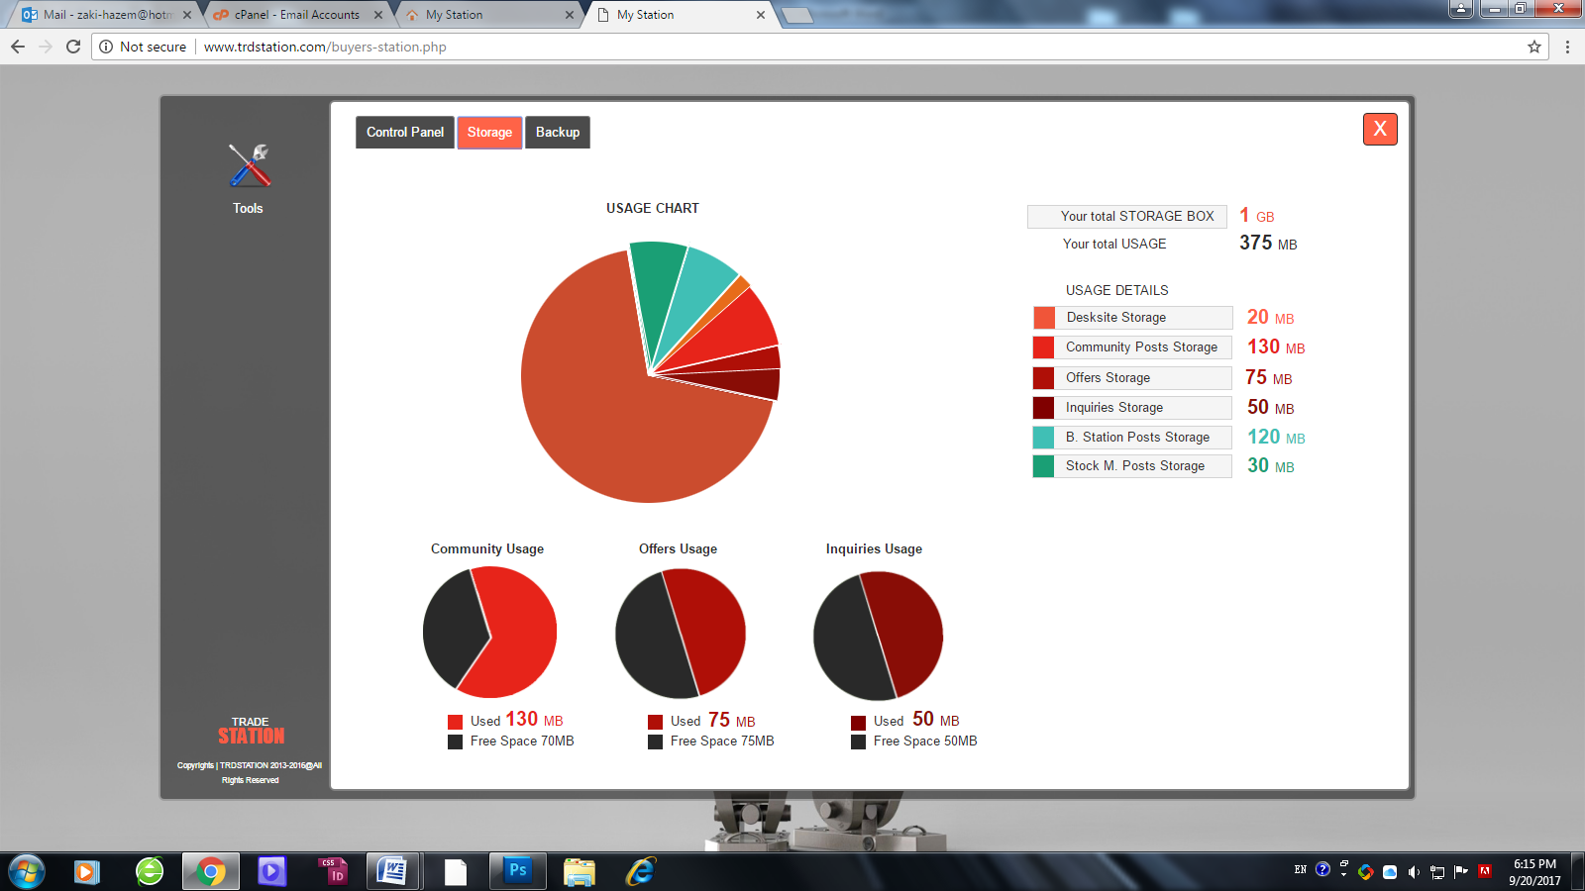The roll over text showing the ( free space) should be same the number written under the chart. - Fixed
2. Buyer storage are: - Fixed

250 MB for community usage.

150 MB for offers storage

100 MB for Inquiries storage

and all showing wrong.

1. The main usage chart still not implemented.

It is implemented but only display if total usage will be more than zero.

**Sub-users:** - Fixed

**After logged in with sub-user, account:**

**I could disable the account and delete it, this is wrong Sub-users can not delete or disable, also can not make backup or restore from ( Tools screen). please fix and apply for all members. ( please ref. to the main document file about this or even read the tips in the same screen).**

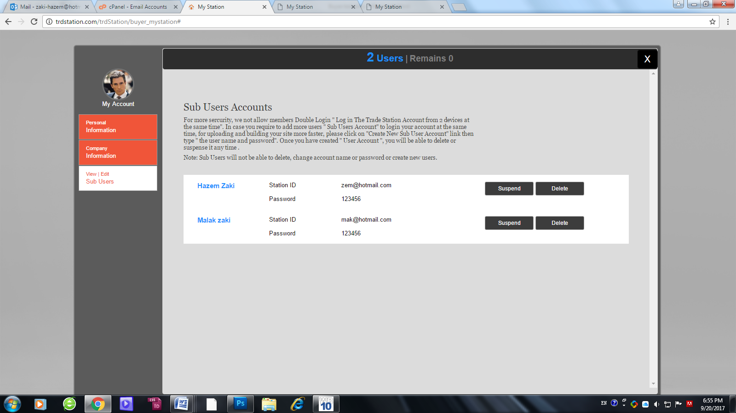

**In Buyer page:**

1. A new issue showing: the company duplicated in 4 time in search result BASED on how many contact person created ( even deleted it still showing), which means:

Showing one time with the main register person + showing one time with the contact person + is delete contact person and add new one it shows one time more and so on.

Please fix and apply for all members in other pages. - Fixed

1. Delete member account still not remove his information from buyer page. - Fixed
2. Please remove the extra size of the layer to be same the other pages, same as product page. - Fixed

