**The Business Station**

This page consider one of the social feature part for our website and it works as follows:

1. This page will be about business, products, services ..
2. Acts as Facebook/Wechat “moments screen”, which means posts will appear one after one in the post scrolling area once users send new posts., And this will be the same part reflected in small UI, at the Home page too.
3. New posts will be above and the previous one pushed under.
4. Users can send post from the page itself and it going to be showing in post area at the same time ( real-time posts).
5. When user’s mouse over the posts scrolling area or he scroll down, we stop retrieving new posts, till he scroll up again.
6. Each users can send posts according to the following limitations:

* Limitation for all users ( sellers, shippers and buyers) Maximum 10 posts per day, no any limitation of storage.

If users try to send post No. 11. the following message will pop up:

Sorry.. you have reached to the maximum limits of posts per day .. Try again tomorrow.

Ok

* Each business post can be live for **1 month** only, after this period it got expired ( Not shown in posts area) and deleted from our server,.
* Users can Delete any post any time ( even it still not expired) by click on “ View My Post “ then checkbox on the required Post then Delete. Please note that the remains days will be displayed in each post, under delete button.

1. The above mentioned functions will be in different tabs between ( Sellers/Shipper and Buyers) will be explained through the page design as follows:

**UI Notes Clarifications**

1. The page will be opened each time on Search screen, to push users to search for a product or shipping services ( such as air freight), in certain country the “Go”.. we have to do this because after our website got Huge number of users and traffics it will be hard to follow each boosted global post in all the products in real-time, it will be so fast for the users to follow, that’s why we have to limit the search and limit to display of posts.. -Done
2. At the upper of this screen ( search screen) there the log in/register/translate bar with the same icons as it implemented in Home page, If user logged in, it will show the user name and profile image normally and it will be easy to know he is seller/Shipper or buyer. -Done
3. Once users click add the keyword and select the country “ Go”, the main page will open with 3

parts as follows:

1. **The login bar** which will change and carry ( the **6 dots Icon** which will open the main Alerts Box and My Alerts same as other pages) . -Done
2. Orange tab (Sellers/Shippers Offers) with posts area: which will display all the posts boosted by them only in real-time according to the keywords and the selected country.

* **WITH OFFER SEARCH BAR AND COUNTRY**, to allow user to change keywords without reload the page .. -Done
* **For Sellers Area:** allows sellers/shipper to send posts, view ( renew or delete) and close previous posts. -Done

1. **Blue tab** ( Buyers requests) with posts area: which will display all the posts boosted by buyers only in real-time according to the keywords and the selected country. -Done

**WITH OFFER SEARCH BAR AND COUNTRY**, to allow user to change keywords without reload the page .. -Done

**For Buyers Area:** allows Buyers to send posts, view ( renew or delete) and close previous posts. -Done

1. If I logged in as a Seller or Shipper, it means I ONLY will be able to send posts from (Sellers/Shipper Offers) from ( For Sellers Area/Add New Post), Also able to view and close my previous posts from the same Area, BUT IF I CLICK ON BUYERS REQUEST, I WILL NOT BE ABLE TO SEE THE “ FOR BUYERS” AREA AND NOT SEE EVEN VIEW OR CLOSE MY POSTS..

And vise versa, if i am a buyer and logged in, I will Only be able to send posts from “ BUYER REQUESTS” tab, from “FOR BUYERS AREA” and , I WILL NOT BE ABLE TO SEE THE “ FOR SELLERS” AREA AND NOT SEE EVEN VIEW OR CLOSE MY POSTS..

1. Please note that all the page will be fixed ( non-moved page) only the posts layer ( in both tabs) will be scrolled up or down .. PLEASE NOTE THAT WE ONLY NEED TO SHOW ONE VERTICL SCROLLING BAR SO PLEASE REMOVE THE HORIZONTAL SCROLLING BAR IN “BUYERS REQUESTS” TAB , TO BE SAME AS “SELLER OFFER” TAB.. I JUST DID IT BY MISTAKE. AS SHOWN HERE UNDER -Done

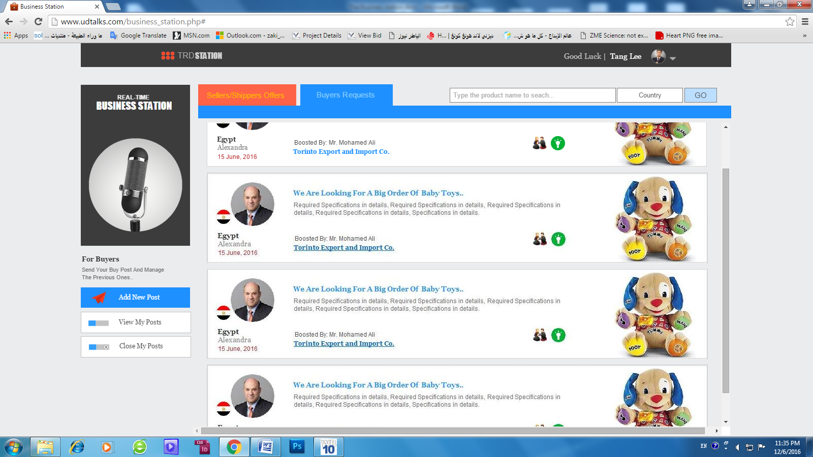

**How to open posts in the scrolling area:** -Done

when user move over the post, a new layer with VIEW icon will appear and disappear if mouse leave.

if user click on the VIEW icon it open the post simply in 2 posts size with 5 functions:

1. Send an offer or request about the same product..
2. Add the post publisher to user community..
3. Chat
4. Visit post publisher Desksite
5. Translate post “ this is the” 4th way” of using translation API in our website, when click on it, a drop down list ask the user to translate the post to which language..

N.B. The opened post will no close unless the user click on “X” button.

**Sending Posts and Lock the posts for the same business type:** -Done

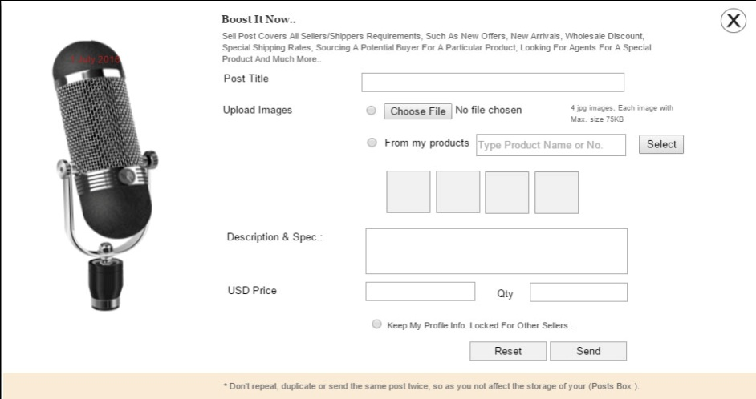Users can send post simply by click on “ Add New Post” on the same tab match his business type, once he click on it, post form will open to allow his fill “ Post Title” + Upload button to upload (4 Images at the same time or use images from a certain product “link” or both, when user select “ FROM MY PRODUCTS” and type the product No. or Name and press select button, we open a window show him the main 5 images of his product to select from, in case he select 2,he can use upload image to add other 2 “ THIS IN SELLER OR SHIPPER ONLY” Buyer same not change) + Post Body “Description“ which should not exceed ( **2000 Characters**), Price and Min. Order for sellers and ( No price or Qty for buyers) as shown here under:

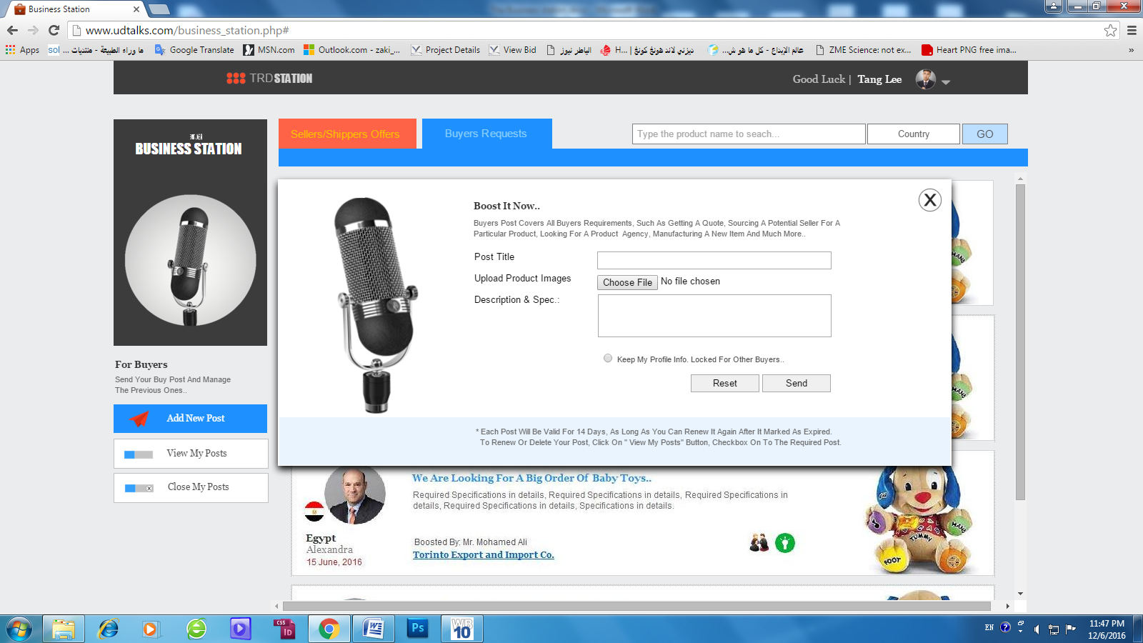

The Important part here is this “ Keep my information Locked for other Buyers” or “ Sellers”, most of the buyer or sellers worry to send offer or requests, if other buyer at the same area ( city) can see it and copy or follow or make the same order, so we have to provide users with the 100% of privacy confidential ..

What we have to do is: if Buyer mark the checkbox “Keep my information Locked for other Buyers” so no other buyer can see his main information “ Photo + Name and company name + Country” also when buyer move mouse on the other buyer post cannot open it, and we shown “LOCK ICON” instead view icon, BUT ALL SELLERS AND SHIPPER CAN SEE HIS POST NORMAL. To be like this:

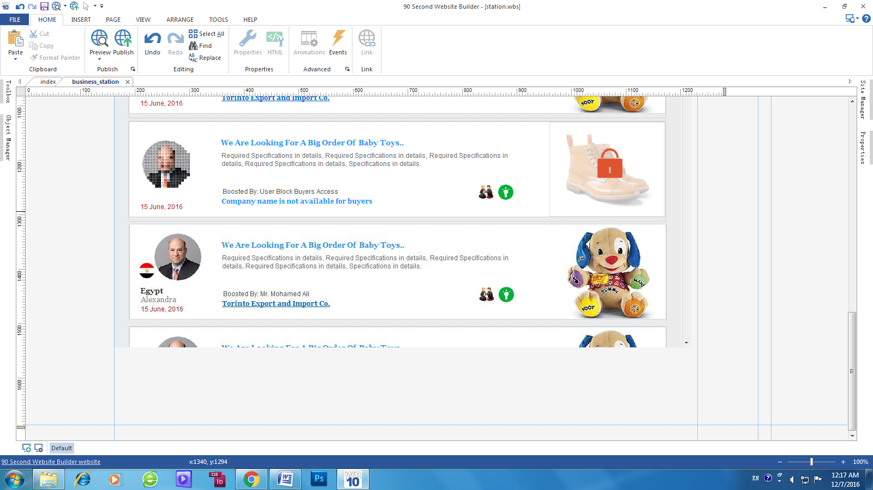

**This mode will not be only in business station or Stock market but in Buyer/Seller /Shipper Desksite also, because in Desksite you can view the buyer latest posts so we apply the same idea to Buyer/Seller/Shipper Desksite too.**