**In Alerts: please note:**

1. 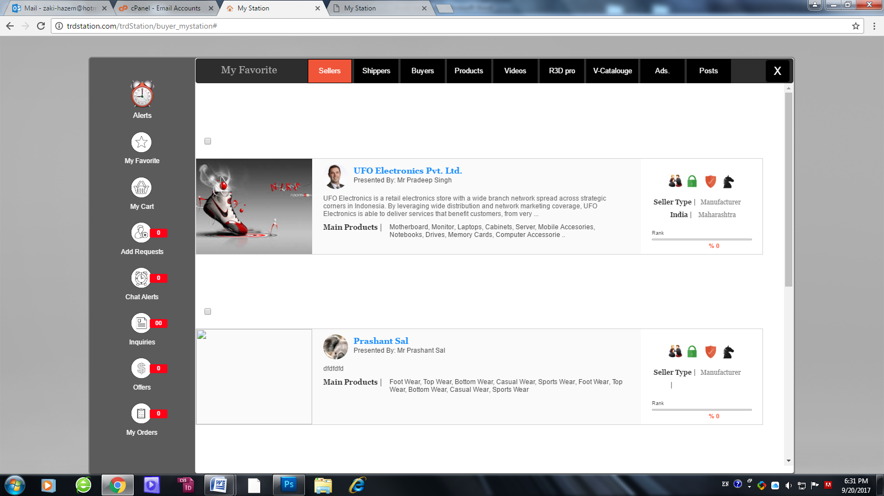The checkbox is above the member information area, which leads to a huge space between Member information and other one as you see hereunder. The space among them should be same as displayed in buyer page. So the checkbox should be on the right side in the center as be my UI.

As this showing here under:

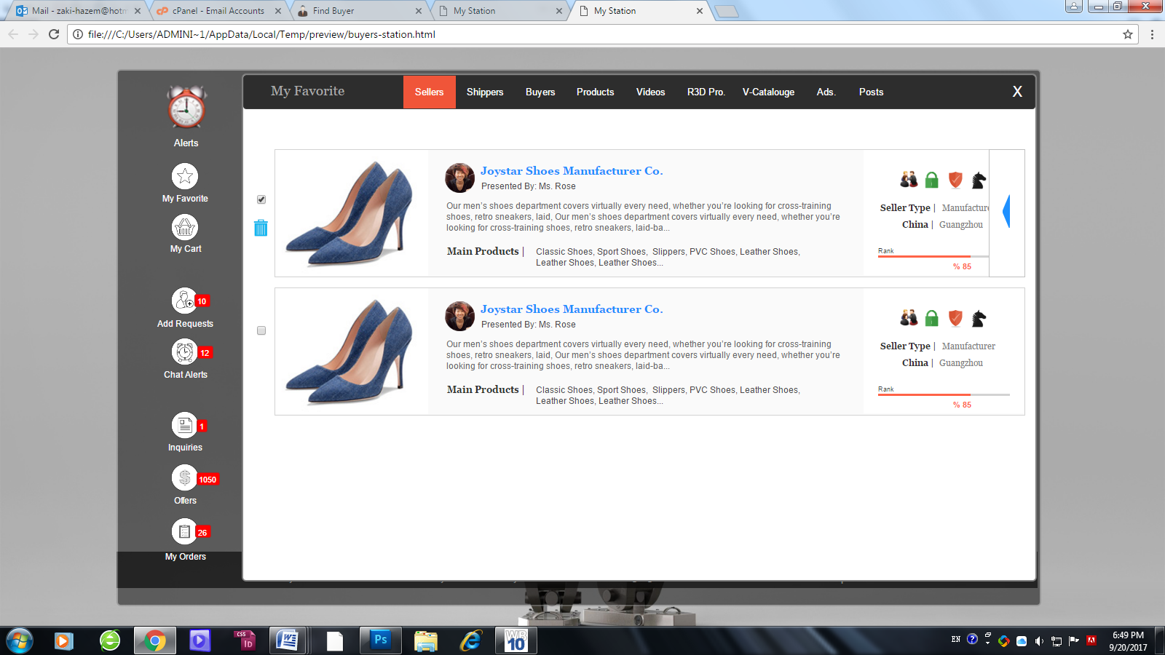

1. How delete showing and hidden ( according to the main clarification doc) is: when member click on checkbox it get selected ( marked as on) and the trash icon showing, and when he un-checkbox the trash icon get hidden. ( I mentioned in the document that my UI has error because I cannot do it). this will be for all members.
2. Products can be added to favorite but still not showing..
3. Videos added but the UI is not required please be simple and added as showing in video page, as showing hereunder. ( Please apply the same UI for 3D pro. & V-Catalogue).

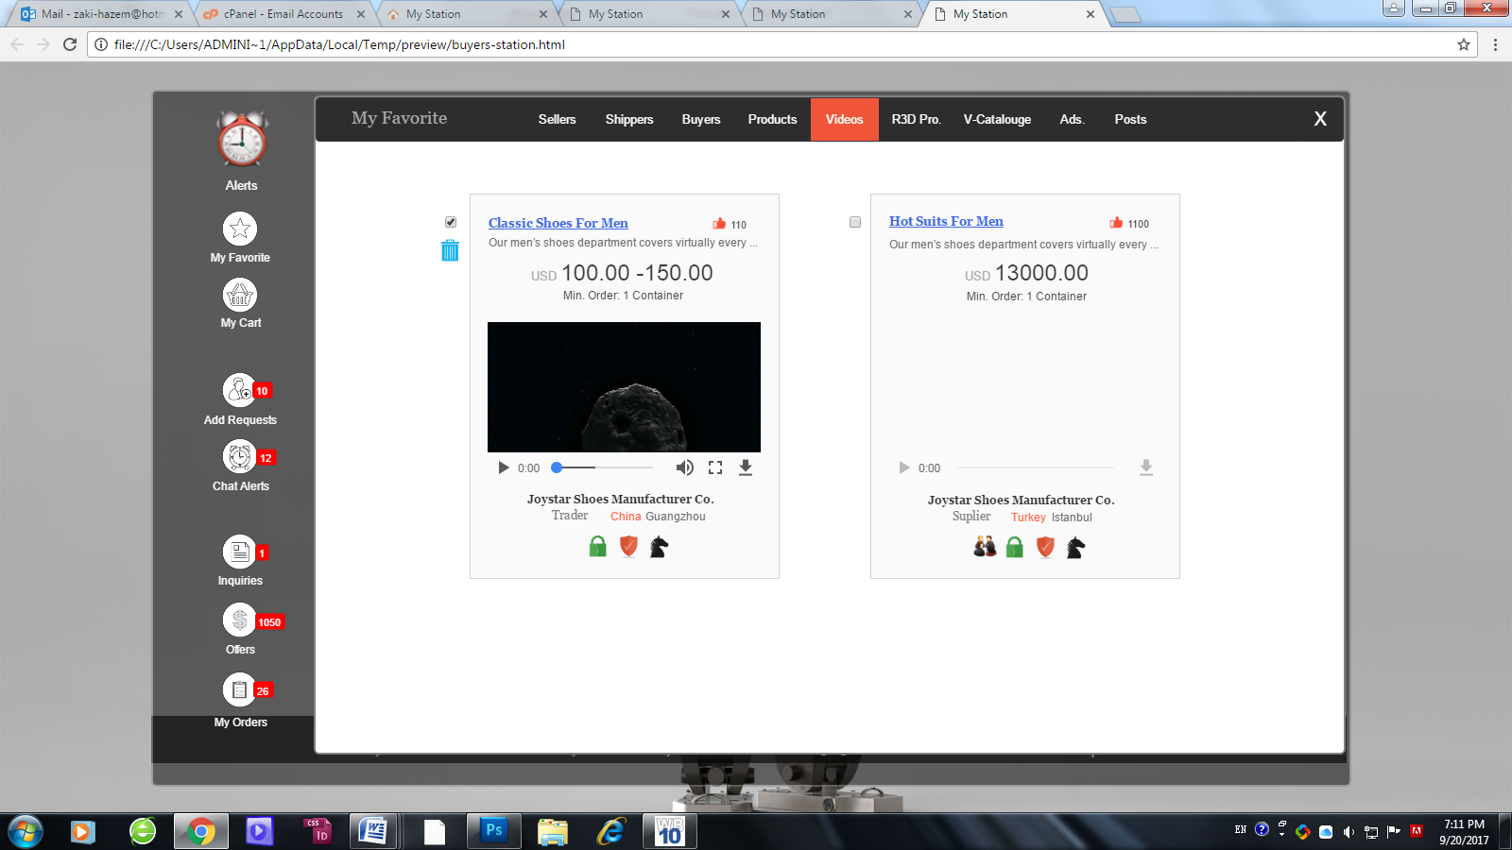

1. In Ads: Please note:

* Home Main screen (Ads) has an expire date according to the period member book with us, after this period his Ads will be delete from our server. But, when another member add this ads to his Favorite it will be shown under Ads. tab, and it will be saved in his own storage and not get expired till he delete the ads by himself.
* Ads in favorite will look same as desk site exactly, as shown hereunder

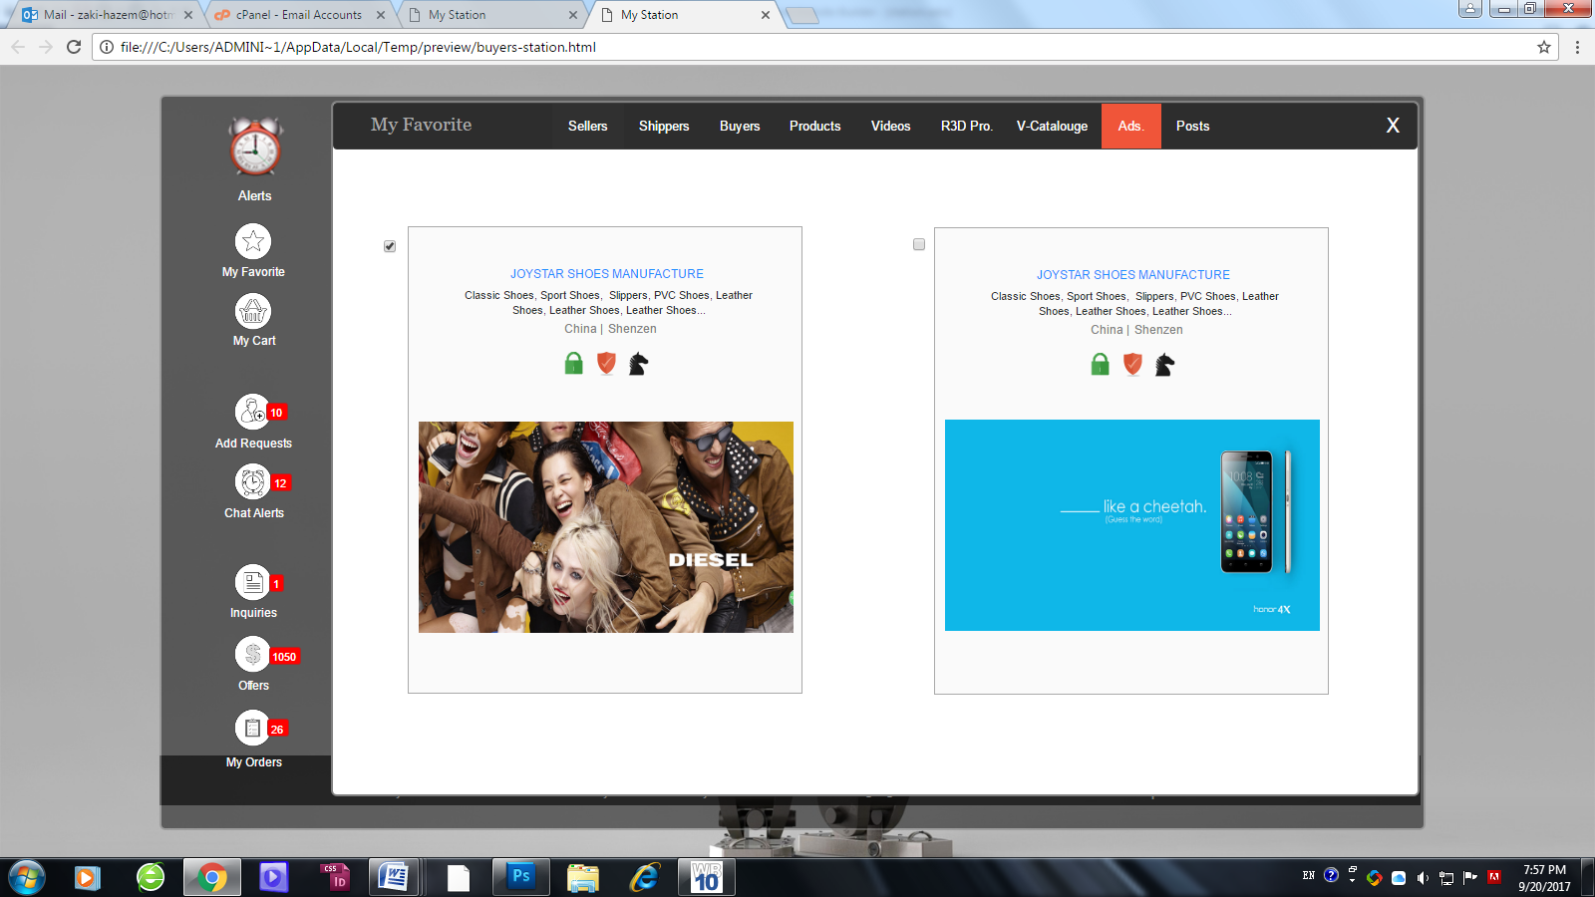

Please note that many icons couldn’t be tested now due to other features such as ( chat alerts…etc).