**Products**

This is the main and most visited page in our website because most of the visitors, members or buyer open it to search for product..

Please note here that search for product means search for ( the items/products sellers has added under his main or sub product..

All the page will be same other pages has:

1. **The main (login/register/language/ how to) upper bar.**
2. **The default Alerts box area including the “ My Alerts” features, which will always display the member alerts in case he logged in.**
3. **Main search bar which include the followings:**
4. search for the required product ( item ) by typing the **product name or No.,** or selecting from categories.
5. Advanced search ( select country plus city)
6. More button, to Sort the result according to the price from low to high or vise versa.
7. **Result Area:**

Result area consists of many Products information rectangle, so as users can view list of products through scrolling the page down or up. And ended with ( View more Bar) which allow the users to view more result or go for next or previous or certain page .

1. **Vertical side area includes:**
2. **More options menu** acts as a filter for the result according to the following :

* Show products produced by verified sellers first ( Above others).
* Show products produced by sellers in my community first ( Above others).
* Hide products produced by sellers in my community first ( Above others).

1. **New trends Links :**

* V- Catalogues Page.
* Desksites Page.
* Products in 3D Page.

1. **The Vertical Carousel which display here the following:**

* The same home page Featured Products
* The same home page Featured Videos
* The same home page Featured sellers

1. **Seller information:**

* A rectangle area as shown here under, holds all the Products information ( with its seller information too) ( retrieved from the each product data-base, according to what each seller has entered when he add the product details in his desksite)..
* Company name ( from company name field in registration) ( Active link to go to seller Desksite too).
* 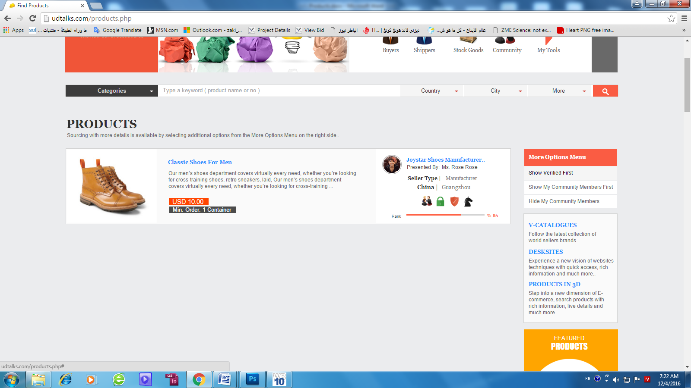Profile image + name from ( Contact person information fields in registration )..

* Product images ( we select the main image of the 6 images seller upload )
* Product details from ( Product details field ), during user entered when he added this product..
* Icons of ( Black Horse member, Verified /Audited member, Goods Guarantee Member, Member of my community )..
* Ranking bar with Percent ( will be explained about it in “My Station” file).
* when mouse over this area a small layer with arrow with appear same as all pages and when click the arrow it opens the following layer

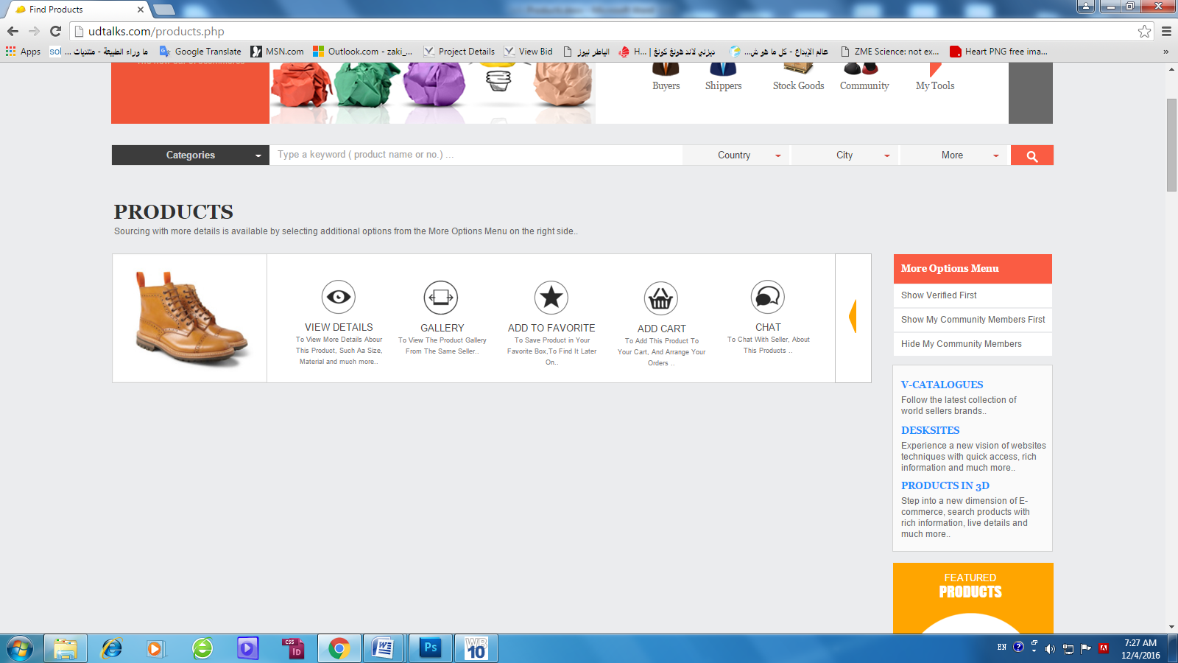

**Chat button**: to open chat window with the seller who provide this product ( as a layer) without showing the URL of chat window..

**File send from user to other will not be stored in our server ( our server just act as a transformer) all the files will be stored in user computer in special directory belongs to TRD Station directory .**. this means user can view his chat history with the other part..

**Add to cart button**: to add the product to the buyer cart..

**Add to Favorite button**: to add the product to buyer favorite box..

**Gallery: when click on gallery icon it opens a carousel in the same rectingle area displyes 8 products of the same keyword produced by the same saller..**

**The carousel should not disappear if mouse out or leave the rectingle area but can be closed if user click on CLOSE buton inside the carousel..**

**View Details**: to open the shown product in **Product Details Page (Details below on page4)..**

1. **Page footer with links buttons..**

**Please note that the final UI is in Home page so ( the header/Login bar + Information windows which open when you click the Eye button, when mouse over seller vertical carousel, or videos..etc to be as shown in home page not as shown now in this page).**

**2 cases to open Products page**

1. From home page: when user search in home page search bar and type product name and select ( Products) from “ Search For drop down list )..

In this case the result should not showing in home page but, First it opens product page then showing the result ( products) user searched for..

1. User also may click on products icon in Toolbox in home page or any other page: In this case we open Products page with random result consists of random products for the first time user open, Till the user type the certain product he search for, so next time the same user click on products page icon we open it with random product match the first keyword he has entered till he enter a certain product to search for ..

**Product Details Page**

This page the main pivot page of the website and consider the final destination of the user’s search ( buyer, sippers).. this page will be displayed from different places as it’s the CENTER HUB ( same data ) between ( sellers page) and (Products Page) explained hereunder

1. When user open **Products Page**/Then **search** **for** a certain product/The **result** will display in product page/ when user mouse over and click “**View Details**” icon/The **product details page** will be shown with full details about the product ( the information retrieved form seller information which he provided during build his Desksite/Website in “ My station “..
2. When user open **seller Desksite/website** from any where /click on **Products** button /Open the Products Category Menu/Click on Main or Sub Product shown in the menu/Opened the Products Category page/ Click on any product displayed in Products Category page/ Product details page will be shown here too..

**So, wherever the user click to view product details, this SAMER page will be shown however and wherever the user is..**

**Product Details Page GUI:**This page consists of 6 parts as follows:

1. **The upper bar**: It includes as 3 parts:
2. Right side carry ( seller’s logos)..
3. Center has ( seller desksite) button when click it opens the seller who sell this product
4. Left side has ( Products) button, when click the same ( same in Desksite bar)product category menu open
5. **The Gray bar**: It includes:

1- Print “ to fit A4 pages”

2- Save “ as PDF”

3- Same by this seller ( it goes for the upper level in “ product category page of the same seller)..

1. **The Main product screen**: It includes:

1- The full path of the products ( all to be active links)

2- 5 images view, with full zoom when mouse scroll over click on the bigger square.

3- The product Quick specifications, starting from up with Product ( item) name + some text of ( about this product down part) with Read More link ( when c lick it take the user to the ( about this product part at the same page), plus the other information as shown hereunder.

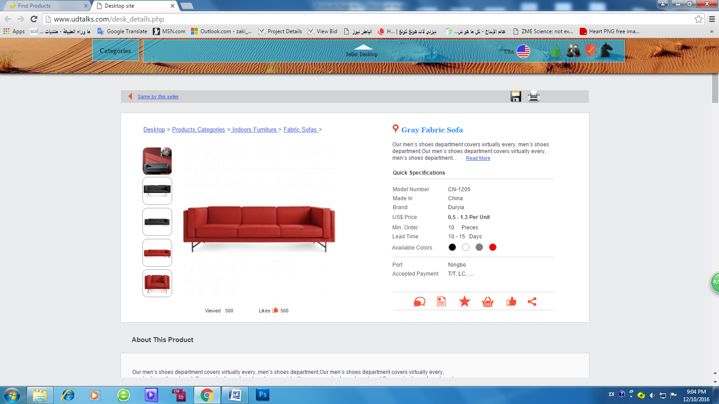

1. the dealing bar includes the shown buttons.
2. **The About This Product part**: displays the information text typed by the seller when he built his Desksite and added this product, with image..
3. **The Product Description part**: displays the information text typed by the seller when he built his Desksite and added this product, with image..
4. **The Product specification part:** displays the information as **table ( 2 columns + many rows)** typed by the seller when he built his Desksite and added this product, with image..