Shoe location detection model
Data preprocessing
1. Labelling the data
The first task is to label the collected data as shoe (x offset, Z distance, orientation angle) as shown in the below figure. All dimensions are in mm and angle in degrees
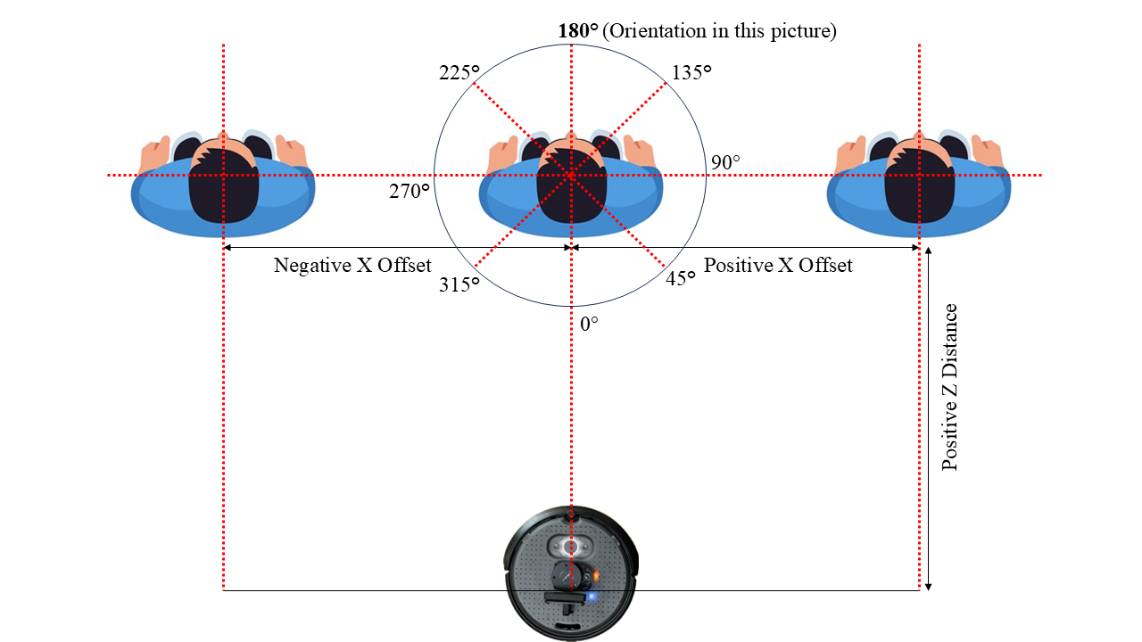
Figure 6 Direction convention used for data labelling
The application used for this task is Labelme. It’s a free application and for more clarity the below image shows an example. The after file is a .jason file.
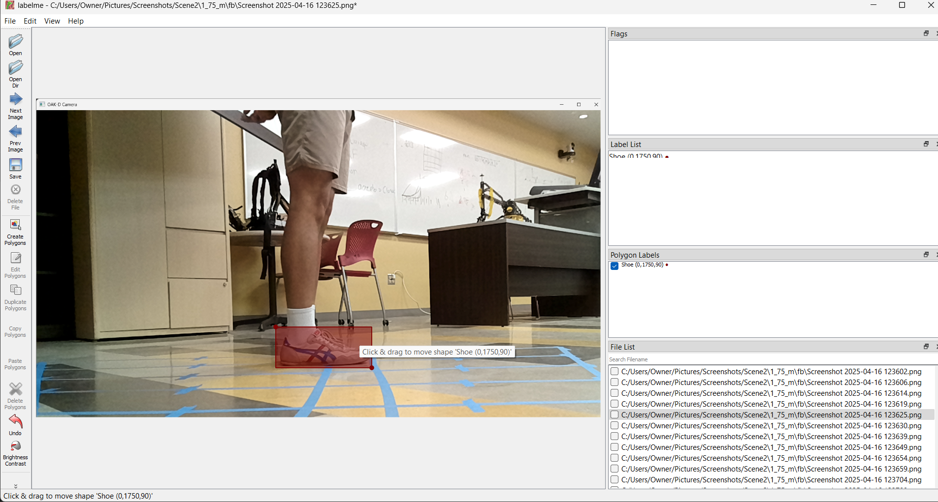
Figure 7 Labelme interface for data labelling
2. Organizing and normalizing the data
Organizing the data in a .csv file will help in loading the training data while model training and simultaneously the data can be normalized to increase the speed of training.
import os
import json
import pandas as pd
import re
import math

labelme_dir = "C:/Users/Owner/Pictures/Screenshots/Scene2/Jason_files"
output_csv = "shoe_dataset.csv"

records = []

for filename in os.listdir(labelme_dir):
if filename.endswith(".json"):
filepath = os.path.join(labelme_dir, filename)
with open(filepath, "r") as f:
data = json.load(f)

image_path = data.get("imagePath", "")
width = data.get("imageWidth", 1) # fallback to avoid division by 0
height = data.get("imageHeight", 1)

for shape in data["shapes"]:
label = shape["label"]
# Extract (x_offset, z_distance, angle) from label string
match = re.match(r"Shoe \(([-\d]+),([-\d]+),([-\d]+)\)", label)
if match:
x_offset = int(match.group(1)) # mm from screen center
z_distance = int(match.group(2)) # mm from camera
angle_deg = int(match.group(3)) # degrees

# Normalize x_offset (optional: assuming image center is at width/2)
x_offset_norm = x_offset / (width / 2) # now -1 to 1 if within screen
z_distance_norm = z_distance / 2000.0 # assuming 2m max range
angle_rad = angle_deg * 3.14159 / 180.0
angle_sin = round(math.sin(angle_rad), 4)
angle_cos = round(math.cos(angle_rad), 4)

records.append({
"image": image_path.replace("\\", "/"), # normalize path
"x_offset": x_offset,
"z_distance": z_distance,
"angle": angle_deg,
"x_offset_norm": x_offset_norm,
"z_distance_norm": z_distance_norm,
"angle_sin": angle_sin,
"angle_cos": angle_cos
})

df = pd.DataFrame(records)
df.to_csv(output_csv, index=False)
print(f"Saved: {output_csv}")

This saves all my data in the below format –
Figure 8 Example image for organized & normalized data
Data training with PyTorch
1. To proceed with the training it’s important to first structure the directory, the project directory must contain the .csv file, all the images in a separate folder in that directory, and the training python code. A new .pth file will be created in the directory when the training is complete.
2. A pretrained CNN model like ResNet18 will do the job with minimum effort and computational power.
import os
import pandas as pd
from PIL import Image
import torch
from torch.utils.data import Dataset, DataLoader, random_split
from torchvision import transforms
import torch.nn as nn
import torch.optim as optim
from torchvision.models import resnet18

# --- Custom Dataset ---
class ShoeDataset(Dataset):
def __init__(self, csv_file, image_dir, transform=None):
self.data = pd.read_csv(csv_file)
self.image_dir = image_dir
self.transform = transform

def __len__(self):
return len(self.data)

def __getitem__(self, idx):
row = self.data.iloc[idx]
image_path = os.path.join(self.image_dir, row['image'])
image = Image.open(image_path).convert("RGB")
if self.transform:
image = self.transform(image)

targets = torch.tensor([
row['x_offset_norm'],
row['z_distance_norm'],
row['angle_sin'],
row['angle_cos']
], dtype=torch.float32)

return image, targets

# --- Model ---
class ShoeRegressor(nn.Module):
def __init__(self):
super(ShoeRegressor, self).__init__()
self.backbone = resnet18(pretrained=True)
self.backbone.fc = nn.Linear(self.backbone.fc.in_features, 4) # 4 regression outputs

def forward(self, x):
return self.backbone(x)

# --- Training Function ---
def train():
# Hyperparameters
BATCH_SIZE = 8
EPOCHS = 100
LR = 1e-4
VAL_SPLIT = 0.2
CSV_FILE = "shoe_dataset.csv"
IMAGE_DIR = "C:/Users/Owner/Pictures/Screenshots/Scene2/images"

# Transforms
train_transform = transforms.Compose([
transforms.Resize((224, 224)),
transforms.RandomHorizontalFlip(),
transforms.RandomRotation(20),
transforms.ColorJitter(brightness=0.3, contrast=0.3),
transforms.ToTensor(),
transforms.Normalize([0.485, 0.456, 0.406],
[0.229, 0.224, 0.225])
])

val_transform = transforms.Compose([
transforms.Resize((224, 224)),
transforms.ToTensor(),
transforms.Normalize([0.485, 0.456, 0.406],
[0.229, 0.224, 0.225])
])

# Load dataset
full_dataset = ShoeDataset(CSV_FILE, IMAGE_DIR, transform=None)
val_size = int(VAL_SPLIT * len(full_dataset))
train_size = len(full_dataset) - val_size
train_data, val_data = random_split(full_dataset, [train_size, val_size])

# Apply transforms to splits
train_data.dataset.transform = train_transform
val_data.dataset.transform = val_transform

train_loader = DataLoader(train_data, batch_size=BATCH_SIZE, shuffle=True)
val_loader = DataLoader(val_data, batch_size=BATCH_SIZE)

# Model, loss, optimizer
device = torch.device("cuda" if torch.cuda.is_available() else "cpu")
model = ShoeRegressor().to(device)
criterion = nn.MSELoss()
optimizer = optim.Adam(model.parameters(), lr=LR)

# Training loop
for epoch in range(EPOCHS):
model.train()
train_loss = 0.0
for images, targets in train_loader:
images, targets = images.to(device), targets.to(device)
optimizer.zero_grad()
outputs = model(images)
loss = criterion(outputs, targets)
loss.backward()
optimizer.step()
train_loss += loss.item()

# Validation
model.eval()
val_loss = 0.0
with torch.no_grad():
for images, targets in val_loader:
images, targets = images.to(device), targets.to(device)
outputs = model(images)
loss = criterion(outputs, targets)
val_loss += loss.item()

print(f"Epoch {epoch+1}/{EPOCHS}, Train Loss: {train_loss/len(train_loader):.4f}, "
f"Val Loss: {val_loss/len(val_loader):.4f}")

# Save model
torch.save(model.state_dict(), "shoe_model.pth")
print("Training complete. Model saved as shoe_model.pth")

if __name__ == "__main__":
train()

Loading the model & predicting the shoe location
To work the model in real time with the OAK-D camera, the frames must be captured in real time. The frames need to be pre processed similar to when training. By running the .pth file as inference new information will be predicted. On looping the postprocess and display prediction we can get the output in real time.
import torch
from torchvision import transforms
from PIL import Image
import numpy as np
import cv2
import depthai as dai
import torchvision.models as models
import torch.nn as nn

# Set torch device
torch_device = torch.device("cuda" if torch.cuda.is_available() else "cpu")

# Define the model and load weights
model = models.resnet18(weights=None)
model.fc = nn.Linear(model.fc.in_features, 4)

state_dict = torch.load("shoe_model.pth")
cleaned_state_dict = {k.replace("backbone.", ""): v for k, v in state_dict.items()}
model.load_state_dict(cleaned_state_dict)
model.to(torch_device)
model.eval()

# Image transform (same as training)
transform = transforms.Compose([
transforms.ToPILImage(),
transforms.Resize((224, 224)),
transforms.ToTensor(),
transforms.Normalize([0.485, 0.456, 0.406],
[0.229, 0.224, 0.225]) # Standard ImageNet normalization
])

# Create DepthAI pipeline
pipeline = dai.Pipeline()

cam_rgb = pipeline.createColorCamera()
cam_rgb.setPreviewSize(640, 480)
cam_rgb.setInterleaved(False)
cam_rgb.setBoardSocket(dai.CameraBoardSocket.CAM_A) # Use CAM_A instead of deprecated RGB

xout_video = pipeline.createXLinkOut()
xout_video.setStreamName("video")
cam_rgb.preview.link(xout_video.input)

# Start pipeline
with dai.Device(pipeline) as depthai_device:
video = depthai_device.getOutputQueue(name="video", maxSize=4, blocking=False)

while True:
in_frame = video.get()
frame = in_frame.getCvFrame()

# Preprocess frame
input_tensor = transform(frame).unsqueeze(0).to(torch_device)

# Predict
with torch.no_grad():
prediction = model(input_tensor).squeeze().cpu().numpy()

# Unpack prediction
x_offset_norm, z_distance_norm, sin_theta, cos_theta = prediction

# Convert normalized to actual (adjust as needed)
frame_width = frame.shape[1]
x_offset = x_offset_norm * frame_width

z_distance = z_distance_norm * 2000 # 0–2000 mm range

angle_rad = np.arctan2(sin_theta, cos_theta)
angle_deg = np.degrees(angle_rad) % 360

# Display results
cv2.putText(frame, f"X Offset: {x_offset:.1f} mm", (10, 30),
cv2.FONT_HERSHEY_SIMPLEX, 0.7, (0, 255, 0), 2)
cv2.putText(frame, f"Z Dist: {z_distance:.1f} mm", (10, 60),
cv2.FONT_HERSHEY_SIMPLEX, 0.7, (0, 255, 0), 2)
cv2.putText(frame, f"Angle: {angle_deg:.1f} deg", (10, 90),
cv2.FONT_HERSHEY_SIMPLEX, 0.7, (0, 255, 0), 2)

cv2.imshow("Shoe Tracker", frame)
if cv2.waitKey(1) == ord('q'):
break

cv2.destroyAllWindows()

The output for the code will tell the position of the shoe and display the screen as shown I the below image.
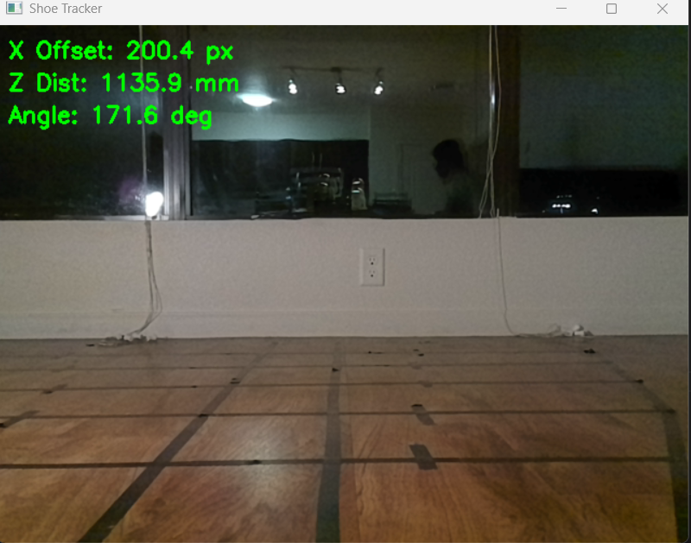
Figure 9 The output screen of the predicted location.

