AI-Generated Paragraph:

Social media has completely ruined students’ academic lives. Most students waste their valuable time scrolling endlessly instead of studying. Social media platforms distract students, reduce concentration, and negatively affect mental health. Students who use social media regularly perform poorly in exams and become less disciplined in their daily routines.

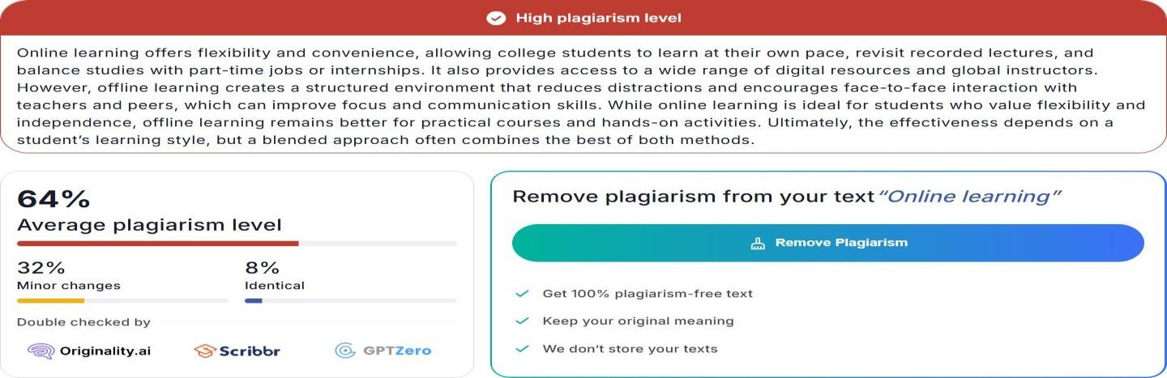

Grammarly:

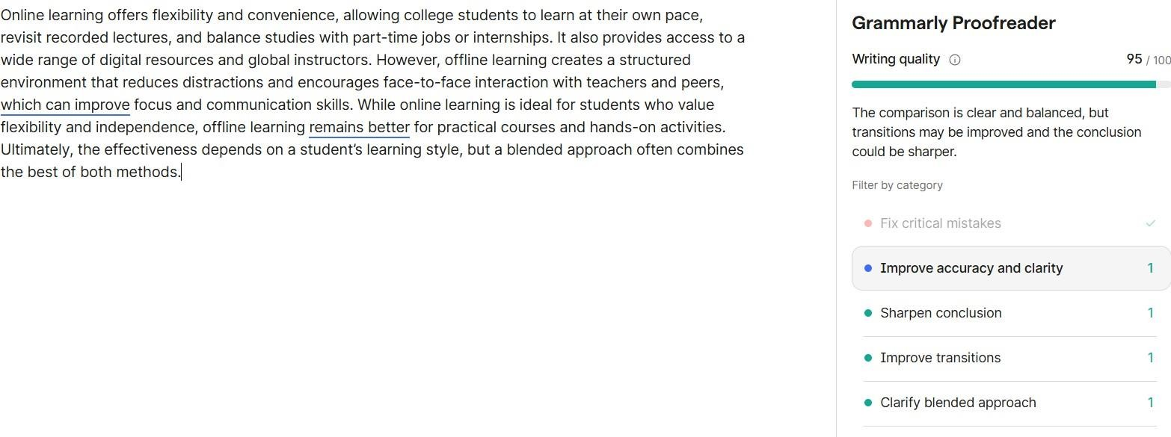

Humanize Paragraph:

"College students can study at their own pace, review lectures that have been recorded, and manage their studies with part- time jobs or internships thanks to the flexibility and convenience of online learning. Additionally, it gives users access to a variety of online resources and instructors from around the world. On the other hand, offline learning fosters a controlled setting that lessens distractions and promotes in- person interactions with peers and teachers, which can enhance concentration and communication abilities. Offline learning is still preferable for practical courses and hands-on activities, but online learning is perfect for students who value flexibility and independence. Although a blended approach frequently incorporates the best aspects of both approaches, the effectiveness ultimately depends on a student's learning style."

